TOURISM

ABSTRACT:

In this project “Tourist”, user will be greeted according to the languages.

FOLDER STRUCTURE OF MULTILINGUAL GREETINGS:

Index.html 🡪 HTML file

Places.html 🡪 HTML file

Taj_mahal.html 🡪 HTML file

Golden_temple.html 🡪 HTML file

Mysore_palace.html 🡪 HTML file

Varanasi_temple.html 🡪 HTML file

Style.css 🡪 Stylesheet/CSS file

Style2.css 🡪 Stylesheet/CSS file

Final.css 🡪 stylesheet/CSS file

Source 🡪 Images container

STEP TO CREATE A FOLDER:

Step 1: Create a folder named “Multilingual Greetings” or the name you prefer. But it is recommended to use the folder name and the project name as same.

Step 2: Create 6 normal text document file and change it’s extension to “.html”, which represents the webpage of our project.

Step 3: Now, create a normal text document like the previous one and change it’s extension to “.css”, which is used to style our webpage.

Step 4: Create a folder and store all the required for our project.

index.html:

this “index.html” is our base file, which helps us to provide content for our webpage.

The basic structure of an HTML file is shown below.

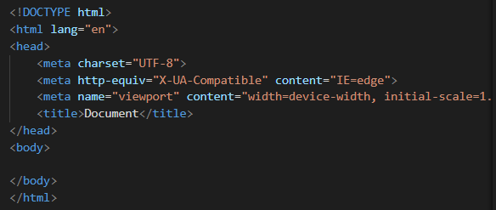

This structure can be simply brought into our file by pressing a shortcut key shift+1(one). This will show an exclamatory(!) symbol. If you press enter, then it will provide the base structure code like shown in the image.

Change the title into “Tourism” which will be provided in the title tag of the html file.

Add link tag to link our external CSS file to our html file.



Inside the body section, define a class named “container” which involves “h1”, paragraph and a button. Button is wrapped inside the anchor tag to navigate it to another HTML file named “places.html”.

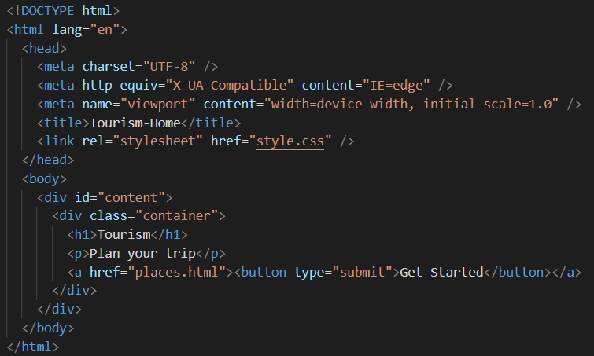

Places.html:  
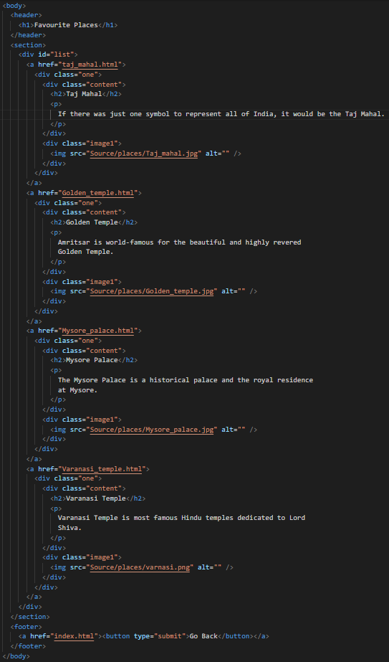

This code is an HTML document that creates a webpage for displaying a list of favorite tourist destinations. The page has a header, a section, and a footer.

The header contains a title "Favourite Places".

The section contains a div with an id of "list" which has four "a" tags, each displaying information about a tourist destination. Each "a" tag contains a "div" tag with a class of "one". Within each "div" tag, there are two "div" tags with classes of "content" and "image1" respectively. The "content" div has a "h2" tag with the name of the tourist destination and a "p" tag with a description. The "image1" div has an "img" tag with an image of the destination. Each "a" tag is linked to a specific HTML document for that particular destination.

The footer has a button that allows the user to navigate back to the previous webpage.

The webpage is linked to an external stylesheet named "style2.css".

Taj_mahal.html:

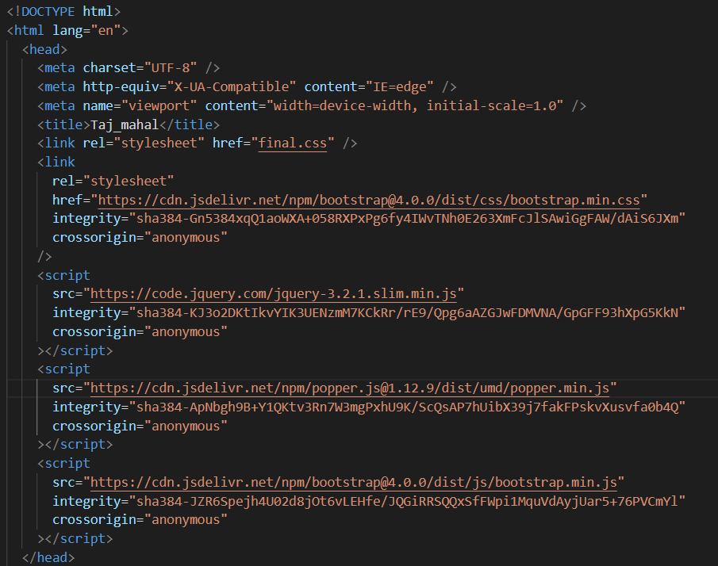

This is an HTML file that appears to be a web page for the Taj Mahal. The file includes metadata in the head section such as the character set, viewport size, and title of the page. Additionally, it includes links to two stylesheets, final.css and bootstrap.css, and three JavaScript files for jQuery, Popper.js, and Bootstrap. These are external libraries that are used to style and add interactive features to the web page.

The body of the page includes the content for the Taj Mahal page, which may include images, text, and possibly videos. However, since the content of the body is not included in the code snippet, it is unclear what the actual content of the page is.

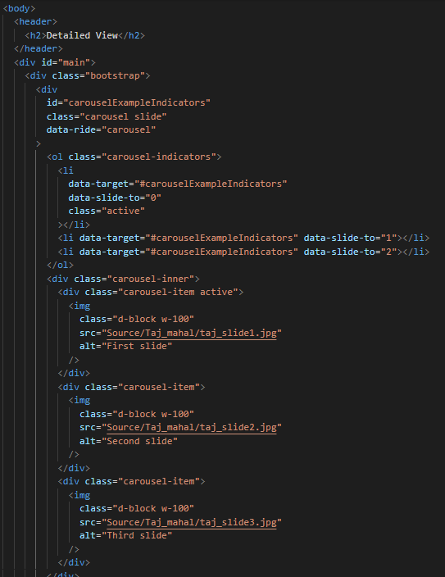 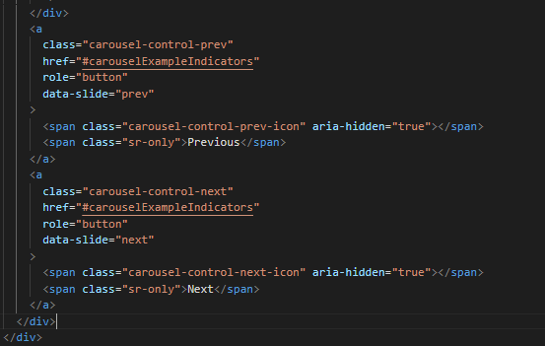

This code appears to be an HTML markup for displaying a carousel of images related to the Taj Mahal, which is a famous landmark in India. The carousel is designed using the Bootstrap framework, as indicated by the class "bootstrap" used in the code. The carousel consists of three images, with each image assigned to a separate carousel item. The carousel also includes controls for navigating between the images, which are represented by the "carousel-control-prev" and "carousel-control-next" classes. Overall, this code appears to be a functional and visually appealing way to display images related to the Taj Mahal.

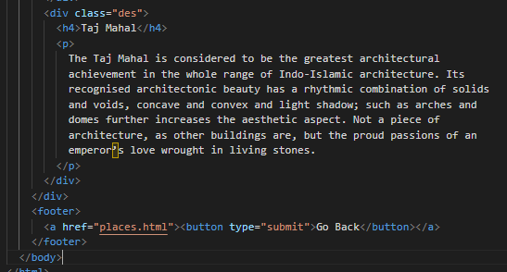

This code appears to be an HTML markup for displaying a description of the Taj Mahal, which is a famous landmark in India. The description is contained within a div element that has a class of "des." The div contains a heading element (h4) that displays the name of the landmark, and a paragraph element (p) that provides a brief overview of the Taj Mahal's architectural beauty and historical significance.

At the bottom of the markup, there is a footer element that includes a button which, when clicked, will redirect the user back to the "places.html" page. This button is wrapped in an anchor tag, which specifies the target URL for the redirection. Overall, this code provides a concise description of the Taj Mahal and includes a simple navigational element to enable the user to return to the previous page.

Similairly, other 3 pages “golden_temple.html”, “mysore_palace.html”, and “Varanasi_temple.html” are designed with their own images.

CSS file:

Style.css:

This code appears to be a CSS style sheet that defines the visual layout and appearance of an HTML page.

The first block of code applies a global style to all elements by setting their margin and padding values to zero.

The next block of code sets the background image of the body element to a specified image URL, and adjusts its size and repetition properties.

The third block of code styles a div element with an ID of "content". This div element is positioned absolutely at the bottom of the viewport and contains the main content of the page. The width of the div is set to 100%, and its text is aligned to the center. The div also has a white background color and rounded corners with a border radius of 20px.

The "container" class is applied to another div element that is used to contain the main content. This div is centered horizontally on the page using margin auto.

The "#content h1" selector sets the font size and weight of the main heading of the page. The "#content p" selector styles the paragraphs by setting the margin and font size.

Finally, the "button" selector styles a button element by setting its dimensions, background color, border radius, border, text color, and font size.

Style2.css:

This code defines the styling for an HTML document using CSS.

The first three lines use the universal selector to set the margin and padding to zero for all elements on the page.

The background color of the body element is set to #0f98bb.

There is a div element with a class of "one" which is styled with a white background color, 10px padding, 100px height, 20px margin, and 5px border-radius. The position property is set to relative.

The header element has white text color and is positioned with 20px margin from the top and left of the page.

Inside the div with a class of "one" there is another div element with a class of "image1" which has an img tag. The image has a width of 130px, a height of 100px, and is positioned absolutely with 20px margin from the left of the page and is located on the right side of the div.

The paragraph element inside the div with a class of "one" has an opacity of 60%.

The footer element has 20px margin and is centered. It contains a button element with a width of 100px, a height of 30px, a 50px border-radius, and a dark grey background color with white text color and bold font-weight.

All anchor elements have no text decoration and a dark blue color.

Final.css:

This is a CSS code snippet that contains various style rules for different HTML elements.

The first rule sets a margin of 3 viewport widths for the entire HTML document.

The second rule sets a margin for the header element, with 10 pixels at the top, 0 pixels on the right and left, and 50 pixels at the bottom.

The third rule sets a white background color for an element with the ID "main".

The fourth rule styles an element with the class "des" with a padding of 20 pixels on the top and bottom, and 20 pixels on the left and right, as well as a solid 1-pixel black border.

The fifth rule sets the opacity of all paragraph elements to 80%.

The sixth rule styles the footer element with a margin of 20 pixels and centers its text. It also styles a button element inside the footer with a width of 100 pixels, a height of 30 pixels, a border radius of 50 pixels, no border, a background color of "dimgrey", white text, and a font weight of 550.

Finally, the last rule styles all anchor elements by removing their underline and setting their color to a dark blue.