1. Go to Amazon Web Services (AWS) management console. <http://aws.amazon.com/>

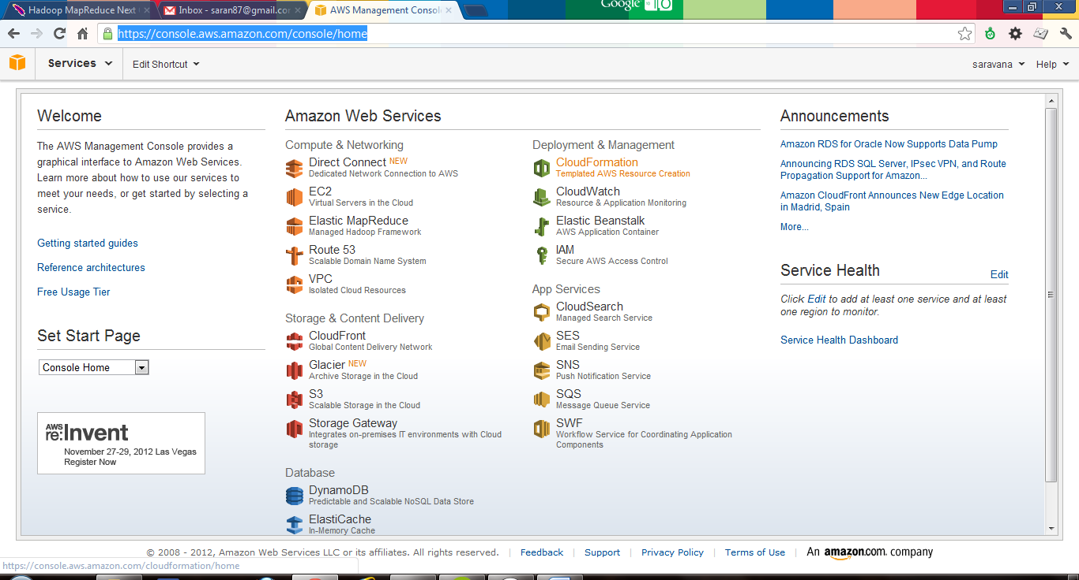

Click on EC2 to create virtual servers

1. Click on Launch Instance to create and get information about an existing instance.

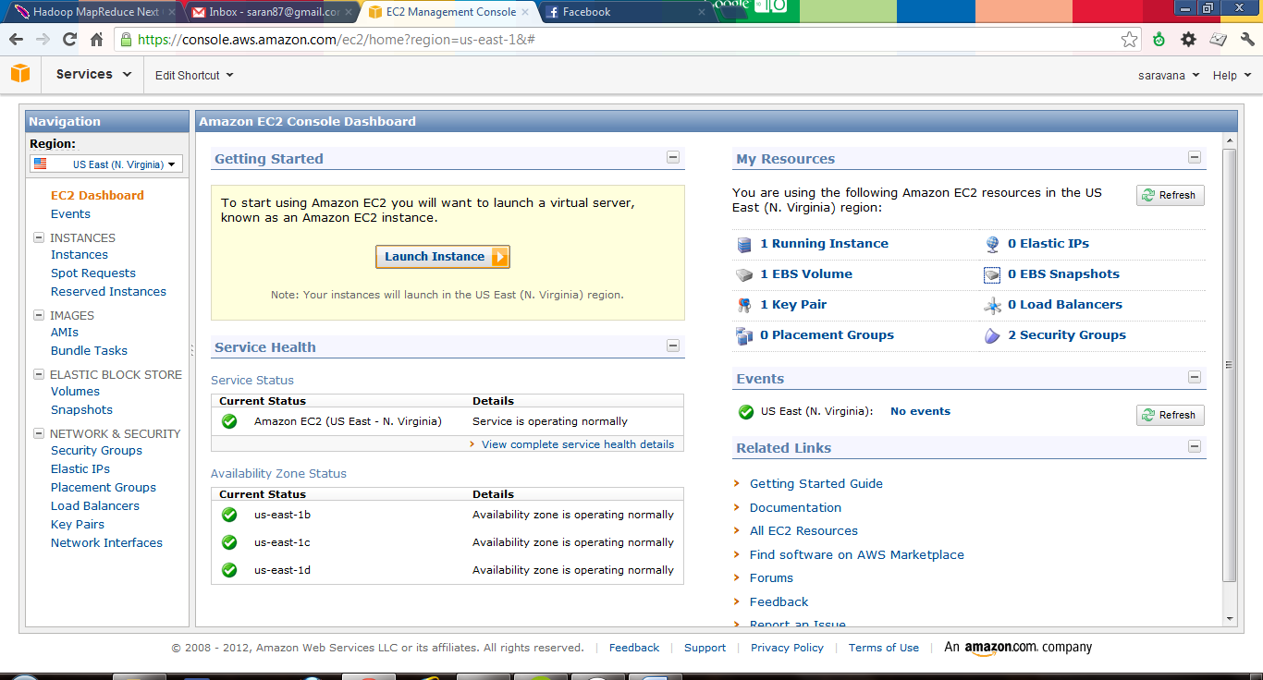

1. Choose classic wizard and click continue

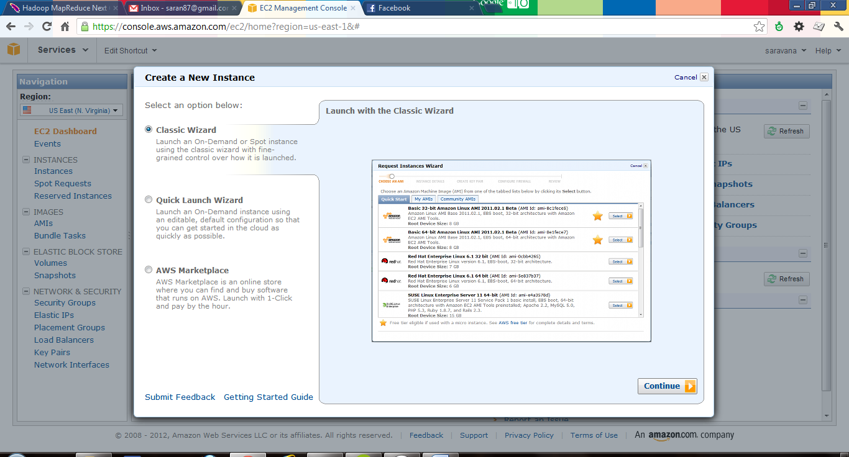

1. In Quick Start tab, select the operating system you need to install, I am installing Ubuntu server 12.04.1LTS

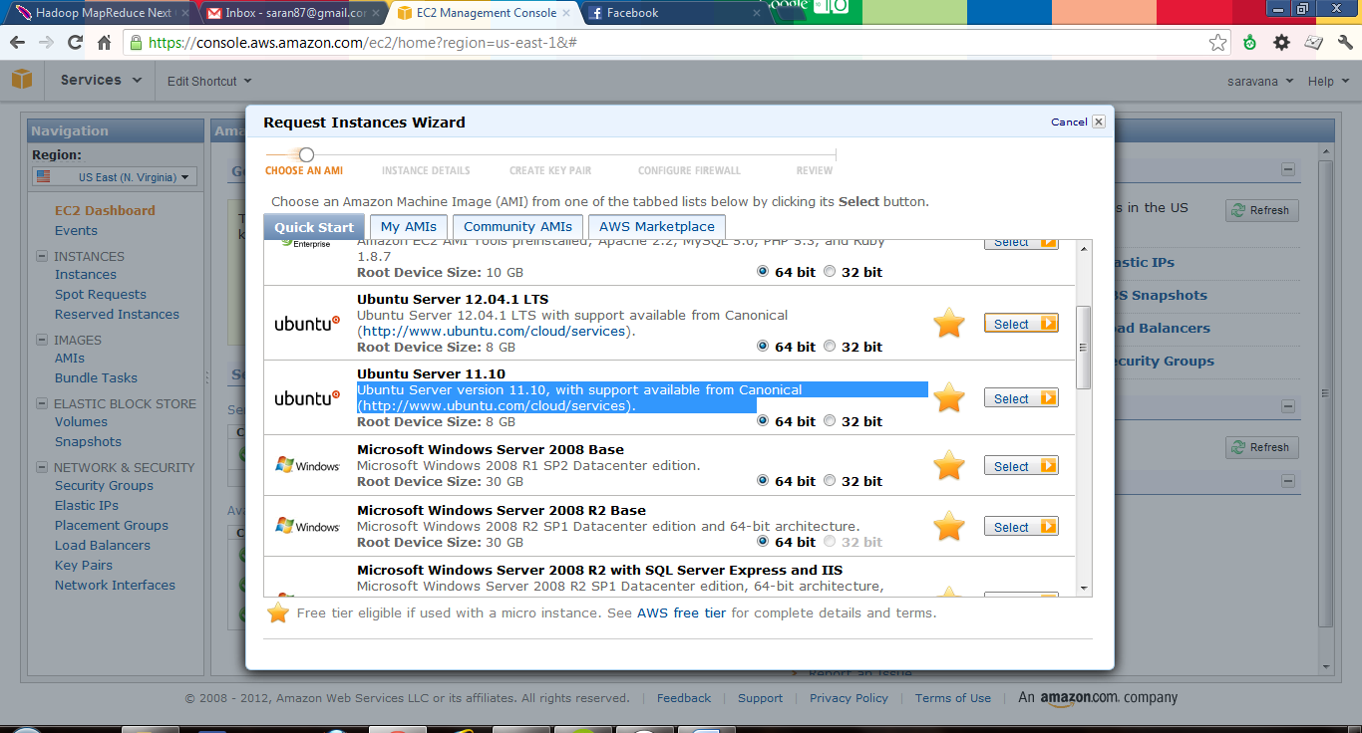

1. Enter the instance details, I choose Micro Instance type (free instance). If you want the availability zone to be changed change it here.

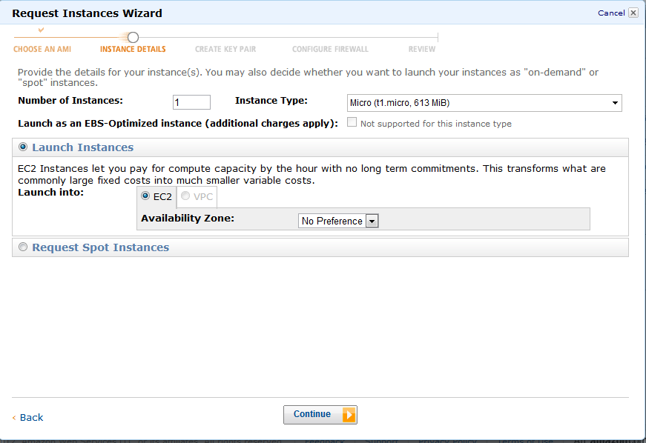

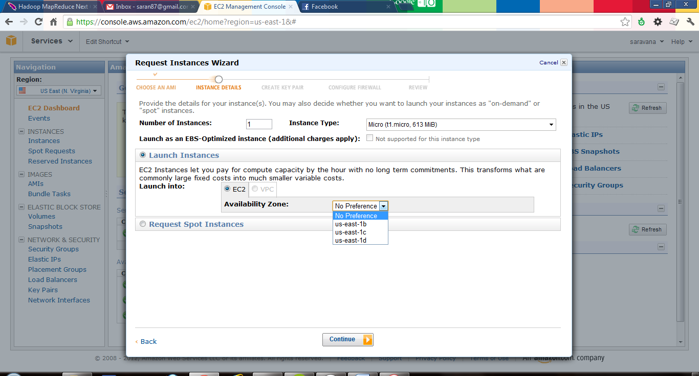

Available Instance Types are listed below

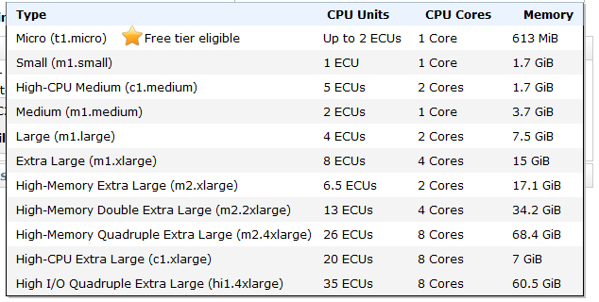

1. You have an option of setting up expandable instance, which fluctuate its processing power based upon the supply and demand.

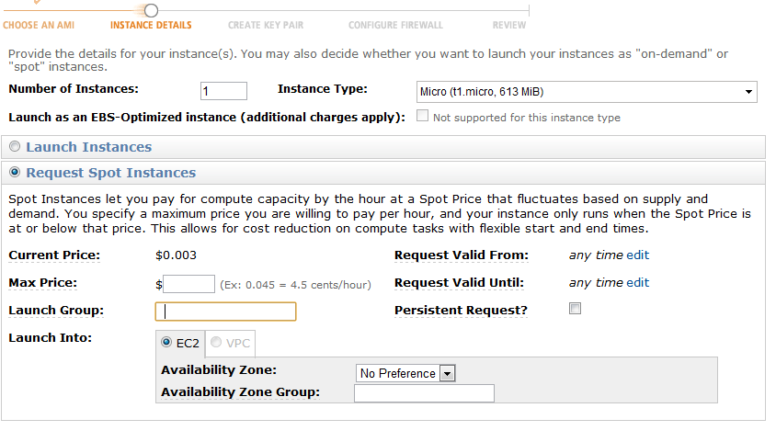

Few more options, if you have any preference you can change it here

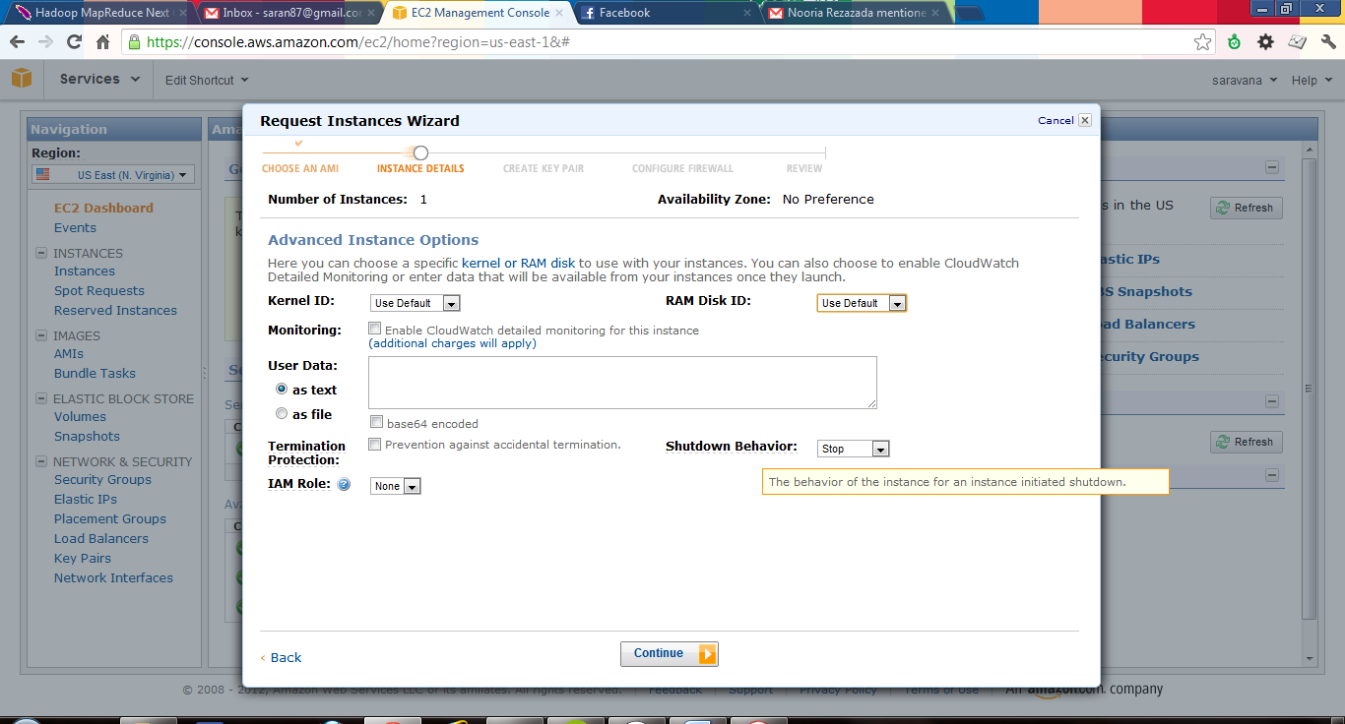

**Storage Device Configuration:**

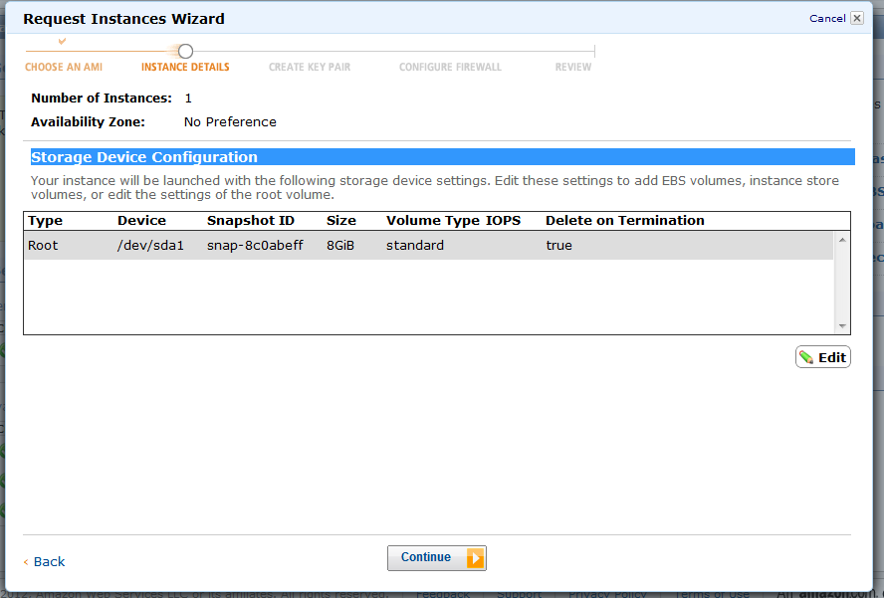

You can edit it and mount Elastic Block Store (EBS) to the instance.

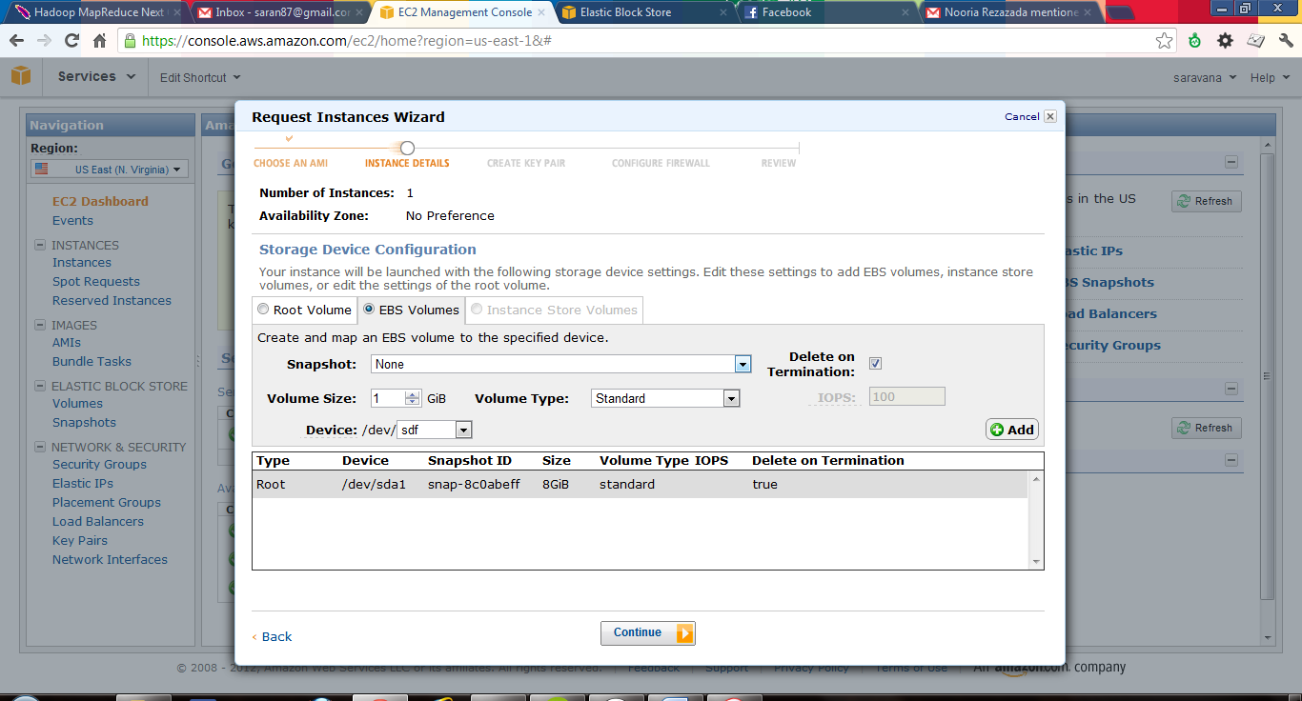

**Tagging Instances:**

You can tag your instances for identifying its purpose.

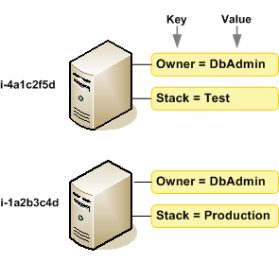

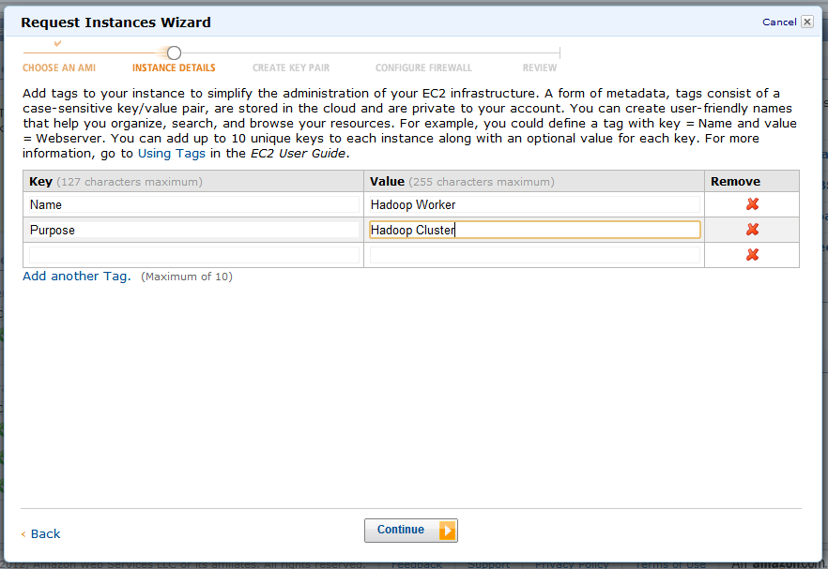

**Creating and Downloading key pair:**

In Order to connect to the instances in cloud securely you need to have public/private key pair. You can create the key value pair and download it in a file.

**Keep this file safe, without this you can’t connect to the instance from you ssh client.**

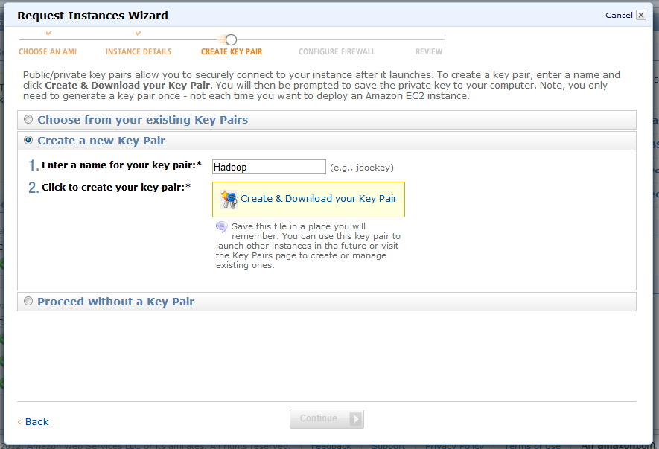

**Configuring Firewall:**

You can create new group or you can select a existing group.

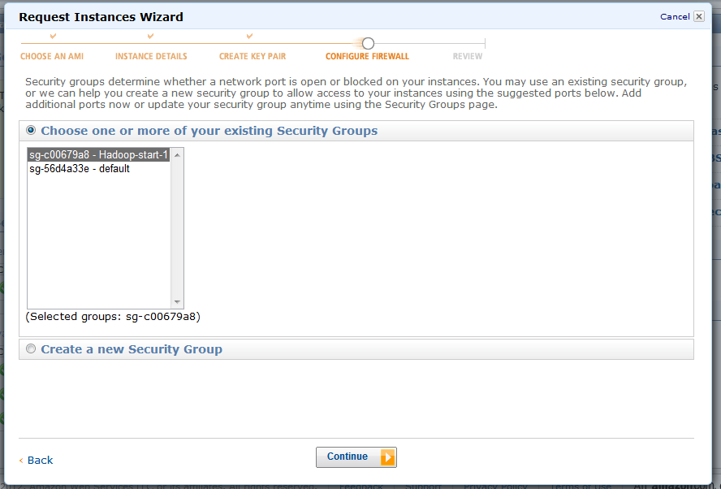

**Review and Launch:**

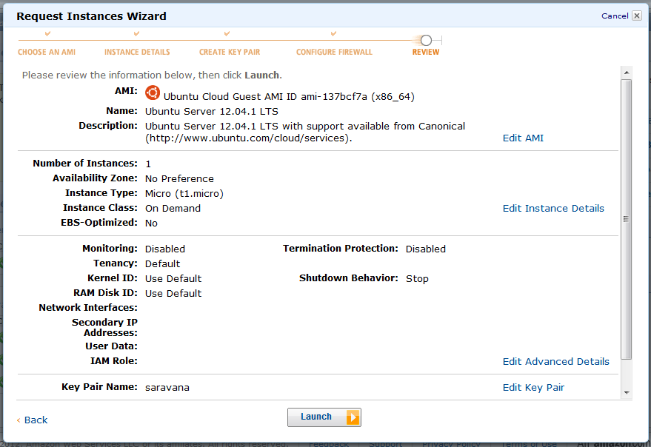

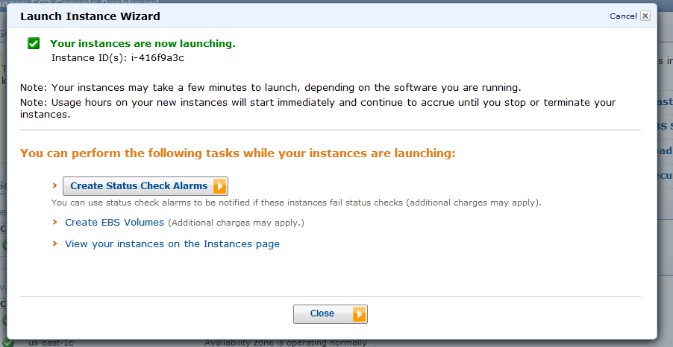

You can connect to your instances from the AWS management console as shown in below images.

