How to create a DB Connection in SQL Developer – Step-by-Step:
- Open SQL Developer > View > SSH
Then SSH options will be displayed:
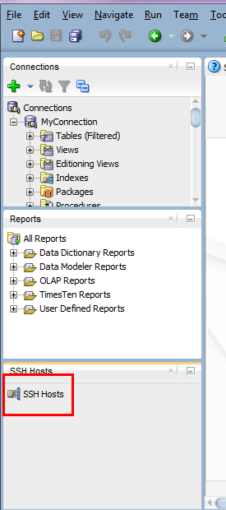

- Right-Click Hosts SSH > New Host SSH …
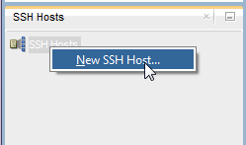

- In the pop-up New Host config window, configure as below:
Name: Any name
Host: <your_pubIP>
Username: oracle
Mark to use key and select the private key you have previous downloaded
Also mark to “Add a Local Port Forward”
Click OK
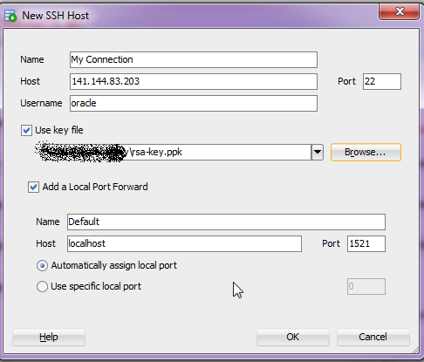
- This will be the result:
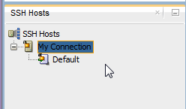
- Now, in order to create the DB connection, right-click Connections and then click New Connection:
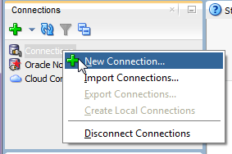
- In the New Connection pop-up window, complete as below (in this example I am connecting as ora25/ora25):
Connection Name: Any Name
UserName: <ora_db_user_name> (ora1..ora25)
Password: <ora_db_password< (ora1..ora25)
Connection Type: SSH
Select “Service Name” and inform its service name which is pdb1.<Domain Name>.oraclecloud.internal (as explained above), in this case it is pdb1.ouopc069.oraclecloud.internal
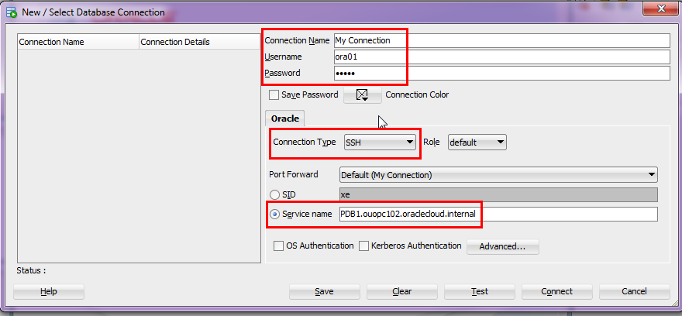

- Click on Test to test the connection:
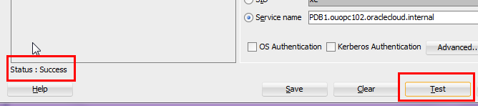

- Then click on “Connect” to create the connection and to connect to the DataBase:

- Connection is now established and we can view DB objects and run queries successfully as shown below:
