PGP - Data Science and Business Analysis - Jan’ 21

Predictive Modeling Project Report

by Sarang Manohar

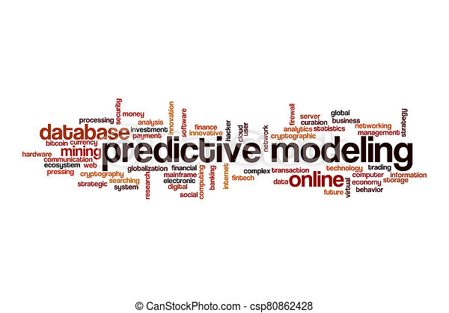

Table of Contents 1
Introduction 2
Problem 1: Linear Regression 2
Data Dictionary: 2
Question 1.1. 3
Question 1.2 11
Question 1.3 12
Question 1.4 14

Introduction
This project report is in response to the final assignment for completion Predictive Modeling module. In this module, we learned regression techniques both linear and logistic, as well as linear discriminant analysis for multi-class classification problems. We also learned the short-comings of ordinary linear regression and how Ridge and Lasso methods can help us overcome them.

Problem 1: Linear Regression
You are hired by a company Gem Stones co ltd, which is a cubic zirconia manufacturer. You are provided with the dataset containing the prices and other attributes of almost 27,000 cubic zirconia (which is an inexpensive diamond alternative with many of the same qualities as a diamond). The company is earning different profits on different prize slots. You have to help the company in predicting the price for the stone on the bases of the details given in the dataset so it can distinguish between higher profitable stones and lower profitable stones so as to have better profit share. Also, provide them with the best 5 attributes that are most important.
Data Dictionary:
Variable Name | Description
Carat | Carat weight of the cubic zirconia.
Cut | Describe the cut quality of the cubic zirconia. Quality is increasing order Fair, Good, Very Good, Premium, Ideal.
Color | Colour of the cubic zirconia.With D being the best and J the worst.
Clarity | cubic zirconia Clarity refers to the absence of the Inclusions and Blemishes. (In order from Best to Worst, FL = flawless, I3= level 3 inclusions) FL, IF, VVS1, VVS2, VS1, VS2, SI1, SI2, I1, I2, I3
Depth | The Height of a cubic zirconia, measured from the Culet to the table, divided by its average Girdle Diameter.
Table | The Width of the cubic zirconia's Table expressed as a Percentage of its Average Diameter.
Price | the Price of the cubic zirconia.
X | Length of the cubic zirconia in mm.
Y | Width of the cubic zirconia in mm.
Z | Height of the cubic zirconia in mm.

Question 1.1.
Read the data and do exploratory data analysis. Describe the data briefly. (Check the null values, Data types, shape, EDA). Perform Uni-variate and Bi-variate Analysis.
We start with import the data and checking first few records. A snapshot of the same is below
Some quick observations on the data after looking at the sample records.
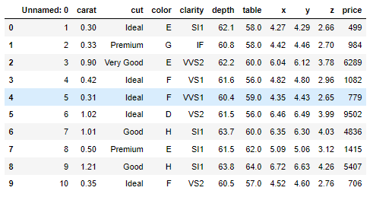Illustration 1: First 10 records from the data
- There are 11 features in the data, of which first feature 'Unnamed: 0' seemed to be the record id which should be dropped, as we already have the index values in our data frame
- cut, color and clarity are categorical as already defined in the data dictionary section of the problem statement
- The carat, depth, table, x, y, & z are continuous features
- The price is the target feature which we need to predict as a solution to this assignment
Moving ahead with EDA, we run a info() check on the data and compare the results with our assumptions from looking at the sample data. However, we should not proceed further before dropping the 'Unnamed: 0' feature.
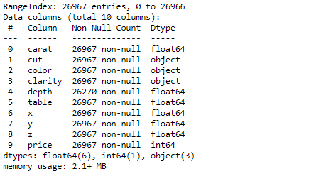Illustration 2: Basic information about the data frame
- There are 26,967 records in the data set
- Except depth which has a few null values, all the features have not null values across all records
- As expected, cut, color & clarity have object datatype which is as per the data dictionary definition
- All the remaining features are float64 or int64 which is as per the expectations as well
Next we run describe method on the continuous features to get am insight on how the data is distributed.
- The carat, table, x, y, & z appear to have NOT normally distributed with some outliers appearing in the data as well. This can be further asserted by other means in later in this section
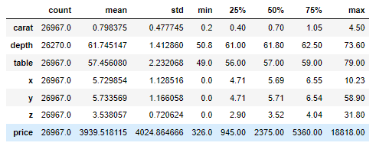Illustration 3: Results of describe method on continuous features
- Only depth appears to be normally distributed
- The features x, y, & z have minimum value as zero which should be deemed as missing data as they are physical dimensions of zirconia. We will be imputing this later considering correlation across the features
Uni-variate analysis
Our focus in this sub-section will be to analyze the each feature individually. For continuous features we will be using Shapiro-Wilk test, Distribution plot, Skewness test, Box plots. For categorical features we will use count plots.
Continuous features
Feature | Shapiro-Wilk test | % age Outliers | Skewness | Distribution plot | Box plot
carat | Stats = 0.893  p value = 0.000 | 22.07% | 1.12 | 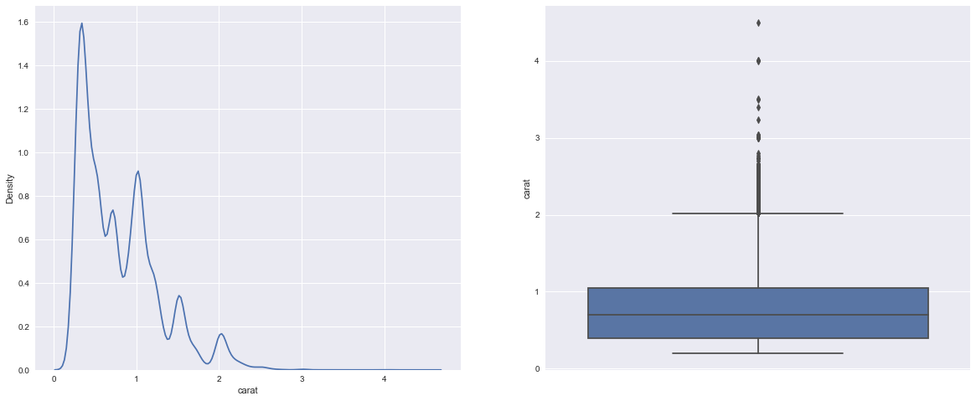Illustration 4: Distribution plot and box plot for carat
depth | Stats = NaN  p value = 1.000 | 22.07% | -0.03 | 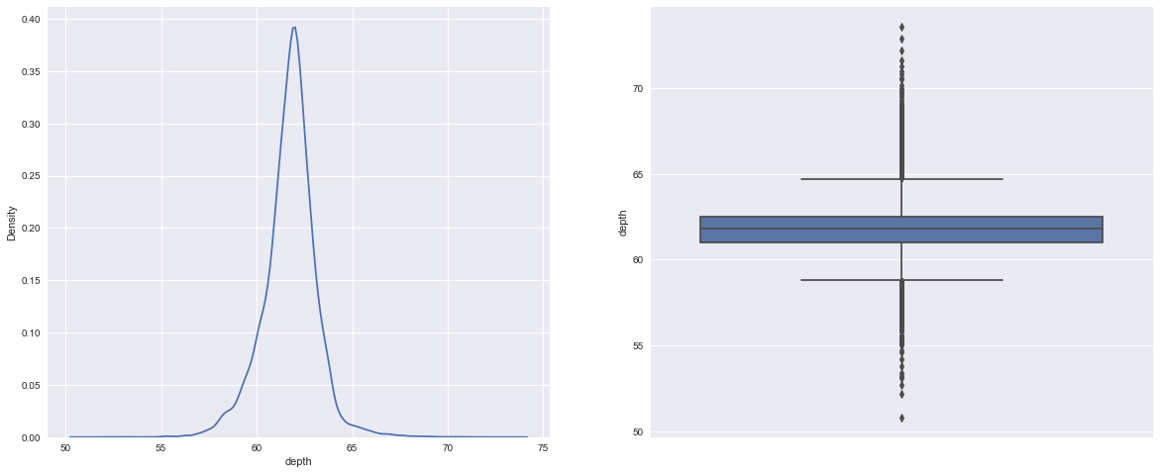Illustration 5: Distribution plot and box plot for depth
table | Stats=0.955  p=value=0.000 | 32.67% | 0.77 | 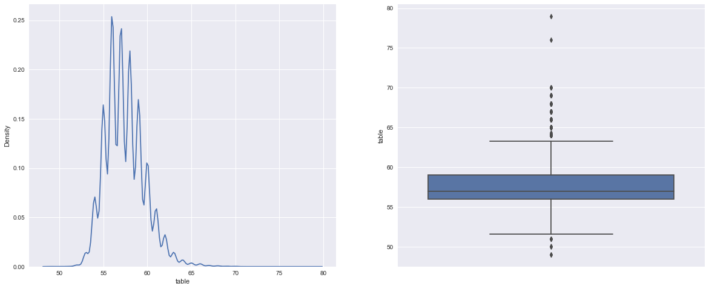Illustration 6: Distribution plot and box plot for table
x | Stats=0.955  p=value=0.000 | 33.17% | 0.39 | 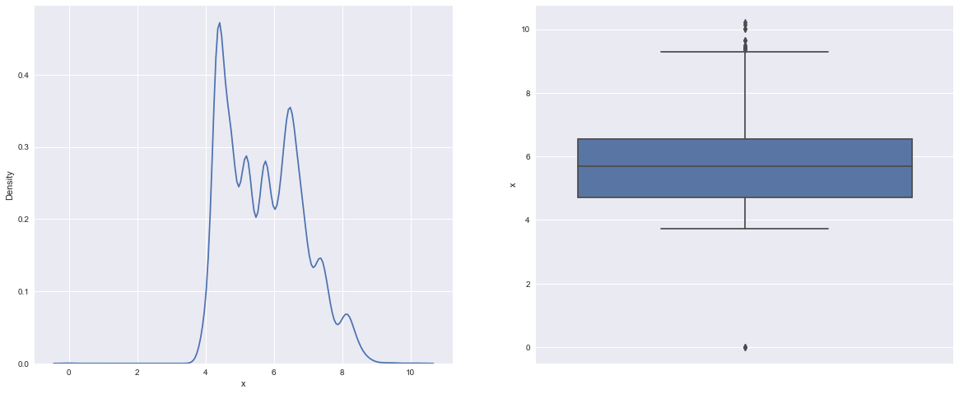Illustration 7: Distribution plot and box plot for x
y | Stats=0.894  p=value=0.000 | 33.67% | 3.85 | 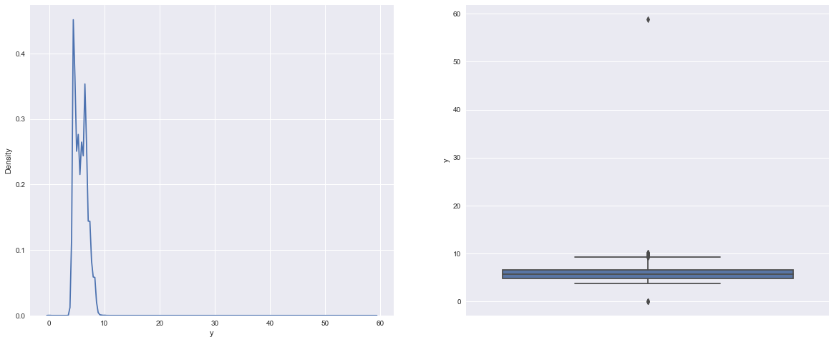Illustration 8: Distribution plot and box plot for y
z | Stats=0.912  p=value=0.000 | 34.43% | 2.57 | 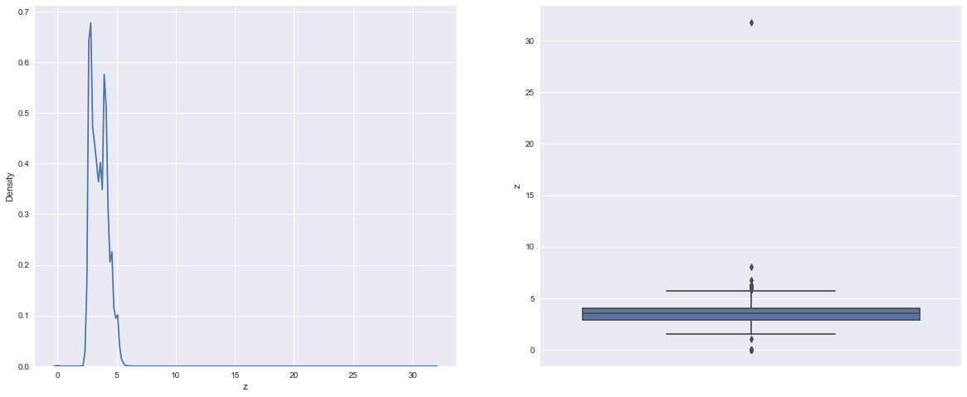Illustration 9: Distribution plot and box plot for z
Table 1. Results of uni-variate analysis of continuous features
As we can see from above analysis, except depth rest all the features not follow Gaussian curve, in fact they are multi-modal and hence are NOT normally distributed. We can also observe that the data has sizable percentage of outliers. However, we will not be treating the outliers as in jewelry industry quiet often we see gems that stand out from the rest and have unusual high carat value and price relatively.

Categorical features
Feature | Bar plot against mean price | Count plot
color | 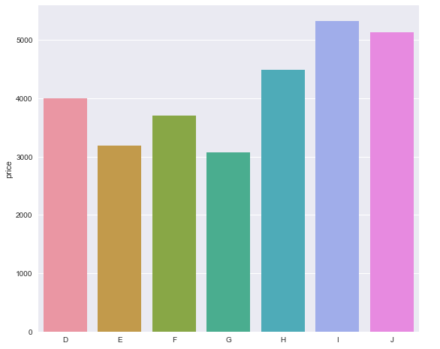Illustration 10: Bar plot with mean price for color | 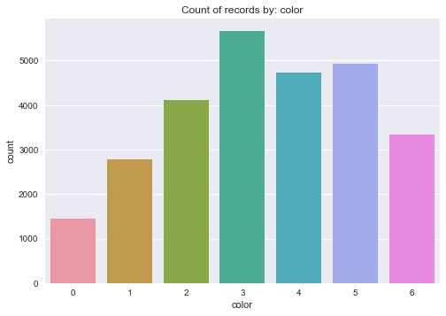Illustration 11: Count plot for color
clarity | 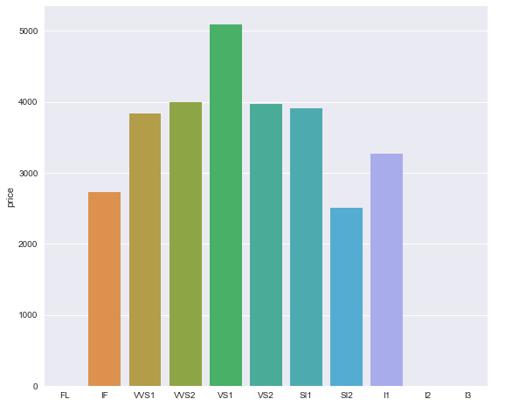Illustration 12: Bar plot with mean price for clarity | 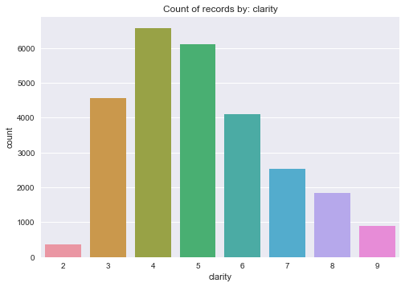Illustration 13: Count plot for clarity
cut | 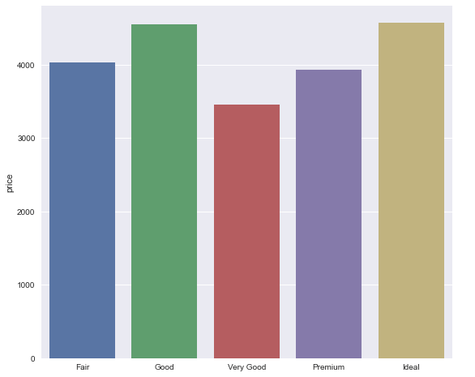Illustration 14: Bar plot with mean price for cut | 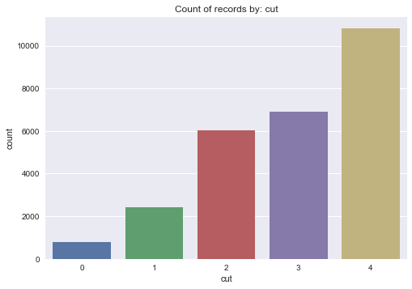Illustration 15: Count plot for cut
Table 2. Results of uni-variate analysis of categorical features
Looking at the bar plots for mean price & record count plots on the categorical features, below are the observations when arranged in increasing order of ratings
- The gem stones with top 3best colors have higher mean price than rest of the colors. The count distribution is slightly left skewed with 'G' having the maximum number of records
- The clarity feature appears to slightly follow a normal distribution with mean price when arranged in ascending order of desirability. The maximum number of observations are in the mid-range, where as there are no observations for the worst and best of the best qualities. The count plot however, is heavily right skewed
- The good and ideal cut gems have the best mean price. The record counts steadily increase from fair to ideal with ideal having maximum number of records
Multi-variate analysis
We will use pair plots, correlation heat map & variance inflation factor to determine the relationship between the continuous features and Chi-Squared contingency analysis for categorical features.
Continuous features
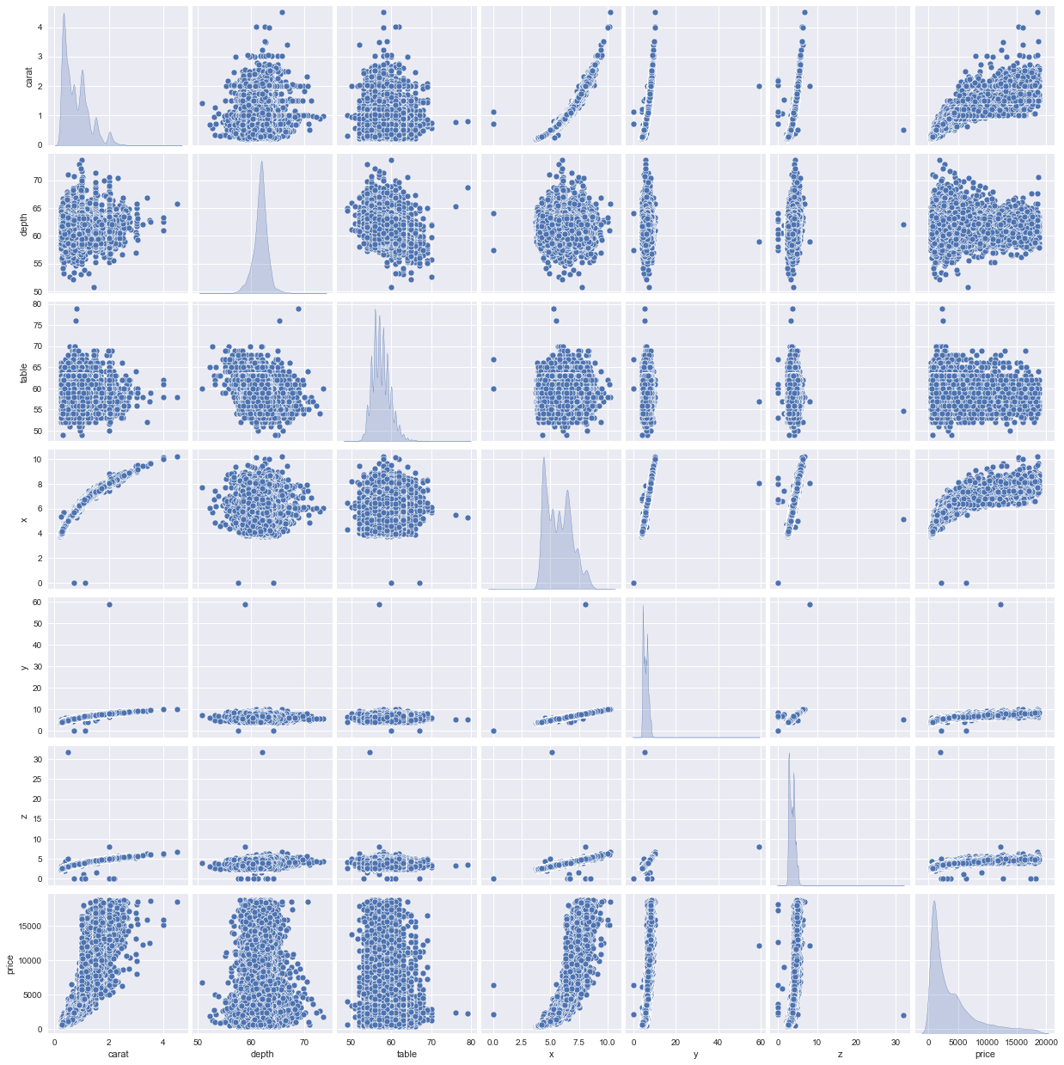Illustration 16: Pair plot of continuous features
The results the pair plot, correlation heat map created using Pearson method and variance inflation factor helps us draw following conclusions
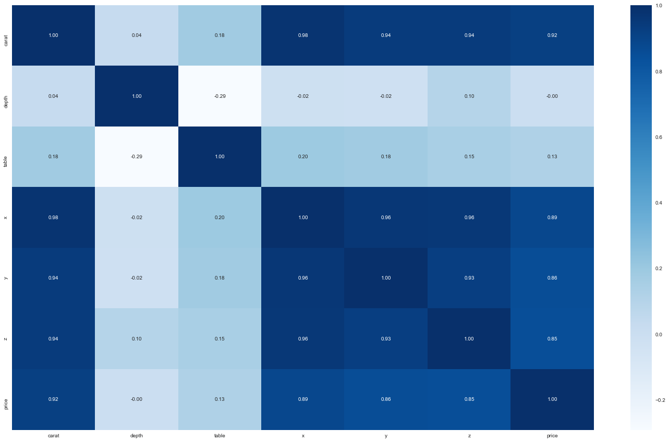Illustration 17: Heat map showing correlation between continuous features using Pearson method
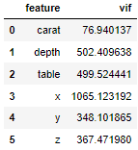Illustration 18: Variance inflation factor calculation
- carat has very strong correlation with x, y, z and eventually on the price
- The heat map shows that depth and table have no correlation with any of the other features and nor between themselves, but they would bring in a lot of variance while predicting the results and may not be good features to continue with
- x, y, & z have very strong correlation among themselves and also with carat. We would later need to decide which of these features should be dropped, else we will risk building a model with high multicollinearity

Categorical features
The results of Chi-Squared contingency test suggest all the categorical features are correlated. Further below the section, the cross tabs capturing the differences between observed values and expected values have been illustrated for each pair wise of combination of clarity, cut and color. Below is a table with results from chi-squared test
Combination | Statistics | P value
Color vs cut | 181.61 | 3.61E-026
Clarity vs color | 954.17 | 1.02E-172
Cut vs clarity | 1967.76 | 0
Table 3: Results of Chi-Squared test between categorical features
Illustration 19: color vs cut, difference between observed values and expected values
Illustration 21: clarity vs cut, difference between observed values and expected values
Illustration 20: color vs clarity, Difference between observed values and expected values
Question 1.2
Impute null values if present, also check for the values which are equal to zero. Do they have any meaning or do we need to change them or drop them? Do you think scaling is necessary in this case?
There are 697 records where 'depth' feature had null/missing values. They were imputed using the median value of the feature across different values of 'cut'. The values used to impute missing values are in the table below.
Cut | Median value of depth
Fair | 65
Good | 63.3
Very Good | 62.1
Premium | 61.4
Ideal | 61.8
Table 4: Reference data used for imputing null values of 'depth'
Apart from these there 8 records which had zero's for z. Within these 8 records three had zero values for x, & y as well. These features represent the physical dimensions of the gem stones and hence cannot be zero.
The zero values were imputed by median of respective features, since, the percentage of these records is very less in comparison to total records.'depth' & 'table' features have values in comparable range to each other. Whereas carat, x, y, & z have values in comparable range to each other but is different from 'depth' & 'table'. The categorical features are of ordinal nature.
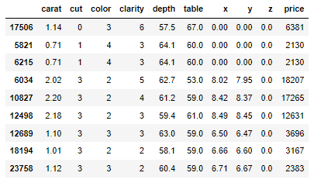Illustration 22: Records with zero for either x, y, & z
As our intent is to predict the price of the stones using these features and also identify the important features which drive the price, for better interpretability we should not scale the data.
Question 1.3
Encode the data (having string values) for Modelling. Data Split: Split the data into train and test (70:30). Apply Linear regression. Performance Metrics: Check the performance of Predictions on Train and Test sets using Rsquare, RMSE.
The first in building the model is to convert the categorical features into numerical fields. Since all the categorical features are of ordinal nature, replacing them with 0 to n(n being the count of unique values of respective categorical feature) would be suffice the use case here. Approaches like OneHotEncoding, get_dummies etc. would further increase the dimensions of the data which would negatively impact the complexity and the performance of the model.
Before we proceed with linear regression model building, it would be good to know the importance of features by running decision tree and random forest models. Below are the results of decision tree and random forest models built on the entire data set.
Decision Tree | Random forest
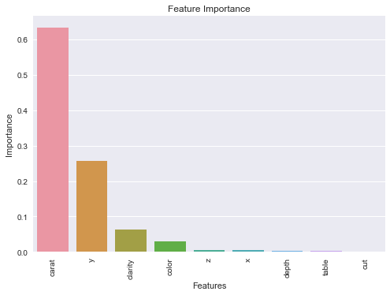Illustration 23: Percentage contribution for features in deciding the price using decision tree | 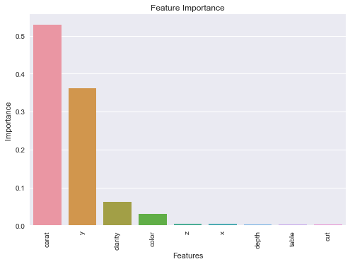Illustration 24: Percentage contribution for features in deciding the price using random forest
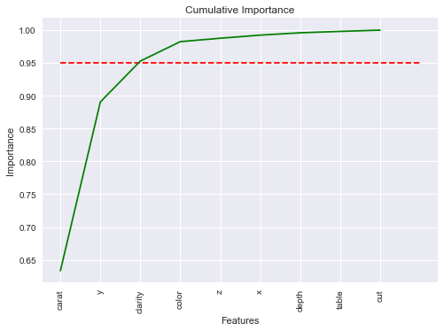Illustration 25: Cumulative sum of contribution for features in deciding the price using decision tree | 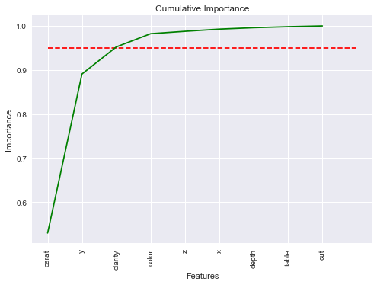Illustration 26: Cumulative sum of contribution for features in deciding the price using random forest
Table 5: Feature importance using decision tree and random forest regressors
Both the models indicate put the features carat, y, clarity, & color as the most important features in predicting the price. The rest of the features don't seem to contribute anything, almost close to zero percentage in predicting the price. The features x, & z were highly correlated to y and carat, so it is understandable that their contribution is minimal. Depth and table has almost no correlation with price and hence don't seem to contribute in predictions. Interestingly, cut also doesn't seem to be contributing to price prediction.
Next step, we step we split the data in training and test in 70:30 ratio and build a linear regression model. After running multiple versions of the model with different combinations of features included, we can see that iteration#5 seems to be best combination when the RMSE, Adjusted R-squared and AIC scores are compared. Both for training and testing data.

Illustration 27: Comparison of model performances with different combinations of features
The finalized sets of the coefficients of the model is as below.
The intercept comes out to be -4893.502239.
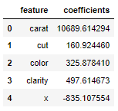Illustration 28: Coefficients of features generated from model
The mathematical formulae of the model would be:
price = -4893.502239 + 10689.614294 x carat + 497.614673 x clarity + 497.614673 x clarity + 160.924460 x cut + 325.878410 x color - 835.107554 x X
Question 1.4
Inference: Basis on these predictions, what are the business insights and recommendations.
From the final version of linear regression model, we can make following insights and recommendations.
- Insight 1 – The top 5 features contributing to prediction of the price of the stones are – carat, clarity, color, cut and length of the stone
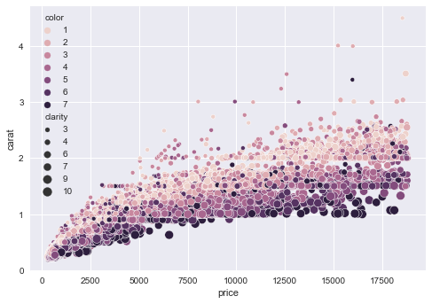Illustration 29: Scatterplot of carat vs price with color and clarity
- Insight 2 – Carat is the biggest factor in determining the price of the stones.
Recommendation: High carat stones encourage higher prices. carat has multi-modal distribution of the information. Price buckets can be created and tagged to each mode of carats say a price bucket for stones less than 1, greater than 1 but less than 1.5, greater than 1.5 but less than 2 and so on
- Insight 3 - Color and Clarity together play an important factor determining the price point of stones
Recommendation: A small carat stone can still be high priced if it is of best color and clarity. Price buckets identified on the basis of carat earlier can be further segregated considering all relevant combinations of clarity and color.
- Insight 4 – Cut has the least importance among the 4 C's but we also saw that majority of the stones are of ideal(the best) cut.
Recommendation: Each step increase in the quality of the cut increases the price by a small bit as compared to other features. For obvious, reasons the price point of the stones should get influenced by quality but only marginally.

Problem 2: Logistic Regression and LDA

You are hired by a tour and travel agency which deals in selling holiday packages. You are provided details of 872 employees of a company. Among these employees, some opted for the package and some didn't. You have to help the company in predicting whether an employee will opt for the package or not on the basis of the information given in the data set. Also, find out the important factors on the basis of which the company will focus on particular employees to sell their packages.

Dataset for Problem 2: Holiday_Package.csv

Data Dictionary:
Variable Name | Description
Holiday_Package | Opted for Holiday Package - yes/no?
Salary | Employee salary
age | Age in years
educ | Years of formal education
No_young_children | The number of young children (younger than 7 years)
No_older_children | Number of older children
foreign | foreigner - yes/no?

2.1 Data Ingestion: Read the dataset. Do the descriptive statistics and do null value condition check, write an inference on it. Perform Univariate and Bivariate Analysis. Do exploratory data analysis.
2.2 Do not scale the data. Encode the data (having string values) for Modelling. Data Split: Split the data into train and test (70:30). Apply Logistic Regression and LDA (linear discriminant analysis).
2.3 Performance Metrics: Check the performance of Predictions on Train and Test sets using Accuracy, Confusion Matrix, Plot ROC curve and get ROC_AUC score for each model Final Model: Compare Both the models and write inference which model is best/optimized.
2.4 Inference: Basis on these predictions, what are the insights and recommendations.
Please explain and summarise the various steps performed in this project. There should be proper business interpretation and actionable insights present.
https://docs.google.com/forms/d/e/1FAIpQLScKuVyrmTTM7Pboh0IB4YIBUbJp2NrDZcsY4SCRn3ZUkwmLGg/viewform
0
Quality of Business Report
6
Please reflect on all that you learnt and fill this reflection report. You have to copy the link and paste it on the URL bar of your respective browser. https://docs.google.com/forms/d/e/1FAIpQLScKuVyrmTTM7Pboh0IB4YIBUbJp2NrDZcsY4SCRn3ZUkwmLGg/viewform
https://docs.google.com/forms/d/e/1FAIpQLScKuVyrmTTM7Pboh0IB4YIBUbJp2NrDZcsY4SCRn3ZUkwmLGg/viewform
0
Points 60

Project Problem Part - 1 – Linear Regression
- Should Outlier treatment be done for this question?
Ans: An observation is considered to be an outlier if that particular observation has been mistakenly captured in the data set. Treating outliers sometimes results in the models having better performance but the models lose out on generalization. So, a good way to approach this would be to build models with and without treating outliers and then report the results. On the other hand, it is perfectly fine if you are building your models only once, i.e. either after treating or not treating the outliers.
- Should both ‘sklearn’ as well as ‘statsmodels’ be used for building the Linear Regression model?
Ans: It is perfectly fine to use either of these libraries to build the Linear Regression model and report the output in the business report. However, you can choose to build the Linear Regression model using both the libraries.
- What methods are suitable for dealing or checking the high multicollinearity in the data?
Ans: Multicollinearity is the presence of a strong correlation between the independent variables. Using correlation heatmap is a way to visually understand the degree of correlation present within the various variables. Pair plots are also a great way to understand how the various variables (taken two at a time) behave with each other. Lastly, you can check the Variance Inflation Factor (VIF) values of the various independent variables and draw a conclusion about the multicollinearity problem. If you feel that there is still some extent of multicollinearity present in the model (which will be present even after all of these treatments), you can always perform Principal Component Analysis. But do remember that the interpretability of the Linear Regression model becomes tedious when we fit the new independent variables (after performing PCA) into the Linear Regression model.
- What kind of encoding procedure needs to be used in order to encode the Categorical variables?
Ans: For the ordinal categorical variables, please do make sure to encode the variables in a way which will highlight the rank order that is mentioned in the problem statement. If there is any categorical variable which is nominal, please do proceed with dummy variable encoding if that is going to help in the model building procedure. Please do check the documentation of a particular function from any libraries.
- Can any kind of transformation be used for any of the variables before fitting them in the Linear Regression model?
Ans: Yes, please do go ahead with appropriate transformations which might make the association between independent and dependent variables linear in nature. After plotting to scatter plots between the various independent variables and the dependent variable, you can take a decision whether a transformation is needed. But it is in no way mandatory to perform a mathematical transformation of a variable before fitting them into a linear regression model.
If a particular mathematical transformation has been applied to the dependent variable and the model has been trained using the transformed variables, please do make sure to take the inverse transformation while calculating and reporting the Root Mean Squared Error value. Please be careful about the interpretation of the model after the transformation.
- Should we scale the data and then split the data into training and test set or vice-versa?
Ans: If you are looking to scale the data for a non-regularized parametric algorithm, it is better to split the data into train and test and then proceed with the scaling operation. But a quick question here would be to stop and think whether scaling is necessary for the Linear Regression model.
- Is there a particular range for Root Mean Squared Error (RMSE) or does it depend on the magnitude and the scale of the variables in the model?
Ans: RMSE does have any pre-defined range within which it has to lie. It can take any values based on the dependent variable.
- What method is to be used for the imputation of missing or null values?
Ans: In this case, the mean or median values can be used for imputing the missing or null values of the continuous numerical variables and the mode can be used for imputing the missing or null values in the categorical variables. However, please do feel free to try out any other imputation method that might seem more appropriate but do provide adequate explanations in the business report for the kind of imputation technique used.

Project Problem Part - 2 – Logistic Regression and Linear Discriminant Analysis
- Should Outlier treatment be done for this question?
Ans: An observation is considered to be an outlier if that particular observation has been mistakenly captured in the data set. Treating outliers sometimes results in the models having better performance but the models lose out on generalization. So, a good way to approach this would be to build models with and without treating outliers and then report the results. On the other hand, it is perfectly fine if you are building your models only once, i.e. either after treating or not treating the outliers.
- In this problem, can a new variable be created/engineered based on the given independent variables?
Ans: Yes, new variables can be derived/created/engineered based on the given independent variables. Clubbing a few categories of the categorical variable is one way to create new variables. However, any kind of feature engineering can be done if the proper explanation of the same is given in the business report. But it is not at all mandatory to perform feature engineering for this project.
- If the model accuracy (or other model performance parameters) of the Logistic Regression model and the Linear Discriminant Analysis model is less, how do we improve it?
Ans: To improve the model performance, hyper-parameters can be tweaked until a suitable combination of hyper-parameters is found which gives the most optimum performance. Some kind of feature engineering (like outlier treatment or encoding of categorical variables amongst other things) can be looked at to improve the model performance.
- Should scaling of the variable be done before fitting the Logistic Regression model and the Linear Discriminant Analysis model?
Ans: No, the data should not be scaled before fitting into either of the Logistic Regression model or the Linear Discriminant Analysis model. The same has been mentioned in the rubric for this particular question.
- Do we need to compare the model performance for both training and test for both Logistic Regression and Linear Discriminant Analysis?
Ans: Yes, the comparison of model performance over both training and test is necessary. This tells us how well the model generalizes on unseen data. All possible model performance measures should be calculated and compared on the training and test data across both Logistic Regression and Linear Discriminant Analysis.
- What kind of business recommendations and business insights should be put in the report?
Ans: It is expected that the EDA results and the model results are summarized and put in a proper format. Any additional pointers that might be necessary for the business to understand from the data. The models need to be evaluated in terms of the various model performance parameters both on the training and the test set.
Illustration Index
Illustration 1: First 10 records from the data 3
Illustration 2: Basic information about the data frame 4
Illustration 3: Results of describe method on continuous features 4

