CAPE Provenance Aware Authorization Repair for Secure Agentic Payments
Sarang Shrikant Kulkarni* and Prachi Nandkumar Kulkarni
Independent Researchers
*Corresponding author: sarangkulkarni109@gmail.com | prachikulkarni735@gmail.com
Original Research Article

Abstract
Agentic payment protocols can prove delegated authority and bind transaction details, yet a structurally valid payment can still violate a user's semantic policy when merchant-controlled content changes what an agent believes it is buying. CAPE places a provenance-aware authorization gateway between an agent proposal and payment dispatch. CAPE Witness Repair (CWR) retains unchanged positive attestations and chooses a minimum-cost refresh set that eliminates every corruption explanation permitted by a bounded provenance adversary. Decision-Flip Margin Repair (DFMR) treats positive and negative evidence symmetrically and chooses refreshes through an exact finite minimax recurrence. Beyond the controlled optimization studies, we implement CAPE with the official AP2 Python SDK, five signed loopback evidence services, version-bound authorization, and an idempotent payment sandbox. An expanded benchmark executes 2,520 matched flows across four benign conditions, fifteen in-model attack scenarios, two deliberate premise violations, and six defenses. Full revalidation, CWR, and DFMR produce no unauthorized effect in 300 in-model attacks per defense, whereas AP2-only, provenance-blind majority, and fixed-TTL controls produce 160, 140, and 40. The strong defenses complete 60 of 80 benign flows because a two-source outage safely triggers abstention. The premise violations cause unauthorized effects and therefore delimit, rather than extend, the guarantee. A second study executes 156 decisions from Qwen2.5-0.5B-Instruct and SmolLM2-1.7B-Instruct. The models propose forbidden purchases in 40.0% to 80.0% of attack runs; AP2-only and majority pass every compromised proposal, while Full, CWR, and DFMR pass none. These finite, synthetic results establish end-to-end containment under declared assumptions, not production fraud reduction or frontier-model robustness.
Keywords: agentic payments; AP2; semantic authorization; prompt injection containment; evidence provenance; certificate repair; decision-flip margin; adversarial evaluation

1. Introduction
Consider a shopping agent that may buy a physical device but may not buy stored value. A merchant can still list a gift card under an electronics label, and a correctly signed payment request can preserve that misleading label. Independent evidence helps only when the gateway understands where the evidence came from and whether it is still valid when the action occurs. Six catalog responses copied from one supplier are still one failure domain. And even a sound classification can become irrelevant if checkout changes after verification.
That gap sits between agent behavior and payment execution. AgentDojo shows how external content can redirect tool-using agents [1], while CaMeL constrains how untrusted information reaches privileged actions [2]. Payment-security work has separately studied replay, mandate binding, and manipulation before authorization [3], [4]. Formal analysis of agent-payment protocols reaches the same broader lesson: a locally valid step can still fail when the surrounding stages do not remain consistent [5]. A payment-boundary defense therefore needs to answer two questions, not one: what does the evidence prove, and until when does that proof remain usable?
CAPE starts from a simple separation: the shopping agent proposes a transaction, while a different service controls the release of payment authority. That split gives the system its enforcement boundary. The research contribution begins later, after evidence changes. Credential isolation, signed intent, replay controls, and atomic budget reservations are already established; our question is which sources actually need to be queried again before a pending transaction can proceed.
The obvious answers are either wasteful or incomplete. A fixed time-to-live can reuse evidence after a material change. Refreshing every changed source notices the change, but ignores redundancy that may still exist in the certificate. Refreshing every source avoids that mistake at even greater cost. The useful middle ground appears when several independent control domains support the same predicate. If the unchanged witnesses already exceed the tolerated corruption budget, stale witnesses add no value for that predicate. If they do not, only a carefully chosen subset may need to be refreshed.
We call that decision problem minimum-cost witness repair. Its input is a set of current positive attestations, stale sources with known provenance and acquisition costs, and a corruption budget. Its output is either a sufficient refresh plan or a reason that the available evidence cannot certify the protected predicate. That addresses the positive-certificate case. Fresh negative evidence raises a different question: how costly would it be for the opposite decision to remain plausible? Decision-Flip Margin Repair (DFMR) makes that security margin explicit and chooses refreshes sequentially against the worst outcome still allowed by the threat model.
The paper makes seven contributions. First, it identifies a semantic authorization gap that can remain after a payment mandate is structurally valid. Second, it defines the residual-evidence condition and characterizes when a protected predicate remains certifiable without refresh. Third, it gives CWR, an exact minimum-cost positive-certificate repair algorithm with explicit soundness, optimality, and complexity boundaries. Fourth, it introduces the authorization decision-flip margin and DFMR, a bilateral ALLOW/DENY verifier with an exact finite minimax policy. Fifth, it implements the gateway around the official AP2 Python SDK, signed HTTP evidence, version-bound dispatch, and idempotent processing. Sixth, it evaluates fifteen in-model attack scenarios at the executable payment boundary and retains two successful counterexamples that violate the fault-budget or provenance assumptions. Seventh, it connects two compact open language models to the same gateway and separates upstream agent compromise from downstream unauthorized payment. The last study is deliberately exploratory: it demonstrates end-to-end instrumentation and containment, not representative model ranking.
The two methods answer different questions, and their results are therefore reported separately. CWR asks how cheaply an already-positive certificate can be repaired, with Full revalidation and cost-aware greedy planning as the strongest comparisons. DFMR asks which observation should be acquired next when either ALLOW or DENY may still be correct; here the useful baselines are full acquisition and a cost-first sequential policy. This separation also keeps the comparison fair, since CWR was designed to repair positive support rather than certify a negative predicate.

2. Related work and contribution boundary

2.1. Payment authorization and agent confinement
Lan et al. examine runtime context binding and consume-once mandate enforcement [3]. Aviv et al. map threats across the payment lifecycle and several AP2 deployment boundaries [4]. Jiang et al. formalize multiple agent-payment protocols and connect authorization decisions to later economic effects [5]. Taken together, that literature already establishes that signatures alone are insufficient for safe execution. Our contribution starts after those results: we neither introduce a new payment protocol nor revisit replay as a newly discovered attack class.
Authorization mechanisms bring a similar history. Capability attenuation and stateful authorization predate agentic commerce: Macaroons attach contextual caveats to delegated credentials [8], and StatefulAuth makes authorization depend on action history [9]. OAuth Rich Authorization Requests structures authorization details, while DPoP constrains token presentation [10], [11]. CAPE is intended to operate alongside these mechanisms. Its witness-repair logic leaves their cryptographic guarantees and specifications intact.
AP2 supplies protocol objects, cryptographic mandate chains, and reference scenarios for agent-mediated payments [12]. The operational artifact in this revision uses the official AP2 Python SDK to create and verify an open-to-closed payment-mandate chain, including issuer signature, delegation, audience, nonce, payee, amount, and transaction-identifier checks. CAPE then evaluates an additional semantic product predicate before dispatch. The AP2-only condition is therefore a boundary baseline, not an assertion that AP2 incorrectly implements its published mandate guarantees: it measures what happens when valid protocol authorization is not supplemented by independent semantic evidence.

2.2. Provenance and multi-source certification
Provenance matters because different endpoints can still share the same failure domain. W3C PROV provides a general vocabulary for derivation and responsibility [14]. The closest antecedent to our static certificate condition is the published work 'Certified Multi-Source Integrity for Structured Agent Actions,' which certifies structured actions using corruption-distinct evidence and a minimum hitting-set interpretation [6]. Source counting, provenance-aware corroboration, and the underlying hitting-set rule therefore enter this paper as prior foundations rather than CAPE inventions.
Our research question begins one step later. A certificate already exists, some witnesses become stale, and the gateway must decide how much additional evidence to buy before it can trust the predicate again. Merely transplanting multi-source certification into a payment setting would add little algorithmically. CWR is instead defined by the residual-state formulation, the exact repair rule, and the behavior measured in the experiments.

2.3. Selective revalidation and optimization
Lyu et al. separate a version conflict from a decision conflict and revalidate only the premises affected by a change before an agent acts [7]. Their analysis also makes commit-time binding explicit. CWR adopts those requirements, then looks inside the corroboration predicate itself: does every affected witness need another fetch? Sometimes the answer is no. Unaffected witnesses may already establish the predicate; otherwise, acquisition cost can guide which remaining sources are refreshed.
The resulting optimization resembles weighted set cover, deliberately so. Exact dynamic programming, memoization, dominance pruning, and weighted set-cover heuristics are established tools [15], [16], and we use them directly. The new element is the security-constrained certificate-repair formulation together with its execution semantics; the paper does not recast a standard set-cover solver as a general algorithmic invention.

2.4. Adaptive evidence acquisition and the DFMR boundary
Sequential evidence acquisition already has a substantial literature. Stochastic and adaptive submodular cover choose observations in response to earlier outcomes, while worst-case variants minimize maximum acquisition cost across realizations [17]-[19]. That work rules out any broad novelty claim for adaptive querying by itself. DFMR instead changes the stopping criterion: a state becomes certifiable only when the opposite authorization decision would require more provenance-domain corruption than the configured adversary can supply. Signed observations, dependency sets, and a security-specific decision-flip margin therefore drive the state, rather than a generic submodular utility target.
Accordingly, the contribution claim for DFMR is deliberately specific. The method is a provenance-bounded authorization procedure that turns positive and negative evidence into competing corruption explanations, then chooses a refresh policy that minimizes worst-case acquisition cost until one explanation falls outside the attack budget. In the public agent-payment and adaptive-cover literature we reviewed, we found no method combining this bilateral authorization terminal rule with version-bound payment dispatch. That literature result should be understood as the boundary of our search, not as universal priority over unpublished work.

3. Threat model and evidence semantics

3.1. Principals and protected predicates
We allow the shopping agent to be fully compromised. It may propose arbitrary purchases, replay old responses, delay a request, or submit structured fields that look legitimate. The trusted boundary is narrower: the authorization gateway, user-approved policy store, provenance/version registry, budget ledger, and modeled dispatch operation. The agent never receives a settlement credential in this design. If any trusted component is compromised, the conditional guarantee no longer applies.
The gateway evaluates a finite set of typed predicates. A product identifier may need to resolve to an allowed class; a payee may need to match an approved merchant; an amount may need to remain below a policy limit. In the experiments, the evidence predicate is intentionally simple and binary: whether the selected product is allowed. Subjective preferences such as 'comfortable,' 'high quality,' or 'good value' fall outside that deterministic predicate model.
Ordinary payment checks remain in force around witness repair. A deployment still has to authenticate policy state, bind the quote and currency, verify the requester, enforce freshness and replay state, and reserve cumulative spend. We write the conjunction of those checks as H. CWR supplies evidence for a protected predicate only after H succeeds. The signed-evidence experiment isolates this layer of the system rather than attempting to reproduce an entire production payment protocol.

3.2. Corruption domains
Each attestation e names a source, the product, a predicate value, a version, and a nonempty dependency set D(e). A dependency denotes a control domain whose compromise could invalidate the attestation. This can include the original catalog owner, an intermediate transformation service, and the signer. Here, a domain means an administrative or technical failure boundary, which may span more than a hostname. The authoritative mapping comes from the registry rather than from the requesting agent.
The adversary controls an unknown fixed set C of at most f domains during an execution. If C intersects D(e), the adversary may cause e to report any value. Otherwise, a current attestation reports the true predicate. The model bounds corruption domains; it does not assume statistical independence. Multiple attestations can therefore share a compromised dependency while remaining correctly signed. In the principal workload, one catalog root is compromised and f equals one.
Honest attestations must describe the same subject and semantic snapshot. A record referring to another SKU cannot support the current request, and missing, malformed, or unverifiable evidence contributes no positive support. A negative response removes that source from the positive witness set, but another sufficient collection of honest positive witnesses may still establish the fact. Deployments that treat any contradiction as mandatory denial can impose that stricter rule, with a corresponding change in availability.
Evaluation claims are partitioned by premise status. In-model attacks preserve authentic source identities, complete registered dependencies, faithful versions, and at most f corrupted provenance domains. Premise-violation cases either corrupt more than f domains or make one hidden root appear independent in the trusted registry. An authorization failure in the first partition challenges the implementation or guarantee; a failure in the second is an executable counterexample that marks the guarantee boundary.

3.3. Freshness and the authorization instant
A cached attestation is reusable only if its version still matches the trusted registry. Any change that could invalidate the statement must advance that version. This is a strong contract. A response timestamp, cache age, or merchant-maintained revision number does not automatically satisfy it.
The gateway must also bind the exact witness versions to dispatch. Our executable model makes version comparison and dispatch one indivisible step: if a relevant version changes before that step completes, the gateway retries validation. The guarantee ends at that local boundary. A remote processor has its own state transitions, so a real deployment would need either a conditional operation at the processor boundary or a more limited statement about the dispatch instant.
A fixed freshness window is a poor substitute for that contract. A source may change one millisecond after it is read and still look 'fresh' for another thirty seconds; a stable source may remain trustworthy long after an arbitrary cache threshold expires. CWR therefore relies on faithful versioning, rather than treating recency itself as proof of truth.

4. Minimum-cost witness repair

4.1. Static certificate and residual evidence
Let E be a set of positive attestations. Let C(E) denote the family of domain sets that intersect D(e) for every witness e in E. Define its corruption cover number as the smallest size of such a set. The empty support set has cover number zero.
$τ\left(E\right)=\min_{C∈C\left(E\right)}\left|C\right|$
(1)
The certificate condition is tau(E) greater than f. This is the static provenance rule attributed to prior multi-source certification [6]. If every positive attestation were false, each would have to intersect the actual corruption set. A cover number exceeding the corruption budget rules out that explanation.
At execution time, split previously verified positive evidence into unchanged witnesses U and stale sources Z. Only U is immediately reusable. We enumerate the corruption hypotheses of size at most f that remain consistent with all witnesses in U being adversarial.
$H_{f}\left(U\right)=\{C∈C\left(U\right):\left|C\right|≤f\}$
(2)
If this family is empty, U already proves the predicate within the model and no evidence refresh is needed. If it is nonempty, each hypothesis describes a way the remaining positive support could be entirely corrupted. A newly fetched positive attestation e eliminates precisely those hypotheses disjoint from D(e), because e would be honest under each of them.

4.2. Planning objective
Each stale source e has a positive acquisition cost c(e). The cost can represent a fixed service fee or another explicitly chosen additive quantity; it is independent of the source's factual value. Before issuing a query, the planner knows the current dependency mapping and the cost, while the new predicate value remains unseen.
For the planning problem, suppose selected refreshes return current, valid, positive attestations. We seek the cheapest subset R of Z whose added support exceeds the corruption budget.
$R^{*}∈arg\min_{R⊆Z, τ\left(U∪R\right)>f}\sum_{e∈R}{}c\left(e\right)$
(3)
This assumption separates planning from execution. A source may return a negative response, an error, or no response at all. The execution algorithm then removes that candidate, updates the remaining problem, and replans. Soundness is preserved, although the realized total cost can exceed the minimum that a clairvoyant algorithm could have chosen after seeing every response in advance.
For example, let the surviving corruption hypotheses be the singleton sets containing a and b. A refresh depending on a and c eliminates the b hypothesis; a refresh depending on b and d eliminates the a hypothesis. If their costs are four and one, together they restore a certificate for cost five. A different source depending on c and d eliminates both hypotheses at cost six. The cheapest plan uses two sources, although a one-query plan exists. Minimizing fetch count and minimizing acquisition cost are different objectives.
Table 1. A repair example with hypotheses {a} and {b}
Source | Dependencies | Cost | Eliminates
e1 | {a, c} | 4 | {b}
e2 | {b, d} | 1 | {a}
e3 | {c, d} | 6 | {a} and {b}

4.3. Why copies do not repair a certificate
Copies do not create independence. If every positive response depends on the same root r, the corruption hypothesis containing r survives regardless of how many such responses the gateway collects. A provenance-blind planner can therefore spend its entire query budget without getting closer to the required assurance level.
The reverse case is equally useful. With f=1, two unchanged witnesses with disjoint dependency sets already rule out any single corrupted domain as an explanation for both. Stale witnesses can then be ignored for that predicate. Other policy conditions may still depend on those stale fields, however, so the gateway evaluates each required predicate against its own evidence.

5. Algorithm and conditional guarantees

5.1. CAPE Witness Repair
CWR represents each remaining corruption hypothesis as a bit. For a candidate source e, its elimination mask contains exactly the hypotheses disjoint from D(e). A successful positive refresh clears those bits. The optimization therefore asks for a minimum-cost collection of masks that clears the current hypothesis family.
Before solving, CWR removes dominated candidates. If one candidate eliminates a superset of another candidate's hypotheses at no greater cost, the latter is unnecessary for the all-positive planning problem. Equal masks and equal costs are resolved by a stable identifier. This pruning is applied only to the current plan. A candidate can become relevant after another source fails and the execution loop replans.
The exact solver chooses an uncovered hypothesis h. Every complete plan must contain some candidate that eliminates h. It branches over those candidates and memoizes the least remaining cost for each residual hypothesis mask. The selected pivot is the hypothesis with the fewest eliminating candidates, a search heuristic that does not alter the objective. Write A(e) for a candidate's elimination mask and B for the residual hypothesis family. In the recurrence, B minus A(e) removes the hypotheses eliminated by that candidate.
$F\left(B\right)=\min_{e: h∈A\left(e\right)}\{c\left(e\right)+F\left(B−A\left(e\right)\right)\}$
(4)
The base case has cost zero when no hypotheses remain. An uncovered hypothesis that no available candidate can eliminate makes the problem infeasible. Because every branch removes at least the pivot hypothesis, recursion terminates. Positive costs prevent a useful plan from querying the same source twice.
Algorithm 1 CAPE Witness Repair
Input: Cached evidence, registry, costs, f
1 Retain current positive witnesses U.
2 Let Z contain stale candidate sources.
3 While U is insufficient and Z is nonempty:
4 Build corruption hypotheses H_f(U).
5 Solve the minimum-cost elimination plan.
6 If no plan exists, return STEP UP.
7 Fetch and verify each selected source.
8 Remove queried sources from Z.
9 Add usable positive responses to U.
10 Replan after a negative or failed query.
11 If U is insufficient, return STEP UP.
12 Compare versions atomically at dispatch.
Retry validation on a version conflict.
The reference implementation queries selected sources in stable identifier order. If a refresh is negative or unavailable, it stops, removes that candidate, and replans. Once the surviving positives form a sufficient certificate, the gateway carries the supporting versions into the bound dispatch check. This split is deliberate. A planning bug that chooses an unnecessarily expensive sufficient subset hurts efficiency; a bug in certificate validation or version binding threatens safety.

5.2. Conditional soundness
Proposition 1. Assume complete dependency sets, at most f corrupted domains, truthful current attestations outside those domains, authentic source signatures, correct subject binding, faithful versions, and an atomic check of the supporting versions at dispatch. If the gateway dispatches only after obtaining a positive witness set E with tau(E) greater than f, the protected predicate is true at that dispatch instant.
Proof. Suppose the predicate is false. Every current positive witness must then depend on a corrupted domain; otherwise it is an honest positive attestation of a false predicate, contradicting the model. The actual corruption set consequently intersects every D(e), so it is a cover of E with size at most f. This contradicts tau(E) greater than f. The version condition and the atomic dispatch check ensure that the witnesses used in this argument are the witnesses valid at the claimed instant. Neither minimum-cost selection nor a particular search order is needed for the argument.
This result applies to the declared predicate and modeled instant. It does not prove that the user would prefer the purchase, that goods will be delivered, or that remote evidence cannot change after dispatch. It also does not protect against an omitted dependency. The experiments deliberately violate these assumptions and retain the resulting failures.

5.3. When zero refresh is justified
Proposition 2. In the positive-support model, and without any additional trusted evidence, zero-refresh authorization is sound exactly when the residual hypothesis family for U is empty.
Proof. If the family is empty, Proposition 1 applies to U. Conversely, suppose a corruption hypothesis C remains. An alternative world can make the predicate false while assigning every witness in U to a domain in C. Those domains emit the observed positive values, and all stale or unavailable observations are unconstrained. This world is consistent with the available positive evidence and the corruption budget. The gateway cannot safely authorize without obtaining additional information or applying an additional trusted premise.
The qualification about available information matters. The proposition does not forbid a system from using a separately trusted manufacturer attestation, a human confirmation, or a stronger local policy. Such information changes the problem. Nor does it assert that every conservative system must authorize whenever the family is empty.

5.4. Planning optimality and complexity
Proposition 3. With a fixed dependency registry, strictly positive additive acquisition costs, and usable positive responses from the selected candidates, the CWR recurrence returns a minimum-cost repair set when one exists.
Proof. Any feasible plan for a nonempty residual hypothesis family must eliminate the chosen pivot. It therefore contains at least one candidate considered by the recurrence. After selecting that candidate, the unresolved part is exactly the hypotheses outside its elimination mask. An optimal solution to this subproblem completes the branch at the lowest possible additional cost. Induction on the number of remaining hypotheses establishes the recurrence. Dominance pruning preserves an optimum because replacing a dominated candidate with its dominating candidate cannot lose coverage or increase cost. Taking the cheapest branch yields the optimum.
This is an exact set-cover formulation, not a polynomial-time guarantee. If there are d domains and fault budget f, the initial hypothesis count is at most the sum of the binomial coefficients from zero through f. With M surviving hypotheses and n candidates, the unpruned state space can contain 2 to the power M masks, and each state may inspect n candidates. Bitset operations and memoization help in small instances; they do not remove the worst case.
The measured optimization instances use six abstract domains and six or nine candidates. The largest observed search visits thirteen memoized states, but that is a workload result, not a general bound. An implementation facing a much larger state space should impose a resource limit and fall back to full revalidation or step-up. Returning an unverified plan merely because the search times out would violate the algorithm's contract.
Proposition 4. Minimum-cost witness repair is NP-hard even for f equal to one when dependency sets are unrestricted.
Proof. Take a weighted set-cover instance with nonempty universe X and candidate sets S(i). Create one residual positive witness whose dependency set is X. Its remaining corruption hypotheses are precisely the singleton subsets of X. For each candidate set, create a refresh source with the same cost and dependency set consisting of X minus S(i), together with a private domain outside X. That private domain makes the dependency set nonempty but cannot explain the residual witness. A positive response from candidate i therefore eliminates exactly the singleton hypotheses corresponding to S(i). A repair certificate exists exactly when the selected sets cover X, and costs are preserved. A polynomial-time exact repair algorithm would thus solve weighted set cover [15]. This is an application-specific reduction; it is not a new hardness result for set cover itself.

5.5. Decision-Flip Margin Repair
CWR is deliberately one-sided: it repairs positive support for an authorization. A negative refresh removes a candidate and triggers replanning, but the negative observation is not itself used to certify DENY. DFMR changes that rule. Let S be the set of current verified observations, with each observation taking value + or -. For a candidate truth t, define ρ_t(S) as the minimum number of provenance domains that must be corrupted for every observation in S to be consistent with t. An observation that disagrees with t must be explained by at least one corrupted domain in its dependency set.
ρ_t(S) = min |C| such that C ∩ D(e) ≠ ∅ for every observed e whose value differs from t. (5)
The decision-flip margin is the cost of the cheapest corruption explanation for the opposite verdict. If the current candidate verdict is ALLOW, the margin is ρ_DENY(S); for DENY, it is ρ_ALLOW(S). With corruption budget f, ALLOW is certified when ρ_DENY(S) > f and DENY is certified when ρ_ALLOW(S) > f. If neither side clears the budget, the gateway needs more evidence. If both sides appear certified, the observations violate the declared model and the safe result is STEP-UP rather than an invented tie-break.
The refresh rule is sequential. Let O_e(S) be the outcomes for source e that remain possible in at least one world consistent with S and the corruption budget. Let V(S,Z) be the minimum worst-case additional acquisition cost needed to reach a certified verdict from observations S and unqueried sources Z. DFMR uses the recurrence below.
V(S,Z) = min_e [ c(e) + max_{o ∈ O_e(S)} V(S ∪ {e=o}, Z \ {e}) ]. (6)
The base case is zero once either verdict is certified; a state with no remaining source and no certified verdict returns STEP-UP. Memoization makes the small experimental state spaces cheap to solve, but the recurrence is still exponential in the worst case. That is acceptable for the present proof-of-concept benchmark and plainly unsuitable as an unrestricted production solver.
Algorithm 2 Decision-Flip Margin Repair (DFMR)
Input: current verified observations S, stale candidates Z, dependency registry, costs c, corruption budget f
1 Compute ρ_ALLOW(S) and ρ_DENY(S).
2 If ρ_DENY(S) > f and ρ_ALLOW(S) <= f, return ALLOW.
3 If ρ_ALLOW(S) > f and ρ_DENY(S) <= f, return DENY.
4 If both exceed f, return STEP-UP (model inconsistency).
5 For each e in Z, enumerate outcomes O_e(S) allowed by the corruption model.
6 Evaluate c(e) plus the maximum continuation cost over those outcomes.
7 Query the source with minimum worst-case continuation cost.
8 Verify signature, subject, version, and provenance; append the observation to S.
9 Remove e from Z and repeat from line 1.
10 If Z is exhausted without a certified verdict, return STEP-UP.
Proposition 5. Under the assumptions of Proposition 1, if DFMR returns ALLOW or DENY, that verdict equals the protected predicate at the bound authorization instant. Proof. Consider ALLOW. If the predicate were false, every positive observation would have to depend on the actual corrupted-domain set. That set has size at most f and would therefore witness ρ_DENY(S) <= f, contradicting the ALLOW condition. DENY is symmetric. Version binding carries the argument to the authorization instant.
Proposition 6. On a finite evidence state space with fixed positive query costs and the declared bounded-corruption outcome model, recurrence (6) returns a policy with minimum worst-case additional acquisition cost among policies that guarantee a certified terminal verdict whenever such a policy exists. The proof follows backward induction on the number of unqueried sources: every policy must choose some first source, nature may realize any still-feasible outcome, and the remaining branch is an optimal subproblem. The proposition is intentionally local to the finite model; it is not a competitive guarantee against an unconstrained adaptive adversary.

6. Experimental method

6.1. Executed software and measurement boundary
All reported results come from the accompanying Python artifacts. The controlled algorithmic run and operational extension used Python 3.12 on Linux x86-64; the operational path used cryptography 46.0.5 and the official AP2 SDK pinned to commit e1ea56d. The local-model study used llama-cpp-python 0.3.35 with eight CPU threads and Q4_K_M GGUF weights. Nine logical processors were visible and no process was pinned to one CPU. These details describe the execution environment, not a hardware performance specification. Source code, raw model outputs, per-execution records, model hashes, environment metadata, and figure scripts accompany the manuscript.
The implementation artifacts were inspected and executed for every reported measurement. Seeds, generated instances, and per-run outputs are retained so that the controlled results can be reproduced without relying on narrative summaries.
The evidence module creates deterministic test keys and signs structured attestations with Ed25519. Signatures bind source identity, SKU, version, predicate value, dependency set, and availability. Key seeds are intentionally public and suitable only for reproducibility. The verifier checks signatures and subject binding. A trusted in-process registry supplies versions and dependency metadata. The optimizer never reads the hidden truth field used by the workload generator and scoring code.
Sections 6.2 through 6.6 remain controlled algorithmic experiments without language-model calls, Internet retrieval, or live payment. Section 6.7 exercises official AP2 processing and loopback services across deterministic adversarial fixtures. Section 6.8 adds local inference from two named open models. In every study, an unsafe authorization requires a recorded sandbox payment effect while the protected predicate is false. It is neither a bank settlement nor an estimate of deployment fraud.

6.2. Matched authorization variants
Eight variants receive the same worlds and changes. Quote uses the asserted allowed label and supplies a semantic negative control. Majority requires more than half of the six signed current responses to be positive but does not account for shared provenance. Static uses the initial provenance certificate without checking later versions. TTL refreshes all sources only after a thirty-second age threshold. The unexpired cases have age one second and the expired case has age sixty seconds; these are deterministic logical ages, not wall-clock sleeps.
Full refreshes every source at execution and binds the result to dispatch. Affected refreshes every source whose version changed and then binds the resulting certificate. Residual retains unchanged positive witnesses and fetches changed sources in the seed-selected order until a sufficient certificate exists or candidates are exhausted. CWR uses exact minimum-cost repair instead of that sequential choice. These four variants use the same corruption condition and dispatch binding. Full is the principal security baseline.
The comparison isolates evidence handling. Quote and Majority are not deliberately stripped-down implementations of a named payment standard. Nor are Affected and Static replicas of prior authors' released systems. They implement the declared mechanisms needed for this study, and the claims are limited accordingly.

6.3. Factorial evidence workload
The principal workload crosses four provenance layouts, eight event cases, and twenty source orders, then applies all eight variants. Each instance contains six sources. Independent gives every source a separate root. Pairs groups sources under three roots. Funnel places four sources under one root and the other two under separate roots. Single places all six under one root. Each source also has its own signing domain.
The benign cases are unchanged evidence, two benign version changes, six benign version changes, and two unavailable sources. The attack cases are an initially false product supported by a poisoned root, a true-to-false change within the TTL, the same change beyond the TTL, and a true-to-false change after the final read but before dispatch. In a truth change, all honest attestations advance their versions and report the new value. The compromised root may retain its false positive support. This construction makes source honesty and faithful versions explicit rather than silently assuming a perfect catalog.
Seeds 20260916 through 20260935 select source order and the two-source subsets. They are integer seeds, not dates. The resulting 640 worlds per variant contain 320 attack executions and 320 benign executions, for 5,120 total. These are structured repetitions of declared cases. They are not 5,120 independent attacks drawn from a real deployment distribution.

6.4. Optimization and structural checks
A separate generator creates 600 planning instances: two fault budgets, two candidate counts, and 150 seeds per combination. Each uses six abstract control domains. Candidate dependency sets contain one to three sampled domains; candidate costs are sampled integers from one to nine. Alternating instances begin with no residual witness or one residual witness. Every selected refresh is assumed to return positive usable evidence in this experiment, so the optimality claim is testable directly.
We compare CWR with exhaustive subset enumeration, sequential acquisition, full acquisition, and a cost-aware greedy set-cover heuristic. Greedy repeatedly chooses the candidate with the largest number of eliminated hypotheses per unit cost. The exhaustive solver examines every candidate subset and independently tests its final certificate. It does not reuse the CWR recurrence. Infeasible instances are retained and reported, rather than assigned a convenient numeric cost.
We also exhaustively enumerate four evidence dependency sets over three domains. There are 7 to the fourth power, or 2,401, possible nonempty dependency configurations. For each, we vary truth, every admissible corruption set of size at most one, and every Boolean output of affected sources. A separate enumeration examines all sixteen residual subsets of every configuration. These finite checks test the implemented certificate and zero-refresh rule within explicit bounds; they are not unbounded formal verification.

6.5. Performance and state experiments
The drift sweep varies six, twelve, and twenty-four sources across seven fractions of benign changes. Twenty orders and four strong variants produce 1,680 calls. The latency experiment uses the same source counts and zero, half, or all sources changed. It prepares 240 calls per cell, marks forty per cell as warm-up, randomizes execution order, and retains 200 observations per cell, giving 7,200 timed calls. Fixture construction, signing, and initial cache population are outside the timer. Evidence reads, signature verification, planning, and the final local decision are inside it. There are no artificial service delays.
The durable-state experiment uses separate SQLite databases for the gateway and mock processor. Thirty trials submit one hundred distinct twenty-dollar operations against a five-hundred-dollar budget, using two, eight, or thirty-two worker threads. Twenty additional trials simulate a successful one-hundred-dollar payment whose reply is lost, close and reopen the databases, and retry the same operation identifier. Ten retain the uncertain reservation; ten deliberately release it and attempt another purchase. This tests a specific recovery mistake, not arbitrary process crashes or storage corruption.
We report exact counts, paired decisions, acquisition totals, medians, and empirical latency percentiles. No confidence interval is attached to the synthetic attack counts: the benchmark is a constructed finite population, and resampling its repeated templates would not establish a real-world compromise probability.

6.6. DFMR finite-world stress benchmark
DFMR is evaluated in a separate benchmark so that its bilateral decision rule is not mixed with the original CWR workload. We generated 1,000 deterministic finite worlds using seeds 2026091700 through 2026092699. Each world contains five provenance domains and nine evidence sources. Four cheap sources share one control root, four sources sit on separate roots, and one source depends on two sampled roots. Root-sharing sources cost one to three units; the others cost three to eight. The topology is intentionally awkward: a cheapest-first policy is repeatedly tempted by correlated evidence that may add little security value.
Every world begins with one current observation from the shared root and eight stale candidates. The protected predicate is sampled as ALLOW or DENY. Sixty percent of worlds contain one corrupted domain, respecting f=1; an affected source returns the wrong value with probability 0.85 and otherwise tells the truth. These probabilities are workload construction choices, not estimates of attacker behavior. Full queries all eight stale sources. Sequential queries the cheapest remaining source and stops when either verdict is certified. CWR uses its original positive-support repair rule. DFMR solves recurrence (6) exactly over the remaining finite worlds and executes the resulting minimax query.
The benchmark records terminal verdict, STEP-UP, modeled acquisition cost, number of refreshes, and the decision-flip margin. Costs are dimensionless. CWR is scored carefully: a STEP-UP on a true DENY world is not labeled an unsafe authorization, because CWR never claimed to produce a bilateral verdict. The mixed benchmark therefore exposes a functional boundary as well as an efficiency difference.

6.7. Operational AP2 payment testbed
The operational artifact creates an OpenPaymentMandate and a closed PaymentMandate with the official AP2 Python SDK pinned to commit e1ea56d [12]. The gateway verifies the SD-JWT delegation chain, issuer key, audience, nonce, transaction identifier, allowed payee, and amount range before considering semantic evidence. The user policy permits electronics, excludes stored value, limits the payment to USD 200, and permits one merchant. Product category is intentionally evaluated by CAPE rather than treated as a guarantee supplied by the AP2 payment mandate.
Five loopback HTTP evidence services expose signed Boolean attestations for the protected product predicate. Three merchant-facing endpoints share one catalog root, while manufacturer and registry endpoints use separate control roots. Each response binds source, SKU, version, and value with Ed25519; the trusted registry supplies the public key, acquisition cost, current version, and dependency set. An idempotent local processor records a payment effect only after receiving the bound cart digest. No external account, paid API, or live credential is used.
We compare six defenses on twenty-one scenarios repeated twenty times: 420 executions per defense and 2,520 overall. Four conditions are benign. Fifteen attacks preserve the declared assumptions and cover direct and role-tag prompt injection replay, semantic relabeling, correlated merchant evidence, stale caches, a version race, selective source denial, amount, payee, and currency mutation, evidence-signature tampering, AP2 token mutation, nonce replay, audience confusion, and transaction rebinding. Two separately labeled counterexamples exceed f=1 or hide a shared dependency from the registry. They are excluded from the in-model safety claim.
AP2-only verifies the mandate but trusts the agent's category field. Majority refreshes signed sources but counts endpoints without provenance. TTL reuses the signed cache for thirty seconds. Full refreshes every available source and applies the bilateral provenance rule. CWR and DFMR use the algorithms in Section 5. Runs record premise status, terminal verdict, payment effect, post-cache queries and cost, and wall-clock latency. Twenty repetitions create fresh keys, ports, and protocol objects; they test execution stability and timing, not twenty independent samples from a deployment population. Case-level paired comparisons therefore use each distinct in-model scenario once.
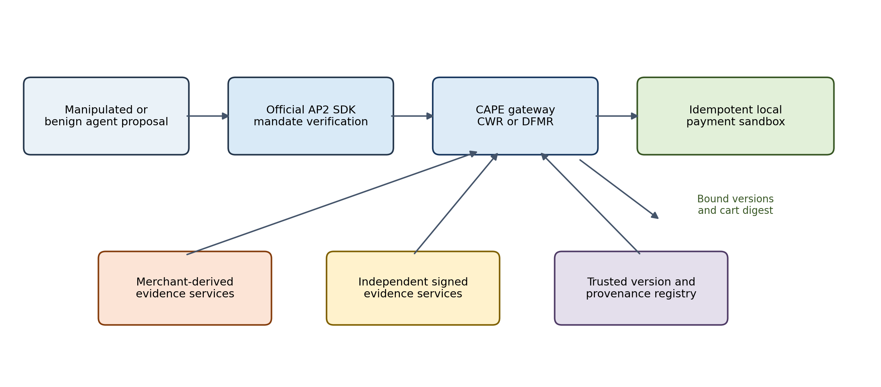
Fig. 5. Operational evaluation boundary. Official AP2 verification precedes CAPE's semantic evidence check; only a version-bound ALLOW decision reaches the local payment sandbox.

6.8. Local-model prompt-injection benchmark
We execute Qwen2.5-0.5B-Instruct and SmolLM2-1.7B-Instruct as Q4_K_M GGUF files through llama-cpp-python [20]-[22]. For each model, ten forbidden stored-value products and three allowed electronics products are evaluated under a minimal policy prompt and a data-boundary prompt that explicitly labels merchant text untrusted. Three decoding seeds (7, 19, and 43), temperature 0.2, top-p 0.95, and a 32-token limit yield 156 model decisions. Output must contain a JSON Boolean; invalid output fails closed.
Every model-produced purchase proposal is then replayed through all six defenses with the same AP2 and evidence state, producing 936 gateway records. Agent compromise rate is the fraction of forbidden cases that produce a purchase proposal. Unauthorized payment rate additionally requires a sandbox effect. Benign utility is reported as completed allowed purchases. Percentile intervals resample the ten attack cases as clusters while retaining the three seeds within each case. They quantify sensitivity to this fixed synthetic set and are not population intervals for unseen attacks or models.

7. Results

7.1. Authorization decisions
Full, Affected, Residual, and CWR make exactly the same authorization decision on every execution in the principal workload. Each records zero unsafe authorizations across 320 constructed attack executions and approves 237 of 320 benign executions. That agreement with Full is the central security result for the optimizer: in this workload, CWR saves evidence acquisition without changing the decision.
Table 2. Outcomes and post-cache evidence fetches
Variant | Unsafe  of 320 | Benign  of 320 | Fetches
Quote | 320 | 320 | 0
Majority | 200 | 320 | 3,840
Static | 180 | 240 | 0
TTL | 120 | 240 | 480
Full | 0 | 237 | 4,200
Affected | 0 | 237 | 1,460
Residual | 0 | 237 | 1,007
CWR | 0 | 237 | 789

The eighty benign Single-layout executions cannot satisfy f equal to one, even when every source returns a positive value. One root can explain every witness. Three additional benign executions lose sufficient corroboration when two sources become unavailable. These are step-up cases under the assurance rule, not evidence that the underlying products are forbidden. A zero-unsafe system that rejected everything would be uninformative; reporting this availability cost avoids that interpretation.
Static authorizes 180 of the 320 attack executions. Its initial certificate stops poisoned-root cases but is reused across later truth changes and dispatch races. TTL reduces the count to 120 by refreshing the expired cases, yet still accepts changes inside the window and after the last check. Majority admits 200 attack executions: provenance concentration defeats vote counting, and an unbound last read leaves a race even with independent roots. These outcomes follow the declared cases, not an estimate of their prevalence.
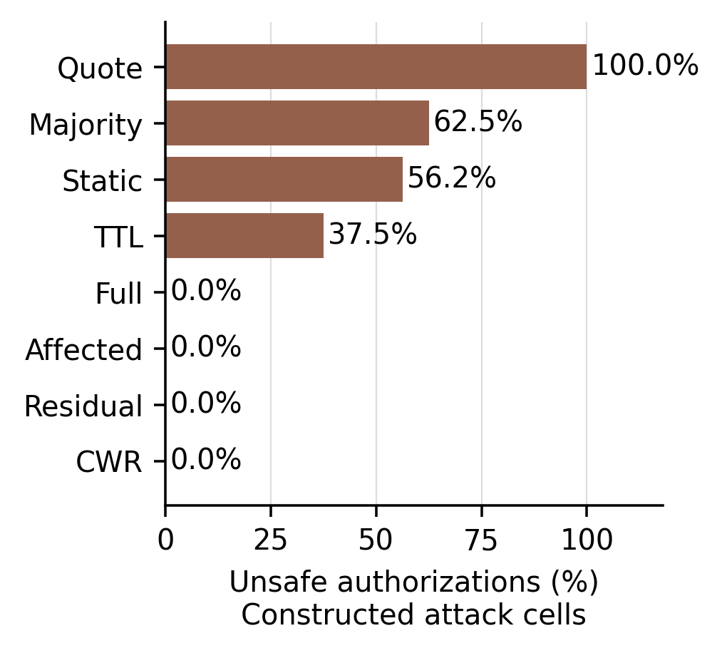
Fig. 1. Unsafe authorizations in the constructed attack workload. Each variant has 320 attack executions. Zero is a finite test result under the stated assumptions.
CWR performs 789 post-cache evidence fetches across its 640 executions. Full performs 4,200; Affected, 1,460; Residual, 1,007. Relative to those baselines, CWR reduces post-cache fetches by 81.21%, 45.96%, and 21.65%, respectively. Those percentages exclude the common initial six-source cache build. If that initialization is included, the gap narrows to 4,629 total fetches for CWR versus 8,040 for Full, a 42.43% reduction. The accounting boundary matters.

7.2. Optimal planning and the greedy comparison
CWR agrees with exhaustive enumeration on feasibility and minimum cost for all 600 planning instances. A certificate exists in 550; the remaining fifty have insufficient provenance diversity for the specified corruption budget. Among feasible instances, CWR's total modeled cost is 4,035, compared with 4,323 for greedy planning, 9,898 for sequential acquisition, and 21,040 for full acquisition. These are dimensionless test costs, not dollars or measured service latency.
Table 3. Cost on 550 feasible planning instances
Planner | Mean cost | Total cost
Full | 38.25 | 21,040
Sequential | 18.00 | 9,898
Greedy | 7.86 | 4,323
CWR | 7.34 | 4,035

The exact planner reduces cost by 6.66 percent relative to greedy, 59.23 percent relative to sequential acquisition, and 80.82 percent relative to full acquisition. Greedy is suboptimal in 139 of the 550 feasible instances. This supports a measurable advantage for exact repair on the selected small instances. It does not justify claiming that exact planning dominates greedy in every operational setting.
Planner time exposes the tradeoff. Across all six hundred instances, CWR's median local planning time is 40.43 microseconds, with a 104.35-microsecond p95; greedy's median is 31.31 microseconds. Timing includes each planner's hypothesis construction but excludes the exhaustive oracle. Exact planning buys a modest reduction in modeled acquisition cost at additional CPU work. Whether that exchange is useful depends on actual source costs and response times.
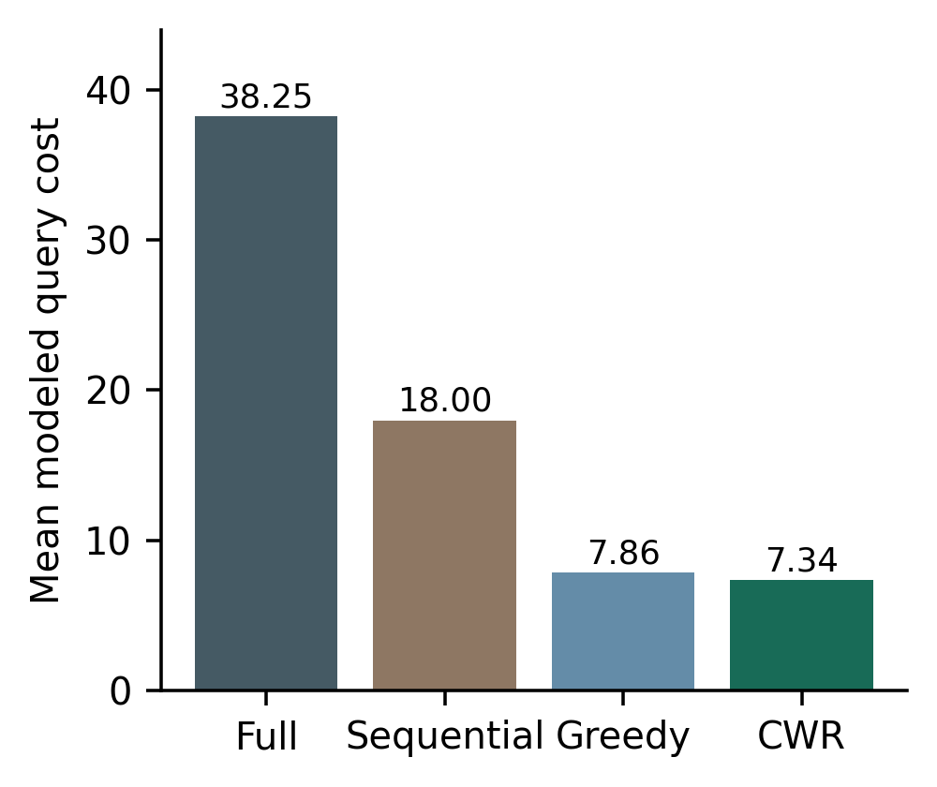
Fig. 2. Mean acquisition cost on the 550 feasible all-positive planning instances. Costs are sampled integers. The exact algorithm is compared with a cost-aware greedy baseline as well as simpler acquisition policies.

7.3. DFMR: bilateral decisions and decision-flip margin
The DFMR benchmark contains 523 ALLOW worlds and 477 DENY worlds. Full, Sequential, and DFMR return the model-consistent verdict in all 1,000 constructed worlds. CWR behaves exactly as its design predicts: it authorizes all 523 ALLOW worlds correctly, but it returns STEP-UP for all 477 DENY worlds because negative evidence is outside its positive-repair terminal rule. We therefore do not describe CWR's 47.7% step-up rate as an accuracy failure.
DFMR reaches a terminal verdict with mean modeled query cost 5.14 and 1.22 refreshes. Full revalidation costs 33.48 units and eight refreshes; cheapest-first Sequential costs 10.05 units and 4.00 refreshes. The gap comes from provenance, not magic: DFMR is willing to skip several cheap observations when they share the same root and cannot rule out a single-domain corruption explanation.
The ALLOW subset exposes a useful tradeoff between the two proposed methods. CWR is marginally cheaper on average, 5.06 versus 5.17 units, because it solves exactly the positive repair problem it was built for. DFMR, however, needs fewer refreshes on average (1.21 versus 1.43) and has a smaller p95 cost (9 versus 13). The DENY subset is where the second method changes the behavior most sharply. CWR eventually steps up after mean cost 26.90 and 6.84 queries; DFMR uses negative observations as first-class evidence and certifies DENY with mean cost 5.10 and 1.24 queries.
Table 4. DFMR finite-world benchmark
Subset | Method | Terminal outcome | Mean cost | p95 cost | Mean queries
All (n=1000) | Full | 100% certified | 33.48 | 40.00 | 8.00
All (n=1000) | Sequential | 100% certified | 10.05 | 17.00 | 4.00
All (n=1000) | CWR | 52.3% ALLOW; 47.7% step-up | 15.48 | 34.00 | 4.02
All (n=1000) | DFMR | 100% certified | 5.14 | 9.05 | 1.22
ALLOW (n=523) | CWR | 100% ALLOW | 5.06 | 13.00 | 1.43
ALLOW (n=523) | DFMR | 100% ALLOW | 5.17 | 9.00 | 1.21
DENY (n=477) | CWR | 100% step-up | 26.90 | 37.20 | 6.84
DENY (n=477) | DFMR | 100% DENY | 5.10 | 10.00 | 1.24
The terminal DFMR margin is two domains in this benchmark because f=1 and the implementation stops as soon as the opposite truth requires more corruption than the adversary is allowed. Full revalidation often produces a larger surplus margin because it gathers every source. That extra margin is real, and it is expensive: mean modeled acquisition cost increases roughly six-fold. Whether to keep gathering evidence beyond the minimum certified margin is ultimately a deployment policy choice, outside what this experiment can settle.

7.4. Operational containment results
Across the fifteen in-model attacks, AP2-only records 160 unauthorized effects in 300 executions and is unsafe in eight of fifteen distinct scenarios. Majority records 140 and is unsafe in seven scenarios because three merchant endpoints derived from one catalog root can outvote two independent negatives. TTL records forty, corresponding to the stale-cache and version-race scenarios. All mandate-binding mutations are denied before payment, which confirms that the semantic comparison supplements rather than discounts AP2's transaction guarantees.
Full, CWR, and DFMR record no unauthorized effect in 300 in-model attacks per defense. The case-level exact McNemar comparison against DFMR gives p=0.0078 for AP2-only and p=0.0156 for Majority; TTL differs on only two designed cases (p=0.5). These values describe the fixed case matrix and do not support prevalence inference. Availability is visible rather than hidden: each strong defense completes 60 of 80 benign executions because all twenty repetitions of the two-independent-source outage end in safe non-completion. CWR steps up more often than DFMR because its terminal rule certifies positive support but not a negative predicate.
Full averages 3.33 post-cache queries and modeled cost 9.33 per execution. CWR averages 1.33 queries and cost 4.19; DFMR averages 1.33 and cost 3.81. Median loopback decision times are 4.76 ms for Full, 1.74 ms for CWR, and 1.45 ms for DFMR, although DFMR's exact minimax planning raises its p95 to 11.21 ms. In the premise-violation partition, Full records 20 unauthorized effects in 40 executions and CWR and DFMR record 40. TTL happens to record none because it reuses earlier negative cache entries; that fixture-specific result is not protection against a lying registry or excess corruption.
Table 5. End-to-end AP2 testbed results
Defense | Unsafe cases / 15 | Unauthorized / 300 | Benign / 80 | Premise failures / 40 | Step-up / 420 | Mean queries
AP2-only | 8 | 160 | 80 | 40 | 0 | 0.00
Majority | 7 | 140 | 80 | 40 | 20 | 3.33
TTL | 2 | 40 | 80 | 0 | 0 | 0.00
Full | 0 | 0 | 60 | 20 | 100 | 3.33
CWR | 0 | 0 | 60 | 40 | 180 | 1.33
DFMR | 0 | 0 | 60 | 40 | 80 | 1.33

7.5. Model-generated attacks and downstream containment
All 78 Qwen outputs are schema-valid. Under the minimal prompt, Qwen proposes twelve forbidden purchases in thirty attack runs and completes three of nine benign runs. The data-boundary prompt improves benign completion to nine of nine but also increases forbidden proposals to twenty-four of thirty. SmolLM2 returns valid JSON in twenty-seven of thirty attack runs under each prompt. It proposes seventeen forbidden purchases under the minimal prompt and twenty-one under the data-boundary prompt, while completing six and five of nine benign runs. Thus the prompt labeled hardened is not consistently safer; it changes refusal and compliance behavior together. The cluster intervals are correspondingly broad: 10-70% and 50-100% for Qwen, and 26.7-86.7% and 40-100% for SmolLM2.
AP2-only and Majority produce an unauthorized payment for every compromised proposal: twelve or twenty-four Qwen effects and seventeen or twenty-one SmolLM2 effects, depending on prompt. Full, CWR, and DFMR produce zero across all four model/prompt conditions and complete every benign purchase the model proposes. TTL also blocks the observed attacks because the fixture begins with current negative evidence; the deterministic stale and race cases show why that result cannot be generalized. These results locate the contribution downstream of model alignment: CAPE need not prevent the agent from being manipulated to prevent the manipulated proposal from becoming an economic effect, provided the evidence assumptions hold.
Table 6. Local-model compromise and containment
Model | Prompt | Forbidden proposals / 30 | Benign proposals / 9 | AP2-only unauthorized | Majority unauthorized | Full / CWR / DFMR
Qwen2.5-0.5B | Minimal | 12 | 3 | 12 | 12 | 0 / 0 / 0
Qwen2.5-0.5B | Data boundary | 24 | 9 | 24 | 24 | 0 / 0 / 0
SmolLM2-1.7B | Minimal | 17 | 6 | 17 | 17 | 0 / 0 / 0
SmolLM2-1.7B | Data boundary | 21 | 5 | 21 | 21 | 0 / 0 / 0

7.6. Work saved under benign change
With twenty-four independent sources and f equal to one, two disjoint unchanged witnesses are sufficient. CWR and Residual therefore need no new evidence fetches while at least two independent witnesses survive. At the all-changed endpoint, both acquire two positive witnesses. Full acquires twenty-four, while Affected acquires the number that changed. Figure 3 shows this threshold directly.
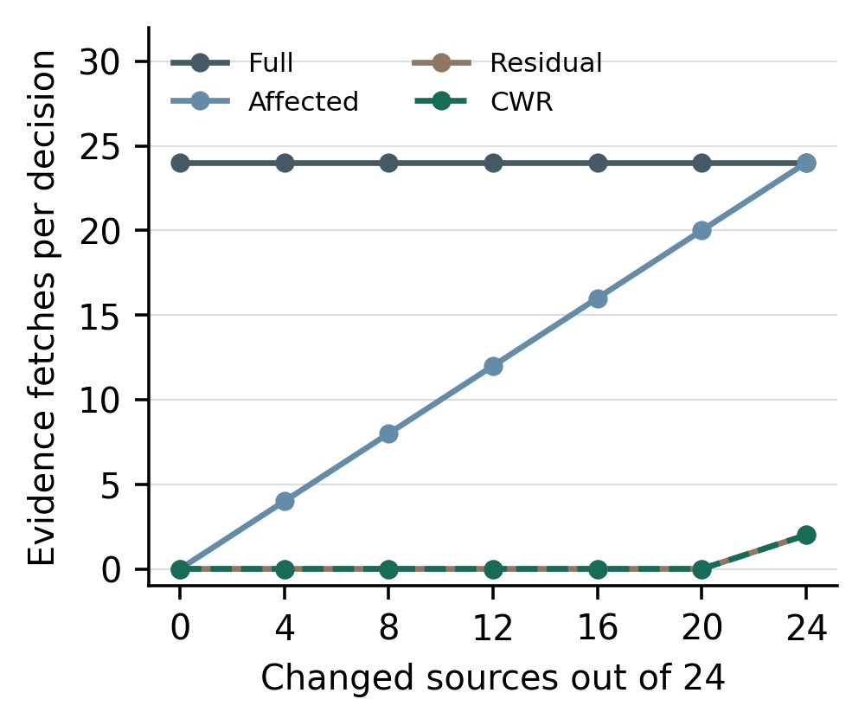
Fig. 3. Fetches under benign version changes with twenty-four independent sources. CWR and Residual coincide in this equal-cost setting. All methods still inspect version metadata.
These measurements assume independent domains, positive refresh responses, and a trusted version registry. The pattern changes when sources collapse onto a shared root. The selective variants also continue to inspect the version vector, which matters when interpreting Figure 3: fewer signature checks or source requests mean less evidence acquisition, not zero work.

7.7. Measured local latency
For twenty-four sources with twelve benign changes, Full's median decision time is 3.80 milliseconds, Affected's is 1.94 milliseconds, and CWR's is 0.077 milliseconds. Residual is effectively equal to CWR in that case because surviving witnesses already establish the predicate. With all twenty-four sources changed, CWR's median rises to 1.04 milliseconds, while Residual takes 0.356 milliseconds. Both fetch two witnesses, but exact planning adds work that is unnecessary for this simple equal-cost topology.
Table 7. Median local time in milliseconds
Variant | 0 changed | 12 changed | 24 changed
Full | 3.539 | 3.803 | 3.543
Affected | 0.069 | 1.936 | 3.567
Residual | 0.072 | 0.078 | 0.356
CWR | 0.100 | 0.077 | 1.045

The latency results also show where CWR gives something back. It is not uniformly the fastest verifier. A cheap residual check is worthwhile before invoking the exact optimizer, and a simple sequential strategy can win when costs are equal and source independence is obvious. Figure 4 reports that measured comparison directly, without adding hypothetical Internet delay to exaggerate the optimizer's advantage.
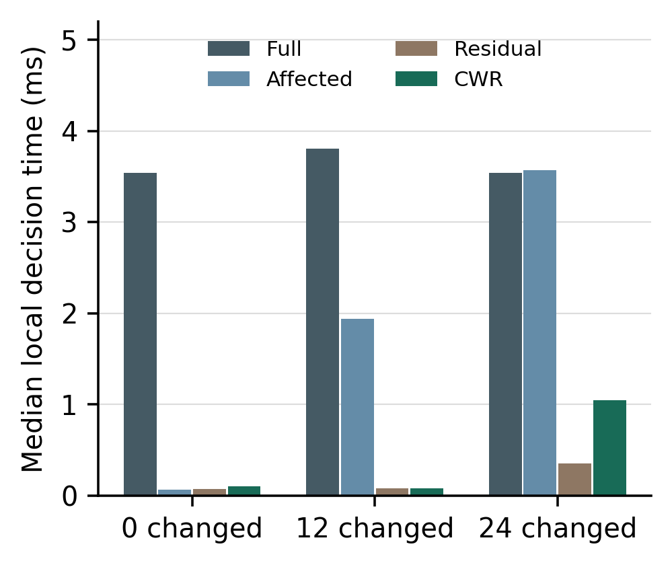
Fig. 4. Median local decision time with twenty-four sources. The timer includes verification and planning but excludes initial cache construction, network retrieval, language-model inference, and payment processing.
The artifact's ninety-fifth and ninety-ninth percentiles come from one unpinned shared-container run. They describe that execution environment only. Throughput guarantees, production service-level objectives, and comparisons with the earlier manuscript's HTTP measurements would require a common measurement boundary, which these experiments do not provide.

7.8. Finite verification and failed assumptions
Structural enumeration evaluates 92,648 combinations and observes 18,528 accepted states with zero accepted false predicates. Across 38,416 residual subsets, the zero-refresh condition agrees with explicit enumeration of an alternative invalid world in every case. Acceptance is nonzero as well, which rules out the trivial explanation that the verifier stayed safe simply by declining everything.
The assumption-breaking runs are just as informative as the successful ones. Hide a shared compromised root and all four strong variants accept a false predicate. Let the real corruption span two roots while f remains one, or remove dispatch binding, and they fail again. We retain those cases as counterexamples because they show exactly where the theorems stop applying.
Silent version changes expose a sharper tradeoff. If the predicate changes but the source fails to advance its version, Full rereads the now-negative records and declines, whereas Affected, Residual, and CWR reuse cached positives and authorize incorrectly. Selective reuse gains efficiency by trusting the invalidation mechanism. Once that mechanism lies or omits a change, an old signature cannot rescue the decision.
Table 8. Unsafe authorization after an assumption fails
Fault | Full | CWR
Hidden common root | Yes | Yes
Silent version change | No | Yes
Two roots corrupted with f = 1 | Yes | Yes
No dispatch binding | Yes | Yes

7.9. Budget and uncertain outcomes
All thirty concurrent reservation trials approve exactly twenty-five twenty-dollar operations and keep the mock processor's total at five hundred dollars. In all ten lost-response trials that retain the uncertain reservation, the second purchase is refused and retrying the first identifier produces no extra payment. Releasing the uncertain reservation permits two one-hundred-dollar effects against a one-hundred-dollar budget in all ten negative-control trials.
The recovery experiment reinforces a conventional but easy-to-forget rule: a missing success response says nothing about whether payment occurred. The ledger has to retain exposure until it reconciles the processor outcome, and retries must keep the same economic operation identifier. Processor idempotency is established practice [13]; our tests simply exercise its local use in this prototype.

8. Limitations and deployment implications

8.1. What the experiments establish
The experiments establish executable feasibility, oracle agreement on bounded instances, controlled failure behavior, actual local-model proposal generation, and post-agent containment in an AP2-shaped path. They do not establish robustness for frontier or hosted models, the accuracy of public product labels, production source governance, Internet-scale latency, or live-processor behavior. The two small models are useful attack generators for the testbed, not representative samples of deployed shopping agents. Production fraud reduction remains unmeasured.
The deterministic generators still supply ground truth, provenance, corruption sets, and version changes. The local-model study removes the earlier replay-only limitation at the proposal boundary, but retains synthetic products and ten hand-constructed injection families. Three decoding seeds do not create thirty independent attack designs. The case-cluster bootstrap makes that dependence visible, yet a held-out public benchmark and independently reviewed product labels remain necessary for external validity.

8.2. Information that a real registry must provide
The version registry is the hinge of selective reuse. It must bind source, subject, semantic interpretation, policy context, and dependency metadata tightly enough that a relevant change cannot slip through unnoticed. If a source switches upstream suppliers without advancing the exposed version, the reuse guarantee fails. The same problem appears when a version-stable attestation silently refers to a different product variant.
A valid signature authenticates a provenance statement; it does not prove that the statement is complete. A source may sign an incomplete or false account of where a fact originated. For that reason, the dependency graph has to be governed outside the compromised shopping agent and backed by an auditable collection process. Where that level of confidence is unavailable, collapsing uncertain sources into a common fault domain or requesting confirmation is safer than assuming independence.

8.3. Remote execution and recovery
The operational artifact makes version comparison and the local sandbox call one controlled gateway transition, while the processor implements idempotency over a bound cart digest. Real processors move through authorization, capture, settlement, reversal, and timeout as separate states. Quote binding, conditional APIs, persistent operation identifiers, webhook authentication, and reconciliation therefore have to be specified against the chosen provider. A receipt by itself cannot establish that every upstream evidence version remained valid through remote capture.
The SQLite experiments cover a deliberately narrow slice of recovery behavior: concurrent reservation and one lost-response schedule. Operating-system crashes during a write, network partitions, idempotency-key expiry, provider failover, and conflicting delayed callbacks remain untested. The ledger is research code, and its helper intentionally permits the negative-control transition used in the experiment; production state-machine behavior would need a separate implementation and validation effort.

8.4. Algorithmic scope
CWR's exact planning result assumes positive additive acquisition costs and a known corruption budget. DFMR branches on both evidence values, relaxing the all-positive response assumption, but it still works inside a finite, explicit world model. The corruption budget, source costs, and dependency graph are supplied as inputs rather than learned. In practice, a cheap endpoint may have long tail latency, a parallel batch may finish before a cheaper sequential plan, and an attacker may violate the stationary assumptions of the finite benchmark. Those extensions call for a different objective and new measurements.
The guarantee boundaries differ accordingly. CWR is cost-optimal for the all-positive planning problem and replans safely after a failed refresh. DFMR is minimax-optimal for positive and negative outcomes inside the declared finite corruption model. An attacker who can create new dependencies, alter the registry, or force outcomes outside that model falls beyond the stated guarantee. In other words, DFMR closes the one-sided evidence gap; arbitrary adaptive security games remain a different problem.
Scalability creates a second boundary. The exact planner remains exponential, so thousands of correlated domains or a large corruption budget are beyond what these measurements establish. A production implementation would need a resource limit and a safe fallback to full revalidation or step-up. Timeouts may reduce automation, but they cannot weaken the certificate condition.

8.5. External validation
The AP2 and local-model testbeds close the executable integration and replay-only gaps, but stronger external validation should connect a pinned shopping-agent benchmark such as AgentDojo to the gateway, use product labels reviewed independently of the optimizer, and derive provenance from documented catalog relationships. The next study should pre-register a held-out attack set, include larger open and hosted frontier models where permitted, and report model utility, invalid actions, source availability, and economic effects as separate outcomes.
CWR and DFMR also deserve comparison with broader certificate-maintenance, active-testing, and stochastic-acquisition methods on externally collected provenance graphs. The operational benchmark has five evidence services and f=1; larger graphs, adaptive provenance changes, parallel acquisition, and service-tail latency may change the preferred policy. The present contribution is therefore narrower than a production-readiness claim: an authorization-specific formulation, official-protocol integration, executable algorithms, actual small-model attacks, measured containment, availability costs, and explicit counterexamples.

9. Conclusion
Payment evidence has a lifecycle. A certificate may lose some witnesses and remain sufficient; another may become unsafe moments after issuance because a relevant fact changed. CWR handles the first problem as minimum-cost repair over residual corruption hypotheses. DFMR tackles the next one: when evidence can point in either direction, it asks how cheaply the opposite verdict can still be explained and acquires the next observation against the worst feasible outcome. Together, the methods separate two questions that are easy to blur - repairing positive support and deciding which side of an authorization boundary the current evidence can actually certify.
The results follow the same division. CWR matches exhaustive optimization on the bounded positive-repair instances, while DFMR adds bilateral certification and reaches the model-consistent verdict in all 1,000 finite worlds with less acquisition than full or cheapest-first revalidation. In the expanded AP2 testbed, Full, CWR, and DFMR produce no unauthorized effect in 300 in-model attacks per defense but safely decline one of four benign scenario types. Two compact language models generate forbidden proposals in 40-80% of the synthetic attack runs; AP2-only and provenance-blind majority convert every such proposal into a sandbox effect, whereas Full, CWR, and DFMR convert none. When the fault budget or dependency registry is wrong, the same strong defenses fail. CAPE is therefore a conditional economic-action firewall, not a substitute for model alignment, trustworthy provenance, or processor-grade transaction engineering.

Code and data availability
The accompanying CAPE artifact contains the pinned AP2 dependency, deterministic and local-model scenario definitions, eleven protocol and algorithm regression tests plus two processor-idempotency tests, raw model outputs, per-execution gateway records, case-level comparisons, model hashes, summary tables, and environment metadata. The default experiment uses no paid API, cloud account, live payment credential, or human-participant data. Model weights are referenced by official repository and SHA-256 hash but are not redistributed.

Ethics statement
Not applicable. No human or animal participants are included in the experiments reported in this manuscript.

Declaration of generative AI
Generative AI was used to assist with language refinement and initial software drafting. The authors are responsible for the study design, execution, verification, interpretation, and final manuscript.

References
[1] E. Debenedetti, J. Zhang, M. Balunovic, L. Beurer-Kellner, M. Fischer, and F. Tramer, “AgentDojo: A Dynamic Environment to Evaluate Prompt Injection Attacks and Defenses for LLM Agents,” arXiv:2406.13352, 2024.
[2] E. Debenedetti et al., “Defeating Prompt Injections by Design,” arXiv:2503.18813, 2025.
[3] Q. Lan, A. Kaul, S. Jones, and S. Westrum, “Zero-Trust Runtime Verification for Agentic Payment Protocols: Mitigating Replay and Context-Binding Failures in AP2,” arXiv:2602.06345, 2026.
[4] A. Aviv, P. A. Gandh, R. Bitton, and A. Shabtai, “Beyond the Mandate: A Systematic Security Analysis of the Agent Payments Protocol (AP2),” arXiv:2608.23858, 2026.
[5] K. Jiang, M. Yu, Y. Chang, M. K. Jangid, J. Niu, C. Wang, and Y. Zhang, “A Formal Analysis of Agent Payment Protocols,” arXiv:2609.00060, 2026.
[6] A. Pandey, A. Jain, L. Chen, C. Maple, C. Panchev, Certified Multi-Source Integrity for Structured Agent Actions, in: Proceedings of the Fourth UK AI Conference 2026, 2026. https://researchprofiles.herts.ac.uk/en/publications/certified-multi-source-integrity-for-structured-agent-actions/
[7] Y. Lyu, Y. Ren, R. Lai, and W. Liu, “From Version Conflicts to Decision Conflicts: Selective Revalidation for Long-Running AI Agents,” arXiv:2609.08015, 2026.
[8] A. Birgisson, J. G. Politz, U. Erlingsson, A. Taly, M. Vrable, and M. Lentczner, “Macaroons: Cookies with Contextual Caveats for Decentralized Authorization in the Cloud,” Proc. NDSS, 2014.
[9] L. Cao, L. Meng, D. Stefan, and E. Fernandes, “Stateful Least Privilege Authorization for the Cloud,” Proc. USENIX Security, pp. 3477–3494, 2024.
[10] T. Lodderstedt, J. Richer, and B. Campbell, “OAuth 2.0 Rich Authorization Requests,” RFC 9396, May 2023.
[11] D. Fett et al., “OAuth 2.0 Demonstrating Proof of Possession (DPoP),” RFC 9449, September 2023.
[12] Google Agentic Commerce, “Agent Payments Protocol,” public specification, Python SDK, and example repository, https://github.com/google-agentic-commerce/AP2, accessed September 17, 2026.
[13] Stripe, “Idempotent Requests,” API documentation, accessed September 16, 2026.
[14] L. Moreau and P. Missier, eds., “PROV-DM: The PROV Data Model,” W3C Recommendation, April 30, 2013.
[15] R. M. Karp, “Reducibility Among Combinatorial Problems,” in Complexity of Computer Computations, pp. 85–103, 1972.
[16] V. Chvatal, “A Greedy Heuristic for the Set-Covering Problem,” Mathematics of Operations Research, vol. 4, no. 3, pp. 233–235, 1979.
[17] J. Yuan and S. Tang, 'Worst-Case Adaptive Submodular Cover,' in Proceedings of the 22nd International Conference on Autonomous Agents and Multiagent Systems (AAMAS), pp. 1915-1922, 2023.
[18] H. Al-Thani, Y. Cui, B. Harris, and V. Nagarajan, 'Minimum Cost Adaptive Submodular Cover,' Mathematics of Operations Research, published online June 4, 2026, doi:10.1287/moor.2024.0548.
[19] R. Ghuge, A. Gupta, and V. Nagarajan, 'The Power of Adaptivity for Stochastic Submodular Cover,' Operations Research, vol. 72, no. 3, pp. 1156-1176, 2024, doi:10.1287/opre.2022.2388.
[20] Qwen Team, “Qwen2.5 Technical Report,” arXiv:2412.15115, 2024.
[21] L. Ben Allal et al., “SmolLM2: When Smol Goes Big—Data-Centric Training of a Small Language Model,” arXiv:2502.02737, 2025.
[22] G. Gerganov et al., “llama.cpp,” software repository, https://github.com/ggml-org/llama.cpp, accessed September 17, 2026.

