1. Connected the Tableau with Excel database as MySQL was not getting downloaded on my m/c.
2. Below is the dragging of three tables

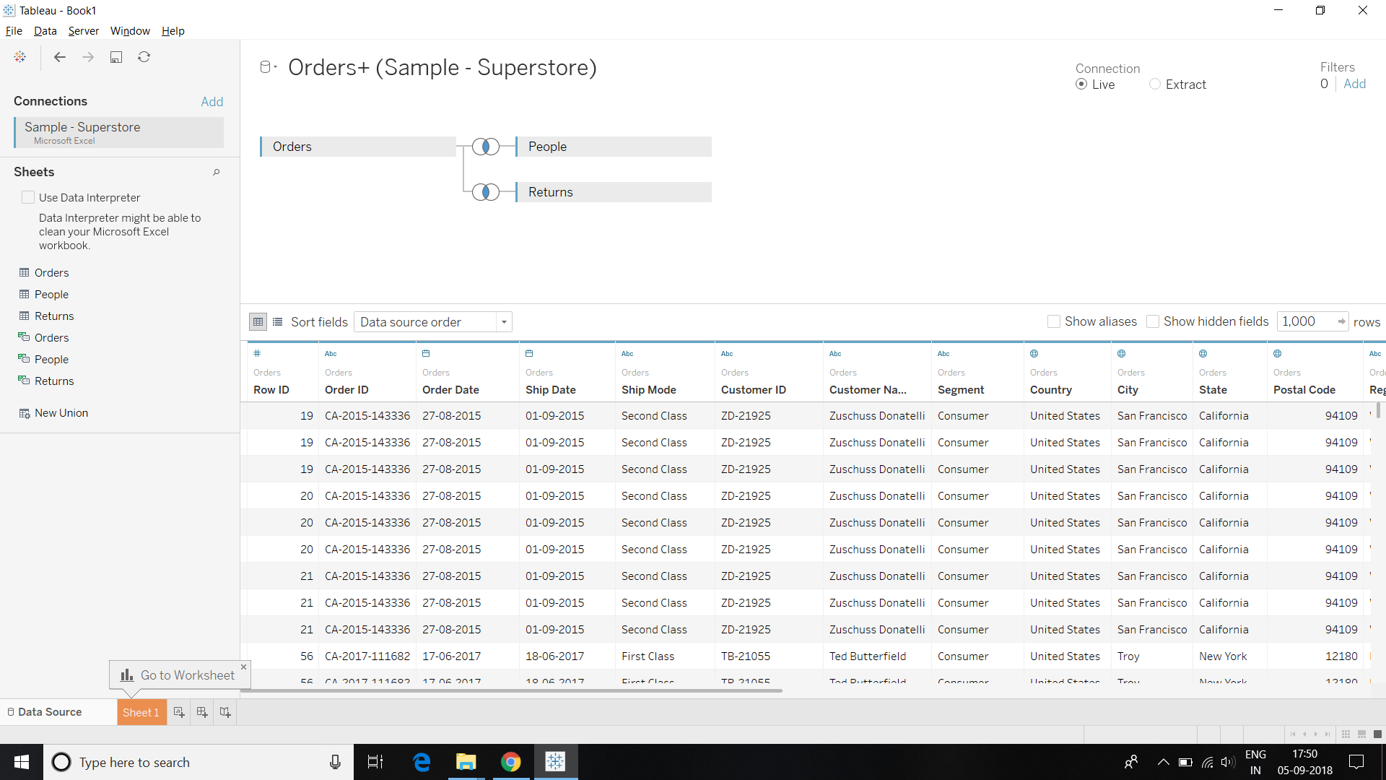

1. Creating an extract out of the data

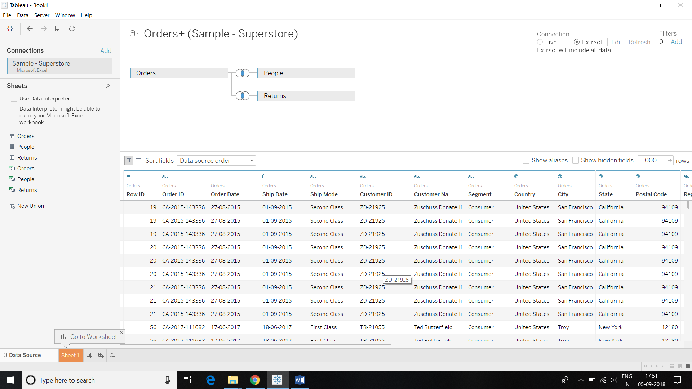

1. Saving the file as Super Store Dashboard.twbx

