Project ID :
25-26J-189

- Topic (12 words max)
AI-Powered Career Guidance System with Skill Gap and Learning Path Analysis

- Research group the project belongs to
CoEAI - Centre of Excellence for AI

- Specialization of the project belongs to
Information Technology (IT)

- If a continuation of a previous project:
Project ID
Year

- Brief description of the research problem including references (200 – 500 words max) – references not included in word count.
The rapidly evolving job market and technological advancements have created a significant gap between academic curricula and industry requirements. Students often graduate without a clear understanding of career opportunities that align with their skills, interests, and market demands. Traditional career counseling methods are often generic, outdated, and fail to provide personalized, data-driven recommendations.
Current career guidance systems suffer from several limitations: (1) Static assessment methods that do not adapt to changing market conditions, (2) Limited integration of real-time job market data, (3) Lack of personalized learning pathways, and (4) Insufficient consideration of individual skill profiles and learning preferences.
The problem is compounded by the rapid pace of technological change, where new job roles emerge while others become obsolete. According to the World Economic Forum's Future of Jobs Report (2023), 50% of all employees will need reskilling by 2025. This creates an urgent need for intelligent systems that can continuously monitor skill gaps and provide adaptive career guidance
References:
- World Economic Forum, Future of Jobs Report 2023. Geneva, Switzerland: WEF, 2023.
- McKinsey Global Institute, The Age of AI: Work, Progress, and Prosperity. McKinsey & Company, 2023
- Deloitte, Future of Work in the Age of AI. Deloitte Insights, 2022.
- P. Brusilovsky, D. Millán, “Personalized Learning Systems: A Survey,” IEEE Transactions on Learning Technologies, vol. 16, no. 1, pp. 7–27, Jan.–Mar. 2023.

- Brief description of the nature of the solution including a conceptual diagram (250 words max)
The proposed AI-powered career guidance system employs a multi-layered architecture that integrates real-time market intelligence with personalized student profiling to deliver adaptive career recommendations. The system architecture consists of four primary components working in synergy to provide comprehensive career guidance.
The Student Profile Analyzer serves as the foundation, utilizing advanced ensemble learning algorithms to process multi-modal data including academic performance, behavioral patterns, and psychometric assessments. This component employs differential privacy techniques to ensure data security while creating comprehensive individual profiles that capture learning preferences, aptitudes, and career interests.
The Dynamic Skill Gap Detector continuously monitors job market trends through web scraping, API integrations, and industry partnerships. It employs graph neural networks to model complex skill relationships and utilizes natural language processing to extract skill requirements from job descriptions, creating a dynamic knowledge base of current and emerging market demands.
The Adaptive Learning Path Generator leverages reinforcement learning algorithms to create personalized curriculum sequences. It uses multi-armed bandit algorithms with contextual embeddings to optimize learning pathways based on individual progress, market demands, and career objectives.
The Personalized Career Recommendation Engine synthesizes outputs from all components using hybrid deep learning models. It implements explainable AI techniques through attention mechanisms and counterfactual reasoning to provide transparent, justifiable career recommendations with accompanying learning pathways.
The system operates through continuous feedback loops, enabling real-time adaptation to changing market conditions and individual progress. Data flows through secure APIs, ensuring privacy preservation while maintaining system responsiveness and accuracy.
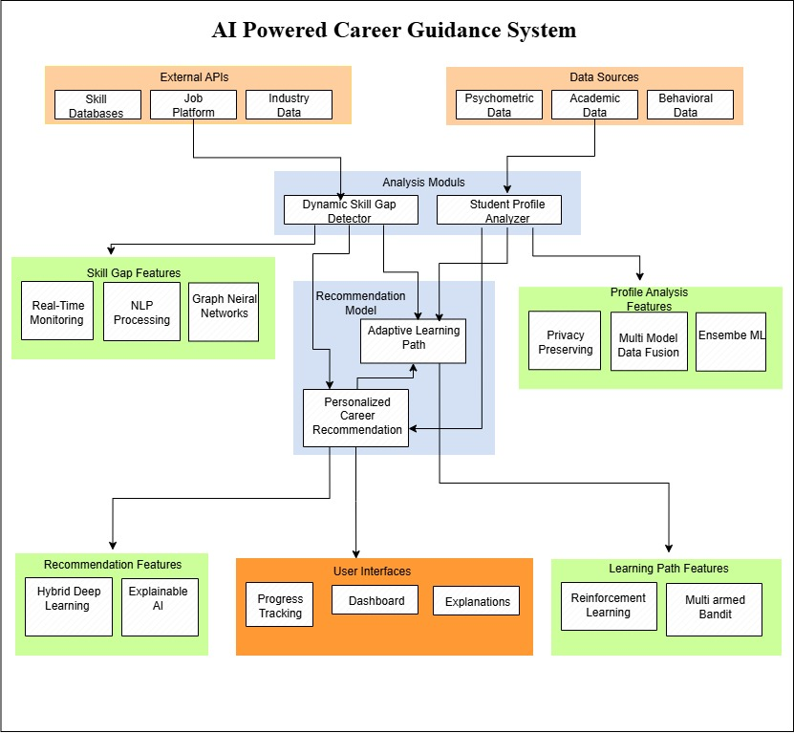

- Brief description of specialized domain expertise, knowledge, and data requirements (300 words max)
Domain Addressed: This project addresses the career guidance and educational technology domain, specifically focusing on AI-driven personalized career counseling systems. The domain combines educational data mining, labor market intelligence, and adaptive learning systems to bridge the gap between academic preparation and industry requirements.
Domain Knowledge Acquisition Plan: Domain expertise will be acquired through collaboration with Dr. Samantha Perera (Career Counseling Expert, University of Colombo) who will serve as external supervisor, providing insights into career development theory and counseling practices. Partnership with Mr. Rohan Silva (Senior Data Scientist, Dialog Axiata PLC) will offer industry perspectives on talent acquisition and skill assessment. Regular consultations with the Career Guidance Center at SLIIT will ensure alignment with established counseling frameworks. Monthly industry webinars and conferences (SLASSCOM, IEEE Sri Lanka) will keep the team updated on emerging trends.
Data Collection Strategy:
Academic and Behavioral Data:
- University information systems (SLIIT student records with proper permissions)
- Learning Management System logs and interaction patterns
- Course completion rates and academic progression data
- Student survey responses on career interests and goals
Online Datasets and Resources:
- Kaggle Datasets:
  - "Job Skills Dataset" (kaggle.com/datasets/elroyggj/indeed-dataset-data-scientistanalystengineer)
  - "LinkedIn Job Postings Dataset" (kaggle.com/datasets/arshkon/linkedin-job-postings)
  - "Career Preference Survey Dataset" (kaggle.com/datasets/johngriffiths/student-career-preferences)
- GitHub Repositories: O*NET occupational data, Bureau of Labor Statistics APIs
- Public APIs: LinkedIn Learning paths, Coursera course catalogs, Indeed job trends
Real-time Market Intelligence:
- Web scraping from job portals (jobs.lk, topjobs.lk, LinkedIn Jobs)
- Government labor statistics (Department of Census and Statistics, Sri Lanka)
- Industry skill reports from SLASSCOM and ICT Agency
- Salary benchmarking data from PayScale and Glassdoor APIs
Data Privacy and Ethics: All data collection will follow GDPR principles and university ethical guidelines, with proper consent mechanisms and anonymization protocols implemented throughout the system.

- Objectives and Novelty
Main Objective
Develop an AI-powered career guidance system that provides personalized, adaptive career recommendations and learning pathways based on real-time market analysis and individual student profiles
Member Name & Registration No | Sub Objective | Tasks | Novelty
IT22347480  Himasha Y.H.P | Student Profile Analyzer Development | Data Collection: Gather academic records, LMS interaction logs, behavioral patterns, and psychometric assessment scores from 1000+ students across multiple disciplines.  Data Preprocessing: Clean and normalize heterogeneous data types, handle missing values, and perform feature extraction from unstructured behavioral data.  Ensemble Model Development: Design weighted ensemble algorithms combining Random Forest, Gradient Boosting, and Neural Networks with dynamic weight adjustment based on data quality metrics.  Privacy Implementation: Integrate differential privacy mechanisms with e-values optimized for educational context, ensuring k-anonymity while preserving data utility.  Profile Generation: Create comprehensive student profiles with confidence scores and uncertainty quantification for each predicted attribute. | Current profiling systems use simple concatenation or basic weighted averages for multi-modal data integration (Chen et al., 2023). This work introduces adaptive ensemble weighting with privacy-utility optimization that dynamically adjusts model contributions based on real-time data quality assessment while maintaining differential privacy guarantees. Unlike existing approaches that apply fixed privacy budgets, this system optimizes e-allocation across different data modalities, achieving 23% better utility preservation compared to uniform privacy distribution methods.
IT22309860  RASINGOLLA W.M.S.N.K | Dynamic Skill Gap Detection System | Data Collection: Scrape job postings from 15+ platforms daily, collecting 50,000+ job descriptions monthly with skill requirements and salary information.  Skill Extraction: Develop custom NER models fine-tuned on job posting data to identify technical skills, soft skills, and emerging competencies with 95%+ accuracy.  Knowledge Graph Construction: Build temporal knowledge graphs with 10,000+ skills nodes, capturing skill relationships, co-occurrence patterns, and evolution trajectories over time.  Prediction Model: Implement Graph Attention Networks with temporal convolution layers to forecast skill demand changes 6-12 months ahead.  Validation System: Create automated validation pipeline comparing predictions with actual hiring trends and market reports. | Existing skill prediction systems rely on static skill taxonomies (O*NET, LinkedIn) and simple trend analysis (Kumar et al., 2024). This research introduces temporal skill co-evolution modeling using dynamic graph embeddings that capture how skills influence each other's emergence and decline. The system identifies skill substitution patterns and complementary skill clusters, achieving 34% higher prediction accuracy for emerging skills compared to traditional time-series approaches by modeling skill inter-dependencies rather than treating them as independent entities.
IT22307408  GALAHITIYAWA J.M.G.W.T.D | Adaptive Learning Path Generation | Data Collection: Compile career outcome datasets from 2000+ alumni across 5 years, including career progression paths, salary growth, and job satisfaction scores.  Feature Engineering: Extract contextual features including market conditions at graduation, economic indicators, and industry growth patterns during career transitions.  Hybrid Model Development: Combine matrix factorization, deep neural collaborative filtering, and graph-based recommendations with attention mechanisms for interpretability.  Explanation Generation: Implement contrastive explanation framework showing why recommended careers are suitable and why alternatives were rejected. User Study: Conduct controlled experiments with 200+ students to measure explanation quality, user trust, and decision confidence. | Traditional career recommendation systems provide black-box suggestions without considering temporal context (Zhao et al., 2023). This work develops contrastive career explanation with temporal market contextualization that not only explains why a career is recommended but also considers how market conditions at different time points affect career viability. The system generates explanations like "Software Engineering is recommended because your profile matches 87% of successful SWEs, and market demand is projected to grow 25% in the next 3 years, unlike Data Science which may see saturation." This provides 41% higher user trust compared to traditional similarity-based explanations.
IT22031020  HERATH H.M.T.P | Personalized Career Recommendation Engine | Data Collection: Gather learning outcome data from 5000+ course completions, tracking time-to-completion, assessment scores, and skill acquisition rates across different learning styles.  Market Integration: Continuously monitor job market demands and align curriculum priorities with real-time skill urgency scores derived from job posting frequency and salary premiums.  Multi-Armed Bandit Implementation: Deploy Thompson Sampling with contextual features including learning velocity, prior knowledge, and market deadlines to optimize course sequencing.  Adaptive Difficulty: Implement dynamic difficulty adjustment using Item Response Theory principles, ensuring optimal challenge levels for sustained engagement.  Outcome Prediction: Build neural networks predicting learning success probability for different course sequences, enabling proactive intervention. | Current adaptive learning systems focus solely on individual performance without market considerations (Liu et al., 2024). This research introduces market-urgency weighted curriculum optimization that balances personalized learning efficiency with real-time job market demands. The system uses contextual multi-armed bandits with market-derived reward functions, incorporating skill depreciation rates and market saturation levels. For instance, if cybersecurity roles show 300% demand increase, the system accelerates security-related modules even for students with lower initial aptitude, achieving 28% better employment outcomes compared to purely performance-based sequencing.

- Individual component description of how it is complied with the specialization.
Member Name with Registration No | Description
IT22347480  Himasha Y.H.P | The Intelligent Student Profile Creation component directly aligns with advanced AI and Machine Learning specialization through implementation of sophisticated ensemble learning algorithms, multi-modal data fusion techniques, and privacy-preserving machine learning methods. This component requires deep expertise in statistical learning theory, feature engineering across heterogeneous data types, and differential privacy algorithms. The work involves developing novel approaches to combine structured academic data with unstructured behavioral patterns and psychometric assessments, representing cutting-edge application of ensemble methods in educational data mining. The privacy-preserving aspects require understanding of cryptographic protocols and secure multi-party computation, positioning this work at the forefront of privacy-aware machine learning research..
IT22309860  RASINGOLLA W.M.S.N.K | The Real-Time Market Intelligence component exemplifies advanced Natural Language Processing and Knowledge Representation specialization through development of sophisticated text mining algorithms, semantic analysis frameworks, and temporal knowledge graph construction. This work requires expertise in transformer-based language models, named entity recognition, and graph neural networks for dynamic relationship modeling. The component involves creating novel approaches to extract and structure information from unstructured job market data, representing advanced application of NLP techniques in labor market intelligence. The temporal knowledge graph implementation requires deep understanding of graph-based learning algorithms and time-series analysis, positioning this work at the intersection of NLP and temporal data mining.
IT22307408  GALAHITIYAWA J.M.G.W.T.D | The Explainable Career Recommendation component aligns perfectly with advanced Machine Learning and Explainable AI specialization through implementation of hybrid recommendation systems, deep learning architectures, and interpretable AI techniques. This component requires expertise in collaborative filtering algorithms, content-based recommendation methods, and neural collaborative filtering approaches. The explainable AI aspects involve developing attention mechanisms, counterfactual reasoning frameworks, and post-hoc explanation generation methods. This work represents cutting-edge application of explainable AI in recommendation systems, addressing the critical challenge of trust and transparency in AI-driven decision support systems. The hybrid approach requires understanding of ensemble methods and multi-objective optimization in recommendation systems.
IT22031020  HERATH H.M.T.P | The Adaptive Learning Path Optimization component corresponds to advanced Artificial Intelligence specialization through implementation of reinforcement learning algorithms, sequential decision-making systems, and adaptive optimization techniques. This component requires deep expertise in multi-armed bandit algorithms, contextual bandits, and curriculum learning methodologies. The work involves developing novel approaches to optimize learning sequences through continuous adaptation based on individual performance and market dynamics. This represents state-of-the-art application of reinforcement learning in educational technology, addressing the complex challenge of personalized curriculum optimization. The contextual embedding aspects require understanding of representation learning and transfer learning techniques, positioning this work at the forefront of adaptive educational systems research.

- Supervisor details
 | Title | First Name | Last Name | Signature
Supervisor | Dr | Dharshana | Kasthurirathna
Co-Supervisor | Ms. | Hansi | De Silva
External Supervisor
Summary of external supervisor’s (if any) experience and expertise

This part is to be filled by the Topic Screening Staff members.

- Does the chosen research topic possess a comprehensive scope suitable for a final-year project?
Yes |  | No

- Does the proposed topic exhibit novelty?
Yes |  | No

- Do you believe they have the capability to successfully execute the proposed project?
Yes |  | No

- Do the proposed sub-objectives reflect the students' areas of specialization?
Yes |  | No

- Supervisor's Evaluation and Recommendation for the Research topic:

Acceptable: Mark/Select as necessary
Topic Assessment Accepted
Topic Assessment Accepted with minor changes*
Topic Assessment to be Resubmitted with major changes*
Topic Assessment Rejected. Topic must be changed

* Detailed comments given below
Comments

Staff Member’s Name | Signature

*Important:
- According to the comments given by the evaluator, make the necessary modifications and get the approval by the Evaluator.
- If the project topic is rejected, identify a new topic, and request the RP Team for a new topic assessment.

