**Handle file having multiple headers with key vault integration**

1.For getting the parameters (clientid, tenantid, secret value) for setting up environment for getting credentials from key vault we need to first register the application from Azure Active Directory.

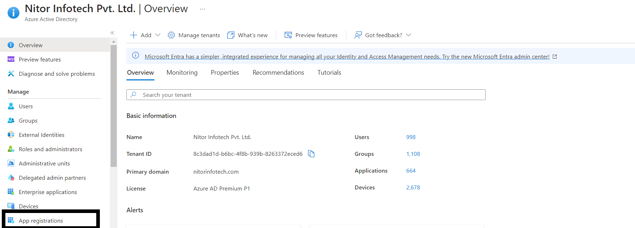

2. If you do not have any app register, Click on new Registration for creation of new application.

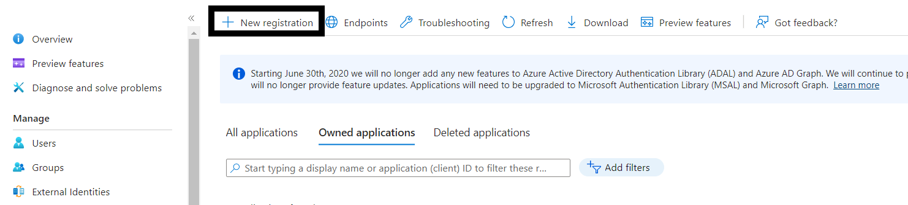

3.Click on the Application you created.

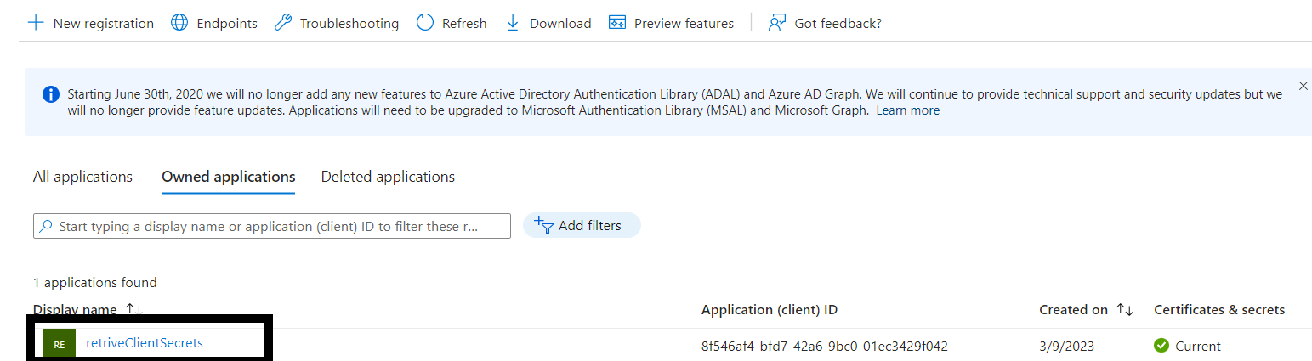

4.Get Client Id and Tenant Id after Clicking the register application.

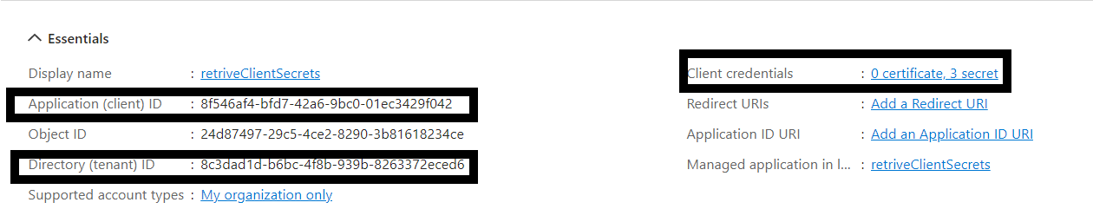

5.Click on ‘New Client Secret' to create Secret Value. Copy the secret value.

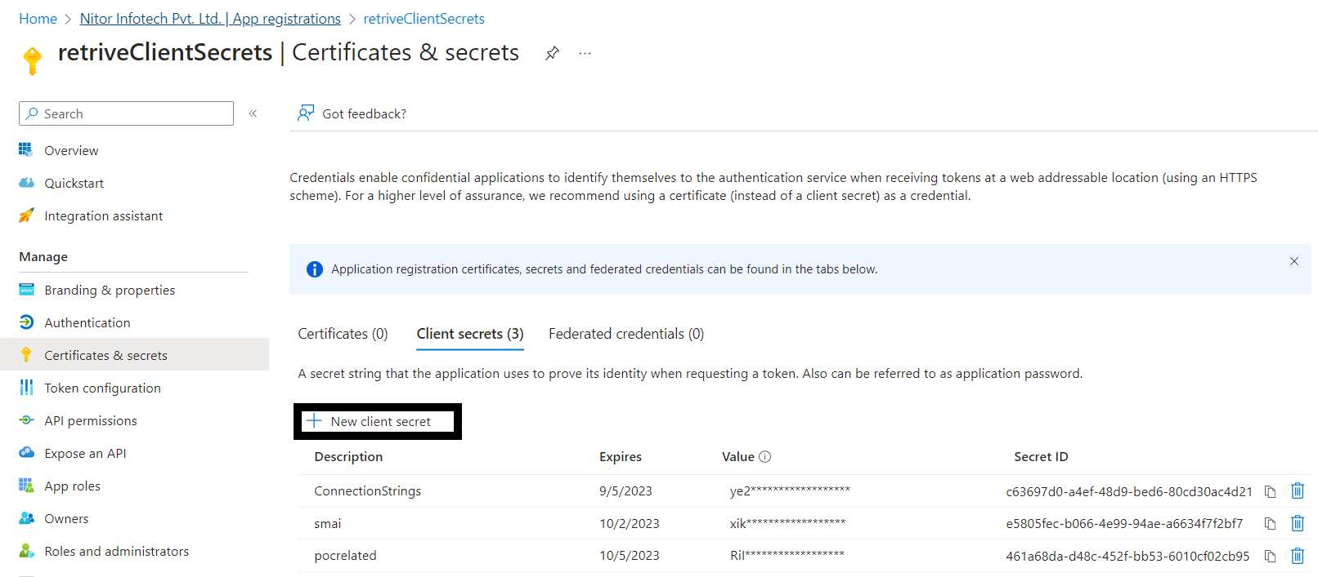

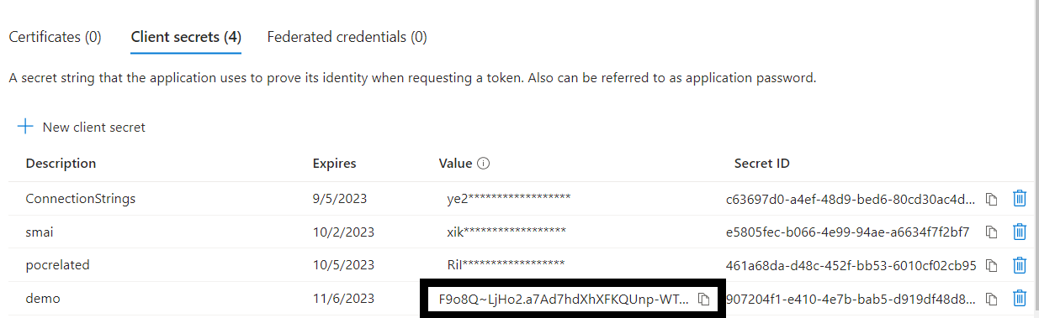

6.After Getting Secret Value go to the key vault you have created. Then go to ‘Access Policies’. Then click on the app and click on ‘Edit’. Then give the app the respective permissions.

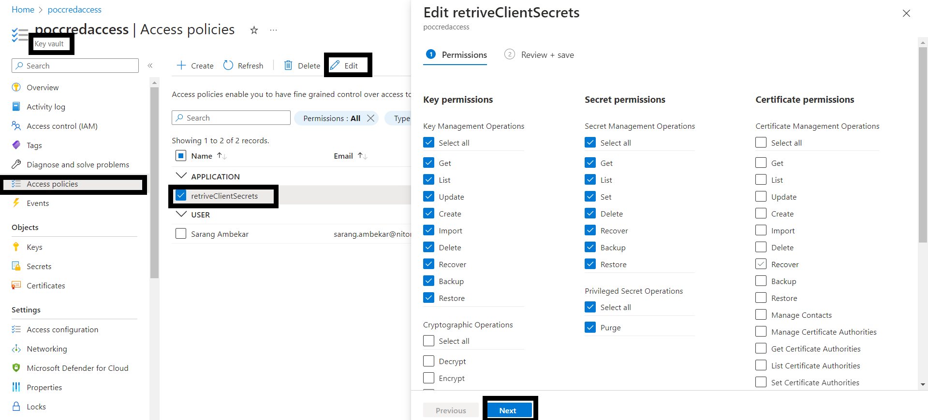

7.For creating Secrets go to ‘Secrets’ in Key Vault and Click on ‘Generate/Import’. Then Store the value of respective value in respective credentials.

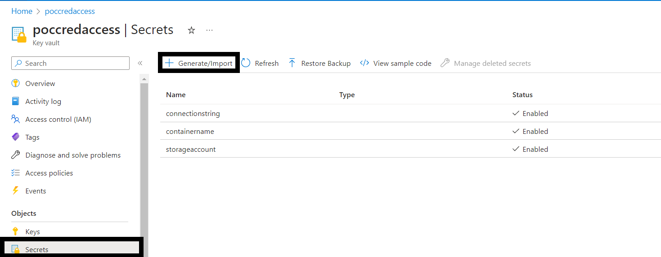

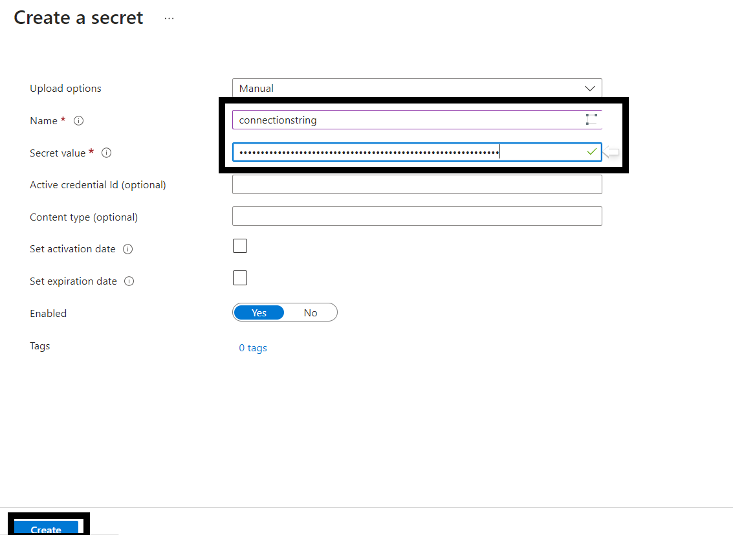

8. For getting the Connection String and Container name go to the ‘storage accounts’ then go to the ‘Access keys’ and copy the value of ‘connection string’.

