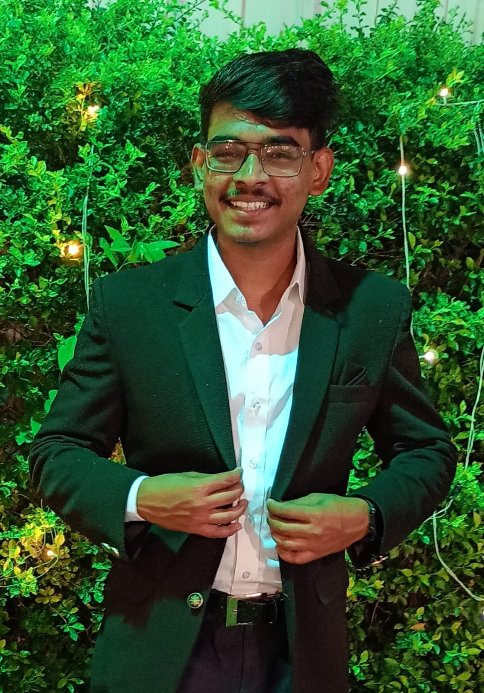
PROFESSIONAL SUMMARY
SARANG BAINALWAR
bainalwarsv@rknec.edu
9168336955

Experienced Web Developer specializing in front-end development with a focus on ReactJS and API integration. Proficient in HTML5, CSS3, JavaScript. Expertise in database management with RDBMS. Skilled in Java programming with a solid understanding of Object-Oriented Programming (OOP) principles. Adept at writing clean, efficient code and solving algorithmic problems. Strong focus on creating responsive, user-centric web solutions that align with client objectives and deliver exceptional user experiences.

EDUCATION

B.Tech in Computer Science, SHRI RAMDEOBABA COLLEGE OF ENGINEERING AND MANAGEMENT,NAGPUR 2021-2025
Class 10th, St. Paul High School, Nagpur (CBSE)
2019
94 percentage
Class 12th, Kamla Nehru Mahavidyalaya, Nagpur (Maharashtra State Board)
2021
95 percentage

SKILLS

Technical Skills: Web development (HTML, CSS, JS), REACTJS, RDBMS, MySQL, Java, OOP, Python, Github, Postman, PopSQL
Soft skills: Team Player, Persistent, Adaptive, Ability to learn new things

CERTIFICATES

Microsoft Azure Foundations: Basics of cloud computing services and Microsoft Azure platform.
Introduction to Blockchain Foundation: Fundamental concepts of blockchain technology and its applications.
Generative AI: Introduction to generative AI techniques and their use in real-world applications

PROJECTS

Library Management System - (SQL)
Key Skills: SQL, Database Management, MySQL
The Library Management System is a simple SQL-based project that helps manage a library’s books, users, and borrowing records efficiently. It uses a relational database model, consisting of multiple tables that store related information, and SQL queries to interact with the database.
React Chat App - ReactJS
Key Skills: ReactJS, React Chat Engine API, hooks, useEffects
Developed a fully functional chat application using React and the React Chat Engine API. The application supports real-time messaging, including text and image sharing, with user authentication and chat room management.

GAN-based Synthetic Image Generation
Key Skills: GAN, Deep Learning
Conducted research on Generative Adversarial Networks (GANs) to create realistic synthetic images, focusing on Convolutional Neural Networks (CNNs) and Deep Convolutional GAN (DCGAN) implementations. Developed a novel approach to enhance synthetic data generation, addressing limitations in existing methodologies

.

EXPERIENCE

CodeClause – Front-end Web developer Intern
November 2023 – December 2023
Responsible for debugging, creating and managing responsive front-end UI designs.

