**Database**

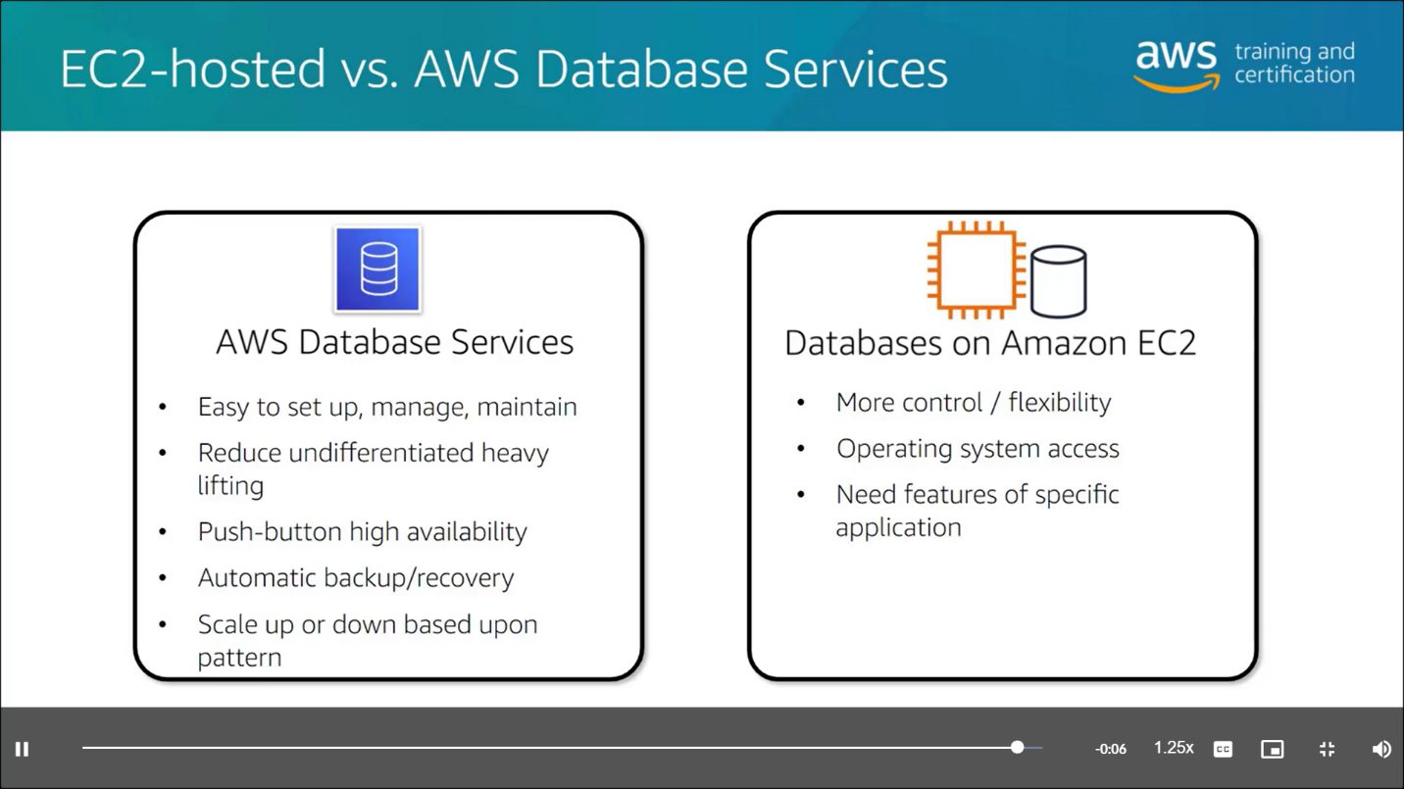

[**Amazon DocumentDB**](https://aws.amazon.com/documentdb) is a document database service that supports MongoDB workloads. (MongoDB is a document database program.)

[**Amazon Neptune**](https://aws.amazon.com/neptune) is a graph database service.

You can use Amazon Neptune to build and run applications that work with highly connected datasets, such as recommendation engines, fraud detection, and knowledge graphs.

[**Amazon Quantum Ledger Database (Amazon QLDB)**](https://aws.amazon.com/qldb) is a ledger database service.

You can use Amazon QLDB to review a complete history of all the changes that have been made to your application data.

[**Amazon Managed Blockchain**](https://aws.amazon.com/managed-blockchain) is a service that you can use to create and manage blockchain networks with open-source frameworks.

Blockchain is a distributed ledger system that lets multiple parties run transactions and share data without a central authority.

[**Amazon ElastiCache**](https://aws.amazon.com/elasticache) is a service that adds caching layers on top of your databases to help improve the read times of common requests.

It supports two types of data stores: Redis and Memcached.

[**Amazon DynamoDB Accelerator (DAX)**](https://aws.amazon.com/dynamodb/dax/) is an in-memory cache for DynamoDB.

It helps improve response times from single-digit milliseconds to microseconds.