**Networks**

Amazon VPC enables you to provision an isolated section of the AWS Cloud. In this isolated section, you can launch resources in a virtual network that you define. Within a virtual private cloud (VPC), you can organize your resources into subnets. A subnet is a section of a VPC in which you can group resources based on security or operational needs. Subnets can be public or private.

Connectivity’s to VPC

* Internet Gateway
* Virtual Private Gateway
* AWS Direct Connect

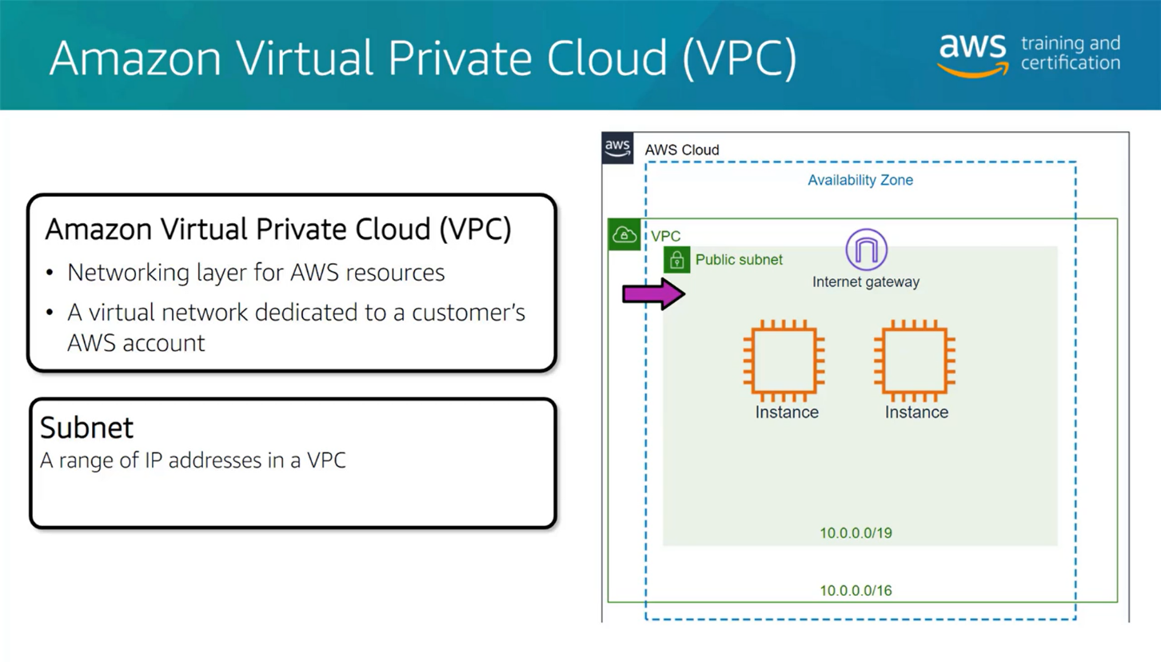

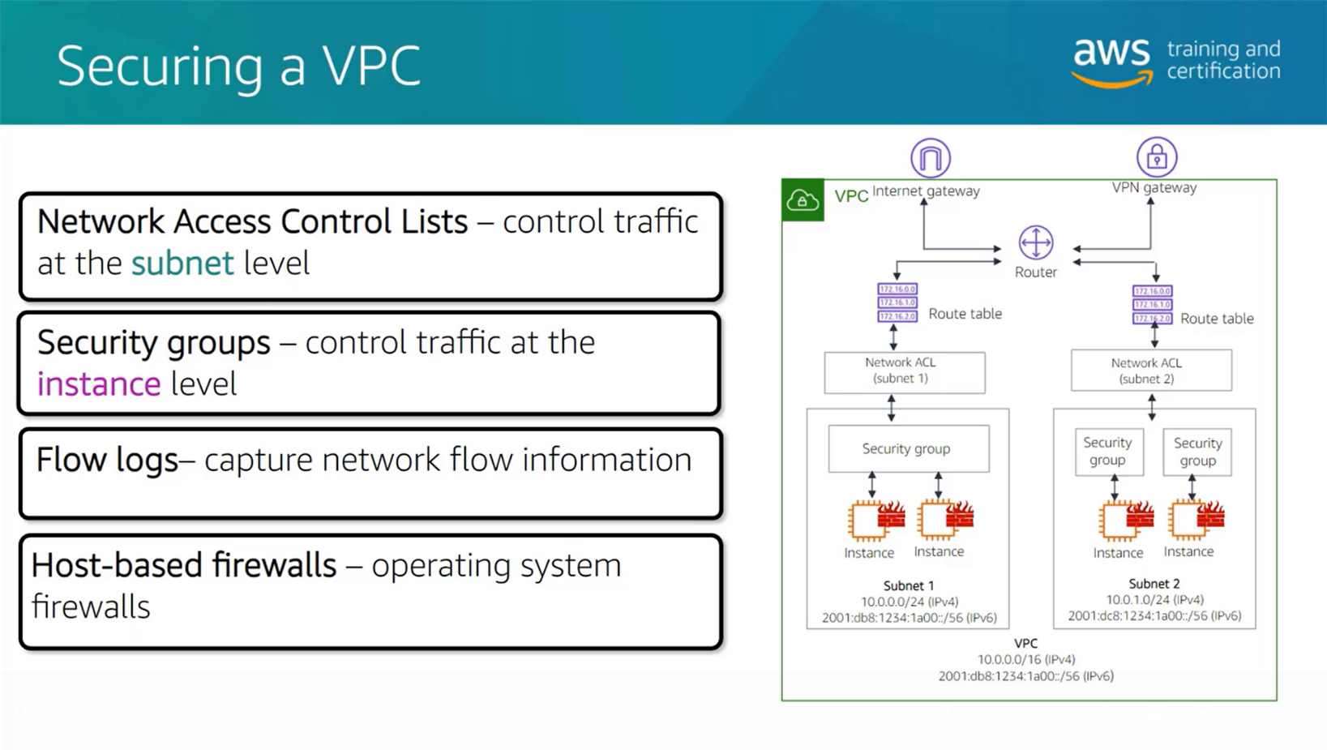

**Network access control lists (ACLs)**

A network access control list (ACL) is a virtual firewall that controls inbound and outbound traffic at the subnet level.

By default, your account’s default network ACL allows all inbound and outbound traffic, but you can modify it by adding your own rules.

Network ACLs perform **stateless** packet filtering. They remember nothing and check packets that cross the subnet border each way: inbound and outbound.

**Security groups**

A security group is a virtual firewall that controls inbound and outbound traffic for an Amazon EC2 instance.

By default, a security group denies all inbound traffic and allows all outbound traffic.

Security groups perform **stateful** packet filtering. They remember previous decisions made for incoming packets.