**Instance stores**

Block-level storage volumes behave like physical hard drives.

An [**instance store**](https://docs.aws.amazon.com/AWSEC2/latest/UserGuide/InstanceStorage.html) provides temporary block-level storage for an Amazon EC2 instance. An instance store is disk storage that is physically attached to the host computer for an EC2 instance, and therefore has the same lifespan as the instance. When the instance is terminated, you lose any data in the instance store.

[**Amazon Elastic Block Store (Amazon EBS)**](https://aws.amazon.com/ebs) is a service that provides block-level storage volumes that you can use with Amazon EC2 instances. If you stop or terminate an Amazon EC2 instance, all the data on the attached EBS volume remains available.

To create an EBS volume, you define the configuration (such as volume size and type) and provision it. After you create an EBS volume, it can attach to an Amazon EC2 instance.

Because EBS volumes are for data that needs to persist, it’s important to back up the data. You can take incremental backups of EBS volumes by creating Amazon EBS snapshots.

An [**EBS snapshot**](https://docs.aws.amazon.com/AWSEC2/latest/UserGuide/EBSSnapshots.html) is an incremental backup. This means that the first backup taken of a volume copy all the data. For subsequent backups, only the blocks of data that have changed since the most recent snapshot are saved.

Incremental backups are different from full backups, in which all the data in a storage volume copies each time a backup occurs. The full backup includes data that has not changed since the most recent backup.

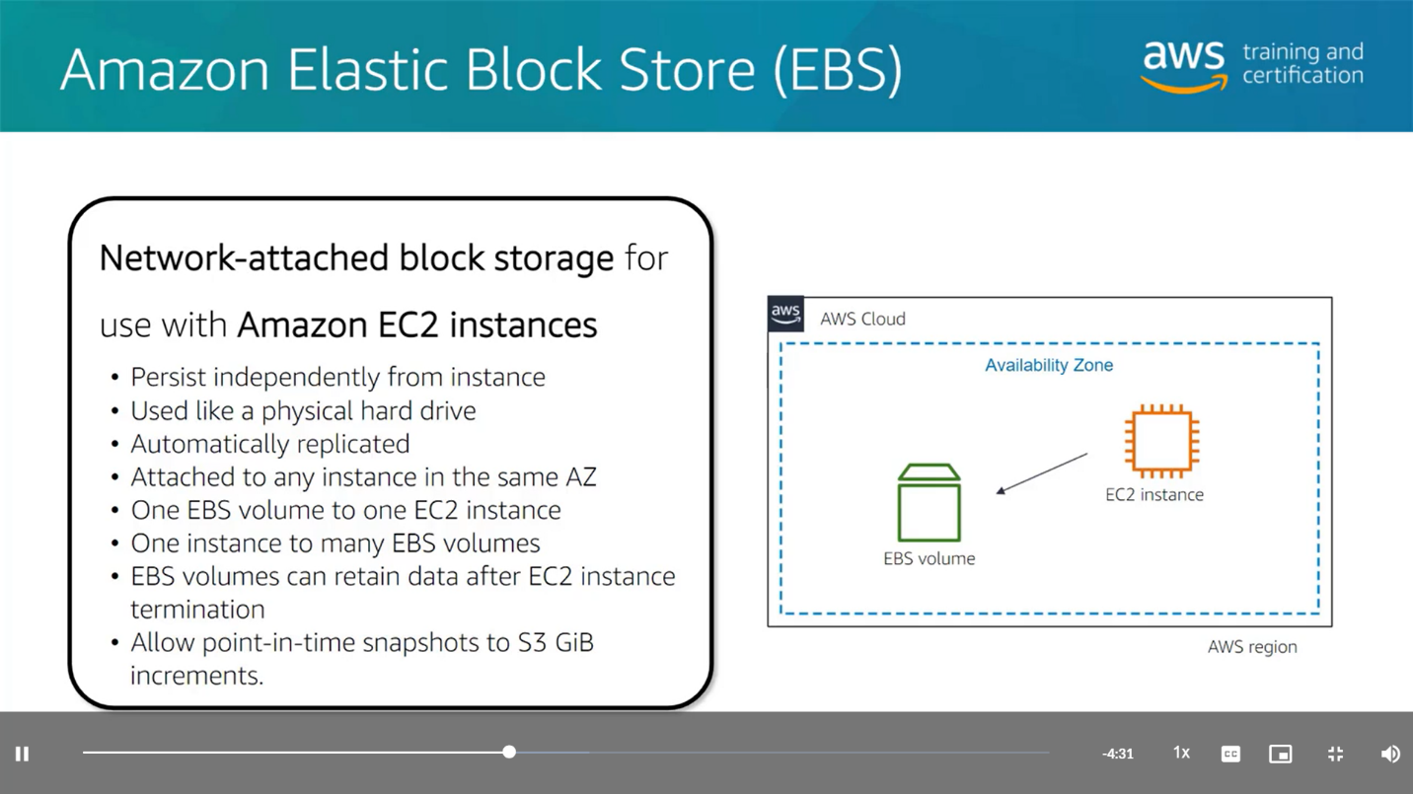

**Object Storage**

In object storage, each object consists of data, metadata, and a key.

The data might be an image, video, text document, or any other type of file. Metadata contains information about what the data is, how it is used, the object size, and so on. An object’s key is its unique identifier.

**Note**

When you modify a file in block storage (EBS), only the pieces that are changed are updated. When a file in object storage (S3) is modified, the entire object is updated.

[**Amazon Simple Storage Service (Amazon S3)**](https://aws.amazon.com/s3/) is a service that provides object-level storage. Amazon S3 stores data as objects in buckets.

You can upload any type of file to Amazon S3, such as images, videos, text files, and so on. For example, you might use Amazon S3 to store backup files, media files for a website, or archived documents. Amazon S3 offers unlimited storage space. The maximum file size for an object in Amazon S3 is 5 TB.

When you upload a file to Amazon S3, you can set permissions to control visibility and access to it. You can also use the Amazon S3 versioning feature to track changes to your objects over time.

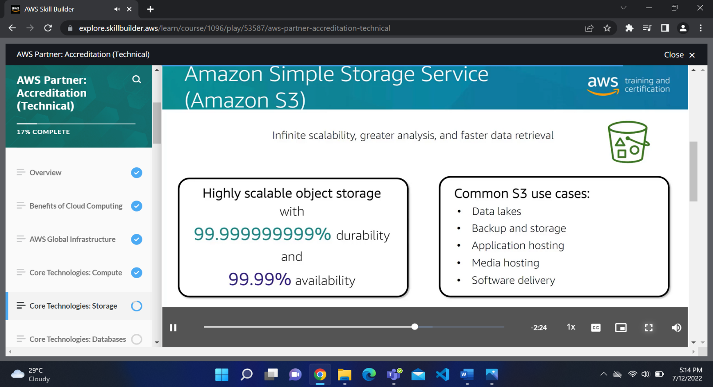

**File storage**

In **file storage**, multiple clients (such as users, applications, servers, and so on) can access data that is stored in shared file folders. In this approach, a storage server uses block storage with a local file system to organize files. Clients access data through file paths.

Compared to block storage and object storage, file storage is ideal for use cases in which a large number of services and resources need to access the same data at the same time.

[**Amazon Elastic File System (Amazon EFS)**](https://aws.amazon.com/efs/) is a scalable file system used with AWS Cloud services and on-premises resources. As you add and remove files, Amazon EFS grows and shrinks automatically. It can scale on demand to petabytes without disrupting applications.

**EBS vs EFS**

An Amazon EBS volume stores data in a single Availability Zone. 

To attach an Amazon EC2 instance to an EBS volume, both the Amazon EC2 instance and the EBS volume must reside within the same Availability Zone.

Amazon EFS is a regional service. It stores data in and across multiple Availability Zones.

The duplicate storage enables you to access data concurrently from all the Availability Zones in the Region where a file system is located. Additionally, on-premises servers can access Amazon EFS using AWS Direct Connect.