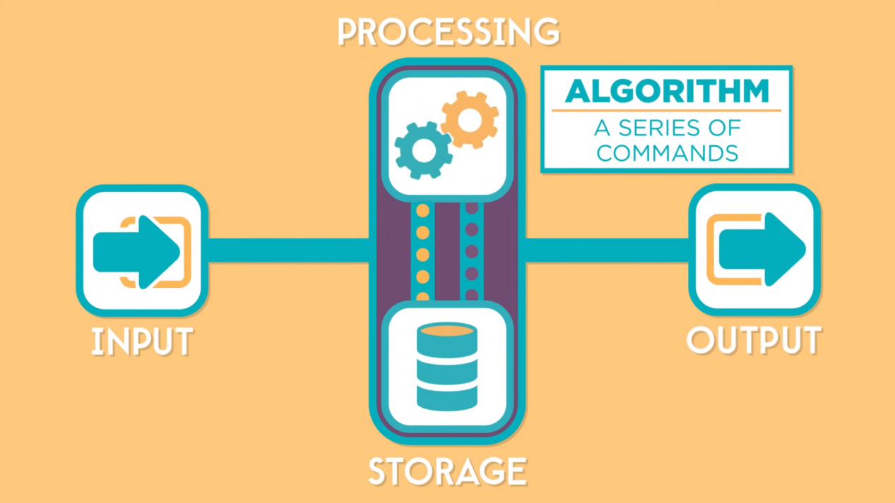

Computer do basic four task.

1. Input
2. Storage
3. Processing
4. Output

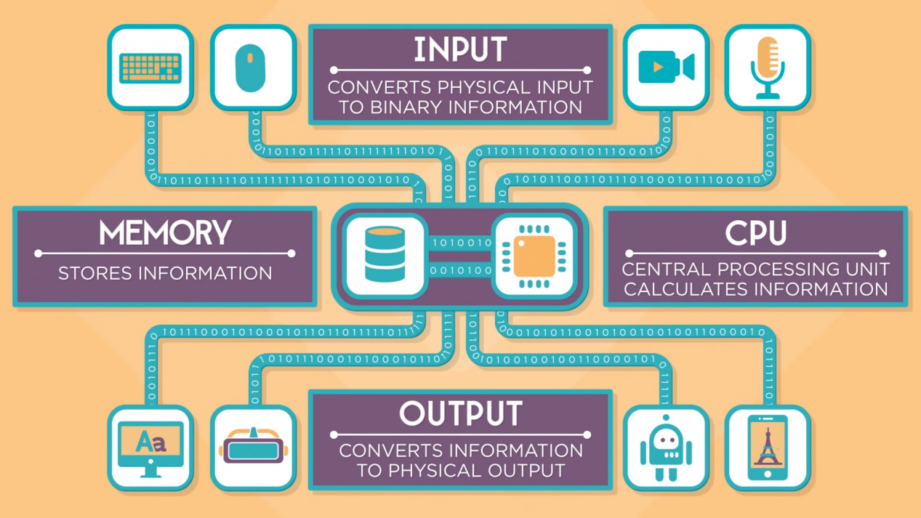

Everything in computer is related to 1s and 0s (binary).

* Decimal- Every decimal number is converted to binary data.
* Text- Every character is mapped to a decimal number (character encoding ASCII & UTF).
* Image- Every image is broken into pixels and each pixel have decimal color code (RGB).
* Audio- Every music has set of frequencies.
* Video- Every video is set of images and audio.