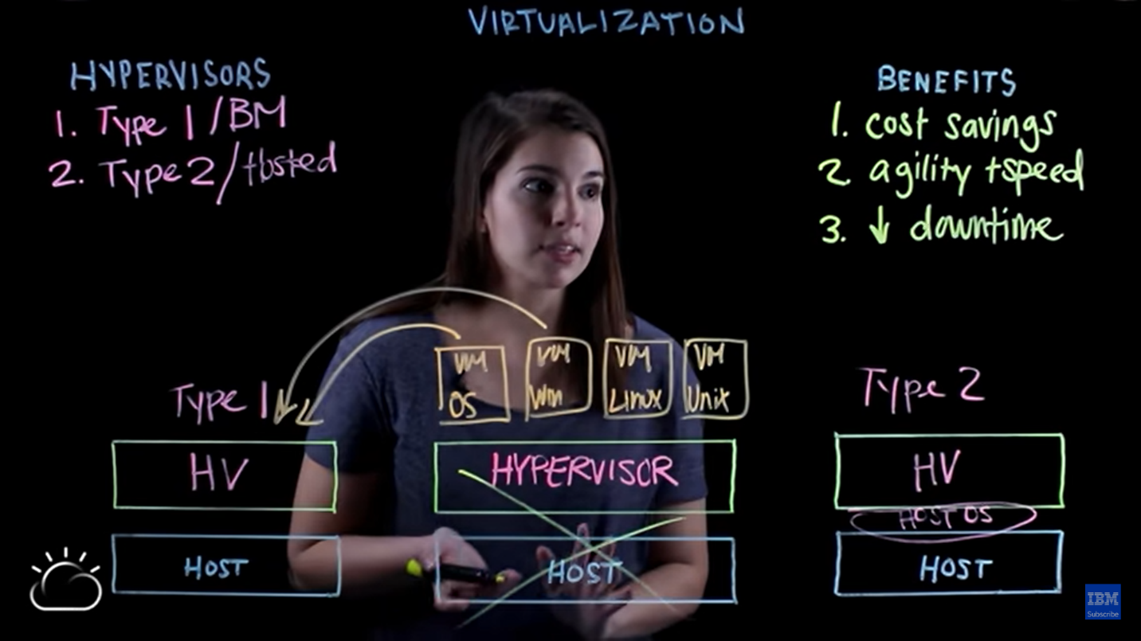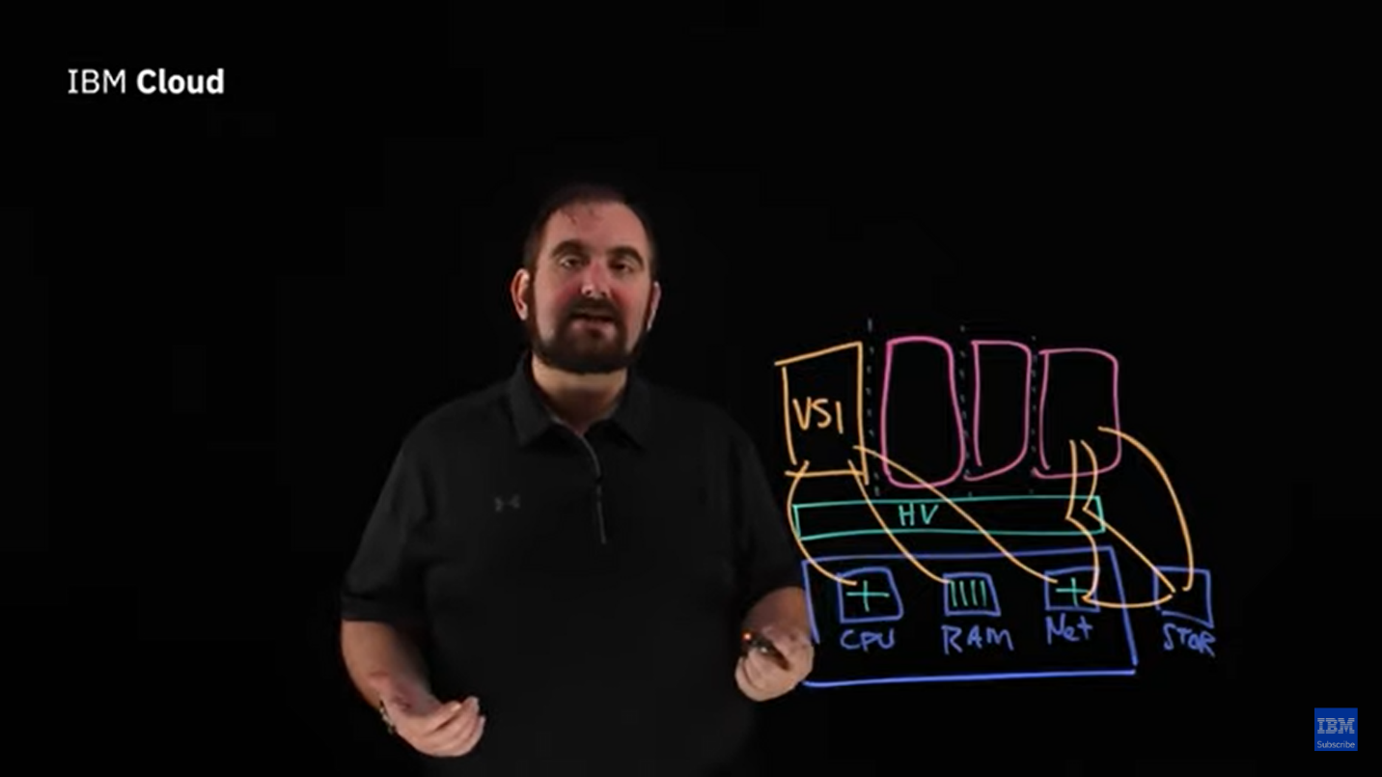

Hypervisor (HV) slices the host CPU, RAM, and network into small pieces.

Intermediate layer of O.S. between HV and host

Install directly on the top of physical server

Portable

Type 1 is most frequently used and secure

Bare metal