*Ansible is simple* ***open-source IT engine*** *which* ***automates application deployment****,* ***intra service orchestration, cloud provisioning*** *and many other IT tools.*

Ansible is very consistent and lightweight, and no constraints regarding the operating system or underlying hardware are present.

It is very secure due to its **agentless** capabilities and open **SSH** security features.

Ansible does not need any special system administrator skills to install and use it.

Ansible has a smooth learning curve determined by the comprehensive documentation and easy to learn structure and configuration.

Its modularity regarding **plugins, inventories, modules,** and **playbooks** make Ansible perfect companion orchestrate large environments.

## Workflow

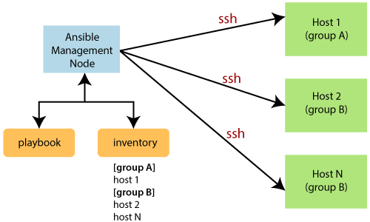

The **Management Node** makes an **SSH** connection and executes the small modules on the host's machine and install the software.

Ansible removes the modules once those are installed so expertly. It connects to the host machine executes the instructions, and if it is successfully installed, then remove that code in which one was copied on the host machine.