In today’s world configuration is not limited to IAC but it has become more complex

* Infrastructure as code
* Configuration as code
* Network as code
* Policy as code
* Security as Code

Or we can call it as **X as code**

The concept behind GitOps is, to use the infrastructure as code in the same way as the application code.

In this we will have a separate repository (git repository) for IAC or XAC project and a full DevOps pipeline for it.

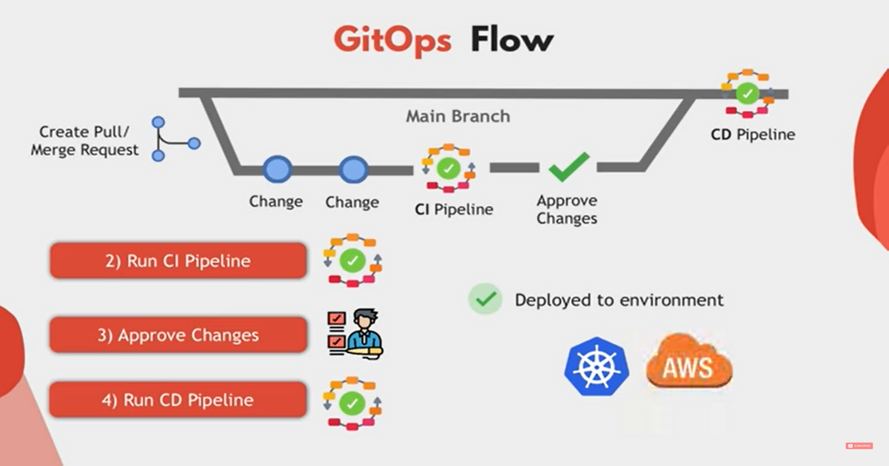

Deployed to the env

collaborate

Tested and well-reviewed changes

Validate the config files and run automated tests

1)

Features

More collaborative process

Automated process

More transparent

Quality IAC

Deployment models

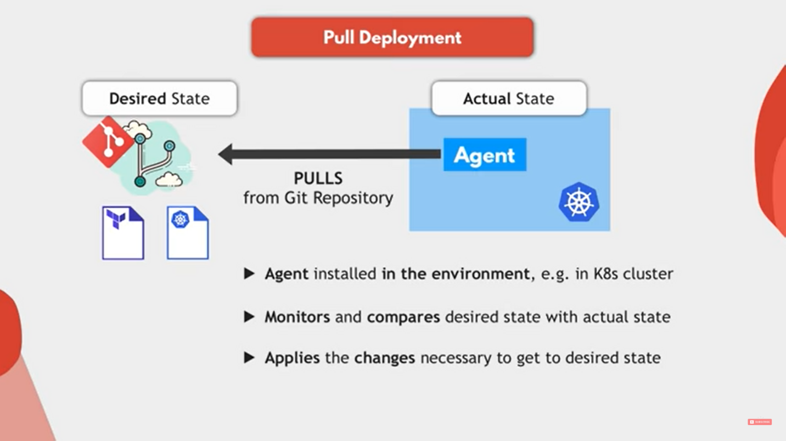

If there is any variation in desired state and actual state (actual state!= desired state). The agent will pull the changes and get it deployed.

E.g.-

Argo CD and flux CD

Advantage

* Less permissions to manage
* More secure environment
* Is anything going wrong we can instantly revert the changes

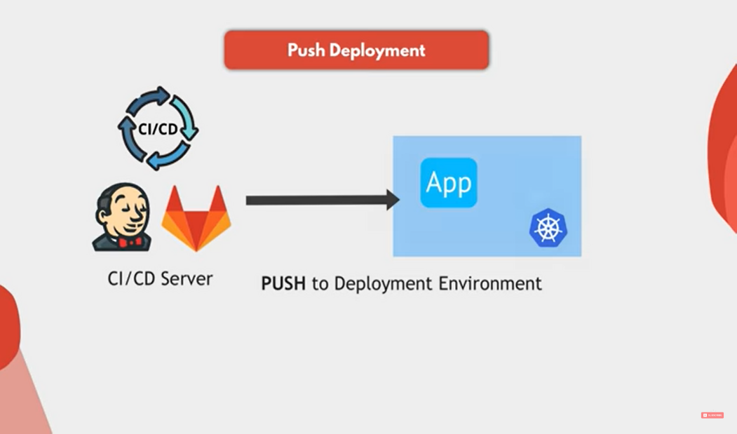

Reference URL https://www.youtube.com/watch?v=f5EpcWp0THw