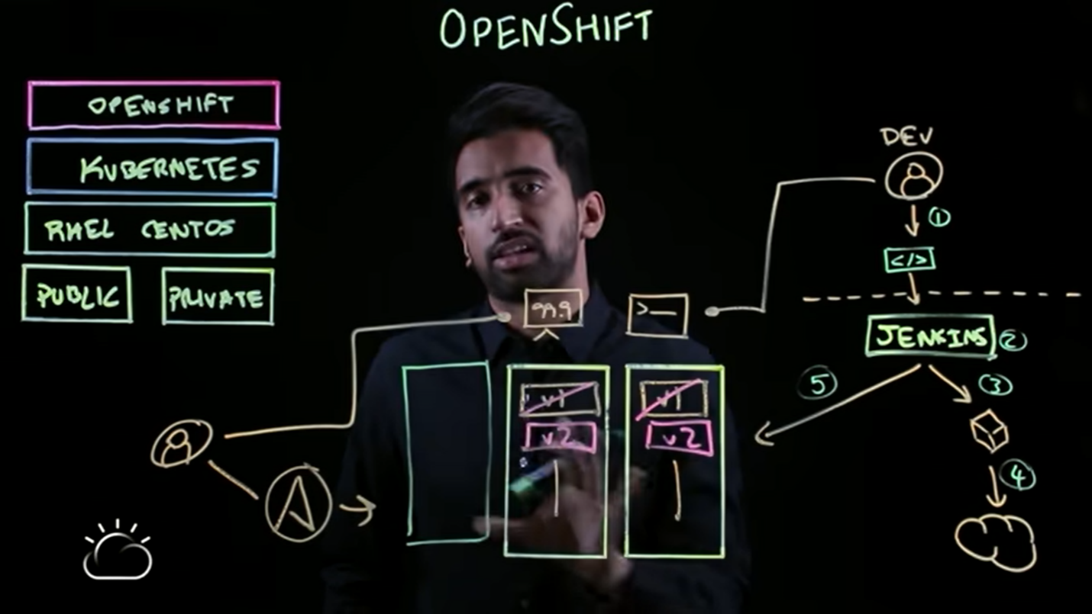

Repository

Ansible Playbooks (Scaling)

Hosts

Registry

Docker Image

Console

CLI

O.S.

Resource

Reference link- https://www.youtube.com/watch?v=KTN_QBuDplo