Internet is ***tangible******and physical system*** used to move information.

The **Internet**is a ***global network of computing devices*** communicating with each other in some way, whether they're sending emails, downloading files, or sharing websites.

The Internet is the ***world's largest open computer network***.

**Physical Network connection**

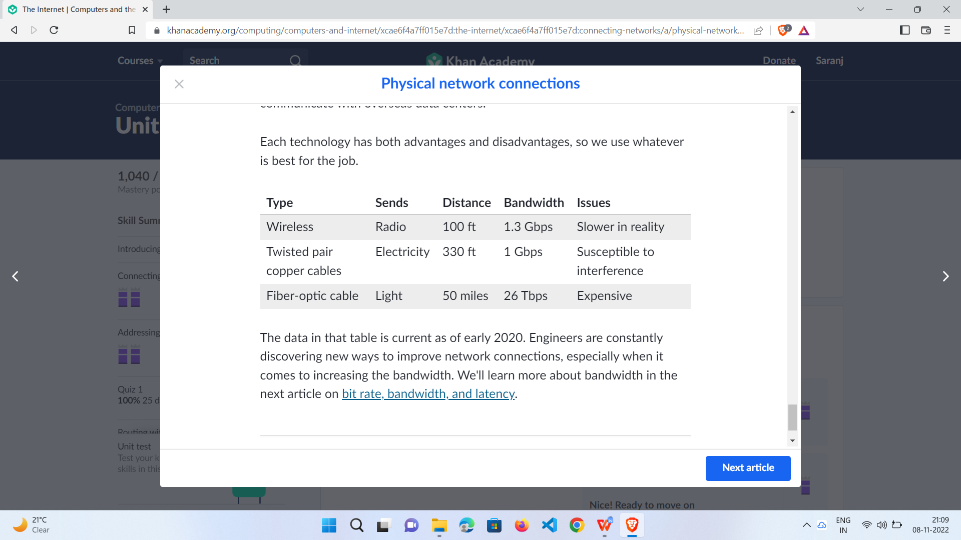

The process of turning ***binary data into a time-based*** signal is known as **line coding**.

### Bit rate- The number of bits of data that are sent each second.

### Bandwidth- Maximum bit rate of a system.

### Latency- Latency (also called the ping rate) is the time between the sending of a data message and the receiving of that message, measured in milliseconds. We typically measure the "round-trip" latency of a request.