**Annual Return**

Return of One time investment

**CAGR** (Compound Annual Growth Rate (CAGR)

Formula-

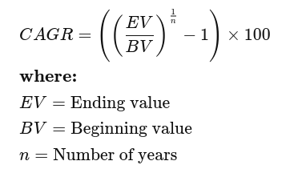

Return of SIP (Systematic investment plans)

**XIRR** (Extended Internal Rate of Return)

Used to calculate returns on investments where there are multiple transactions taking place in different times.

Formula-

Summation of CAGR of different transitions of SIP

**Absolute return**

Absolute return can be defined as the return, i.e., absolute gain or loss, an investment generates over a specific period of time. The gain or loss is expressed as a percentage of the total investment.

Absolute Return = ((Current Value - Purchase Value)/Purchase Value)*100