**Linux began in 1991** as a personal project by [Linus Torvalds](https://en.wikipedia.org/wiki/Linus_Torvalds" \o "Linus Torvalds)

Operating System

to create a new free operating system kernel.

***Linux is not an operating system it is a kernel.***

Kernel

|  |  |
| --- | --- |
| [Written in](https://en.wikipedia.org/wiki/Programming_language" \o "Programming language) | [C](https://en.wikipedia.org/wiki/C_(programming_language)" \o "C (programming language)), [assembly languages](https://en.wikipedia.org/wiki/Assembly_language" \o "Assembly language) |

|  |  |
| --- | --- |
| Linux | Unix |
| Linux is Open Source, and a large number of programmers work together online and contribute to its development. | Unix was developed by AT&T Labs, different commercial vendors, and non-profit organizations. |
| It is an open-source operating system which is freely accessible to everyone. | It is an operating system which can be only utilized by its copywriters. |
| Threat recognition and solution is very fast because Linux is mainly community-driven. So, if any Linux client posts any sort of threat, a team of qualified developers starts working to resolve this threat. | Unix clients require longer hold up time, to get the best possible bug fixing patch. |
| It supports more file system than Unix. | It also supports file system however lesser than Linux. |
| It is used everywhere from servers, PCs, smartphones, tablets to mainframes. | It is used in servers, workstations, and PCs. |
| The default interface is BASH (Bourne Again Shell). | It initially used Bourne shell. But is also compatible with other GUIs. |
| Anybody can use Linux whether a home client, developer or a student. | Developed mainly for servers, workstations, and mainframes. |
| The source is accessible to the general public. | The source is not accessible to the general public. |
| Some Linux versions are Ubuntu, Debian GNU, Arch Linux, etc. | Some Unix versions are SunOS, Solaris, SCO UNIX, AIX, HP/UX, ULTRIX, etc. |

# Architecture

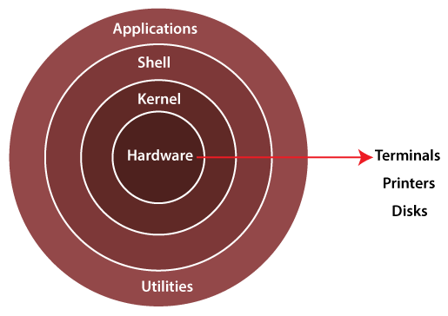

1. **Kernel: -**

[Kernel](https://www.geeksforgeeks.org/kernel-i-o-subsystem-in-operating-system/) is **core component(heart)** of an operating system.

It manages operations of computer and hardware; it basically **manages operations of memory and CPU time**.

Kernel acts as a **bridge** between applications and data processing performed at hardware level using inter-process communication and system calls.

**Kernel loads first into memory when an operating system is loaded and remains into memory until operating system is shut down again**.

It is **responsible** for various tasks such as **disk management, task management, and memory management.**

It decides which process should be allocated to processor to execute and which process should be kept in main memory to execute.

The major aim of kernel is to manage communication between software i.e., user-level applications and hardware i.e., CPU and disk memory.

There are some of the important kernel types which are mentioned below:

* Monolithic Kernel | Micro kernels | Exo kernels |Hybrid kernels

**2. System Libraries: -** These libraries can be specified as some special functions. These are applied for implementing the operating system's functionality and don't need code access rights of the modules of kernel.

**3. System Utility Programs: -** It is responsible for doing specialized level and individual activities. Utility software is a software program to help to analyse, configure, optimize or maintain a computer

Types- System Utilities | storage device management system | file management utilities | Miscellaneous utilities.

**4. Hardware layer: -** Linux operating system contains a hardware layer that consists of several peripheral devices like CPU | HDD | [RAM](https://www.javatpoint.com/ram)

**5. Shell: -** It is an interface among the kernel and user. It can afford the services of kernel. It can take commands through the user and runs the functions of the kernel. The shell is available in distinct types of OS. These operating systems are categorized into two different types, which are the **graphical shells** and **command-line shells**.

There are a few types of these shells which are categorized as follows:

* Korn shell | Bourne shell | C shell | POSIX shell

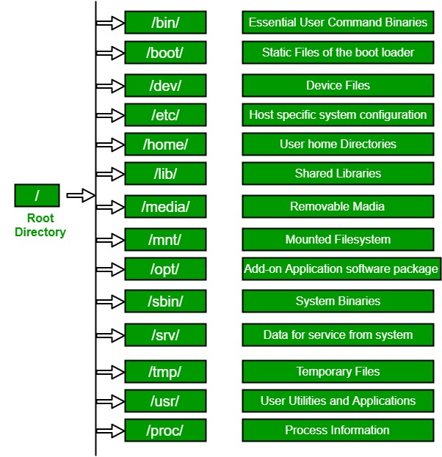

Linux File Hierarchy Structure