1. Provider Block is created for AWS
2. A VPC module is created with CIDR 10.0.0.0/16
3. Public Subnet is created with CIDR 10.0.1.0/24
4. Private Subnet is created with CIDR 10.0.2.0/24
5. An Internet gateway is created named IGW
6. Public Route table is created and IGW is associated with it
7. Private Route Table is created, and NAT Gateway associated with it
8. Security group is crated with HTTPS and SSH enabled
9. Network interface is created
10. An Elastic IP is created and attached to the Network interface
11. An EC2 instance is created with user data having code for Apache and PHP
12. Run the code
    1. Terraform init
    2. Terraform Plan
    3. Terraform apply

Application is done

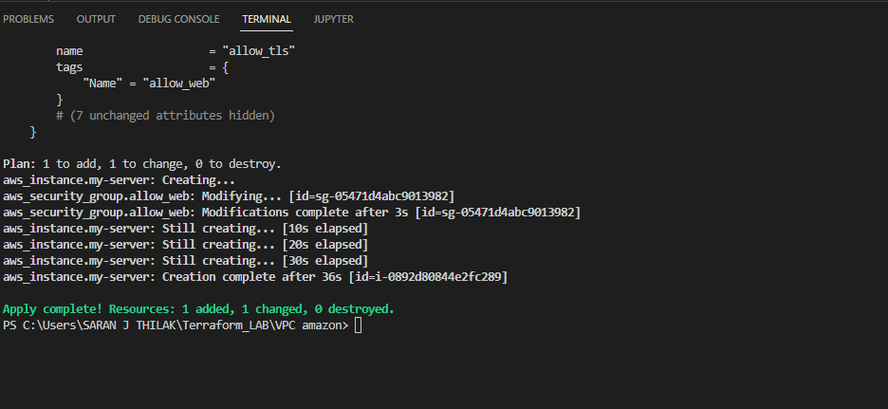

Output

