🧑‍🤝‍🧑 Community Help Provider
KMC Hackathon 1.0 Project Report
Team: Tech Innovators
Lead Developer: [Your Name]
Mentor: Santosh Sharma

📄 Abstract
Social media is effective for entertaining content and informal communications, but it is not an ideal platform for requesting or offering specific help. In times of local emergencies or daily community needs, information is often scattered across social media or lost in group chats. Community Help Provider is a centralized web platform that connects people who need help with those who can offer it. By using real-time location tagging and categorized posting, the system ensures that help reaches the right person in the right location at the right time.
❓ Problem Statement
When a crisis occurs (like a medical emergency) or when a citizen wants to volunteer, there is no dedicated platform to match needs with resources locally.
- Fragmentation: Needs are posted across various apps (Facebook, WhatsApp).
- Searchability: No way to filter requests by "Urgency" or "Category."
- Location: Difficult to pinpoint exactly where help is required in a city like Kathmandu.
🏗️ Existing System
Our system allows users to create posts classified as either a Request Post or an Offer Post. Users can quickly access the email or phone number of the post creator. We have implemented a secure authentication system where each user has a personal profile consisting of information such as email, contact, name, and location. To maintain data integrity, a user can only create a post if they are logged in.
The home page features a scrollable feed containing dynamic cards for different posts, sorted by creation date. Additionally, users maintain full control over their data and can delete their own posts at any time.
💡 Proposed Solution
Our system automates the community aid workflow:
- Creation: Users post "Need" or "Offer" with descriptions.
- Categorization: Needs are sorted into Medical, Education, Food, etc.
- Geolocation: Precise coordinates via PlainLocationField.
- Automation: Django Signals automatically manage user profiles. Contact, Location, and User's name are automatically pulled from the user's profile instead of asking during each post creation.
- Efficiency: A live feed that automatically hides "Closed" posts.
🎯 Objectives
- Efficiency: Drastically reduce the time taken to find local help.
- Accuracy: Use specific status codes (Open, In-Progress, Closed) to track aid.
- Digitalization: Maintain organized, cloud-based community records.
- Accessibility: A clean, Bootstrap-based UI accessible on any device.
🛠️ Technology Used
Layer | Technology
Frontend | HTML5, CSS3, JavaScript, Bootstrap 5
Backend | Python 3.13, Django 6.0.1
Database | SQLite3 (Relational)
Maps | Leaflet / OpenStreetMap via django-location-field
Architecture | MVT (Model-View-Template)
📐 System Wireframe & Workflow
- Home Feed: Chronological list of active help requests.
- Profile System: Automatically generated via Django post_save signals.
- Workflow: [User Auth] → [Post Creation] → [Location Tagging] → [Resolution] → [Status Update].
📈 Results
Based on our development and testing:
- Response Speed: Needs are visible to the entire community instantly upon posting.
- Organization: Data is categorized by priority and city automatically.
- Reliability: The .exclude(status=Closed) logic ensures users only see relevant, active posts.
✅ Advantages
- Precision: Real-time map integration for exact location finding.
- Scalability: The category system allows for endless types of community aid.
- Accountability: Every post is linked to a verified user profile.
- Eco-Friendly: Replaces manual bulletin boards and paper tracking.
⚠️ Limitations
- Requires a stable internet connection for map services.
- Assumes users have basic digital literacy to update post statuses.
🚀 Future Improvements
- Real-time Notifications: SMS alerts to nearby volunteers when an "Emergency" post is created.
- Mobile App: Dedicated Progressive Web Apps (PWA) for better field usage.
- Offline Mode: Local syncing for areas with poor connectivity.
- Moderator Users: Allows moderators, government departments, or organizations to observe real-time posts.
🏁 Conclusion
The Community Help Provider bridges the gap between traditional mutual aid and modern technology. By digitizing the act of helping, we allow citizens to focus more on the support itself and less on the search for where to provide it.

Home Page
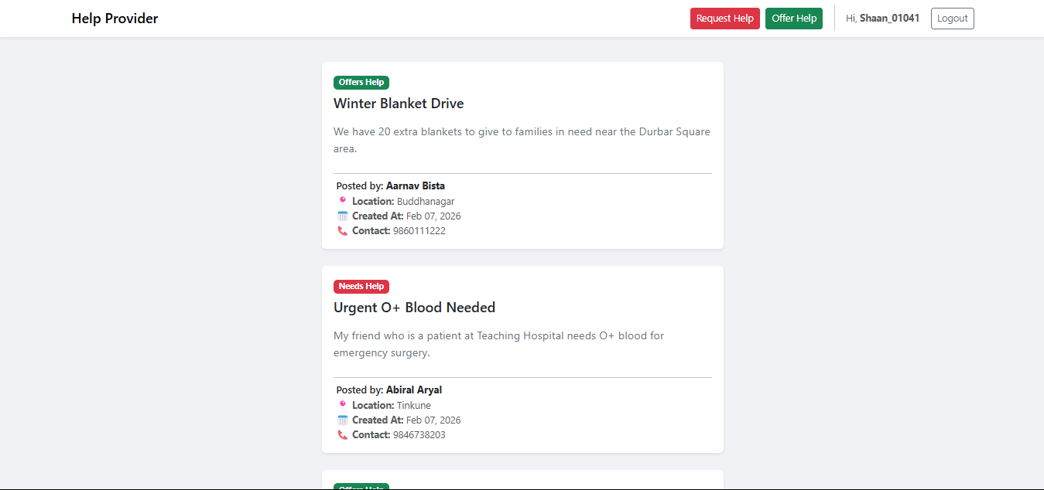

Login Page
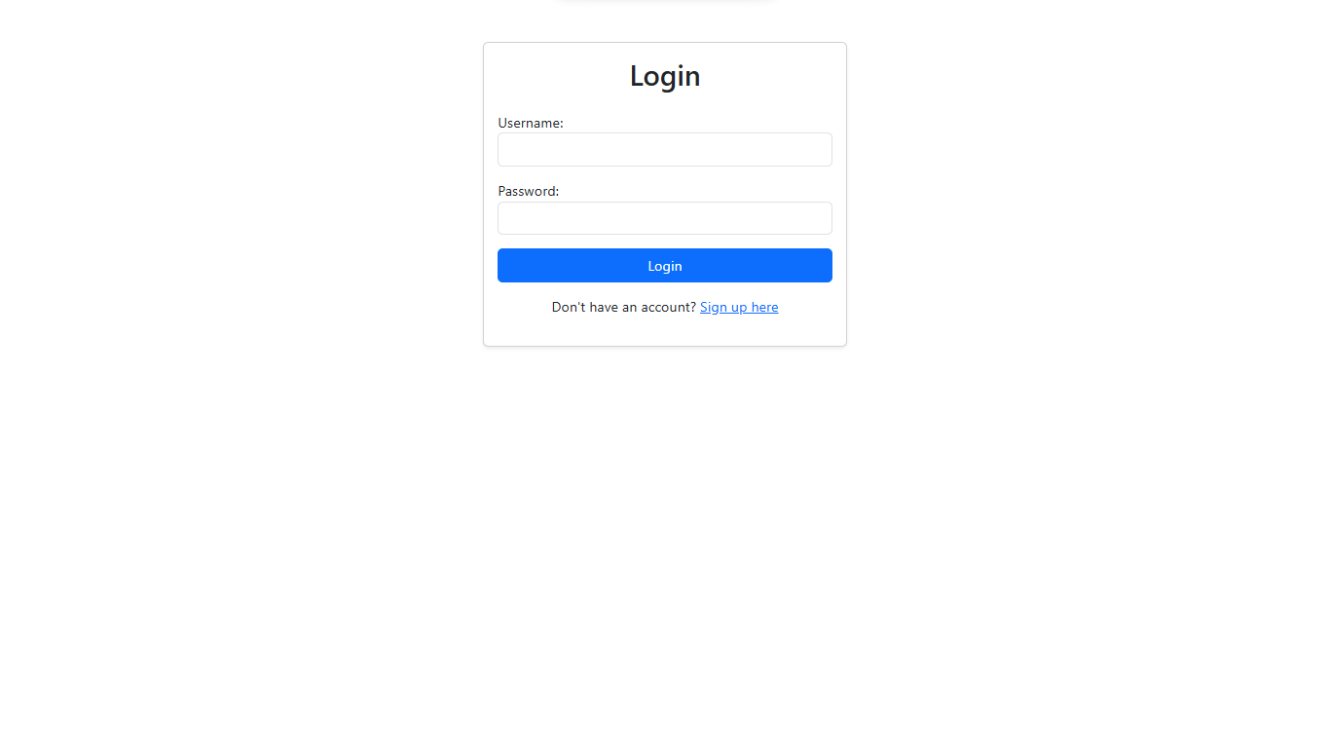

Creating Posts
