# Task-16

In this file contains screenshots of the MySQL shell commands:

using MySQL, design a database whose name is IMDB. create proper MySQL tables, primary key, foreign key, add data into the MySQL tables do the following given below :-

1.movie should have multiple media (video or image)

2.movie can belong to multiple genre

3.movie can have multiple reviews and reviews can belongs to user

4.artist can have multiple skills

5.artist can perform multiple roles in a single film

-- Create IMDB database

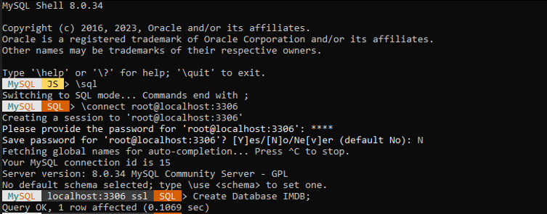

--USE IMDB:

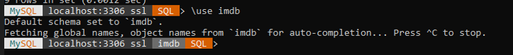

--create Table to store information about movie:

CREATE TABLE Movie (movie_id INT PRIMARY KEY,title VARCHAR(70),release_date DATE);



-- Add data for movie:

--INSERT INTO Movie (movie_id, title, release_date) VALUES:

-- Table to store media related to movies (images or videos):

CREATE TABLE Media (media_id INT PRIMARY KEY,movie_id INT,media_type ENUM('image', 'video'),media_url VARCHAR(100),FOREIGN KEY (movie_id) REFERENCES Movie(movie_id));



-- Add media for movies:

INSERT INTO Media (media_id, movie_id, media_type, media_url) VALUES

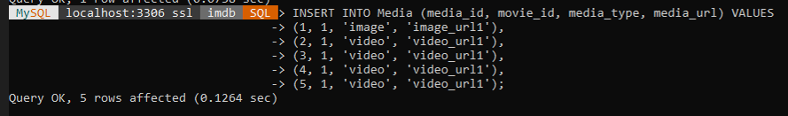

-- Table to store information about genres:

CREATE TABLE Genre (genre_id INT PRIMARY KEY,genre_name VARCHAR(50));



-- Add genres for movies:

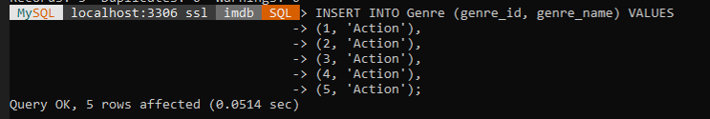

-- Table to associate movies with genres:

CREATE TABLE MovieGenre (movie_id INT,genre_id INT,PRIMARY KEY (movie_id, genre_id),FOREIGN KEY (movie_id) REFERENCES Movie(movie_id),FOREIGN KEY (genre_id) REFERENCES Genre(genre_id));



-- Associate movies with genres:

INSERT INTO MovieGenre (movie_id, genre_id) VALUES

-- Table to store information about reviews:



-- Add reviews for movies:

INSERT INTO Review (review_id, movie_id, user_id, rating, review_text) VALUES

-- Table to store information about artists:

CREATE TABLE Artist (artist_id INT PRIMARY KEY,name VARCHAR(20));



INSERT INTO Artist (artist_id,name) VALUES

Use select * from table_name to get inserted values:

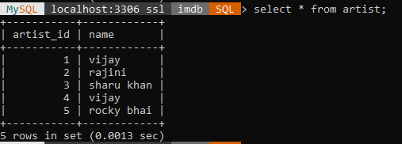

-- Table to store information about skills:

CREATE TABLE Skill (skill_id INT PRIMARY KEY,skill_name VARCHAR(50));



INSERT INTO SKILL (skill_id,skill_name) VALUES (1,'Fantastic comic timing'), (2,'High Self Esteem'), (3,'Life Skills from a Struggler'), (4,'Fantastic comic timing'), (5,'A hardworking actor'); 

-- Table to associate artists with skills:

CREATE TABLE ArtistSkill (artist_id INT,skill_id INT,PRIMARY KEY (artist_id, skill_id),FOREIGN KEY (artist_id) REFERENCES Artist(artist_id),FOREIGN KEY (skill_id) REFERENCES Skill(skill_id));



-- Table to store information about roles in movies:

CREATE TABLE Role (role_id INT PRIMARY KEY,role_name VARCHAR(50));



INSERT INTO Role (role_id,role_name) VALUES (1,'Leo das'),(2,'muthuvel pandian'),(3,'pathaan'),(4,'veera raghavan'),(5,'rocky'); 

-- Table to associate artists with roles in movies:

CREATE TABLE ArtistRole (artist_id INT,role_id INT,movie_id INT,PRIMARY KEY (artist_id, role_id, movie_id),FOREIGN KEY (artist_id) REFERENCES Artist(artist_id),FOREIGN KEY (role_id) REFERENCES Role(role_id),FOREIGN KEY (movie_id) REFERENCES Movie(movie_id));

