AI FAQ Assistant
AI-Powered FAQ & Customer Support Automation Platform
Project Report
Phases Covered
Phase 1 — Brainstorming & Ideation
Phase 2 — Requirement Analysis
Phase 3 — Project Design
Phase 4 — Project Planning
Phase 5 — Project Development
Phase 6 — Project Testing
Phase 7 — Documentation
Phase 8 — Demonstration

Phase 1 — Brainstorming & Ideation

1.1 Brainstorm & Idea Prioritization
The team conducted a brainstorming session to identify pain points in manual FAQ/support-content management and shortlisted ideas based on impact and feasibility.
Idea | Description | Priority
AI-generated FAQs | Auto-generate question/answer pairs from a topic using an AI model | High
Keyword-based search | Fast retrieval of relevant FAQs using keyword/semantic matching | High
Role-based access | Separate permissions for Admin, Content Creator, and Public users | High
Category management | Group FAQs into categories for easier navigation | Medium
Secure authentication | JWT-based login/signup with encrypted passwords | High
Analytics dashboard | Track most-searched FAQs and trending topics | Low
Multi-language support | Generate/translate FAQs in multiple languages | Low

1.2 Empathy Map Canvas
Persona:
saran — Customer Support Operations Manager, handling large volumes of repetitive user inquiries.
Quadrant | Observations
Says | "I spend hours writing the same answers again and again." / "I need our FAQs updated faster."
Thinks | "There must be a faster way to draft accurate answers." / "I worry about outdated or inconsistent documentation."
Does | Manually drafts FAQ content, searches old tickets for answers, copies responses across channels.
Feels | Overwhelmed by backlog, frustrated by repetitive work, anxious about response-time SLAs.
Pain | No centralized, secure system; time-consuming manual drafting; hard to track query trends.
Gain | Faster FAQ creation, organized categories, secure role-based control, real-time searchability.

1.3 Problem Statements
Problem statements are framed using the standard "I am ___ trying to ___ but ___ because ___, which makes me feel ___" structure.
- PS-1: I am a support operations manager trying to keep FAQ documentation current, but I struggle to draft and organize new answers quickly because the process is entirely manual, which makes me feel overwhelmed and behind schedule.
- PS-2: I am a support agent trying to find the right existing answer to a customer query, but I cannot search efficiently because there is no centralized, searchable FAQ system, which makes me feel inefficient and slows down resolution time.
- PS-3: I am a system administrator trying to protect internal documentation, but unauthorized users can potentially edit shared content because there is no permission layer, which makes me feel concerned about data integrity.

Phase 2 — Requirement Analysis

2.1 Solution Requirements

Functional Requirements
ID | Requirement | Description
FR-1 | User Registration | Users can register with name, email, and password.
FR-2 | User Login | Registered users can log in and receive a JWT token.
FR-3 | Create FAQ | Authenticated users can create new FAQ entries.
FR-4 | Update/Delete FAQ | Authors can update or delete their own FAQ records.
FR-5 | View FAQs | Public users can view published FAQ entries.
FR-6 | Search FAQs | Users can search FAQs using keyword-based queries.
FR-7 | AI FAQ Generation | System generates question/answer pairs from a topic via Gemini AI.
FR-8 | Category Management | FAQs can be organized and filtered by category.
FR-9 | Role-Based Access | Access to routes is restricted based on user role.
FR-10 | Error Handling | Centralized error responses returned for all failed requests.

Non-Functional Requirements
ID | Requirement | Description
NFR-1 | Security | Passwords hashed with bcrypt; routes protected using JWT.
NFR-2 | Performance | Indexed MongoDB queries for fast FAQ retrieval.
NFR-3 | Scalability | Modular Express.js routing supports horizontal scaling.
NFR-4 | Reliability | Centralized error middleware ensures consistent uptime behavior.
NFR-5 | Usability | Simple, predictable REST API contract for client integration.
NFR-6 | Maintainability | MVC architecture keeps business logic decoupled and testable.

2.2 Data Flow Diagram & User Stories
Data Flow (Level 0 → Level 1):
- Level 0: Client (Postman / Frontend) ⇄ Express API Gateway ⇄ MongoDB Database, with an external AI service (Google Gemini) invoked for content generation.
- Level 1: Request → Auth Middleware (token validation) → Controller (business logic) → Model/Service (Mongoose schema operations or Gemini SDK call) → Database/AI response → JSON response returned to client.
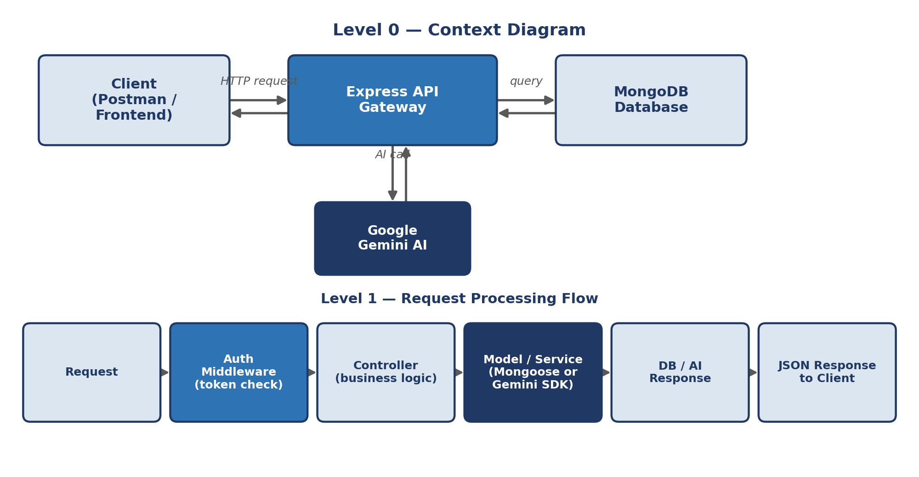
User Stories:
ID | As a | I want to | So that
US-1 | New user | register an account | I can access the FAQ platform securely
US-2 | Registered user | log in | I can receive a token and access protected routes
US-3 | Content creator | create a new FAQ | customers can find answers to common questions
US-4 | Content creator | generate a FAQ using AI | I can save time drafting content
US-5 | Public user | search FAQs by keyword | I can quickly resolve my query
US-6 | Admin | manage all users and FAQs | I can maintain data quality across the system

2.3 Technology Stack
Layer | Technology
Runtime | Node.js (v18+)
Web Framework | Express.js (v4/v5)
Database | MongoDB with Mongoose ODM
Authentication | JWT (JSON Web Tokens), bcrypt for password hashing
AI Integration | Google Gemini SDK (@google/genai)
API Testing | Postman / ThunderClient
Environment Config | dotenv
Cross-Origin Support | cors
IDE | Visual Studio Code

Phase 3 — Project Design

3.1 Proposed Solution
Parameter | Description
Problem | Manual FAQ creation, poor searchability, and unsecured content editing slow down support teams.
Solution | A secure REST API platform that centralizes FAQ management, adds AI-assisted content generation, and enforces role-based access.
Unique Selling Point | Combines JWT-secured CRUD operations with AI-powered (Gemini) automated FAQ generation in one lightweight backend.
Customers | Support operations teams, SaaS companies, internal helpdesk teams.
Business Model | Can be offered as an embeddable backend module / API-as-a-service for support platforms.
Scalability | Stateless JWT auth and modular MVC routing allow horizontal scaling across multiple server instances.

3.2 Problem–Solution Fit
Each identified problem statement maps directly to a system capability, validating that the proposed backend addresses the real operational pain points identified during ideation.
Problem Statement | Solution Mapping
PS-1: Manual, slow FAQ drafting | AI FAQ Generation endpoint (Gemini) auto-drafts question/answer pairs from a topic.
PS-2: Poor searchability | Keyword-based search endpoint (GET /api/faqs/search) for fast retrieval.
PS-3: Unsecured editing | JWT authentication + authorization middleware restrict edits to record owners/admins.

3.3 Solution Architecture
The system follows a layered, headless REST API architecture based on the MVC pattern:
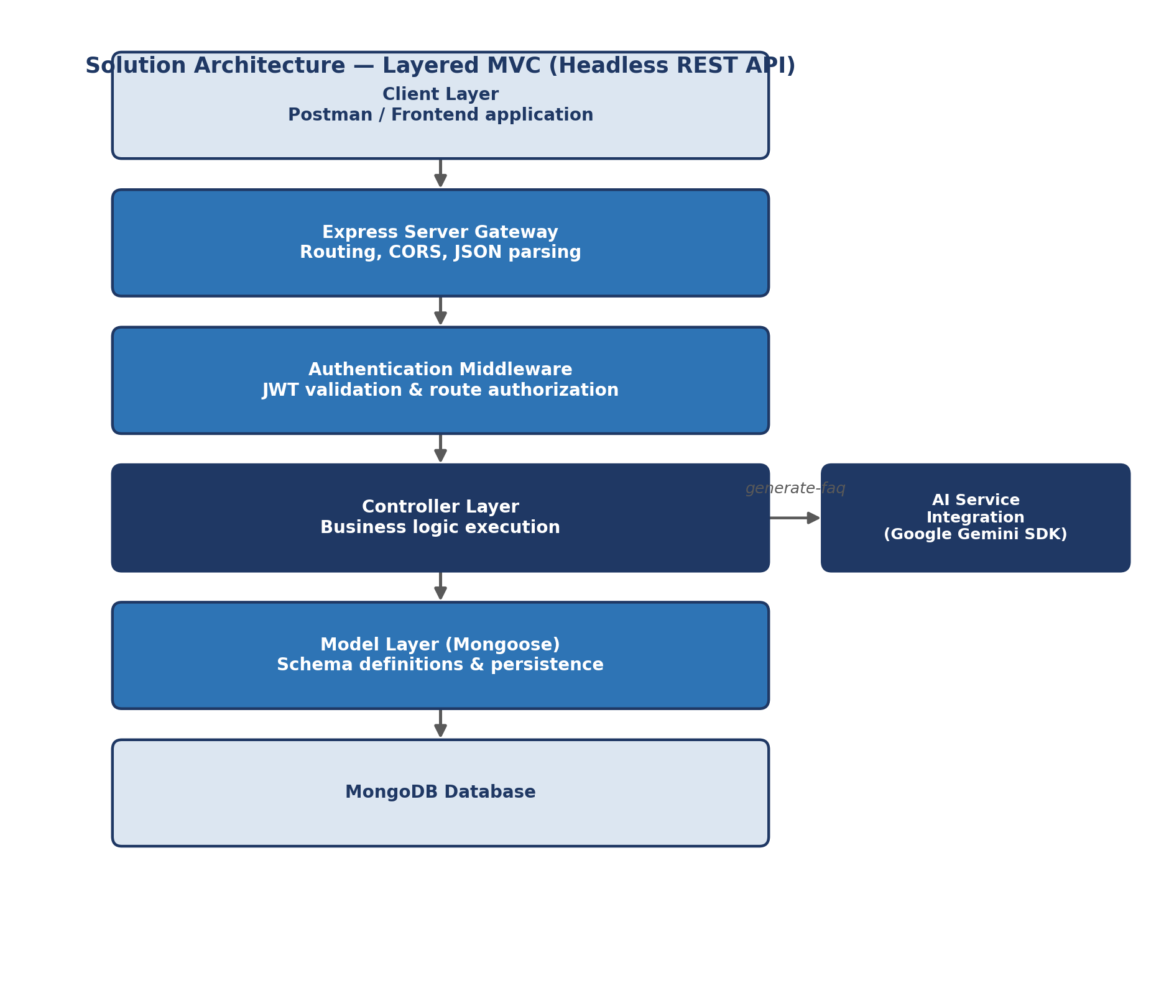
- Client Layer: API tools (Postman) or a frontend application issue HTTP requests.
- Express Server Gateway: Handles routing, CORS, JSON parsing, and maps HTTP methods to controllers.
- Authentication Middleware: Validates JWT tokens and enforces route-level authorization.
- Controller Layer: Executes business logic, coordinates between models and AI services.
- Model Layer (Mongoose): Defines schemas and persists data to MongoDB.
- AI Service Integration: Google Gemini SDK handles automated question/answer/topic generation.
Model Layer (Data Blueprint):
Strongly enforced Mongoose schemas map fields into MongoDB collections with validation and defaults.
Controller Layer (Execution Matrix):
Captures requests, validates constraints, delegates to models/services, and returns standardized JSON responses.
View Layer (Routing Network Interface):
As a headless backend, this layer exists as the API Routing Layer, mapping request paths to controller handlers.

Phase 4 — Project Planning

4.1 Product Backlog
Epic | User Story ID | Story | Priority | Story Points
Setup | US-0 | Initialize project structure, npm, folders | High | 2
Auth | US-1 | User registration | High | 3
Auth | US-2 | User login with JWT | High | 3
FAQ Mgmt | US-3 | Create FAQ (protected) | High | 5
FAQ Mgmt | US-3b | Update/Delete own FAQ | Medium | 3
FAQ Mgmt | US-5 | View & search FAQs (public) | High | 5
AI | US-4 | AI-generated FAQ from topic | High | 8
Admin | US-6 | Admin manage users/FAQs | Medium | 5
Quality | US-7 | Centralized error handling | Medium | 3

4.2 Sprint Planning
The backlog was distributed across four sprints of roughly one week each, sequencing setup and authentication first, followed by core FAQ operations, AI integration, and finally admin/quality hardening.

4.3 User Stories
Detailed user stories are listed in Section 2.2 (Data Flow Diagram & User Stories) and expanded into backlog items in Section 4.1 above.

4.4 Story Points
Story points were estimated using a modified Fibonacci scale (1, 2, 3, 5, 8) based on relative complexity, uncertainty, and effort — for example, AI FAQ Generation (8 points) required external SDK integration and prompt handling, while User Login (3 points) followed a well-understood JWT pattern.

4.5 Sprint Schedule
Sprint | Duration | Story Points Planned | Focus Area
Sprint 1 | Week 1 | 8 | Project setup, folder structure, DB connection, User model
Sprint 2 | Week 2 | 11 | Authentication (register/login), auth middleware
Sprint 3 | Week 3 | 13 | FAQ CRUD, search, category handling
Sprint 4 | Week 4 | 8 | AI FAQ generation, admin routes, error handling, testing

4.6 Velocity / Burndown Chart
Total planned story points: 40 across 4 sprints (average velocity ≈ 10 points/sprint). The table below illustrates planned vs. completed points per sprint, forming the basis of the burndown trend.
Sprint | Points Planned | Points Completed | Remaining
Sprint 1 | 8 | 8 | 32
Sprint 2 | 11 | 11 | 21
Sprint 3 | 13 | 12 | 9
Sprint 4 | 8 | 9 | 0

Phase 5 — Project Development
This phase covers the actual implementation of the AI FAQ Assistant backend.

5.1 Project Setup and Configuration
- Create a project folder with a src subfolder, opened in VS Code.
- Initialize the project: npm init -y
- Install dependencies: npm install express mongoose dotenv cors jsonwebtoken bcrypt @google/genai
Folder structure follows the MVC pattern: src/models, src/controllers, src/routes, src/middleware, plus server.js and app.js at the root of src.

5.2 Core System Components
- Gateway Server (src/server.js): Loads environment variables, connects to MongoDB, and starts the HTTP listener on the configured port.
- Express App Setup (src/app.js): Configures middleware (CORS, JSON body parsing) and mounts route modules.
- Auth Middleware (src/middleware/authMiddleware.js): Extracts and verifies JWT tokens from the Authorization header.
- Error Middleware (src/middleware/errorMiddleware.js): Catches thrown errors and returns standardized JSON error responses.

5.3 Database Configuration

User Schema (src/models/User.js)
Field | Type | Notes
_id | ObjectId | Primary Key
name | String | Required
email | String | Required, Unique
password | String | Required, Hashed (bcrypt)
role | String | Default: "user"
createdAt / updatedAt | Date | Auto-managed timestamps

FAQ Schema (src/models/FAQ.js)
Field | Type | Notes
_id | ObjectId | Primary Key
question | String | Required
answer | String | Required
category | String | Required
createdBy | ObjectId | References User collection
createdAt / updatedAt | Date | Auto-managed timestamps

5.4 API Router Endpoints
- Public Authentication Operations — src/routes/authRoutes.js (register, login)
- Protected FAQ Operations — src/routes/faqRoutes.js (create, update, delete, search, list)
- AI Automation Operations — src/routes/aiRoutes.js (generate-faq)

5.5 Running the Application
- Install Postman or the ThunderClient VS Code extension for testing.
- Start the development server: npm run dev

Phase 6 — Project Testing
User Acceptance Testing (UAT) was performed against each major API endpoint to validate functional correctness prior to release.
Test Case ID | Test Scenario | Test Steps | Expected Result | Actual Result | Pass/Fail | Bug Tracking
TC-01 | User registration | POST /api/auth/register with valid payload | User created, 201 response | As expected | Pass | -
TC-02 | Duplicate email registration | Register with an existing email | 400 error, duplicate email message | As expected | Pass | -
TC-03 | User login | POST /api/auth/login with valid credentials | 200 response with JWT token | As expected | Pass | -
TC-04 | Login with wrong password | POST /api/auth/login with incorrect password | 401 Unauthorized error | As expected | Pass | -
TC-05 | Create FAQ without token | POST /api/faqs with no Authorization header | 401 Unauthorized error | As expected | Pass | -
TC-06 | Create FAQ with token | POST /api/faqs with valid Bearer token | 201 response, FAQ saved | As expected | Pass | -
TC-07 | Search FAQs | GET /api/faqs/search?q=configure | 200 response with matching FAQs | As expected | Pass | -
TC-08 | AI FAQ generation | POST /api/ai/generate-faq with topic | 200 response with generated Q&A | As expected | Pass | -
TC-09 | Update FAQ by non-owner | PUT /api/faqs/:id by a different user | 403 Forbidden error | As expected | Pass | -
TC-10 | Delete FAQ | DELETE /api/faqs/:id by owner | 200 response, FAQ removed | As expected | Pass | -

Phase 7 — Documentation
This project report consolidates the ideation, requirement analysis, design, planning, development, and testing artifacts of the AI FAQ Assistant into a single reference document. It includes:
- Problem statements and empathy mapping (Phase 1)
- Functional and non-functional requirements, data flow, and technology stack (Phase 2)
- Proposed solution, problem-solution fit, and architecture (Phase 3)
- Product backlog, sprint plan, and story-point estimation (Phase 4)
- Implementation details of the Express/MongoDB/JWT/Gemini backend (Phase 5)
- UAT test cases and results (Phase 6)
This document, along with the source code repository and API collection, forms the complete project documentation package for submission and review.

Phase 8 — Demonstration
The final working application was demonstrated end-to-end, covering user registration, login, FAQ creation, search, and AI-assisted FAQ generation via Postman.
Reference Links:

- Demo Link: https://drive.google.com/file/d/1dZPkBdJXvvkSSSosbqxskgdiBf0aeXWm/view?usp=sharing

