PROJECT REPORT
NORTHWIND TRADE
Sales Performance Analysis Using an Interactive Power BI Dashboard
Submitted by
G. SARANRAJ
B.Com FinTech with AI
Academic Year 2026

Table of Contents
1. Introduction
2. Objectives and Scope
3. About Northwind Trade and the Dataset
4. Tools and Methodology
5. Key Performance Indicators (KPIs)
6. Sales Analysis by Product Category
7. Monthly Order Trend
8. Employee Performance Analysis
9. Customer Analysis by Country
10. Product-Level Analysis
11. Dashboard Design and Interactivity
12. Key Findings
13. Recommendations
14. Relevance to FinTech and AI
15. Conclusion
Appendix: Dashboard Screenshots

1. Introduction
Northwind Traders is a well-known sample trading company that imports and exports specialty food products to customers around the world. Its database is widely used in business analytics education because it contains realistic information on orders, customers, products, categories, employees and freight.
This report presents a sales performance analysis of Northwind Trade built around an interactive Power BI dashboard titled the Northwind Sales Dashboard. The dashboard converts raw transactional data into clear indicators and visuals that help management understand how much the company sells, what it sells, who sells it, and where its customers are located.
The report is prepared as part of the B.Com FinTech with AI programme and shows how data analytics tools can support financial and commercial decision-making.

2. Objectives and Scope

2.1 Objectives
- To measure the overall sales performance of Northwind Trade using headline KPIs.
- To identify the strongest and weakest product categories by sales value.
- To study seasonal patterns in the number of orders received each month.
- To compare the order-handling performance of sales employees.
- To understand the geographic spread of the customer base.
- To suggest practical, data-backed actions for improving sales and controlling freight cost.

2.2 Scope
The analysis covers the four dashboard pages: Sales Overviews, Products & Customer analysis, Sales Dashboard (with filters) and Tool tips. Figures are taken from the dashboard. Values for monthly orders, employee orders and category sales were read from the charts and are therefore approximate; headline KPIs and product table values are exact as displayed.

3. About Northwind Trade and the Dataset
The dataset follows the classic Northwind relational structure. The main entities used in the dashboard are listed below.
Table / Entity | Description
Orders | Each customer order with date, freight charge and responsible employee
Order Details | Products, unit price and quantity sold on every order
Products | Product name and the category it belongs to
Categories | Eight product groups such as Beverages and Dairy Products
Customers | 91 customers across 21 countries
Employees | Sales staff who handle the orders
Table 1: Main data entities used in the dashboard

4. Tools and Methodology
The analysis follows a simple business-intelligence workflow:
- Data collection: Northwind tables for orders, products, categories, customers and employees were loaded.
- Data modelling: tables were linked through keys such as OrderID, ProductID, CustomerID and EmployeeID.
- Measures: key metrics such as Total Sales, Total Orders, Total Freight, Average Freight, Number of Customers and Total Quantity Sold were created as calculated measures.
- Visualisation: line, bar and column charts, KPI cards, a product table and slicers were designed on separate report pages.
- Interpretation: patterns, ranking and comparisons were studied to draw findings and recommendations.
Total Sales is calculated as unit price multiplied by quantity (after discount) summed over all order lines. Average Freight is Total Freight divided by Total Orders.

5. Key Performance Indicators (KPIs)
The top of the Sales Overviews page displays six KPI cards. Together they give a quick health check of the business.
KPI | Overall View | Filtered View (2014-2015)
Total Sales | 1.27M (1,265,793.04) | 1.03M
Total Orders | 809 | 657
Number of Customers | 91 | 91
Total Quantity Sold | 51K (51,317) | 41K
Total Freight | 63.96K | 53.68K
Average Freight per Order | 79.05 | 81.70
Table 2: Headline KPIs from the Northwind Sales Dashboard
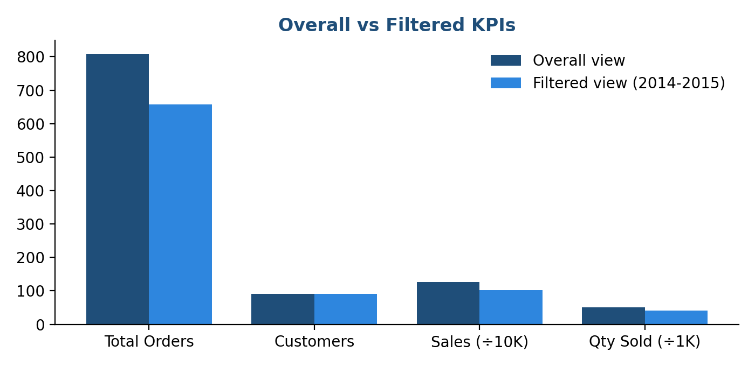
Figure 1: Comparison of overall and year-filtered KPIs

5.1 Derived Ratios
Ratio | Value | Meaning
Average sales per order | about 1,565 | Total Sales / Total Orders
Average sales per customer | about 13,909 | Total Sales / Customers
Orders per customer | about 8.9 | Total Orders / Customers
Average quantity per order | about 63 | Quantity / Total Orders
Freight as % of sales | about 5.1% | Total Freight / Total Sales
Table 3: Ratios derived from the overall KPIs
On average every order brings in roughly 1,565 in sales while the shipping cost is only about 5% of sales, which shows that freight is a manageable but still meaningful cost item.

6. Sales Analysis by Product Category
Sales are spread over eight product categories. Beverages lead the list, followed by Dairy Products and Confections. The three leading categories together contribute nearly 53% of total sales.
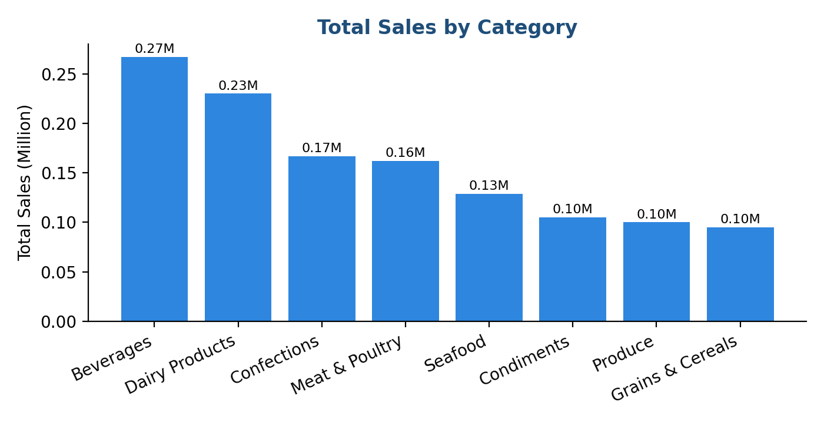
Figure 2: Total Sales by Category (approximate values in millions)
Category | Approx. Sales (M) | Share of Sales
Beverages | 0.27 | 21.3%
Dairy Products | 0.23 | 18.3%
Confections | 0.17 | 13.3%
Meat & Poultry | 0.16 | 12.9%
Seafood | 0.13 | 10.3%
Condiments | 0.11 | 8.4%
Produce | 0.10 | 8.0%
Grains & Cereals | 0.10 | 7.6%
Table 4: Category-wise sales and share
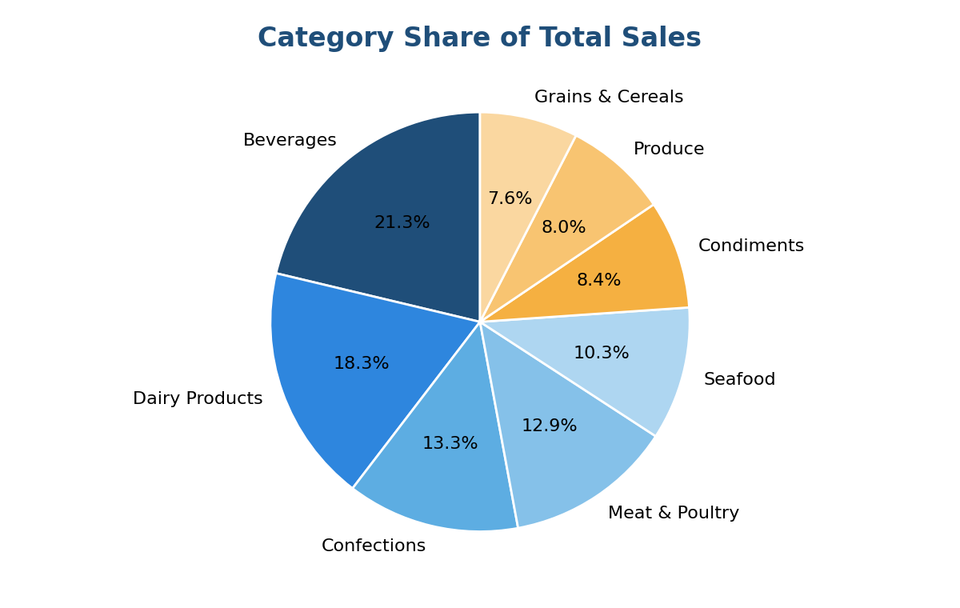
Figure 3: Share of each category in total sales
Beverages generate about 2.8 times the sales of Grains & Cereals, so the portfolio depends heavily on a few strong categories while the smaller ones offer room for growth.

7. Monthly Order Trend
The line chart of Total Orders by Month shows a clear seasonal pattern. Orders are high in the first four months, peaking in March at just over 100 orders, then fall sharply in May and June. They recover gradually through the second half of the year and rise again in December.
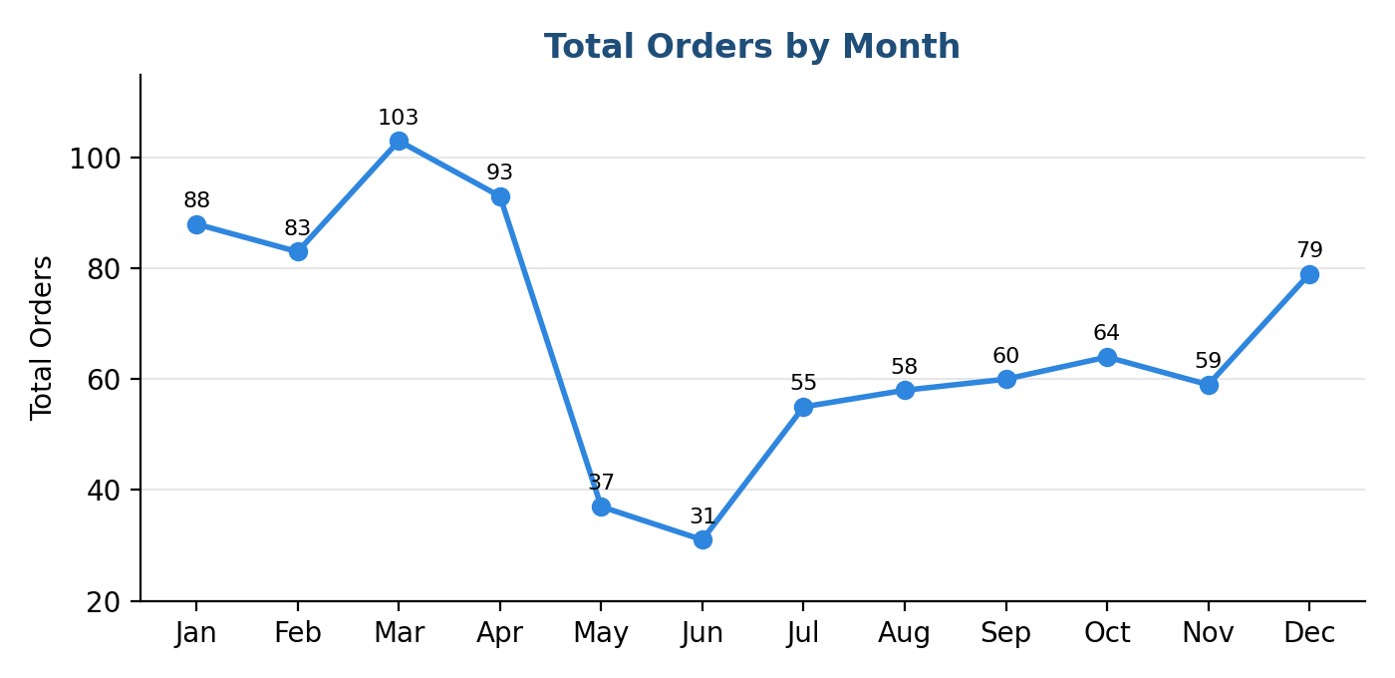
Figure 4: Total Orders by Month (approximate values)
Period | Approx. Orders | Observation
January - April | 83 - 103 | Strongest period, peak in March
May - June | 31 - 37 | Sharp fall, lowest point in June
July - November | 55 - 64 | Slow and steady recovery
December | 79 | Year-end rise
Table 5: Seasonal pattern of orders

8. Employee Performance Analysis
Nine employee entries appear in the dashboard, including one blank entry for orders that are not linked to a named employee. Margaret Peacock handles the highest number of orders, followed by Janet Leverling and Nancy Davolio.
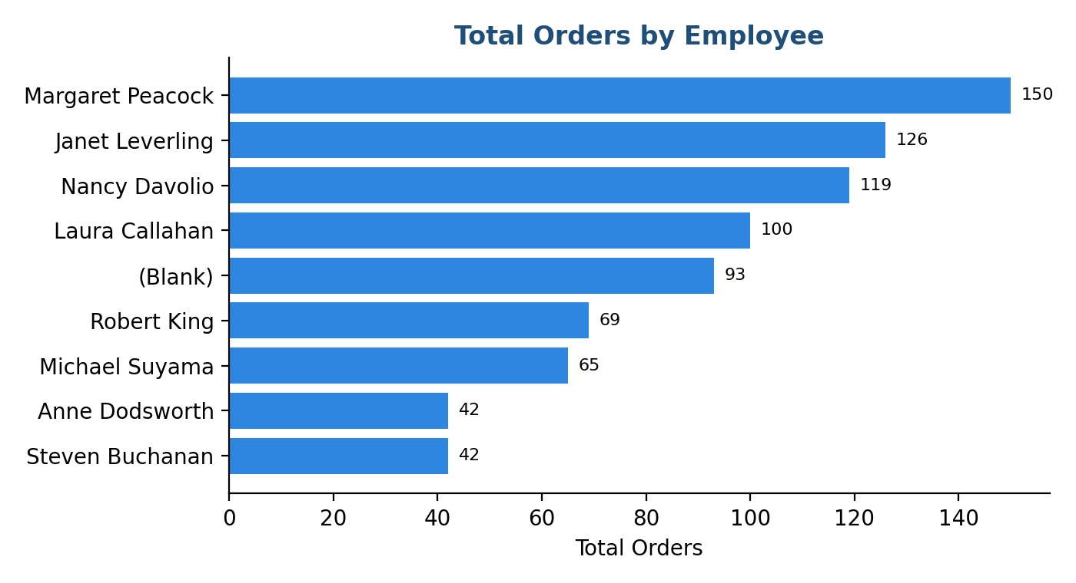
Figure 5: Total Orders by Employee (approximate values)
Employee | Approx. Orders | Share of Orders
Margaret Peacock | 150 | 18.5%
Janet Leverling | 126 | 15.6%
Nancy Davolio | 119 | 14.7%
Laura Callahan | 100 | 12.4%
(Blank) | 93 | 11.5%
Robert King | 69 | 8.5%
Michael Suyama | 65 | 8.0%
Anne Dodsworth | 42 | 5.2%
Steven Buchanan | 42 | 5.2%
Table 6: Employee-wise order volume
The top three employees handle close to half of all orders. About 11% of orders have no employee name, which is a data-quality gap that should be corrected.

9. Customer Analysis by Country
Northwind serves 91 customers in 21 countries. The United States has the largest number with 13 customers, followed by France and Germany with 11 each and Brazil with 9. These four countries account for 44 customers, nearly half of the total.
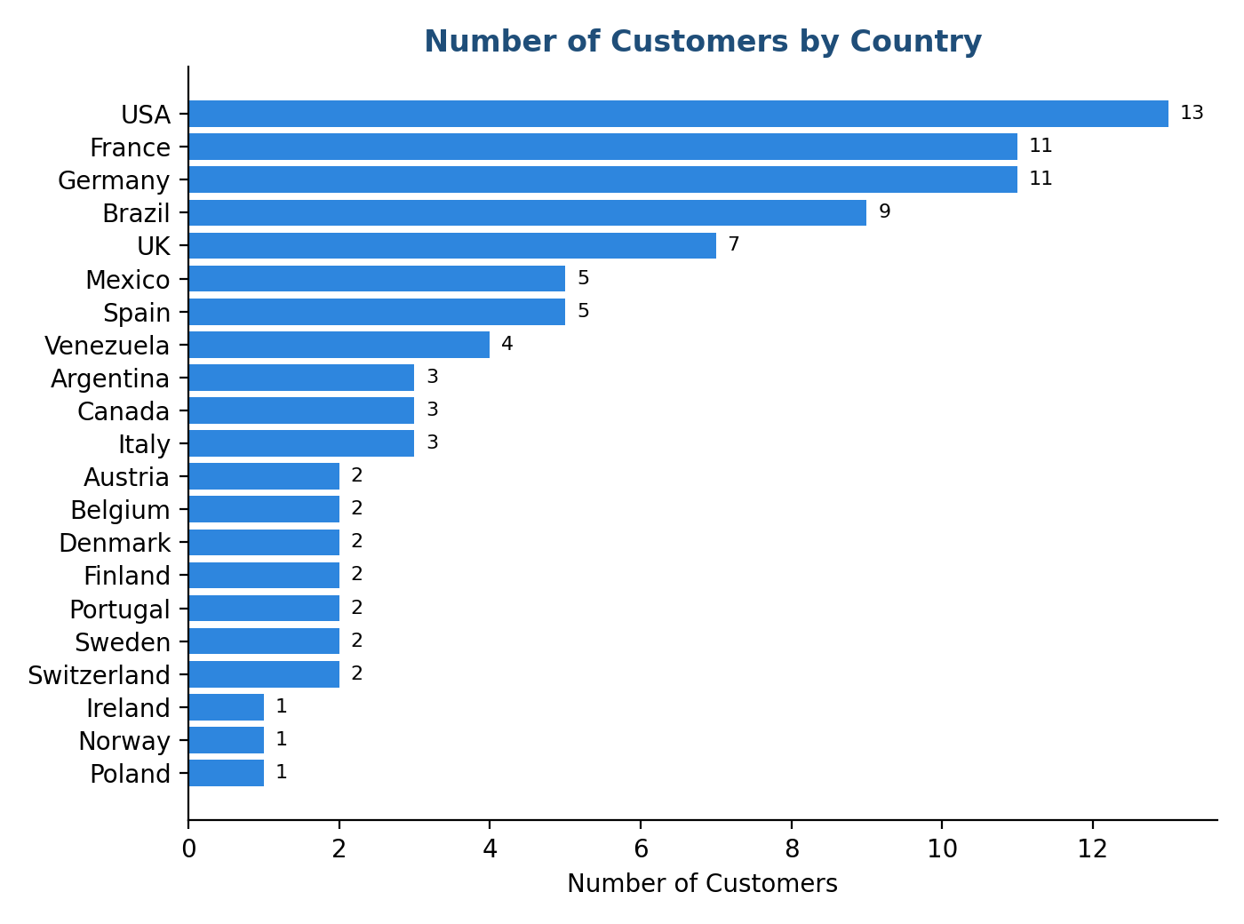
Figure 6: Number of Customers by Country
Customer Group | Countries | Customers
10 or more customers | USA, France, Germany | 35
5 to 9 customers | Brazil, UK, Mexico, Spain | 26
3 to 4 customers | Venezuela, Argentina, Canada, Italy | 13
2 customers | Austria, Belgium, Denmark, Finland, Portugal, Sweden, Switzerland | 14
1 customer | Ireland, Norway, Poland | 3
Total | 21 countries | 91
Table 7: Customer concentration by country

10. Product-Level Analysis
The Products & Customer analysis page contains a detailed table listing every product with its category, total sales and total quantity sold. The table below shows the ten highest-selling products among the rows visible in the dashboard view.
Product | Category | Total Sales | Qty Sold
Côte de Blaye | Beverages | 141,396.74 | 623
Camembert Pierrot | Dairy Products | 46,825.48 | 1,577
Gnocchi di nonna Alice | Grains & Cereals | 42,593.06 | 1,263
Alice Mutton | Meat & Poultry | 32,698.38 | 978
Carnarvon Tigers | Seafood | 29,171.88 | 539
Ipoh Coffee | Beverages | 23,526.70 | 580
Gudbrandsdalsost | Dairy Products | 21,942.36 | 714
Ikura | Seafood | 20,867.34 | 742
Gumbär Gummibärchen | Confections | 19,849.14 | 753
Flotemysost | Dairy Products | 19,551.03 | 1,057
Grand Total (all products) |  | 1,265,793.04 | 51,317
Table 8: Top products by sales among the visible rows of the product table
Côte de Blaye alone contributes more than 141 thousand, over 11% of total company sales, from only 623 units, so it is a very high-value item. In contrast, products such as Camembert Pierrot and Gorgonzola Telino sell in much larger quantities at lower value per unit.

11. Dashboard Design and Interactivity
The dashboard is organised into four report pages.
Page | Purpose
Sales Overviews | Six KPI cards, monthly order line chart, orders by employee and sales by category
Products & Customer analysis | Customers by country and the product-wise sales table with totals
Sales Dashboard | Titled presentation page with the same visuals plus Year, Country and Category filters
Tool tips | Small pop-up card showing Total Orders, Total Sales and Total Quantity Sold on hover
Table 9: Pages of the Northwind dashboard
On the Sales Dashboard page, three slicers allow users to filter every visual at once: a Year slider (2014 to 2015), a Country drop-down and a Category drop-down. When the year filter is applied, the KPIs change to 657 orders and 1.03M in sales. The Tool tips page gives extra detail when a user hovers over a chart element, keeping the main pages clean.

12. Key Findings
- Overall performance: Total sales of 1.27M from 809 orders and 51K units sold to 91 customers.
- Category concentration: Beverages and Dairy Products together contribute about 40% of sales.
- Seasonality: Orders peak from January to April and fall sharply in May and June.
- Employees: Order volume is uneven; the top three staff handle nearly half of all orders.
- Customers: The USA, France and Germany hold 35 of 91 customers.
- Freight: Freight is about 5% of sales with an average cost of 79.05 per order.
- Data quality: Some orders have no employee assigned.

13. Recommendations
- Smooth the seasonal dip. Run promotions and bundle offers in May and June to lift the low-demand months.
- Grow smaller categories. Promote Produce, Grains & Cereals and Condiments through cross-selling with the strong categories.
- Protect top sellers. Keep Beverages and Dairy well stocked and protect high-value items such as Côte de Blaye.
- Diversify customers. Reduce dependence on a few countries by targeting markets with only one or two customers.
- Balance employee workload. Share workload more evenly and use the best performers' methods for training others.
- Control freight cost. Negotiate freight rates, consolidate shipments and review cost for high-freight destinations.
- Fix data quality. Ensure every order is linked to an employee so performance reporting is complete.

14. Relevance to FinTech and AI
As a B.Com FinTech with AI student, this project connects directly to modern finance and technology practice:
- Financial reporting: Dashboards give finance teams real-time visibility of revenue, cost and profitability drivers.
- Forecasting with AI: Monthly order and sales history can feed machine-learning models to forecast demand and cash flow.
- Risk analysis: Customer concentration by country supports credit-risk and exposure analysis.
- Cost management: Freight-to-sales ratios and product profitability support pricing and cost-control decisions.
- Data quality and fraud checks: Missing employee entries and unusual spikes can be flagged automatically by anomaly-detection tools.

15. Conclusion
The Northwind Sales Dashboard successfully turns raw trading data into clear, actionable insight. Northwind Trade earned 1.27M in sales from 809 orders across 91 customers in 21 countries. Sales are led by Beverages and Dairy Products, orders show a strong seasonal dip in May and June, and a small group of employees and countries account for a large share of activity.
By acting on the recommendations given in this report, namely smoothing seasonality, growing smaller categories, diversifying customers and controlling freight, the company can improve both revenue and efficiency. The project also shows how business-intelligence tools and AI-driven analytics can strengthen decision-making in modern finance.

Appendix: Dashboard Screenshots
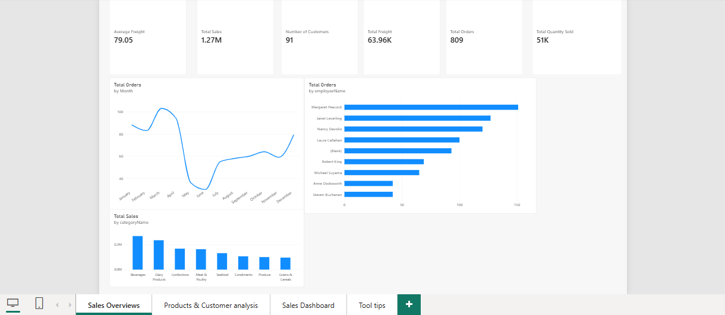
Screenshot 1: Sales Overviews page
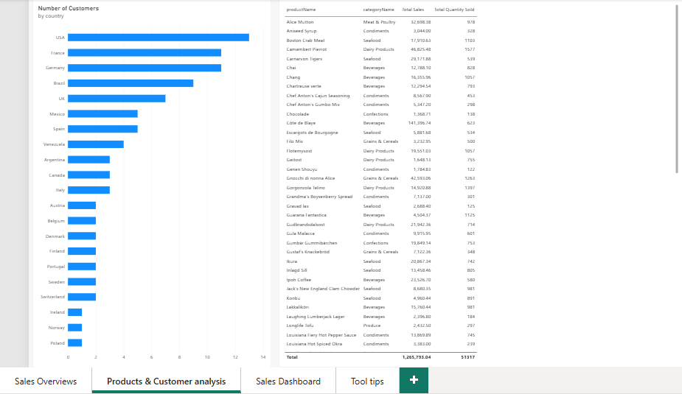
Screenshot 2: Products & Customer analysis page
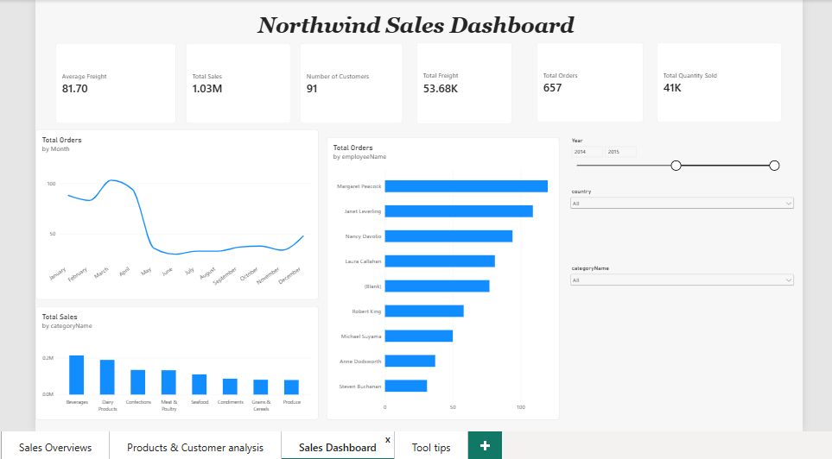
Screenshot 3: Sales Dashboard page with filters
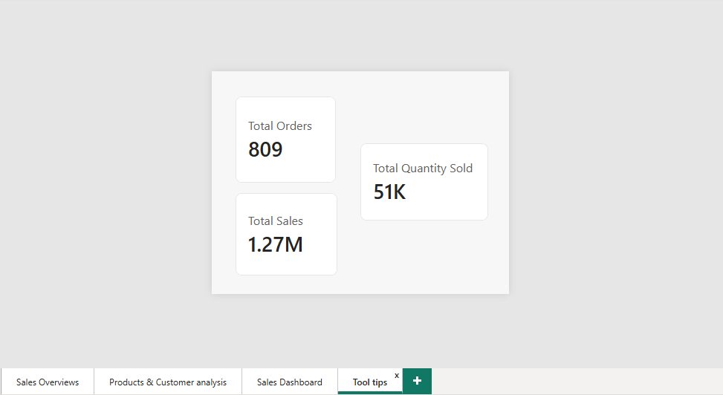
Screenshot 4: Tool tips page

