PROGRAM:

import javafx.application.Application;
import javafx.geometry.Insets;
import javafx.scene.Scene;
import javafx.scene.control.*;
import javafx.scene.layout.GridPane;
import javafx.scene.paint.Color;
import javafx.scene.text.Font;
import javafx.stage.Stage;
import java.sql.*;
public class StudentManagementApp extends Application {
private Connection connection;
private TextField idField = new TextField();
private TextField nameField = new TextField();
private TextField ageField = new TextField();
private TextField courseField = new TextField();
private TextArea displayArea = new TextArea();
public static void main(String[] args) {
launch(args);
}
public void start(Stage primaryStage) {
connectToDatabase();
// Set up the layout
GridPane gridPane = new GridPane();
gridPane.setPadding(new Insets(10));
gridPane.setHgap(10);
gridPane.setVgap(10);
// Set up font
Font font = new Font("Arial", 14);
idField.setPromptText("ID (for Update/Delete)");
idField.setFont(font);
nameField.setPromptText("Name");
nameField.setFont(font);
ageField.setPromptText("Age");
ageField.setFont(font);
courseField.setPromptText("Course");
courseField.setFont(font);
Button createButton = new Button("Create");
createButton.setFont(font);
createButton.setStyle("-fx-background-color: #4CAF50; -fx-text-fill: white;");
createButton.setOnAction(e -> createStudent());
Button readButton = new Button("Display");
readButton.setFont(font);
readButton.setStyle("-fx-background-color: #2196F3; -fx-text-fill: white;");
readButton.setOnAction(e -> readStudents());
Button updateButton = new Button("Update");
updateButton.setFont(font);
updateButton.setStyle("-fx-background-color: #FF9800; -fx-text-fill: white;");
updateButton.setOnAction(e -> updateStudent());
Button deleteButton = new Button("Delete");
deleteButton.setFont(font);
deleteButton.setStyle("-fx-background-color: #F44336; -fx-text-fill: white;");
deleteButton.setOnAction(e -> deleteStudent());
displayArea.setFont(font);
displayArea.setEditable(false);
displayArea.setWrapText(true);
// Arrange elements in the grid
gridPane.add(new Label("ID:"), 0, 0);
gridPane.add(idField, 1, 0);
gridPane.add(new Label("Name:"), 0, 1);
gridPane.add(nameField, 1, 1);
gridPane.add(new Label("Age:"), 0, 2);
gridPane.add(ageField, 1, 2);
gridPane.add(new Label("Course:"), 0, 3);
gridPane.add(courseField, 1, 3);
// Arrange buttons in two rows with gaps
gridPane.add(createButton, 0, 4);
gridPane.add(readButton, 1, 4);
gridPane.add(updateButton, 0, 5);
gridPane.add(deleteButton, 1, 5);
GridPane.setMargin(createButton, new Insets(5, 5, 5, 5));
GridPane.setMargin(readButton, new Insets(5, 5, 5, 5));
GridPane.setMargin(updateButton, new Insets(5, 5, 5, 5));
GridPane.setMargin(deleteButton, new Insets(5, 5, 5, 5));
// Add display area
gridPane.add(displayArea, 0, 6, 2, 1);
// Set up the scene
Scene scene = new Scene(gridPane, 400, 500);
primaryStage.setTitle("Student Management");
primaryStage.setScene(scene);
primaryStage.show();
}
public void connectToDatabase() {
try {
// Load the MySQL JDBC driver
Class.forName("com.mysql.cj.jdbc.Driver");

// Establish a connection to the database
connection = DriverManager.getConnection("jdbc:mysql://localhost:3306/studentdb",
"root", "1234");
System.out.println("Database connection successful");

} catch (ClassNotFoundException e) {
System.err.println("MySQL JDBC Driver not found");
e.printStackTrace();
} catch (SQLException e) {
System.err.println("Database connection failed");
e.printStackTrace();
}
}
private void createStudent() {
String name = nameField.getText();
int age = Integer.parseInt(ageField.getText());
String course = courseField.getText();
String sql = "INSERT INTO students (name, age, course) VALUES (?, ?, ?)";
try (PreparedStatement pstmt = connection.prepareStatement(sql)) {
pstmt.setString(1, name);
pstmt.setInt(2, age);
pstmt.setString(3, course);
pstmt.executeUpdate();
displayArea.setText("Student created successfully.");
} catch (SQLException e) {
e.printStackTrace();
}
}
private void readStudents() {
String sql = "SELECT * FROM students";
try (Statement stmt = connection.createStatement(); ResultSet rs = stmt.executeQuery(sql)) {
StringBuilder sb = new StringBuilder();
while (rs.next()) {
sb.append("ID: ").append(rs.getInt("id"))
.append(", Name: ").append(rs.getString("name"))
.append(", Age: ").append(rs.getInt("age"))
.append(", Course: ").append(rs.getString("course"))
.append("\n");
}
displayArea.setText(sb.toString());
} catch (SQLException e) {
e.printStackTrace();
}
}
private void updateStudent() {
int id = Integer.parseInt(idField.getText());
String name = nameField.getText();
int age = Integer.parseInt(ageField.getText());
String course = courseField.getText();
String sql = "UPDATE students SET name = ?, age = ?, course = ? WHERE id = ?"; ` try (PreparedStatement pstmt = connection.prepareStatement(sql)) {
pstmt.setString(1, name);
pstmt.setInt(2, age);

pstmt.setString(3, course);
pstmt.setInt(4, id);
pstmt.executeUpdate();
displayArea.setText("Student updated successfully.");
} catch (SQLException e) {
e.printStackTrace();
}
}
private void deleteStudent() {

int id = Integer.parseInt(idField.getText());
String sql = "DELETE FROM students WHERE id = ?";
try (PreparedStatement pstmt = connection.prepareStatement(sql)) {
pstmt.setInt(1, id);
pstmt.executeUpdate();
displayArea.setText("Student deleted successfully.");
} catch (SQLException e) {
e.printStackTrace();
}

}
@Override
public void stop() throws Exception {
if (connection != null && !connection.isClosed()) {
connection.close();
}
super.stop();
}
}

OUTPUT:
Compilation Command:
G:\IFET\prgs>set CLASSPATH="C:\Program Files\Java\mysql-connector-j-8.4.0\mysql-connector-java-8.4.0.jar;C:\Program Files\Java\openjfx-22.0.1_windows-x64_bin-sdk\javafx-sdk-22.0.1\lib\*"
G:\IFET\prgs>javac --module-path "C:\Program Files\Java\openjfx-22.0.1_windows-x64_
bin-sdk\javafx-sdk-22.0.1\lib" --add-modules javafx.controls,javafx.fxml StudentManagementApp.java
Run Command:
G:\IFET\prgs>java --module-path "C:\Program Files\Java\openjfx-22.0.1_windows-x64_bin-sdk\
javafx-sdk-22.0.1\lib;C:\Program Files\Java\mysql-connector-j-8.4.0\mysql-connector-j-8.4.0.jar" --add-modules javafx.controls,javafx.fxml -cp ".;C:\Program Files\Java\mysql-connector-j-8.4.0\mysql-
connector-j-8.4.0.jar" StudentManagementA pp

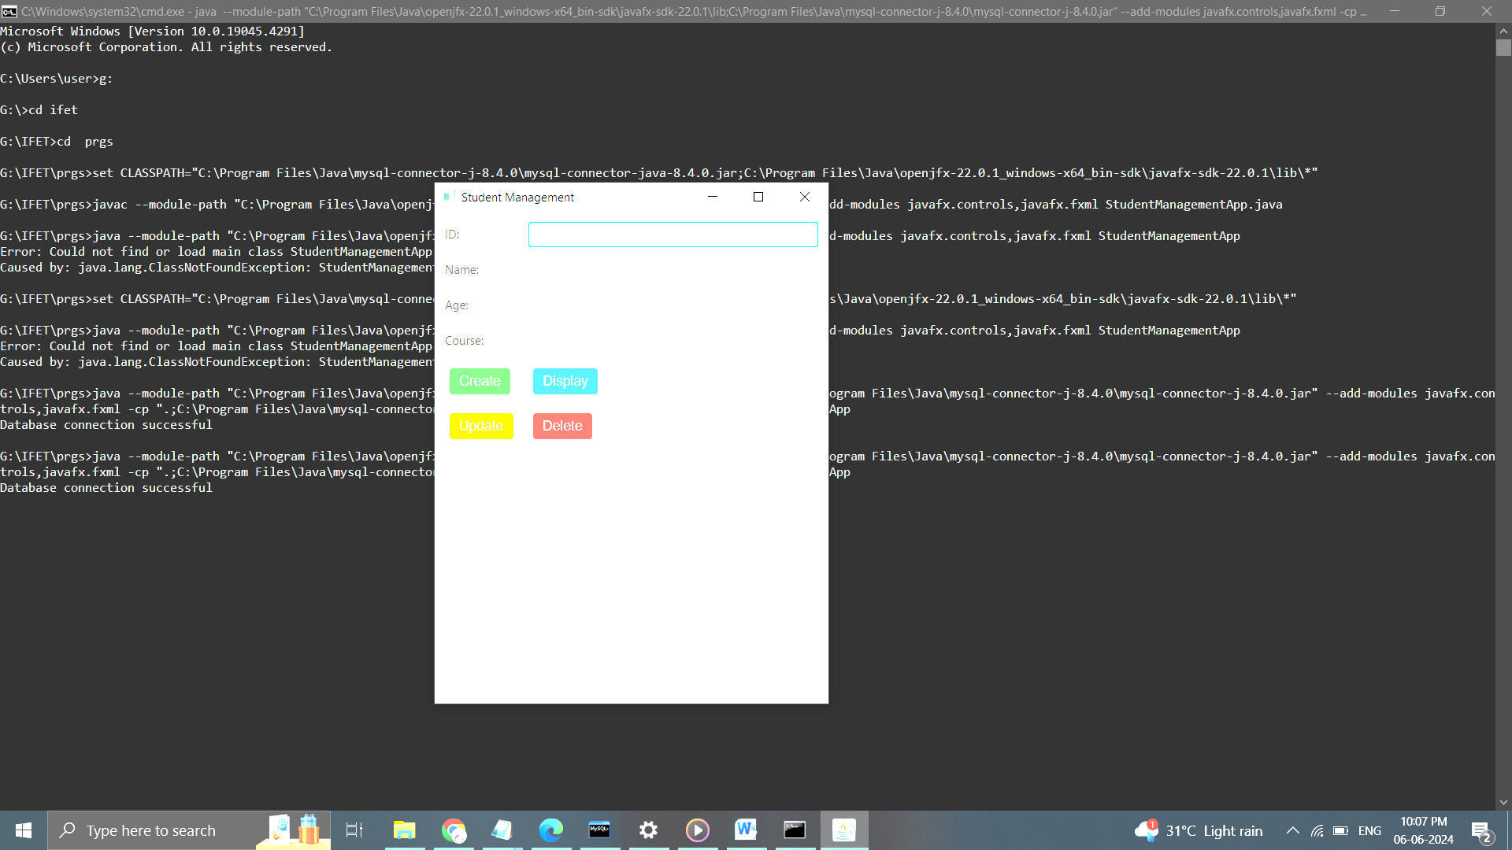
Fig. 1 Student Management Interface

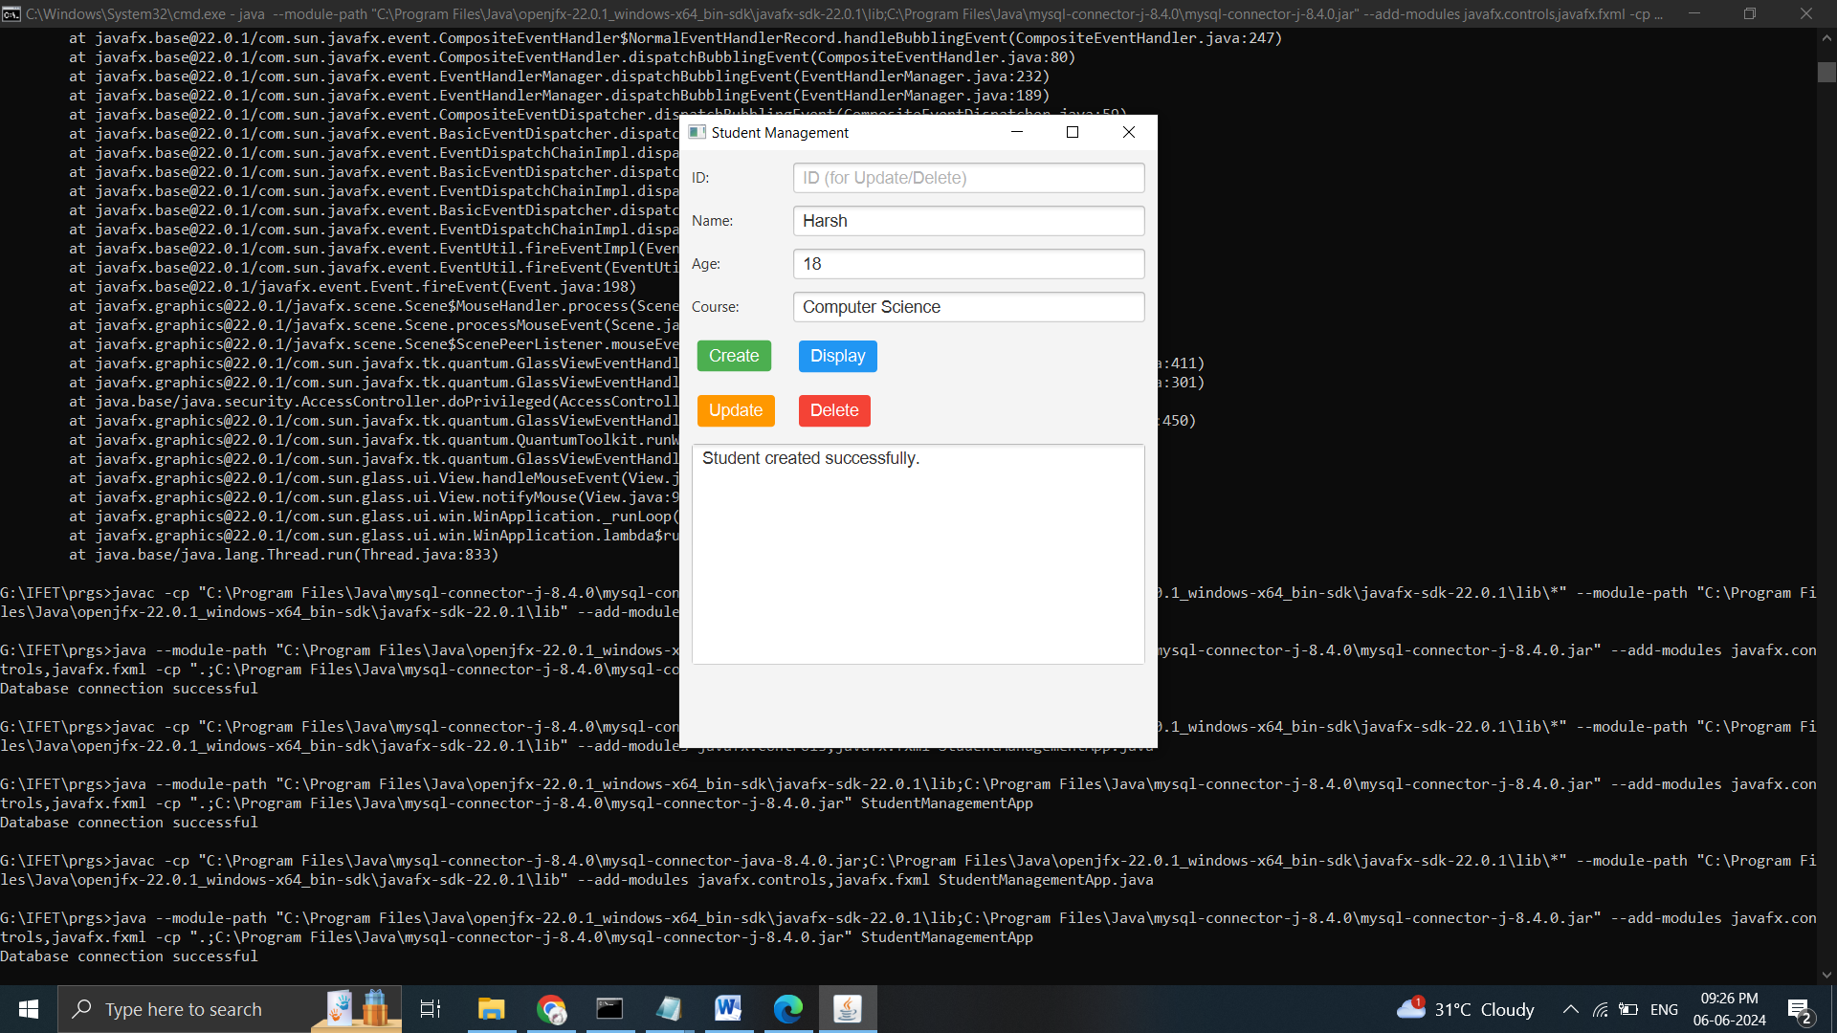
Fig. 2 :Data Insertion

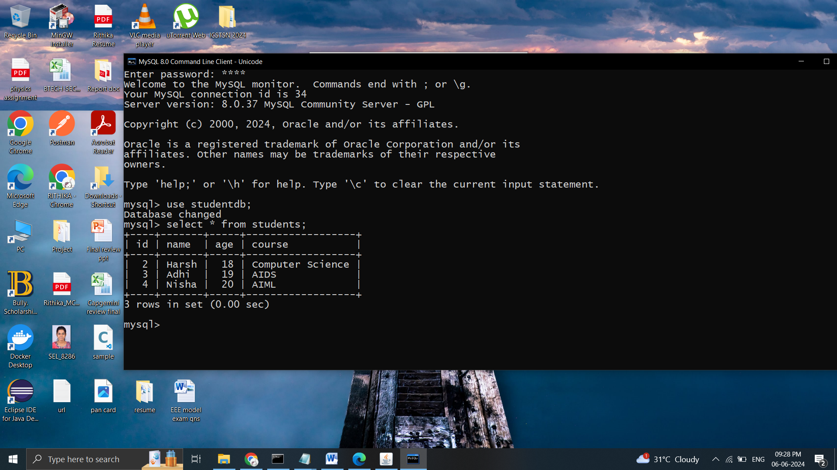
Fig. 3: Student data in database mysql

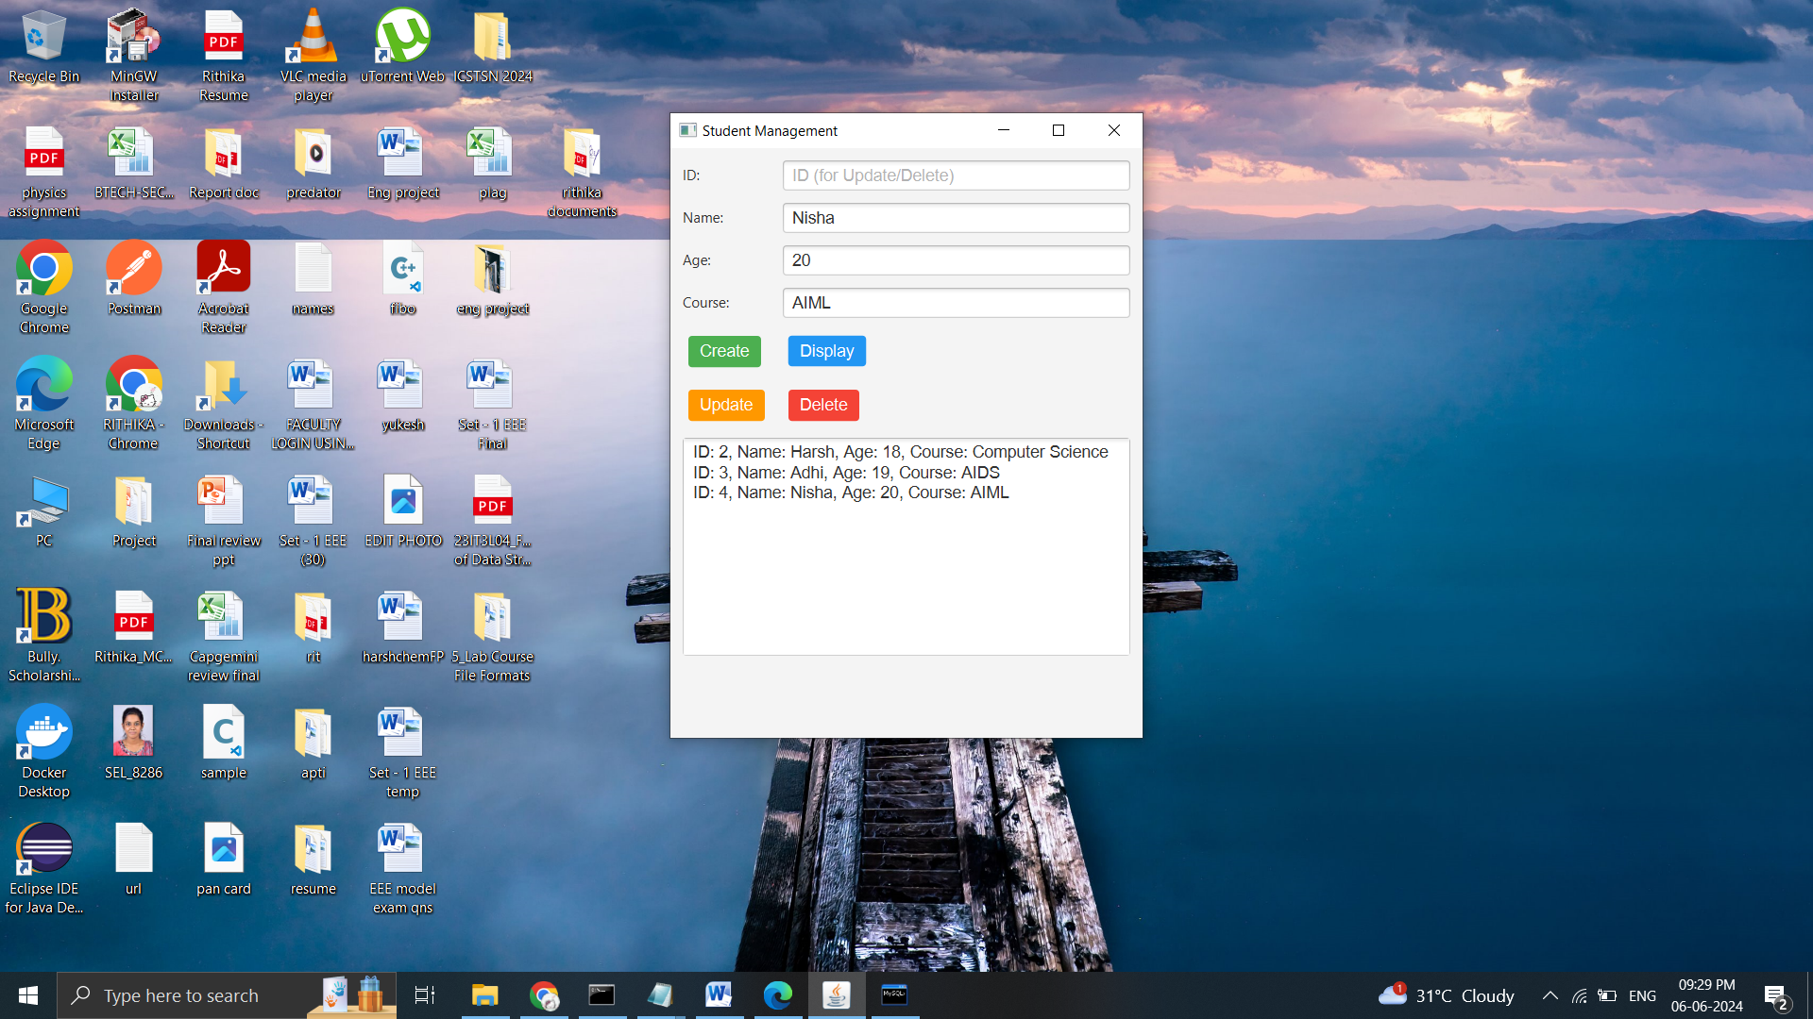
Fig. 4: Display All the data from Database

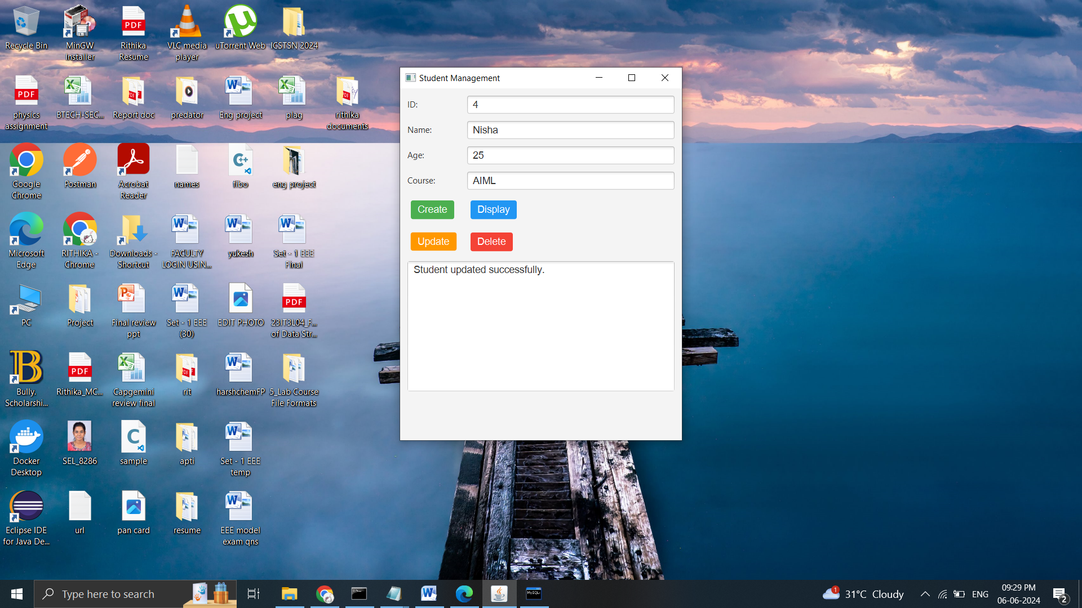
Fig. 5: Updating Student information

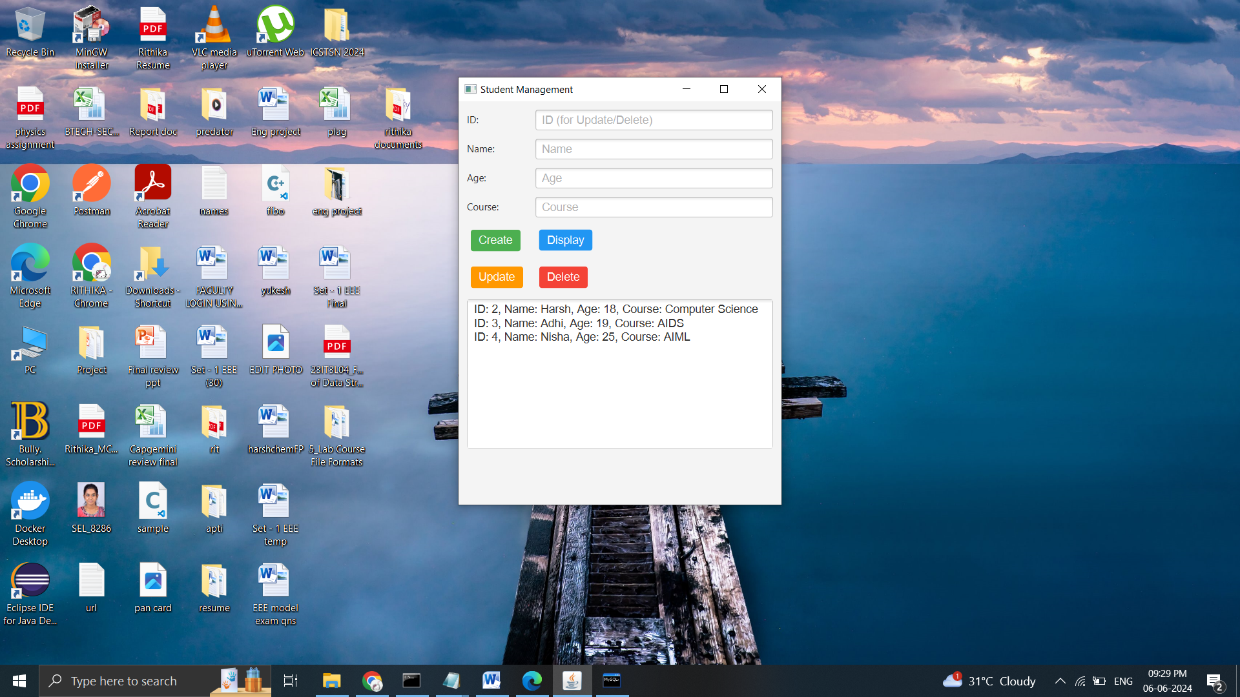
Fig. 6: Displaying data after updation

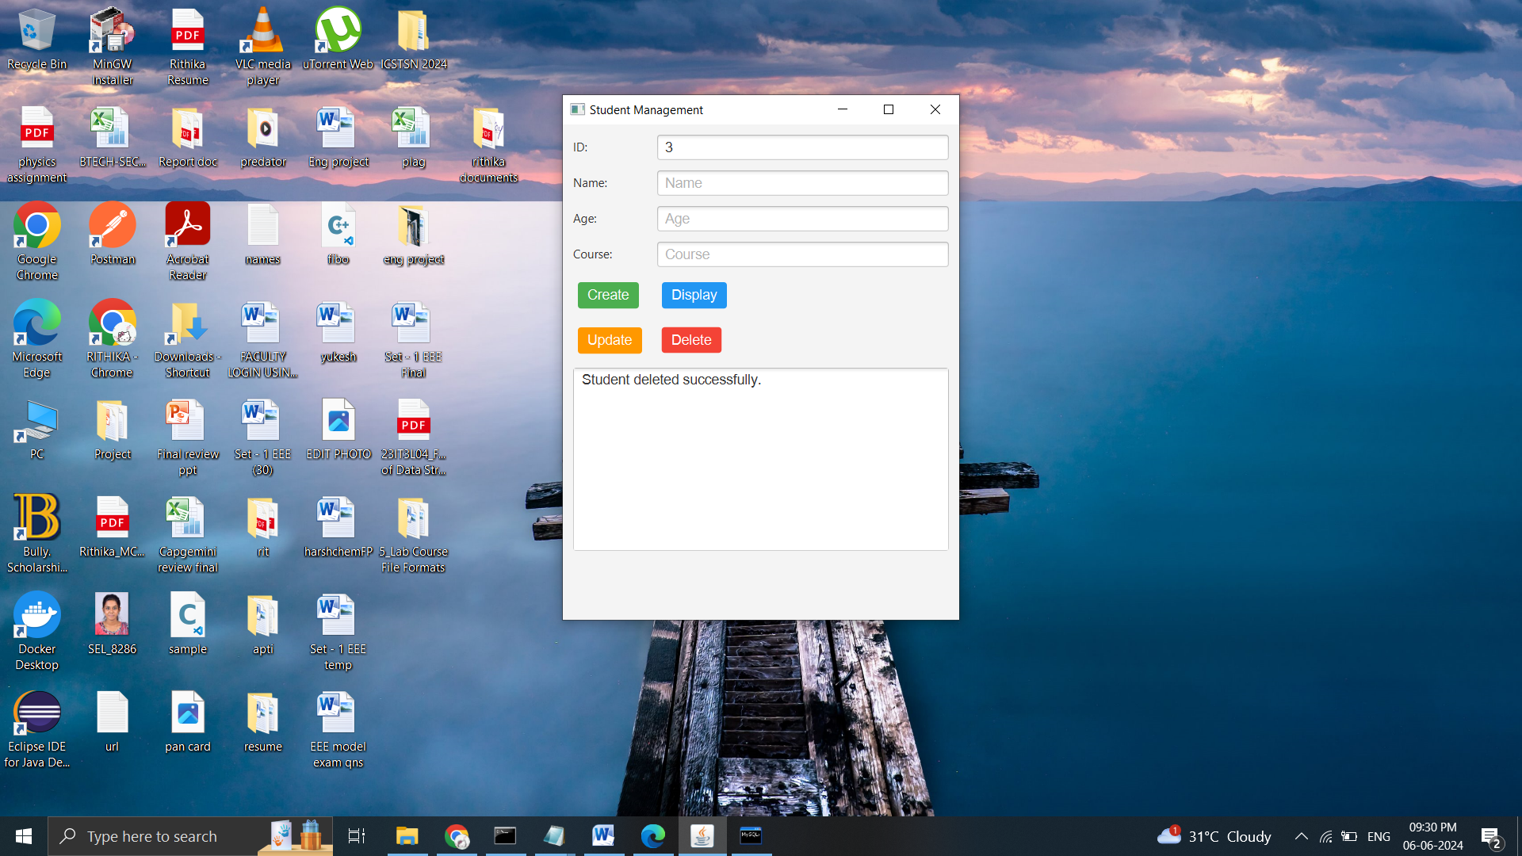
Fig. 7: Deletion

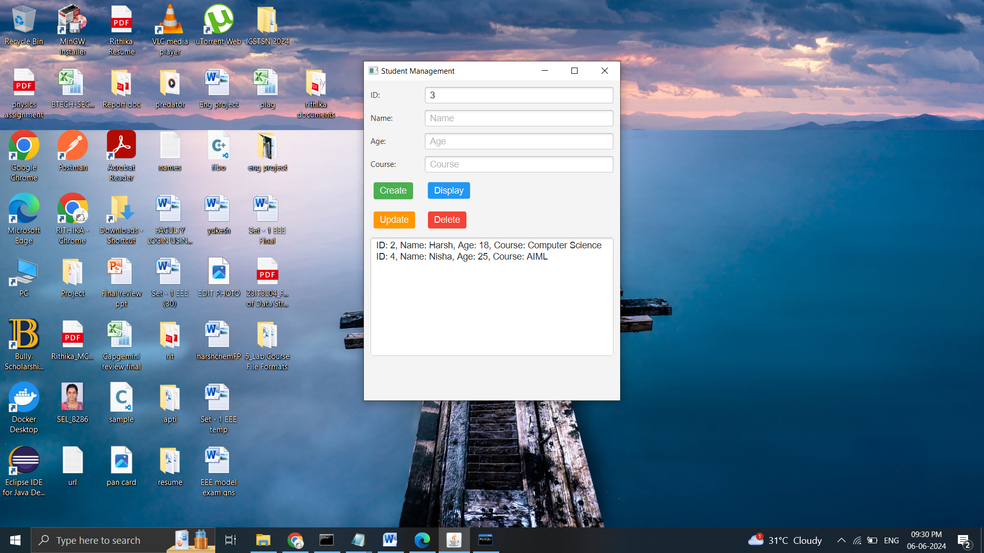
Fig. 8: Displaying information after deletion

