Software Architecture and Design Specification

Project: Academic Performance Analytics System

Version: 1.0

Authors: SUHAS, T B AKASH, MANEESH, SARANSH

Date: 07-10-2026

Status: Draft

Revision History
Version | Date | Author | Change Summary
1.0 | 07-10-2026 | Your Team | Initial draft

Approvals
Role | Name | Signature/Date

1. Introduction

1.1 Purpose

This document specifies the architecture and design of the Academic Performance Analytics System. It describes the system components, architecture, data flow, interfaces, security design, and interactions between different modules.

1.2 Scope

Covers the management and analysis of student marks, attendance, assignment marks, internal assessment marks, and examination marks. The system provides performance dashboards, analyzes performance trends, identifies declining students, and identifies students requiring academic intervention.

1.3 Audience

Developers, QA engineers, project evaluators, instructors, and maintenance teams.

1.4 Definitions

AAS – Academic Performance Analytics System

SRS – Software Requirements Specification

SAD – Software Architecture and Design Specification

STP – Software Test Plan

UI – User Interface

API – Application Programming Interface

RTM – Requirements Traceability Matrix

NFR – Non-Functional Requirement

FR – Functional Requirement

2. Document Overview

2.1 How to use this document
Provides architectural and design details including UML diagrams, component descriptions, architecture decisions, security architecture, data flow, and API design.

2.2 Related Documents
SRS, STP, RTM.

3. Architecture

3.1 Goals & Constraints

Goals: Secure, reliable, modular, and easy-to-use academic performance analytics system.

Constraints: Accurate academic data is required for analysis; access to information is restricted based on user roles; system depends on web browser and database availability.

3.2 Stakeholders & Concerns

Students: Easy access to personal performance, marks, attendance, and trends.

Faculty: Easy management of academic data and identification of students requiring intervention.

Administrators: User, student, and subject management and system monitoring.

Developers: Maintainability, modularity, and reliable system operation.

3.3 Component (UML) Diagram

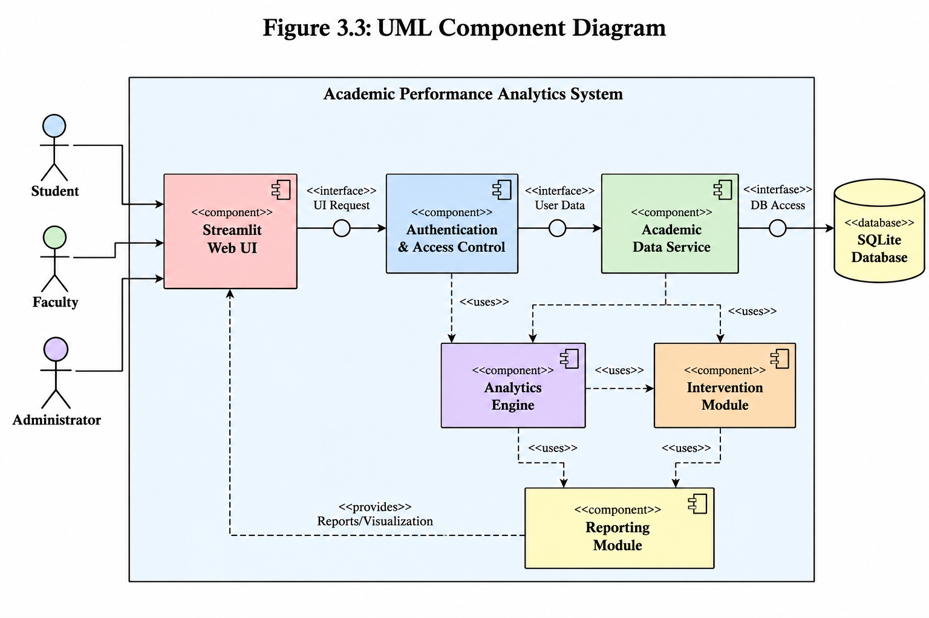
  - Component Descriptions
- Streamlit Web UI: Provides the user interface for students, faculty, and administrators.

Authentication & Access Control: Authenticates users and provides role-based access.

Academic Data Service: Manages student, subject, attendance, assignment, internal assessment, and examination data.

Analytics Engine: Calculates performance scores and analyzes performance trends.

Intervention Module: Identifies declining students and students requiring academic intervention.

Reporting Module: Generates academic performance reports.

SQLite Database: Stores user and academic information.

3.5 Chosen Architecture Pattern and Rationale

A layered architecture is chosen to provide clear separation between the user interface, application logic, analytics, and database layers. This makes the system easier to develop, test, and maintain. A microservices architecture is not chosen because it would add unnecessary complexity for the project.

3.6 Technology Stack & Data Stores

Python, Streamlit, Pandas, Plotly, SQLite, and pytest.

SQLite is used for storing user and academic data. Pandas is used for data processing and analysis, while Plotly is used for performance visualizations.

3.7 Risks & Mitigations

Risk: Incorrect or incomplete academic data may produce inaccurate performance analysis.
Mitigation: Validate academic data before storing and analyzing it.

Risk: Unauthorized users may access academic records.
Mitigation: Use authentication and role-based access control.

3.8 Traceability to Requirements

AAS-F-001 (User Authentication) → Authentication & Access Control

AAS-F-005 (Manage Attendance) → Academic Data Service

AAS-F-010 (Calculate Performance Score) → Analytics Engine

AAS-F-011 (Analyze Performance Trends) → Analytics Engine

AAS-F-013 (Identify Intervention Students) → Intervention Module

AAS-F-014 (Student Performance Dashboard) → Streamlit Web UI / Dashboard Module

AAS-F-016 (Generate Performance Reports) → Reporting Module

3.9 Security Architecture

The system uses authentication and role-based access control (RBAC) to protect academic information.

Authentication: Users must log in using valid credentials.

Authorization: Students, Faculty, and Administrators receive access according to their roles.

Data Protection: Academic records are accessible only to authorized users.

Access Control: Students can view only their own academic information, while Faculty and Administrators have additional permissions according to their roles.

4. Design

4.1 Design Overview
The Academic Performance Analytics System is designed using modular layers for clear separation of concerns, easier maintenance, and reliable academic data processing. The design includes the user interface, authentication and access control, academic data management, analytics, intervention detection, and reporting modules.

4.2 UML Sequence Diagrams
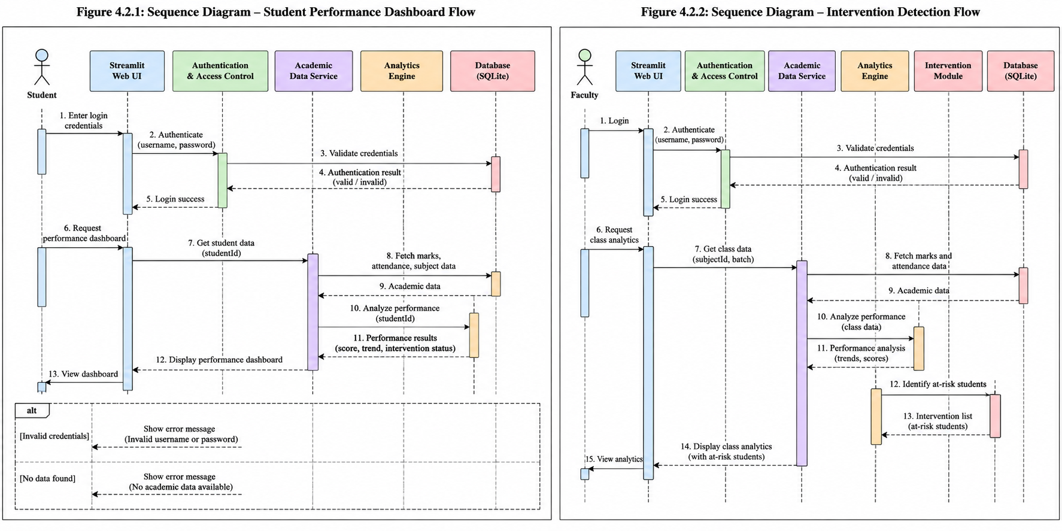

4.3 API Design

Use at least 2 component interfaces:

Endpoint: /student/performance
Method: GET
Request: {studentId}
Response: {marks, attendance, performanceScore, trend, interventionStatus}
Errors: 401 Unauthorized, 404 Student Not Found

Endpoint: /faculty/intervention-students
Method: GET
Request: {facultyId, subjectId}
Response: {students, performanceScore, attendance, riskStatus}
Errors: 401 Unauthorized, 404 Data Not Found

4.4 Error Handling, Logging & Monitoring

The system shall provide standardized error messages for invalid input, unauthorized access, missing data, and database errors. Sensitive user information and academic records shall not be included in application logs.

Monitoring includes:

Login failures

Data entry errors

Database errors

Analytics processing errors

Dashboard response time

Intervention detection failures

4.5 UX Design

The system provides a simple web-based interface with separate views for Students, Faculty, and Administrators. Dashboards use tables, charts, performance scores, attendance information, trends, and intervention status to present academic information clearly.

The interface shall provide readable text, clear navigation, and understandable error messages.

4.6 Open Issues & Next Steps

Future enhancements may include:

Integration with institutional academic databases.

Email or notification alerts for students requiring intervention.

Advanced performance prediction using machine learning.

Mobile-friendly interface.

Additional academic performance reports.

5. Appendices

5.1 Glossary

AAS – Academic Performance Analytics System

SRS – Software Requirements Specification

SAD – Software Architecture and Design Specification

STP – Software Test Plan

API – Application Programming Interface

UI – User Interface

RTM – Requirements Traceability Matrix

RBAC – Role-Based Access Control

NFR – Non-Functional Requirement

5.2 References

Software Requirements Specification (SRS)

Software Test Plan (STP)

Requirements Traceability Matrix (RTM)

5.3 Tools

Python

Streamlit

SQLite

Pandas

Plotly

pytest

Mermaid / PlantUML for UML diagrams

