Software Requirements Specification (SRS) Template

Project: Academic Performance Analytics System
Version: 1.0
Authors: < Instructor / Suhas , Akash , Maneesh , Saransh>
Date: 07-10-2026
Status: Draft

Revision history
Version | Date | Author | Change summary | Approval
1.0 | 07-10-2026 | Project Team | Initial SRS draft for Academic Performance Analytics System

Approvals
Role | Name | Signature / Email | Date
Course Coordinator

Table of Contents
1. Introduction
2. Overall description
3. External interfaces
4. System features (detailed)
5. Non-functional requirements (detailed)
6. Quality attributes & Acceptance tests
7. UML Use-Case Diagram
8. Requirements Traceability Matrix (RTM)

1. Introduction

1.1 Purpose
The purpose of the Academic Performance Analytics System is to collect and analyze student academic data such as marks, attendance, assignments and examinations. The system provides performance dashboards, tracks academic performance over time, and identifies students whose performance is declining or who require academic intervention.
1.2 Scope
The system covers the management and analysis of student academic information including marks, attendance, assignment scores and examination results. It provides dashboards for students, faculty and administrators, tracks performance trends, identifies students with declining performance or those requiring intervention, and supports generation of academic performance reports.

1.3 Audience
Students, Faculty/Teachers, Administrators, Developers, Testers, and Assessment Evaluators.
1.4 Definitions
SRS – Software Requirements Specification
SAD – Software Architecture and Design Specification
STP – Software Test Plan
FR – Functional Requirement
NFR – Non-Functional Requirement
RTM – Requirements Traceability Matrix
API – Application Programming Interface
UI – User Interface.

2. Overall description

2.1 Product perspective
The Academic Performance Analytics System is a web-based application that collects and analyzes student academic information. It interacts with students, faculty and administrators to manage academic data such as marks, attendance, assignments and examination results. The system processes this data through an analytics engine and presents performance dashboards, trends and intervention alerts.

2.2 Major product functions (detailed)
• User authentication and role-based access
• Student information management
• Student and subject management
• Attendance recording and management
• Assignment marks recording and management
• Internal assessment marks recording
• Examination marks recording
• Calculation of overall student performance
• Calculation of attendance percentage
• Display of student performance dashboards
• Display of class performance analytics
• Analysis of performance trends
• Identification of students with declining performance
• Identification of students requiring academic intervention
• Generation of academic performance reports
• Viewing of academic performance by students

2.3 User roles and characteristics (expanded)
• Student: Can view their marks, attendance, assignment and examination performance, performance dashboard, trends and intervention status.
• Faculty/Teacher: Can enter and update academic data, view class performance, identify students at risk and generate performance reports.
• Administrator: Can manage students, faculty, subjects and system configuration and view overall academic analytics.

2.4 Operating environment
The system operates as a web-based application accessible through a standard web browser. The application can be developed using Python and Streamlit, with SQLite used for data storage. Pandas is used for data processing and Plotly is used for performance visualizations.

2.5 Constraints
• The system requires a web browser and network access to access the web application.
• Academic data must be entered accurately by authorized users.
• Access to student academic records must be restricted according to user roles.
• The analytics results depend on the availability and accuracy of marks, attendance, assignment and examination data.
• The system is intended as an academic performance monitoring and analytics system and does not replace formal institutional academic evaluation procedures.

3. External interface requirements

3.1 User interfaces
The system shall provide a web-based user interface with separate views for students, faculty and administrators. The interface shall provide dashboards, tables, forms and charts for viewing and managing academic information. The dashboard shall display performance scores, attendance, assessment results, performance trends and intervention status in a clear and understandable manner.

3.2 Hardware interfaces
No specialized hardware interfaces are required. The system can be accessed using a standard computer or laptop with a keyboard, mouse/touchpad and display.

3.3 Software interfaces
• Streamlit: Provides the web-based user interface and dashboards.
• SQLite: Stores student, faculty, subject, attendance and academic performance data.
• Pandas: Processes and analyzes academic data.
• Plotly: Provides charts and visualizations for performance dashboards.

3.4 Communications
- The system shall communicate with the application server through standard web communication.
- User authentication and session management shall be used to protect access to academic information.
- Data submitted through the web interface shall be transmitted to the application for processing and storage.
- The system shall handle communication or database errors and display appropriate error messages to users.

<< Make sure overall there are at least 15 FRs for overall project, 5 NFRs, 2 security objectives and 5 Security requirements>>

4. System features (detailed)

Each requirement below includes acceptance criteria and a reference test case. IDs follow AAS-F-###.

4.1 User Authentication and Access Control
Description: The system shall authenticate users and provide access to system features based on their assigned roles such as Student, Faculty and Administrator.

Req ID | Requirement | Type | Priority | Source/Stakeholder | Acceptance criteria / Test case ref | Comments / Dependencies
AAS-F-001 | The system shall authenticate users using valid login credentials. | Functional | High | Student / Faculty / Admin | Valid credentials allow login. Invalid credentials display an error message. Test: TC-AUTH-01 | Requires user account data.
AAS-F-002 | The system shall provide role-based access for Student, Faculty and Administrator users. | Functional | High | Security / Admin | Users can access only features permitted for their role. Test: TC-AUTH-02 | Depends on user roles.

4.2 Student and Subject Management
Description : The system shall maintain student and subject information required for academic performance analysis.
Req ID | Requirement | Type | Priority | Source/Stakeholder | Acceptance criteria / Test case ref | Comments / Dependencies
AAS-F-003 | The system shall allow authorized users to add, update and manage student information.. | Functional | High | Admin | Student information is successfully added or updated and stored. Test: TC-STU-01 | Admin access required.
ATM-F-011 | The system shall allow authorized users to manage subject information. | Functional | High | Admin / Faculty | Subjects can be added, updated and associated with academic records. Test: TC-SUB-01 | Admin access required.

4.3 Attendance Management
Description: The system shall allow faculty to record and manage student attendance and calculate attendance percentages.
Req ID | Requirement | Type | Priority | Source/Stakeholder | Acceptance Criteria / Test Case Ref | Comments / Dependencies
AAS-F-005 | The system shall allow faculty to record and update student attendance. | Functional | High | Faculty | Attendance records are stored correctly. Test: TC-ATT-01 | Faculty access required.
AAS-F-006 | The system shall calculate the attendance percentage for each student. | Functional | High | Faculty / Student | Attendance percentage is calculated correctly from attendance records. Test: TC-ATT-02 | Requires attendance data.

.

4.4 Assignment and Examination Management
Description : The system shall allow faculty to record assignment, internal assessment and examination marks.
Req ID | Requirement | Type | Priority | Source/Stakeholder | Acceptance Criteria / Test Case Ref | Comments / Dependencies
AAS-F-007 | The system shall allow faculty to record and update assignment marks. | Functional | High | Faculty | Assignment marks are stored and displayed correctly. Test: TC-ASSIGN-01 | Faculty access required.
AAS-F-008 | The system shall allow faculty to record and update internal assessment marks. | Functional | High | Faculty | Internal marks are stored and displayed correctly. Test: TC-INTERNAL-01 | Faculty access required.
AAS-F-009 | The system shall allow faculty to record and update examination marks. | Functional | High | Faculty | Examination marks are stored and displayed correctly. Test: TC-EXAM-01 | Faculty access required.

4.5 Performance Analysis
Description
The system shall analyze academic data and calculate student performance, performance trends and risk status.
Req ID | Requirement | Type | Priority | Source/Stakeholder | Acceptance Criteria / Test Case Ref | Comments / Dependencies
AAS-F-010 | The system shall calculate an overall performance score using academic assessment data. | Functional | High | Faculty / Student | Performance score is calculated according to the defined scoring rule. Test: TC-ANL-01 | Requires marks and attendance data.
AAS-F-011 | The system shall analyze student performance trends by comparing current and previous performance. | Functional | High | Faculty / Student | The system correctly identifies improving, stable or declining performance. Test: TC-ANL-02 | Requires historical performance data.
AAS-F-012 | The system shall identify students whose performance is declining. | Functional | High | Faculty | A student whose performance drops by the defined threshold is flagged as declining. Test: TC-ANL-03 | Depends on trend analysis.
AAS-F-013 | The system shall identify students who require academic intervention based on defined risk conditions. | Functional | High | Faculty | Students satisfying one or more risk conditions are flagged for intervention. Test: TC-ANL-04 | Depends on performance and attendance data.

4.6 Dashboards and Reports
Requirements: Provide a technician menu for diagnostics, remote monitoring API integration, secure admin authentication, and encrypted log shipping. IDs ATM-F-040..ATM-F-045.
Req ID | Requirement | Type | Priority | Source/Stakeholder | Acceptance Criteria / Test Case Ref | Comments / Dependencies
AAS-F-014 | The system shall provide a student performance dashboard displaying marks, attendance, assessment results, trends and intervention status. | Functional | High | Student | Dashboard displays the student's current academic information correctly. Test: TC-DASH-01 | Requires analyzed academic data.
AAS-F-015 | The system shall provide faculty with class-level performance analytics and a list of students requiring intervention. | Functional | High | Faculty | Faculty dashboard displays class statistics and flagged students. Test: TC-DASH-02 | Requires class and student data.
AAS-F-016 | The system shall allow authorized users to generate academic performance reports. | Functional | Medium | Faculty / Admin | Report contains correct academic and performance information. Test: TC-REPORT-01 | Requires academic data.
AAS-F-017 | The system shall allow students to view their academic performance information. | Functional | High | Student | Student can view only their own academic information. Test: TC-STUDENT-01 | Role-based access required.

5. Non-functional requirements (detailed)
NFRs below are measurable and tied to test plans. IDs follow AAS-NF-###.

Req ID | Requirement | Category | Priority | Acceptance criteria / Measurement
AAS-NF-001 | The system shall load the performance dashboard within 3 seconds under normal operating conditions. | Performance | High | Dashboard loads within 3 seconds during normal usage. Test: TC-PERF-01
AAS-NF-002 | The system shall provide at least 99.5% availability excluding planned maintenance periods. | Reliability | High | Availability is at least 99.5% during the defined monitoring period. Test: TC-REL-01
AAS-NF-003 | The system shall restrict access to academic records to authorized users based on their assigned roles. | Security | High | Unauthorized users cannot access protected academic records. Test: TC-SEC-01
AAS-NF-004 | The system shall provide a clear and readable user interface for students, faculty and administrators. | Usability | Medium | Users can access and understand required information without usability issues. Test: TC-UX-01
AAS-NF-005 | The system shall maintain regular backups of academic data to prevent data loss. | Reliability / Data Management | High | Backup is created successfully and academic data can be restored. Test: TC-BACKUP-01
AAS-NF-006 | The system shall maintain consistent and accurate academic records when data is added or updated. | Data Integrity | High | Added or updated academic data is stored correctly without inconsistency. Test: TC-DATA-01

5.1. Security

5.1.1 Security Objectives

SO-001: Protect student academic information from unauthorized access.

SO-002: Ensure that only authorized users can access and modify academic records according to their assigned roles.

5.1.2 Security Requirements

Req ID | Requirement | Type | Priority | Acceptance criteria / Test case ref
AAS-SR-001 | The system shall authenticate users before allowing access to academic information. | Security | High | Unauthorized users cannot access protected pages. Test: TC-SEC-01
AAS-SR-002 | The system shall enforce role-based access for Student, Faculty and Administrator users. | Security | High | Users can access only features permitted for their role. Test: TC-SEC-02
AAS-SR-003 | The system shall restrict students from viewing or modifying other students' academic records. | Security | High | A student can access only their own academic information. Test: TC-SEC-03
AAS-SR-004 | The system shall restrict modification of academic records to authorized Faculty or Administrator users. | Security | High | Unauthorized users cannot modify academic records. Test: TC-SEC-04
AAS-SR-005 | The system shall protect user credentials from unauthorized disclosure. | Security | High | Credentials are not displayed or stored in plain text. Test: TC-SEC-05
AAS-SR-006 | The system shall maintain access control for academic performance reports and student data. | Security | Medium | Only authorized users can access protected reports and data. Test: TC-SEC-06

6. Quality attributes & Acceptance tests
- Exit criteria for acceptance: All high-priority functional requirements are implemented and verified, no critical NFR failures are present, and the RTM shows that all required test cases have passed.
- Acceptance test suites: Authentication, Student Data Management, Attendance, Assignment Marks, Internal Assessment, Examination Marks, Performance Analytics, Dashboard, Intervention Detection, Performance, Security, and Usability tests.

7. System models and diagrams

7.1 UML Use-Case diagram
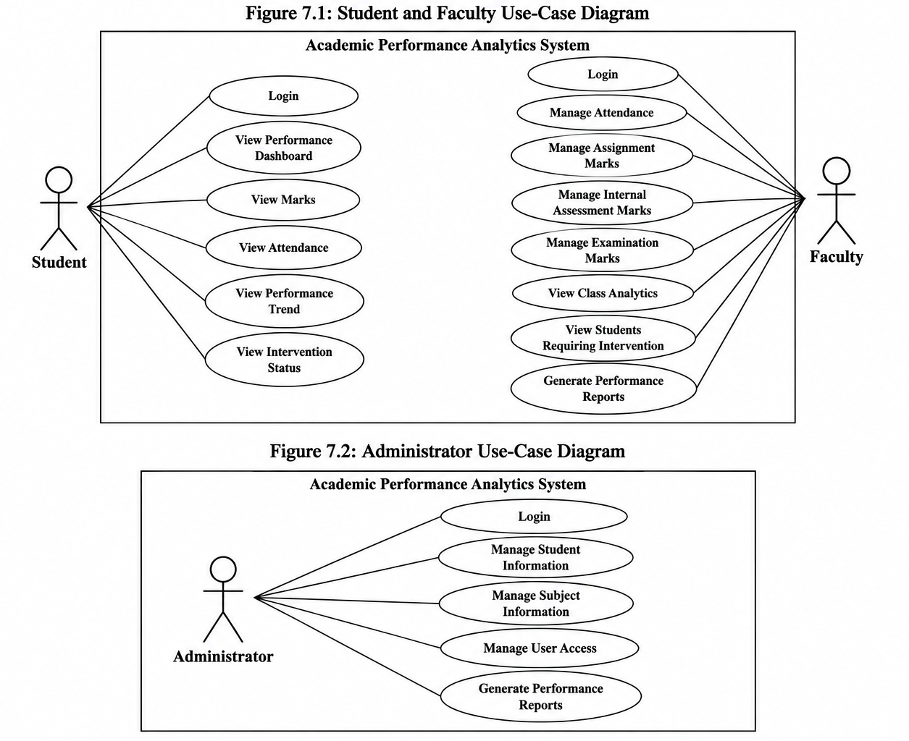

8. Requirements Traceability Matrix (RTM)

Req ID | Requirement short | Section ref / Design Spec | Module | Test case(s) | Status (N/P/A) | Comments
AAS-F-001 | User authentication | 4.4 / DS-Auth-01 | Authentication Module | TC-AUTH-01 | N | Requires valid credentials.
AAS-F-002 | Role-based access | 4.4 / DS-Auth-02 | Access Control Module | TC-AUTH-02 | N | Depends on user role.
AAS-F-003 | Manage student information | 4.4 / DS-Student-01 | Student Management Module | TC-STU-01 | N | Admin access required.
AAS-F-004 | Manage subject information | 4.4 / DS-Subject-01 | Subject Management Module | TC-SUB-01 | N | Admin/Faculty access required.
AAS-F-005 | Manage attendance | 4.4 / DS-Attendance-01 | Attendance Module | TC-ATT-01 | N | Faculty access required.
AAS-F-006 | Calculate attendance percentage | 4.4 / DS-Attendance-02 | Analytics Module | TC-ATT-02 | N | Requires attendance data.
AAS-F-007 | Manage assignment marks | 4.4 / DS-Assessment-01 | Assessment Module | TC-ASSIGN-01 | N | Faculty access required.
AAS-F-008 | Manage internal assessment marks | 4.4 / DS-Assessment-02 | Assessment Module | TC-INTERNAL-01 | N | Faculty access required.
AAS-F-009 | Manage examination marks | 4.4 / DS-Assessment-03 | Assessment Module | TC-EXAM-01 | N | Faculty access required.
AAS-F-010 | Calculate performance score | 4.4 / DS-Analytics-01 | Analytics Module | TC-ANL-01 | N | Requires marks and attendance data.
AAS-F-011 | Analyze performance trends | 4.4 / DS-Analytics-02 | Analytics Module | TC-ANL-02 | N | Requires historical data.
AAS-F-012 | Identify declining students | 4.4 / DS-Analytics-03 | Analytics Module | TC-ANL-03 | N | Depends on trend analysis.
AAS-F-013 | Identify intervention students | 4.4 / DS-Intervention-01 | Intervention Module | TC-ANL-04 | N | Depends on performance and attendance data.
AAS-F-014 | Student performance dashboard | 4.4 / DS-Dashboard-01 | Dashboard Module | TC-DASH-01 | N | Requires analyzed data.
AAS-F-015 | Class-level performance analytics | 4.4 / DS-Dashboard-02 | Dashboard Module | TC-DASH-02 | N | Requires class and student data.
AAS-F-016 | Generate performance reports | 4.4 / DS-Report-01 | Reporting Module | TC-REPORT-01 | N | Requires academic data.
AAS-F-017 | View student performance | 4.4 / DS-Student-02 | Student Dashboard Module | TC-STUDENT-01 | N | Student can view only own information.
AAS-NF-001 | Dashboard response time | 5 / DS-Perf-01 | Web UI / Dashboard | TC-PERF-01 | N | Target response time is within 3 seconds.
AAS-NF-002 | System availability | 5 / DS-Reliability-01 | System / Database | TC-REL-01 | N | Target availability is at least 99.5%.
AAS-NF-003 | Academic data access security | 5 / DS-Security-01 | Authentication & Access Control | TC-SEC-01 | N | Access restricted by role.
AAS-NF-004 | User interface usability | 5 / DS-UX-01 | Web UI | TC-UX-01 | N | Interface should be clear and readable.
AAS-NF-005 | Academic data backup | 5 / DS-Backup-01 | Database / Backup Module | TC-BACKUP-01 | N | Data should be recoverable from backup.
AAS-NF-006 | Academic data integrity | 5 / DS-Data-01 | Database / Data Management | TC-DATA-01 | N | Records must remain accurate and consistent.

