TaskFolio

*Crafting your To-Dos into Dones with Style*

*Presented By:*

***Prerna Sharma***

***Rudra Pratap Singh***

***Saransh Singh***

TABLE OF CONTENTS

1. Abstract
2. Introduction
3. System Architecture
4. Dockerization
5. Service Management and Orchestration
6. Conclusion
7. Future Scope

ABSTRACT

TaskFolio is an advanced task management application designed to enhance productivity through a seamless integration of functionality and aesthetic appeal. The application features a user-friendly interface, real-time synchronization, advanced task categorization, reminders, notifications, and analytics to optimize task management. The backend is powered by Flask, with data stored in a MySQL database, all containerized using Docker for consistent development and deployment. HELM and Kubernetes streamline application management, while AWS provides a scalable and reliable cloud hosting environment. TaskFolio addresses the need for a comprehensive and visually appealing task management solution, transforming the task management process into an engaging and efficient experience.

**Keywords: *Task Management, Productivity, Docker, Kubernetes, AWS.***

INTRODUCTION

In today’s fast-paced world, effective task management is crucial for both personal and professional success. TaskFolio is an innovative task management application designed to meet this need by combining robust functionality with an elegant user experience. It aims to transform the way users handle their tasks, providing a seamless and intuitive platform that enhances productivity and organization.

The application is built on a two-tier architecture, leveraging modern technologies to ensure reliability and scalability. The backend is powered by Flask, a lightweight web framework that handles the core logic and API endpoints. Data is securely stored in a MySQL database, ensuring efficient data management and retrieval. Both Flask and MySQL are containerized using Docker, which facilitates consistent development environments and streamlined deployment processes.

To manage and deploy the application, HELM and Kubernetes are utilized, simplifying the orchestration of containerized applications. The final deployment is hosted on AWS (Amazon Web Services), providing a scalable and reliable cloud infrastructure capable of handling a growing user base.

SYSTEM ARCHITECTURE

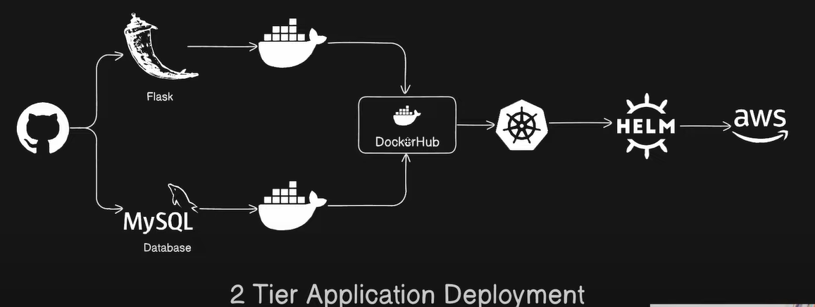

1. **Frontend (User Interface):**
   * *TaskFolio Interface:* This is the web application interface where users interact with the system. It includes features like adding tasks, viewing tasks, and managing them. The interface is built using HTML, CSS, and JavaScript for a responsive and interactive user experience.
2. **Backend (Application Logic):**
   * *Flask Application:* The backend is developed using Flask, a Python web framework. Flask handles the application logic, processes user requests, and interacts with the database. It serves the web pages and APIs required for the frontend to function.
3. **Database:**
   * *MySQL Database:* The application uses MySQL to store task data. This includes task titles, descriptions, completion status, and other relevant information. The database ensures data persistence and supports CRUD (Create, Read, Update, Delete) operations.
4. **Containerization:**

* *Docker:* Both the Flask application and MySQL database are containerized using Docker. Docker ensures that the application runs consistently across different environments by packaging the application and its dependencies into containers.

1. **Container Registry:**

* *DockerHub:* The Docker images of the Flask application and MySQL database are stored in DockerHub. This allows for easy distribution and deployment of the application containers.

1. **Orchestration:**

* Kubernetes: Kubernetes is used to manage and orchestrate the deployment of the Docker containers. It handles the scaling, load balancing, and management of the containerized applications. Kubernetes ensures high availability and reliability of the application.

1. **Package Management:**

* *HELM:* HELM is used as a package manager for Kubernetes. It simplifies the deployment and management of Kubernetes applications by using Helm charts. These charts define, install, and upgrade the Kubernetes applications.

1. **Cloud Infrastructure:**

* *AWS (Amazon Web Services):* The entire application is deployed on AWS, which provides the cloud infrastructure. AWS services like EC2 (Elastic Compute Cloud) are used to host the Kubernetes cluster. AWS ensures scalability, security, and reliability of the infrastructure.

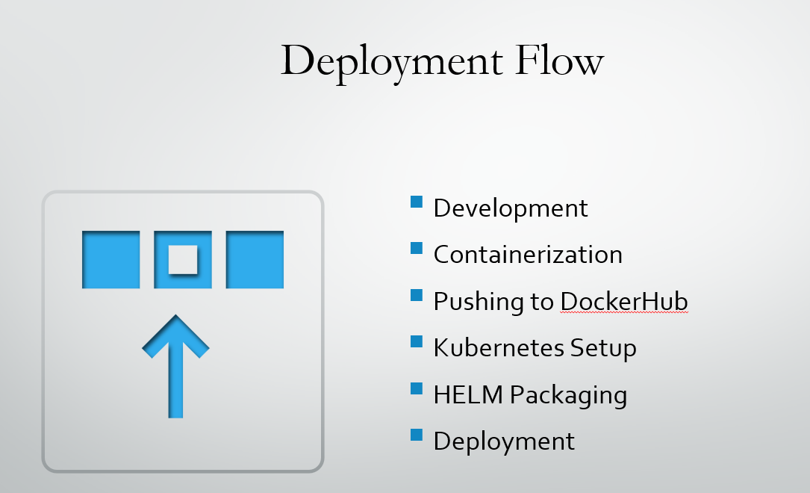

DOCKERIZATION

Dockerization involves packaging the application and its dependencies into Docker containers. This ensures that the application runs consistently across different environments. In this project, we will dockerize both the Flask application and the MySQL database.

**1. Dockerizing the Flask Application**

**Step-by-Step Process**:

1. **Create a Dockerfile**:
   * A Dockerfile is a script that contains a series of instructions on how to build a Docker image for the Flask application.
   * Example Dockerfile for Flask:

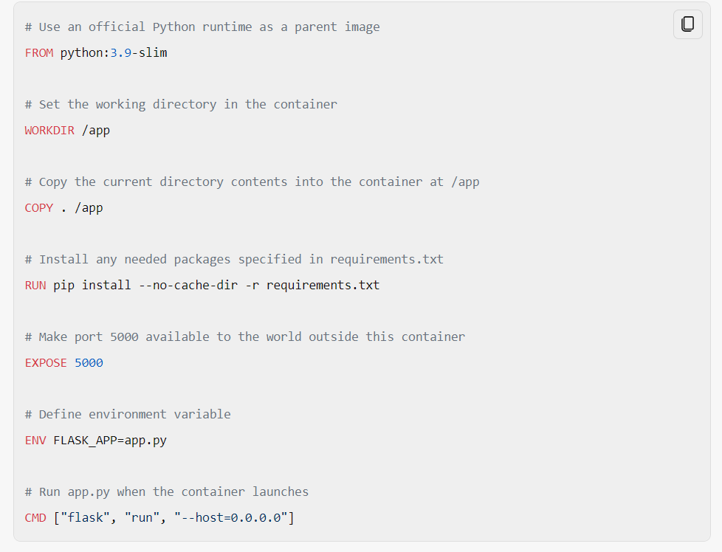

1. **Build the Docker Image**:

* Use the Docker CLI to build the Docker image from the Dockerfile.
* Command:



1. **Run the Docker Container**:
   * Run the Docker container from the built image.
   * Command:



**2. Dockerizing the MySQL Database**

**Step-by-Step Process**:

1. **Create a Dockerfile**:
   * A Dockerfile for MySQL is not always necessary as you can use the official MySQL image from DockerHub.
   * Example Dockerfile for MySQL (if customization is needed):

1. **Build the Docker Image** (if using a custom Dockerfile):
   * Command:



1. **Run the Docker Container**:
   * Run the Docker container using the official MySQL image or the custom image.
   * Command:

**3. Docker Compose for Multi-Container Applications**

To manage both the Flask application and MySQL database together, you can use Docker Compose. Docker Compose allows you to define and run multi-container Docker applications.

**Step-by-Step Process**:

1. **Create a**docker-compose.yml**File**:
   * This file defines the services (Flask and MySQL) and their configurations.
   * Example docker-compose.yml:

1. **Build and Run the Containers**:
   * Use Docker Compose to build and run the containers.
   * Command:



This setup ensures that both the Flask application and MySQL database are containerized and can be managed together. Docker Compose simplifies the orchestration of multi-container applications, making it easier to develop, test, and deploy the 2-Tier application.

SERVICE MANAGEMENT AND ORCHESTRATION

Service management and orchestration are crucial for ensuring that your application runs smoothly, scales efficiently, and remains highly available. In this project, Kubernetes is used for orchestration, while services are managed through Kubernetes resources and HELM charts.

**1. Kubernetes Overview**

**Kubernetes** is an open-source platform designed to automate deploying, scaling, and operating application containers. It groups containers that make up an application into logical units for easy management and discovery.

**Key Components**:

* **Master Node**: Manages the Kubernetes cluster, schedules workloads, and maintains the desired state.
* **Worker Nodes**: Run the containerized applications and report to the master node.

**2. Service Management**

**Services** in Kubernetes define a logical set of pods and a policy by which to access them. They enable communication between different parts of the application and external users.

**Key Points**:

* **Service Types**:
  + **ClusterIP**: Exposes the service on a cluster-internal IP. This is the default type.
  + **NodePort**: Exposes the service on each node’s IP at a static port.
  + **LoadBalancer**: Exposes the service externally using a cloud provider’s load balancer.
* **Service Configuration**:
  + **Flask Service**: Exposes the Flask application to the internet.
  + **MySQL Service**: Exposes the MySQL database to the Flask application.

**Example Service Configuration**:

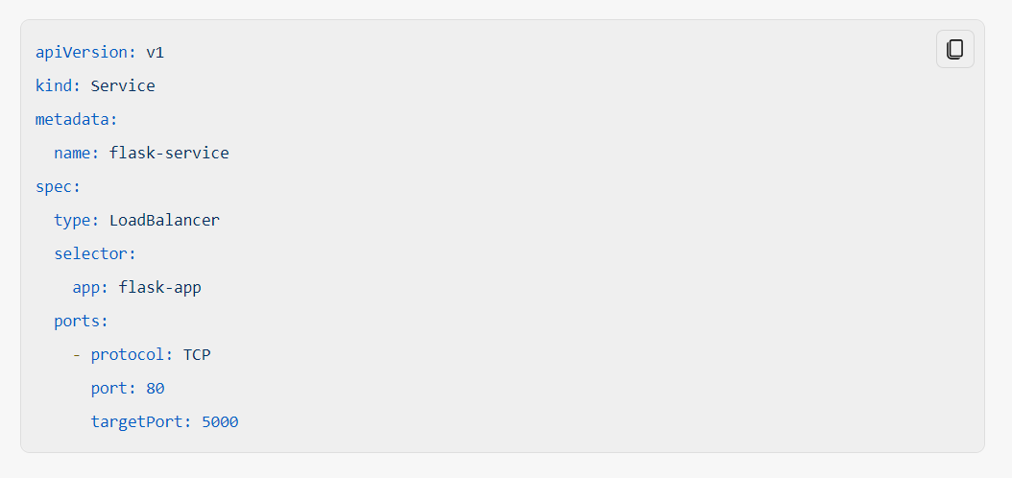

3. **Orchestration with Kubernetes**

**Orchestration** involves managing the lifecycle of containers, ensuring they are deployed, scaled, and maintained efficiently.

**Key Points**:

* **Deployments**:
  + Define the desired state for your application, including the number of replicas, update strategy, and rollback capabilities.
  + **Example Deployment Configuration**:

* **Scaling**:
  + Kubernetes can automatically scale your application based on resource usage (CPU, memory) or custom metrics.
  + **Horizontal Pod Autoscaler (HPA)**: Automatically scales the number of pods in a deployment based on observed CPU utilization or other select metrics.
* **Load Balancing**:
  + Distributes incoming network traffic across multiple pods to ensure no single pod is overwhelmed.
  + **Service Load Balancer**: Automatically created when you define a service of type LoadBalancer.
* **Rolling Updates and Rollbacks**:
  + **Rolling Updates**: Gradually replace old pods with new ones to ensure zero downtime.
  + **Rollbacks**: Revert to a previous deployment state if something goes wrong.

1. **HELM for Kubernetes**

**HELM** is a package manager for Kubernetes that simplifies the deployment and management of applications.

Below are the final results of the web application along with database stored in MySQL, also dockerization of containers is shown here:

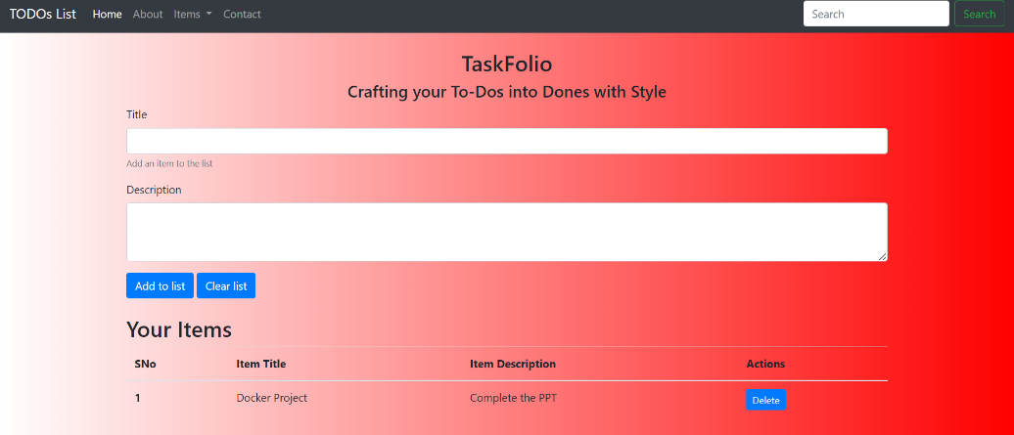

Final User Interface

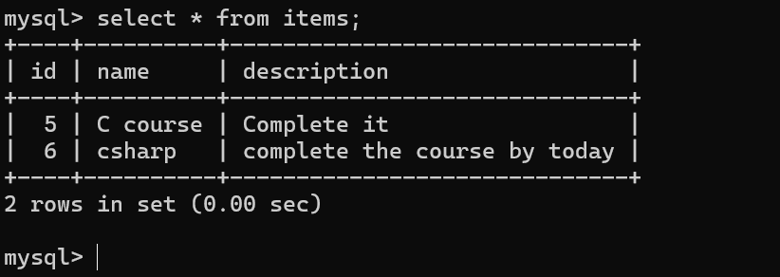

MySQL Database

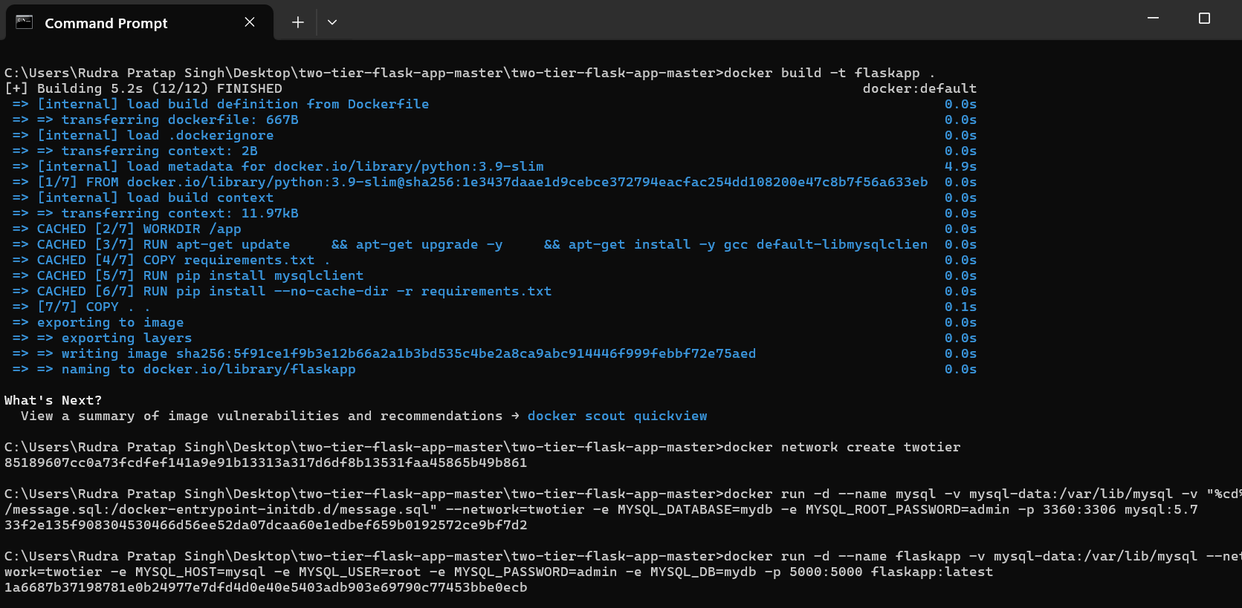

Dockerization of Containers

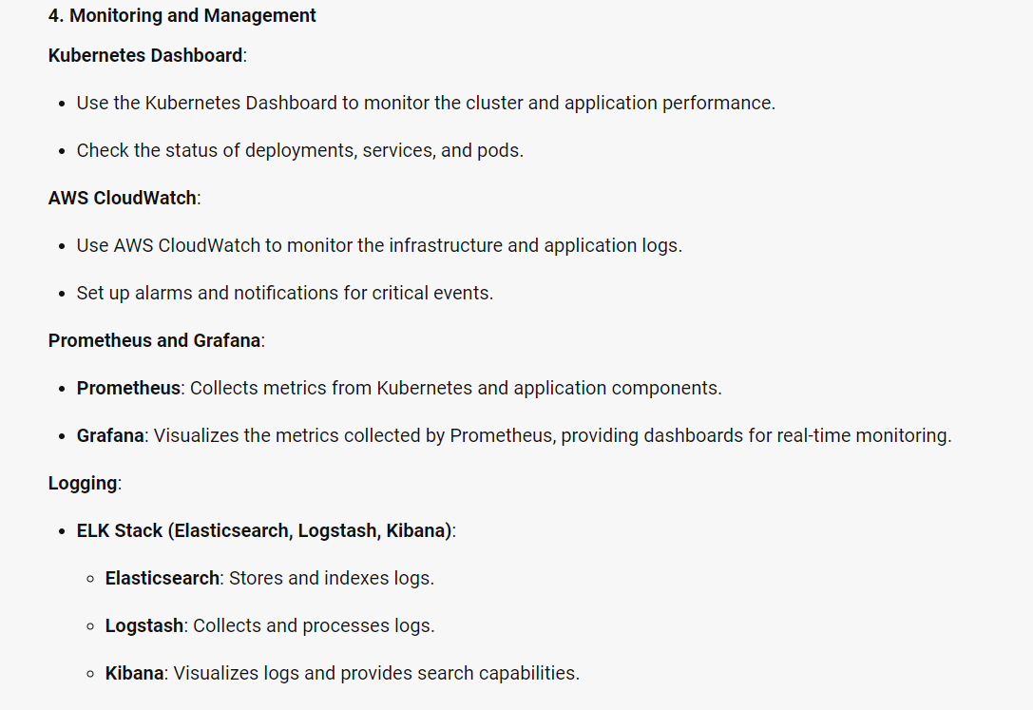

CONCLUSION

The deployment of your 2-Tier application using Docker, Kubernetes, HELM, and AWS represents a modern, scalable, and efficient approach to application management. By containerizing the Flask application and MySQL database, you ensure consistency across different environments. Kubernetes provides robust orchestration, managing the deployment, scaling, and maintenance of your containers. HELM simplifies the packaging and deployment process, making it easier to manage complex Kubernetes applications. AWS offers a reliable and scalable cloud infrastructure, ensuring high availability and performance.

This architecture not only enhances the application’s scalability and reliability but also simplifies the deployment and management processes. The use of monitoring and logging tools like Kubernetes Dashboard, AWS CloudWatch, Prometheus, Grafana, and the ELK Stack ensures that you can maintain visibility into the application’s performance and quickly address any issues that arise.

Overall, this project demonstrates a comprehensive and modern approach to deploying and managing a 2-Tier application, leveraging the best practices and tools available in the industry. It sets a strong foundation for future enhancements and scalability, ensuring that the application can grow and adapt to changing requirements.

FUTURE SCOPE

The deployment of TaskFolio using Docker, Kubernetes, HELM, and AWS sets a strong foundation for future enhancements and scalability. Here are some potential areas for future development and improvement:

**1. Enhanced Scalability and Performance**

* **Auto-Scaling**: Implement advanced auto-scaling policies to handle varying loads more efficiently. This can include horizontal pod autoscaling based on custom metrics.
* **Load Testing**: Conduct comprehensive load testing to identify performance bottlenecks and optimize resource allocation.

**2. Advanced Monitoring and Logging**

* **Distributed Tracing**: Integrate distributed tracing tools like Jaeger or Zipkin to trace requests across microservices and identify latency issues.
* **Enhanced Logging**: Implement centralized logging solutions with more advanced features, such as log aggregation and analysis using the ELK Stack (Elasticsearch, Logstash, Kibana).

**3. Security Enhancements**

* **Security Best Practices**: Implement security best practices for containerized applications, such as using secure images, regular vulnerability scanning, and applying security patches.
* **Network Policies**: Define and enforce network policies in Kubernetes to control traffic between pods and enhance security.

**4. Continuous Integration and Continuous Deployment (CI/CD)**

* **CI/CD Pipelines**: Set up CI/CD pipelines using tools like Jenkins, GitLab CI, or GitHub Actions to automate the build, test, and deployment processes.
* **Automated Testing**: Integrate automated testing frameworks to ensure code quality and reliability before deployment.

**5. Multi-Cloud and Hybrid Deployments**

* **Multi-Cloud Strategy**: Explore deploying the application across multiple cloud providers to enhance redundancy and avoid vendor lock-in.
* **Hybrid Cloud**: Implement a hybrid cloud strategy to leverage both on-premises and cloud resources for better flexibility and cost management.

**6. Microservices Architecture**

* **Service Decomposition**: Gradually decompose the monolithic Flask application into smaller, independent microservices to improve scalability and maintainability.
* **Service Mesh**: Implement a service mesh like Istio to manage microservices communication, security, and observability.

**7. User Experience Improvements**

* **UI/UX Enhancements**: Continuously improve the user interface and user experience based on user feedback and usability testing.
* **Mobile Support**: Develop a mobile version of the TaskFolio application to reach a broader audience.

**8. Data Analytics and Insights**

* **Analytics Integration**: Integrate analytics tools to gather insights on user behavior and application performance.
* **Data Warehousing**: Implement data warehousing solutions to store and analyze large volumes of data for business intelligence purposes.