**SVKM’s NMIMS**

**Mukesh Patel School of Technology Management & Engineering**

**Computer Engineering Department**

Program: MBA TECH - Sem II

**Course: Data Structure and Algorithm**

**Faculty:** Prof. Ameyaa Biwalkar

PART A

(PART A : TO BE REFFERED BY STUDENTS)

**Experiment No.01**

**A.1 Aim:**

Revise the concept of basic programming and array data structures.

**TASK 1:**

Write a C/C++ program of array to perform following **(1D Array)**

1. Find the sum and Average of all the elements.
2. Find highest and lowest element in an array.
3. Insert and delete an element in an array (by passing array to the function)

**A.2 Prerequisite:**

1. Knowledge of array data structures.

2. Fundamental concepts of C\C++.

**A.3 Outcome:**

**After successful completion of this programming exercise students will be able to**

1. Implement array data structures.

**A.4 Theory:**

**A.4.1. Introduction of Data structure**

* The data may be organized into many different ways. The logical and mathematical model of a particular organization of data is called data structure.
* A data structure helps you to understand relationship of one data element with the other and organize it within the memory.
* Data structure specified following:
  + Organization of data
  + Accessing methods
  + Degree of associativity
  + Processing alternatives for information
* Classification of data structure:

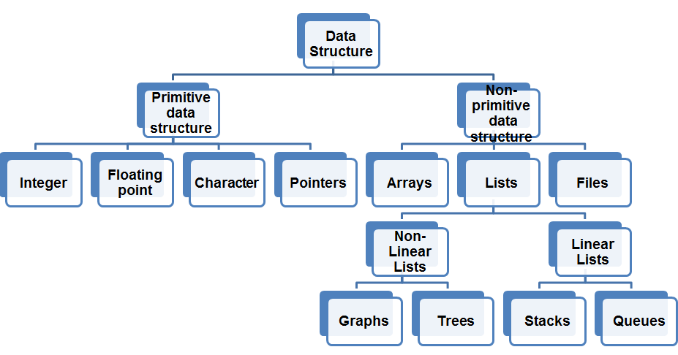

* Primitive data structure:
  + Basic structures
  + Directly operated upon by the machine instructions
* Non- Primitive data structures:
  + Derived from primitive data structure.
  + Emphasize on structuring of a group of homogenous or heterogeneous data structure.
  + Ex: Arrays, Lists, Files
* Various data structure:

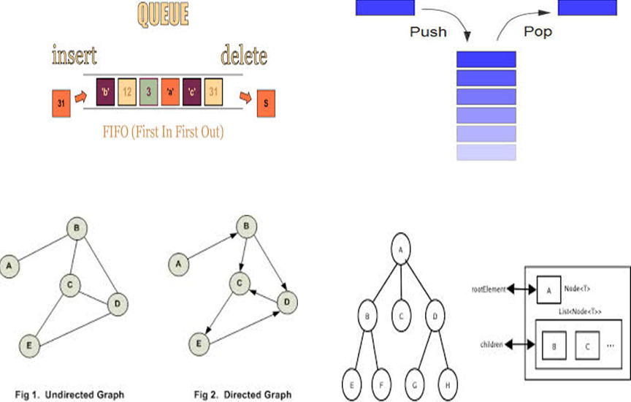

**********************

PART B

(PART B : TO BE COMPLETED BY STUDENTS)

***(Students must submit the soft copy as per following segments within two hours of the practical. The soft copy must be uploaded on the Blackboard or emailed to the concerned lab in charge faculties at the end of the practical in case the there is no Black board access available)***

|  |  |
| --- | --- |
| Roll No. N021 | Name: Saransh Singh dhapola |
| Class : | Batch : D2 |
| Date of Experiment: | Date of Submission21-01-22 |
| Grade : |  |

**B.1 Software Code written by student:**

***1)Finding sum and average*** 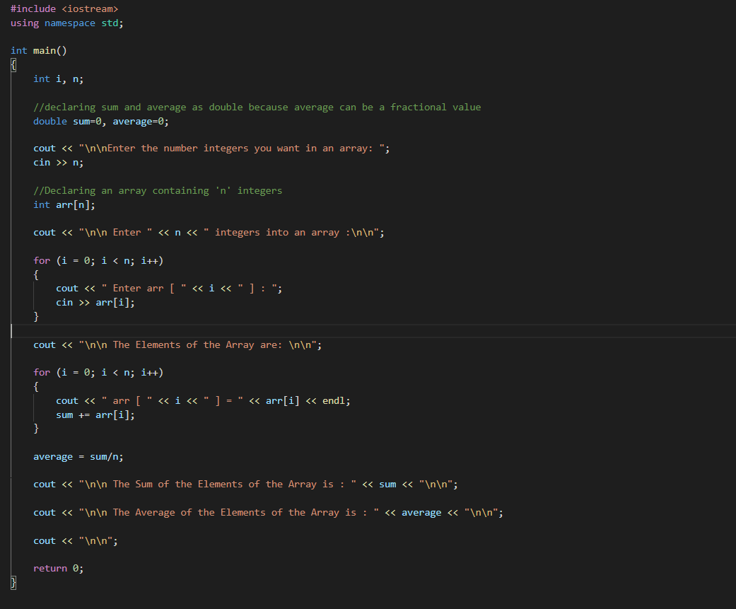

***2) Finding maximum and minimum value in array***

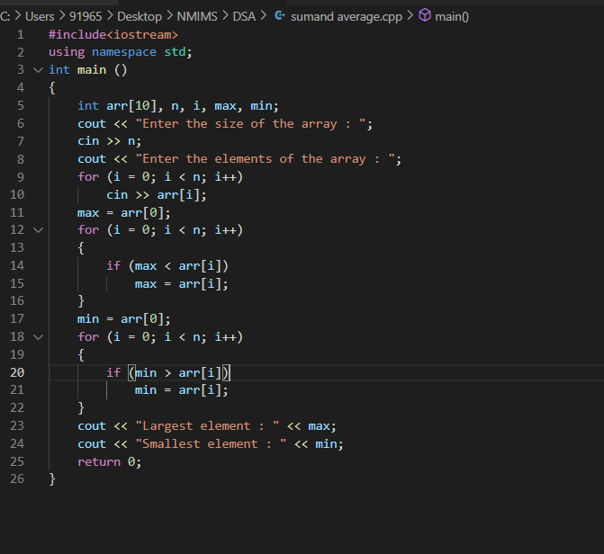

***3)Inserting element:***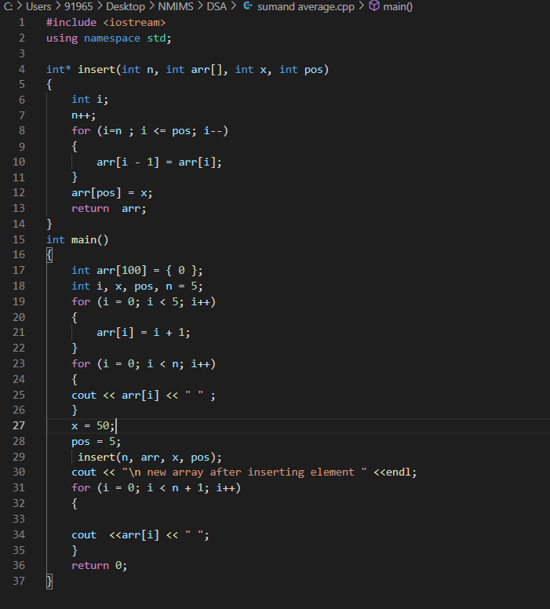

***3 b) Deleting element:***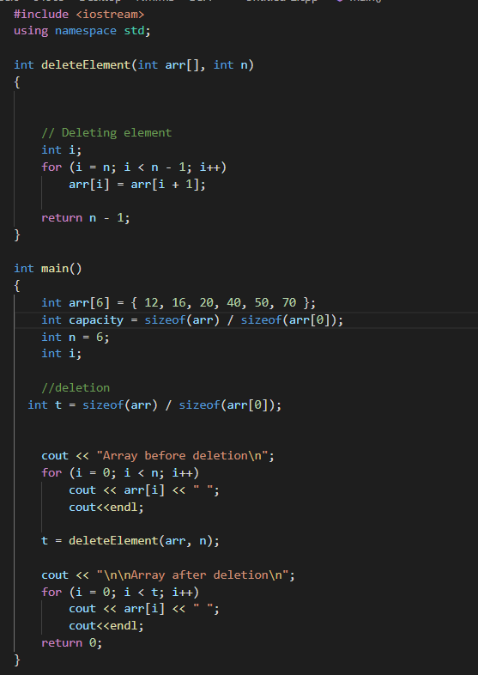

**B.2 Input and Output: (Task 1)**

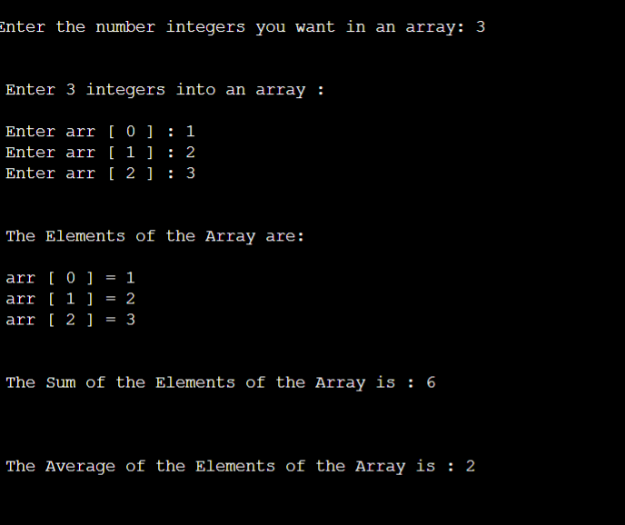

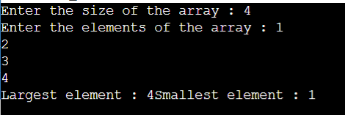

**3.a) inserting element:**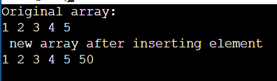

**3.b) Deleting element:**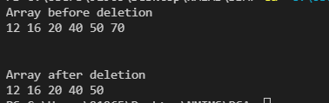

**B.3 Observations and learning [w.r.t. all tasks]:**

***Passing array through functions and augmenting it according to needs.***

**B.4 Conclusion:**

*Revised basic concept of array structure and passing it through functions.*

************************