At first login <https://rbsconnect.rbspeople.com> using your User name, password & token passcode.

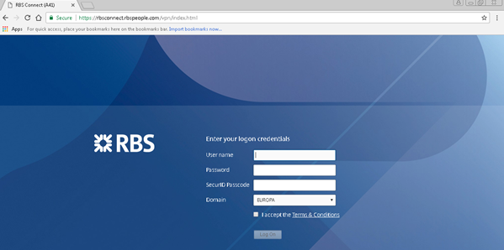

Once logged in successfully, the below page will appear. Click🡪 Detect Receiver.

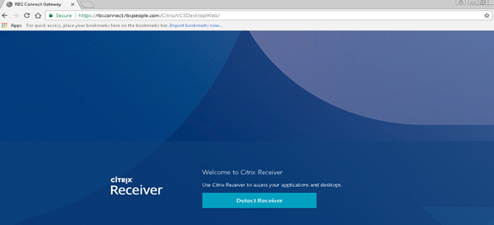

The below page will appear along with VCSe\VCS ICON, whichever machine is applicable.

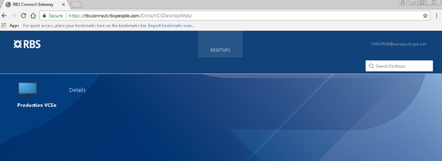

Click your [UserID@Domain.rbsgrp.net](mailto:UserID@Domain.rbsgrp.net) located at top right corner, which will then have two options for you to choose from.

1. Install Citrix Receiver

2. Log Off.

CLICK 🡪 Install Citrix Receiver, as shown below

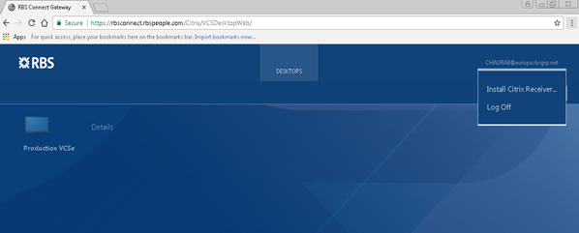

Once clicked Install Citrix Receiver, one will receive the message as below.

Just a moment, we’re detecting if Citrix Receiver is already installed. If Citrix Receiver is detected, you will see a window in a few seconds. Please choose **Launch Application**. If no window appears, select **Already Installed**.

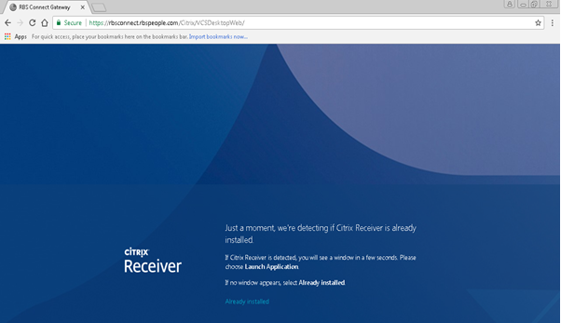

Accordingly one need to CLICK 🡪 **Launch Application** OR **Already Installed**

If you have clicked on **Launch Application**, the below page will appear.

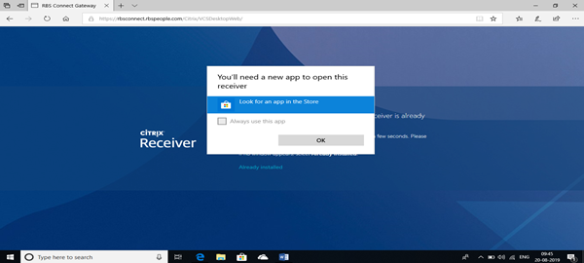

CLICK 🡪 OK and type in Citrix Workspace, as shown below.

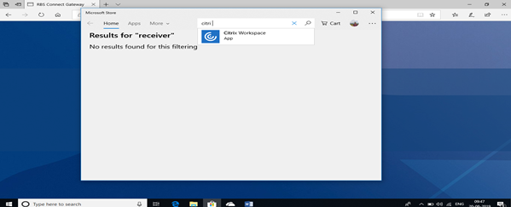

CLICK 🡪 **Get**

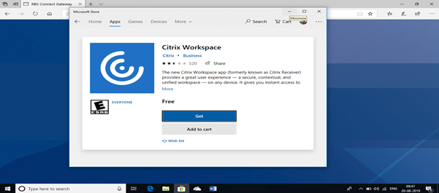

The below pop-up will appear, CLICK 🡪 close.

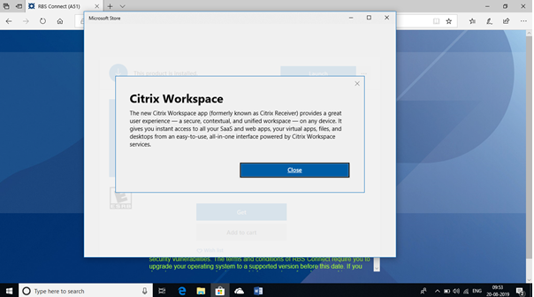

Once the Citrix App is installed successfully, the below pop-up will appear – user may close this Microsoft Store pop-up window.

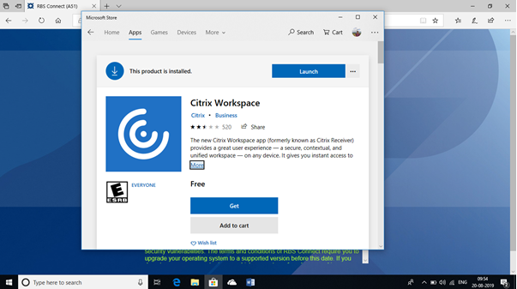

Once the above Microsoft Store pop-up window is closed one will be presented with the below page to login. User may login the below page using ones credentials and token passcode.

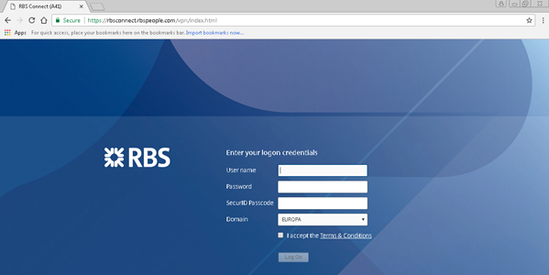

In case of successful authentication/login, user will be presented with below page.

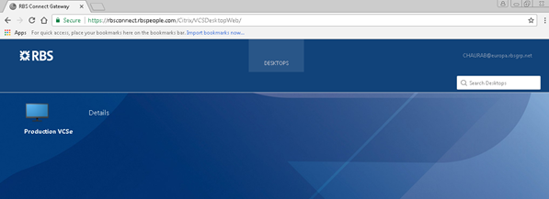

**Internet Explorer**: CLICK 🡪 VCSe\VCS icon, whichever is applicable – this will present you with your machine.

**CHROME**: CLICK 🡪VCSe\VCS icon, whichever is applicable and a file will be downloaded ends up with .ica. Click on the file and this will present you with your machine.

END OF DOCUMENT