**Java Assignment Outputs**

**Ques15**

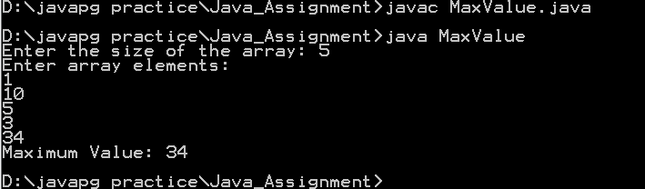

**Ques17**

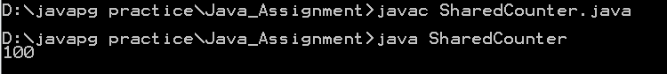

**Ques16**

