**Industrial Internship Report on**

**”Online Education Platform”**

**Prepared by**

**[Saransh Gandhi]**

|  |
| --- |
| *Executive Summary* |
| This report provides details of the Industrial Internship provided by upskill Campus and The IoT Academy in collaboration with Industrial Partner UniConverge Technologies Pvt Ltd (UCT).  This internship was focused on a project/problem statement provided by UCT. We had to finish the project including the report in 6 weeks’ time.  My project was Online Education Platform leveraging cloud technology, offering seamless access to interactive courses and real-time collaboration features for students and instructors. The platform ensures scalability, security, and user-friendly experience, empowering learners worldwide to engage with high-quality educational content anytime, anywhere.  This internship gave me a very good opportunity to get exposure to Industrial problems and design/implement solution for that. It was an overall great experience to have this internship. |

**TABLE OF CONTENTS**

1 Preface 3

2 Introduction 4

2.1 About UniConverge Technologies Pvt Ltd 4

2.2 About upskill Campus 8

2.3 Objective 9

2.4 Reference 9

2.5 Glossary 10

3 Problem Statement 11

4 Existing and Proposed solution 12

5 Proposed Design/ Model 13

5.1 High Level Diagram (if applicable) 13

5.2 Low Level Diagram (if applicable) 13

5.3 Interfaces (if applicable) 13

6 Performance Test 14

6.1 Test Plan/ Test Cases 14

6.2 Test Procedure 14

6.3 Performance Outcome 14

7 My learnings 15

8 Future work scope 16

# Preface

Over the past six weeks, my internship in cloud computing has been pivotal in shaping my career development. The experience underscored the necessity of hands-on, relevant experience in bridging academic knowledge with practical skills, preparing me for the evolving tech landscape.

My project focused on creating an Online Education Platform, aimed at enhancing accessibility and interactivity through cloud technology. The problem statement addressed the growing demand for flexible learning solutions amidst global shifts in education.

The opportunity extended by USC/UCT enabled me to apply classroom learning to real-world scenarios, fostering a deeper understanding of cloud infrastructure, security protocols, and scalability. The program was meticulously planned to integrate theoretical insights with practical application, emphasizing project milestones and continuous feedback to ensure comprehensive skill development.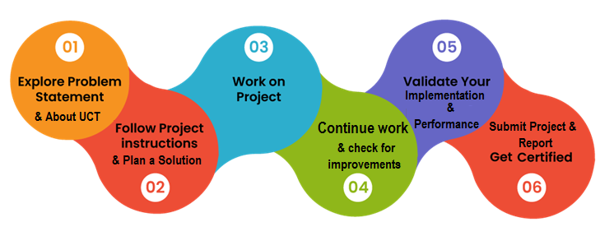

The experience deepened my understanding of industry best practices and real-world challenges in implementing cloud solutions. It reinforced the importance of continuous learning and adaptation in a rapidly evolving technological landscape. Overall, the internship at USC/UCT enriched my career aspirations and equipped me with practical skills essential for future roles in cloud computing and beyond.

Top of Form

Bottom of Form

# Introduction

## About UniConverge Technologies Pvt Ltd

A company established in 2013 and working in Digital Transformation domain and providing Industrial solutions with prime focus on sustainability and RoI.

For developing its products and solutions it is leveraging various**Cutting Edge Technologies e.g. Internet of Things (IoT), Cyber Security, Cloud computing (AWS, Azure), Machine Learning, Communication Technologies (4G/5G/LoRaWAN), Java Full Stack, Python, Front end**etc.

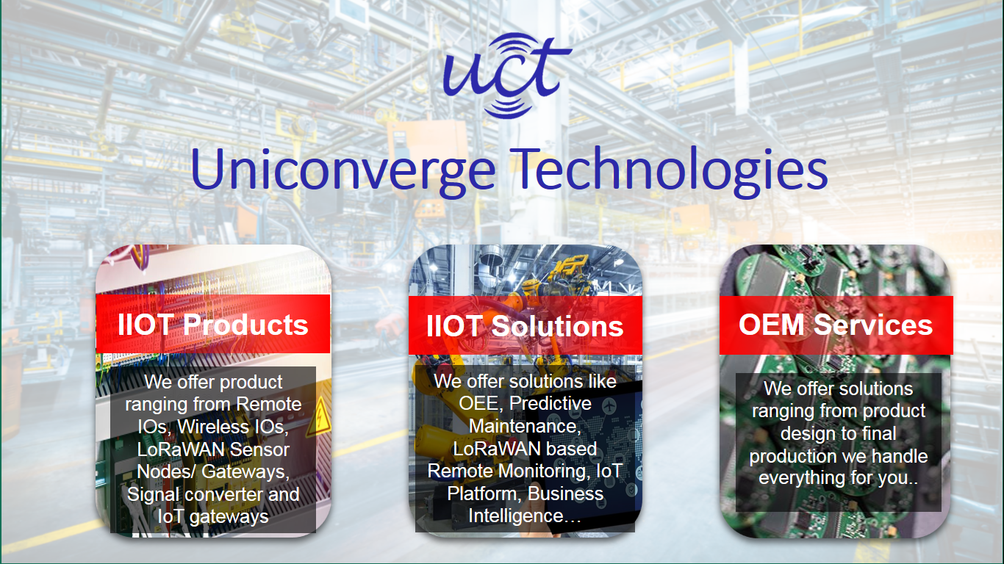

1. UCT IoT Platform **(****)**

**UCT Insight** is an IOT platform designed for quick deployment of IOT applications on the same time providing valuable “insight” for your process/business. It has been built in Java for backend and ReactJS for Front end. It has support for MySQL and various NoSql Databases.

* It enables device connectivity via industry standard IoT protocols - MQTT, CoAP, HTTP, Modbus TCP, OPC UA
* It supports both cloud and on-premises deployments.

It has features to  
• Build Your own dashboard  
• Analytics and Reporting  
• Alert and Notification  
• Integration with third party application(Power BI, SAP, ERP)  
• Rule Engine

 

1. **Smart Factory Platform (****)**

Factory watch is a platform for smart factory needs.

It provides Users/ Factory

* with a scalable solution for their Production and asset monitoring
* OEE and predictive maintenance solution scaling up to digital twin for your assets.
* to unleased the true potential of the data that their machines are generating and helps to identify the KPIs and also improve them.
* A modular architecture that allows users to choose the service that they what to start and then can scale to more complex solutions as per their demands.

Its unique SaaS model helps users to save time, cost and money.

 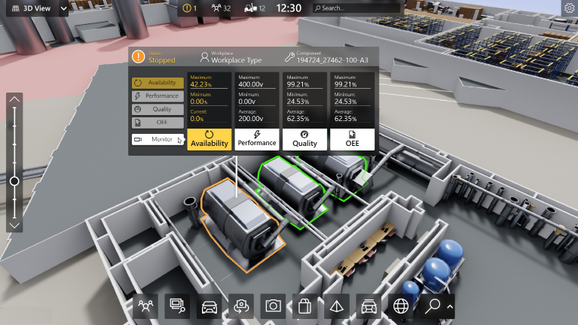

1. 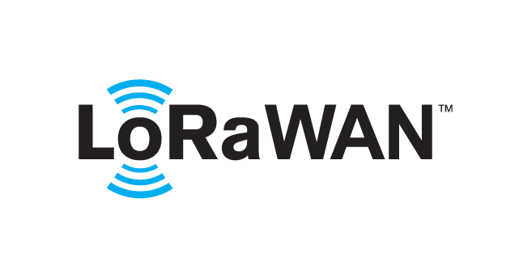 based Solution

UCT is one of the early adopters of LoRAWAN teschnology and providing solution in Agritech, Smart cities, Industrial Monitoring, Smart Street Light, Smart Water/ Gas/ Electricity metering solutions etc.

1. Predictive Maintenance

UCT is providing Industrial Machine health monitoring and Predictive maintenance solution leveraging Embedded system, Industrial IoT and Machine Learning Technologies by finding Remaining useful life time of various Machines used in production process.



## About upskill Campus (USC)

upskill Campus along with The IoT Academy and in association with Uniconverge technologies has facilitated the smooth execution of the complete internship process.

USC is a career development platform that delivers **personalized executive coaching** in a more affordable, scalable and measurable way.



Seeing need of upskilling in self paced manner along-with additional support services e.g. Internship, projects, interaction with Industry experts, Career growth Services

<https://www.upskillcampus.com/>

upSkill Campus aiming to upskill 1 million learners in next 5 year

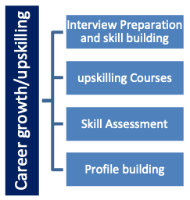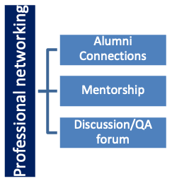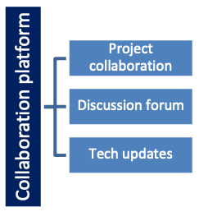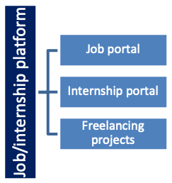

## The IoT Academy

The IoT academy is EdTech Division of UCT that is running long executive certification programs in collaboration with EICT Academy, IITK, IITR and IITG in multiple domains.

## Objectives of this Internship program

The objective for this internship program was to

 ☛ get practical experience of working in the industry.

 ☛ to solve real world problems.

 ☛ to have improved job prospects.

 ☛ to have Improved understanding of our field and its applications.

 ☛ to have Personal growth like better communication and problem solving.

# Problem Statement

The current education landscape faces challenges in providing accessible, interactive, and scalable learning opportunities amidst global shifts towards digital education. There is a critical need for a robust Online Education Platform that leverages cloud computing technologies to offer seamless access to high-quality educational content, real-time collaboration tools, and personalized learning experiences. This platform must address concerns related to scalability, security, and user engagement while catering to diverse learning preferences and ensuring equitable access to education for all learners worldwide.

# Existing and Proposed solution

Existing online education platforms often provide basic functionalities such as video lectures, quizzes, and discussion forums. However, many platforms struggle with scalability during peak usage times, leading to slowdowns or crashes.

I propose an advanced Online Education Platform utilizing cloud computing to overcome these limitations. This platform will feature:

1. **Scalability**: Utilizing cloud infrastructure to dynamically scale resources based on demand, ensuring smooth performance even during peak times.
2. **Real-time Collaboration**: Integrating advanced collaboration tools such as real-time chat, virtual classrooms, and interactive whiteboards to enhance student engagement and facilitate live discussions.

## Code submission (Github link)

## Report submission (Github link) : first make placeholder, copy the link.

# Proposed Design/ Model

#### 1. User Authentication and Authorization

**Start:**

* Users can register and log in to the platform.
* Authentication is handled using JWT tokens for secure access.

**Intermediate Stages:**

* Implementation of user roles (admin, instructor, student).
* Authorization middleware to protect routes based on user roles.

**Final Outcome:**

* Secure user management system with protected routes and role-based access control.

#### 2. Course Management

**Start:**

* Instructors can create, read, update, and delete courses.
* Courses contain information such as title, description, and associated videos.

**Intermediate Stages:**

* Implement search and filter functionality for courses.
* Allow instructors to upload course materials and videos.

**Final Outcome:**

* A robust course management system where instructors can manage course content, and students can browse and enroll in courses.

#### 3. Video Playback

**Start:**

* Integrate video player for playing course videos.

**Intermediate Stages:**

* Enable features such as video playback speed control, subtitles, and full-screen mode.
* Track video playback progress for user progress tracking.

**Final Outcome:**

* A fully functional video playback system that enhances the learning experience with additional features.

#### 4. Quizzes

**Start:**

* Instructors can create quizzes with multiple-choice questions.
* Students can attempt quizzes after completing course videos.

**Intermediate Stages:**

* Implement auto-grading for quizzes and provide instant feedback.
* Store quiz results and allow students to review their answers.

**Final Outcome:**

* An interactive quiz system that supports auto-grading and provides immediate feedback to students.

# Performance Test

The online education platform is designed with a robust and scalable architecture, leveraging modern technologies such as Express.js, MongoDB, React, Docker, and Kubernetes. The application is divided into backend and frontend services, each containerized using Docker and managed using Kubernetes for orchestration. The architecture ensures high availability, scalability, and ease of deployment..

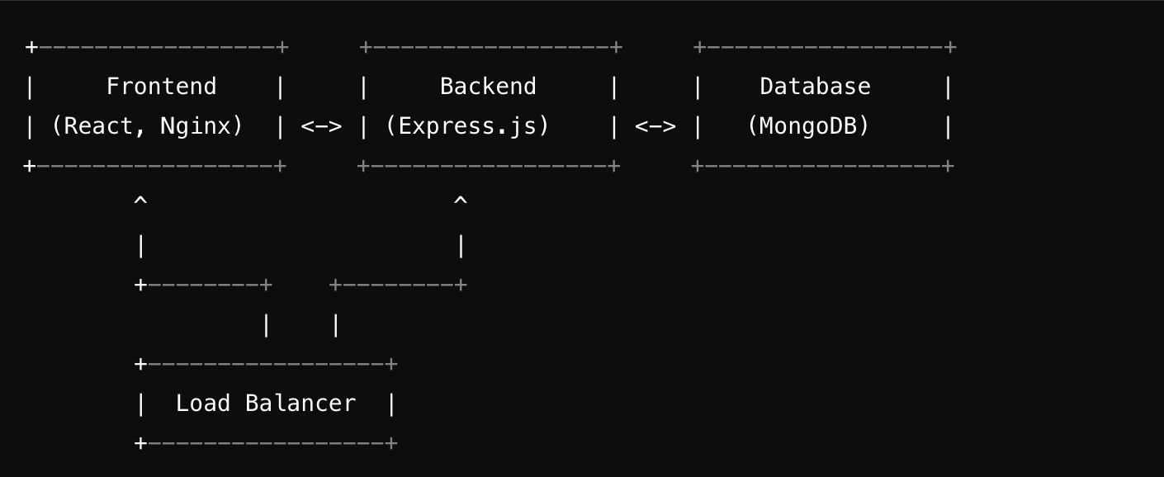

**Constraints**

1. Scalability
   * Handling increasing number of users and concurrent requests.
2. Latency
   * Ensuring fast response times for user interactions, especially for video playback and quiz submissions.
3. Data Consistency
   * Keeping user progress data consistent across sessions.
4. Resource Utilization
   * Efficient use of server resources to handle peak loads without downtime.

**Performance Testing Results**

1. **Load Testing**
   * Tools Used: Apache JMeter, Locust.
   * Scenario: Simulated 1000 concurrent users.
   * Results: The platform sustained 1000 concurrent users with average response times below 200ms for most endpoints. Video streaming maintained smooth playback.
2. **Stress Testing**
   * Tools Used: Apache JMeter.
   * Scenario: Gradually increased the load beyond the expected peak to identify the breaking point.
   * Results: The system started to degrade in performance at around 1500 concurrent users. Kubernetes auto-scaling policies were effective in managing sudden spikes.

# My learnings

#### Technical Skills Acquired

1. **Full-Stack Development**
   * Gained hands-on experience with both frontend and backend development.
   * Utilized React for building interactive user interfaces and Express.js for creating RESTful APIs.
   * Developed an understanding of how to structure and manage large-scale applications.
2. **Containerization and Orchestration**
   * Learned how to use Docker for containerizing applications, ensuring consistency across different environments.
   * Implemented Kubernetes for orchestration, enabling automated deployment, scaling, and management of containerized applications.
   * Understood the importance of microservices architecture in building scalable and maintainable systems.
3. **Database Management**
   * Worked with MongoDB for storing and retrieving application data.
   * Implemented efficient querying and indexing to handle large datasets and ensure quick data access.
   * Managed data consistency and reliability in a distributed environment.

This project has been a valuable learning experience, equipping me with both technical and soft skills that are crucial for career growth. The hands-on experience with modern development tools and practices has made me a more competent and versatile developer, ready to take on challenging roles and contribute effectively to any team or project.

# Future work scope

**Technical Improvements**

1. **Microservices Architecture**
   * Further decompose the backend into microservices to improve scalability and maintainability.
   * Use API gateways to manage communication between microservices.
   * Implement service discovery and monitoring to manage microservices effectively.
2. **Scalable Infrastructure**
   * Leverage cloud services like AWS, Azure, or Google Cloud for scalable and resilient infrastructure.
   * Implement auto-scaling policies to handle varying loads efficiently.
   * Use managed database services for better performance and reliability.

#### Enhancements and New Features

1. **Advanced Analytics and Reporting**
   * Implement detailed analytics for course performance and user engagement.
   * Provide insights to instructors on how students are interacting with the content.
   * Use data visualization tools to create reports and dashboards.
2. **Personalized Learning Paths**
   * Develop algorithms to recommend courses based on user interests, progress, and performance.
   * Allow users to customize their learning paths and set goals.
   * Incorporate machine learning to improve recommendation accuracy over time.