**ISME Conference**

Present ISME Conference on Mechanical Engineering is the Nineteenth in the series of conferences organized by Indian Society of Mechanical Engineers (ISME). The conference will be held during December 20th - 22nd 2018 at Dr B. R. Ambedkar National Institute of Technology, Jalandhar. To keep abreast of latest developments in the industry, a platform is set-up under the aegis of ISME to organize conferences. The purpose of this conference is to bring together the Mechanical Engineering community to explore, disseminate and strengthen initiatives in new directions under the broad areas of Machine Design, Materials and Manufacturing, Thermal Engineering and Industrial Engineering. The conference is aimed at enabling sustainable development through cutting edge technologies of Mechanical Engineering.

**Dr. B. R. Ambedkar National Institute of Technology, Jalandhar**

The Institute is named after Bharat Ratna Dr B. R. Ambedkar, founder of Indian Constitution. The institute came into existence in the year 1988 as Regional Engineering College on a beautiful campus of about 154 acres close to the heart of Jalandhar city. The institute obtained the status “Institute of National Importance” by Act of Parliament in 2007. The institute is located on the G.T Road Amritsar bye-pass at a distance of 15 km from Jalandhar Bus Stand, 12 km from Jalandhar City Railway Station, and 18 km from Jalandhar Cantt. railway station. The institute is well connected to the National Capital through rail and road link.

**Department of Mechanical Engineering**

The Department of Mechanical engineering was founded in 1990 and has grown as one of the dynamic departments of the Institute over the last three decades. The department offers B Tech, M Tech and PhD programmes. The B. Tech program is accredited by the NBA.

**Call for Papers/Posters**

The organizers invite papers from students, teachers, scientists and researchers in academia and industry to present the results of their research and development efforts in Mechanical Engineering. Papers must report original academic or industrial research in any of the following topics not limited to but relevant to the conference.

|  |  |
| --- | --- |
| **Track – 01:**   * **Machine Design** *Multi-body Dynamics* * *Bond Graph Modeling* * *CAD / CAE* * *Design of Mechanical Systems* * *Fatigue Fracture & Failure Analysis* * *FEM* * *Mechanisms* * *Rotor Dynamics* * *Vibrations & Control* * *Friction Wear & Lubrication* * *Product Design & Development* | **Track – 02:**  **Thermal Engineering**   * *Alternate Fuels* * *Automobile Engineering* * *Multi Phase flow* * *CFD* * *Combustion & IC Engines* * *Fluid Mechanics* * *Gas Turbines and Gas Dynamics* * *Heat Transfer* * *Micro fluidics* * *Refrigeration and Air-conditioning* * *Renewable Sources of Energy* * *Thermal System Simulation* |
| **Track – 03:**  **Materials and Manufacturing**   * *Advances in Welding / Casting/ Forming Processes* * *CIM / CAM* * *Conventional /* * *Un conventional Machining* * *Composite Materials* * *FMS* * *Micro and Nano Manufacturing* * *Powder metallurgy* * *Rapid Prototyping* * Robotics and *Mechatronics* | **Track – 04:**  **Industrial Engineering**   * *Design and Analysis of Experiments* * *Entrepreneurship Development* * *Lean Manufacturing* * *Manufacturing Management* * *Product Life cycle Management* * *Quality Engineering* * *Reliability Engineering* * *Soft Computing Techniques* * *Supply Chain Management* |

**Author Guidelines**

The presenters should submit an abstract of approximately 300 words with Times New Roman, 12 point, fonts in Windows-based Microsoft Word (.doc /.docx) document by attaching an e-mail to [**isme2018@**](mailto:isme2018@)**nitj.ac.in** by mentioning the **Track No.** and **Type of Presentation** (i.e., Oral or Poster) in the mail subject with other relevant details. The abstract shall be reviewed by a peer committee. Selected manuscripts will be accepted for either oral or poster presentation. All the templates and detailed guidelines are available at conference website [**http://nitj.ac.in/isme2018**](http://nitj.ac.in/isme2018)**.** Selected Papers of 19th ISME conference will be published in ISME journals (Journal of Mechanics and Design, Journal of Thermo-fluid, Journal of Manufacturing Sciences) after conducting the review process of journals.

**Registration Fees**

At least one author of each accepted paper must register by October 18, 2018 in order for the paper to be included in the proceedings. Student registrations are only acceptable if first author of the paper is a full-time student at an Institution.

**Registration Details**

The registration fees for attending the conference:

|  |  |
| --- | --- |
| **Participants from Industry** | **INR 10,000** |
| **Participants from Academia** | **INR 6,000** |
| **Participants with ISME membership** | **INR 4,000** |
| **Student Participants** | **INR 2,000** |
| **Student with ISME membership** | **INR 1,500** |
| **Foreign Delegates** | **USD 500** |

**Important Dates**

|  |  |
| --- | --- |
| **Abstract Submission** | June 15, 2018 |
| **Acceptance of Abstract** | July 15, 2018 |
| **Submission of Full length Manuscript** | August 10, 2018 |
| **Notification of Acceptance** | September 25, 2018 |
| **Registration begins** | September 26, 2018 |
| **Authors Registration ends** | October 18, 2018 |
| **Participant Registration till** | December 20, 2018 |

**Organizing Committee**

**Patron:**

Professor L.K. Awasthi, Director, NIT Jalandhar

**Chairman:** Dr. Rajeev Kukreja

**Organizing Secretary:** Dr. Pramod Kumar

**Treasurer:** Dr. Dinesh Kumar Shukla

**Joint Secretaries:**

|  |  |
| --- | --- |
| * Dr. Subhash Chander | * Dr. R.S. Bharj |
| * Mr. Ajay Trehan | * Dr. Anish Sachdeva |
| * Dr. Raman Bedi | * Dr. S.K.Tiwari |
| * Dr S S Sandhu |  |

**Executive Members**

|  |  |
| --- | --- |
| * Dr Sumit Sharma | * Dr Rajan Kumar |
| * Dr Saurabh Kango | * Dr Dwesh K. Singh |
| * Dr Manoj Kumar | * Dr Sanjay |
| * Dr Nitin Sharma | * Dr Satyender Singh |
| * Dr Ashok Kumar |  |

**Advisory Committee**

* Prof. Anjan Ray, IIT Delhi
* Prof. B. P. Patel, IIT Delhi
* Prof. N. K. Gupta, IIT Delhi
* Prof. P. V. Rao, IIT Delhi
* Prof. R.K. Pandey, IIT Delhi
* Prof. S. K. Saha, IIT Delhi
* Prof. S. P. Singh, IIT Delhi
* Prof. S. Veeravalli, IIT Delhi
* Prof. Sanjeev Jain, IIT Delhi
* Prof. C. S. P. Rao, NIT Waranga;
* Prof. G. Amba Prasad, NIT Warangal
* Prof. Sachin Maheshwari, NSIT, Delhi
* Prof. P. K. Singh, SLIET, Longowal
* Prof. Joseph A. Vaz , NIT, Jalandhar
* Prof. Arvind Bhardwaj, NIT Jalandhar
* Dr Nomesh Bolia, IIT Delhi
* Dr Premchandran, IIT Delhi  
  Dr Prabal Talukdar, IIT Delhi
* Dr Balaji Srinivasan, IIT Madras
* Dr K. Hariharan, IIT Madras
* Dr Navin Kumar, IIT Ropar
* Dr Kanwar Singh Arora, Tata Steel, Jamshedpur
* Dr S. Venkatachalapathy, NIT, Trichy
* Dr Ajay Gupta, NIT Jalandhar
* Dr Vishal S Sharma, NIT Jalandhar
* Dr Zaheer Khan, IITBHU, Varanasi

**Accommodation Guidelines**

Delegates will be provided suitable accommodation in the Institute. This accommodation is limited and will be available to registered participants on a first come first served basis. Accommodation charges will be borne by the delegates. For student delegates, accommodation will be provided at hostels on campus at nominal charges.

**Address for Communication**

Dr. Pramod Kumar , Organizing Secretary, ISME2018

Department of Mechanical Engineering,

Dr B R Ambedkar National Institute of Technology, Jalandhar-11.

Phone: +91 – 2690301/02, Ext: 3107  
Mobile: +91-9465242268   
Fax: +91 - 2690320  
Email**:** [**kushwahapramod@nitj.ac.in**](mailto:kushwahapramod@nitj.ac.in)

[**isme2018@nitj.ac.in**](mailto:isme2018@nitj.ac.in)

**Payment of Fees**

DD in favour of **“19th ISME Conference”** payable at Jalandhar **or**

Bank Transfer - Account Number: **37477865107**

State Bank of India, REC Jalandhar (Branch Code: 50841)

IFSC Code: SBIN0050841

SWIFT Code: SBININBBP36

MICR Code: 144002065

For further details, please visit the conference website: [**http://nitj.ac.in/isme2018**](http://nitj.ac.in/mechanical/isme2018)

***We request you to have a regular watch on our Conference website for updates.***

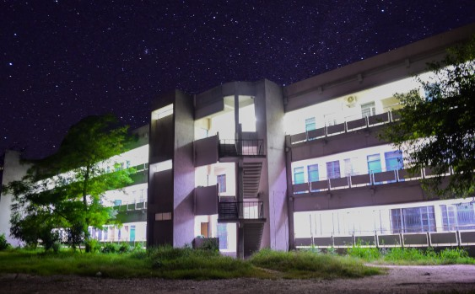

**19th ISME conference**

**ON**

**ADVANCES IN MECHANICAL ENGINEERING**

**(Mechanical Systems and Sustainability)**

**December 20th-22nd, 2018**



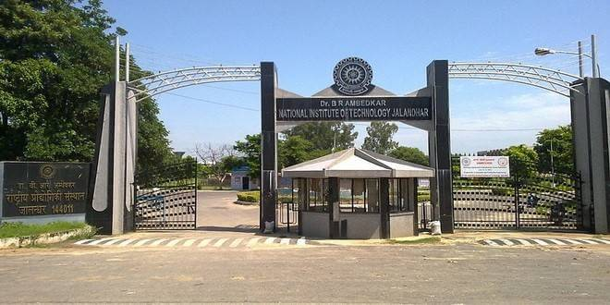

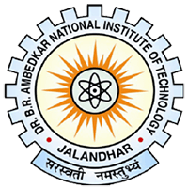

Organized by

Department of Mechanical Engineering

Dr B. R. Ambedkar National Institute of Technology

Jalandhar-144011

PUNJAB, INDIA