📘 Data Structures and Algorithms: Programming Assignment

Submitted By:
Name: Saransh Tiwari
Course: MBA Tech – Computer Engineering
Roll No: N251

✅ Problem 1: Best Time to Buy and Sell Stock – (Array Based Problem)
🔗 Platform: LeetCode
🔗 Problem Link: https://leetcode.com/problems/best-time-to-buy-and-sell-stock/

📌 Problem Description
You are given an array prices[] where prices[i] represents the price of a stock on the i-th day. Your task is to determine the maximum profit you can achieve by buying and selling once. You may not engage in multiple transactions (i.e., buy once and sell once).

✅ Sample Input / Output
Input: [7, 1, 5, 3, 6, 4]
Output: 5
Explanation:
Buy on day 2 (price = 1) and sell on day 5 (price = 6). Profit = 6 - 1 = 5.

🧠 Concepts Used
✔ Arrays
✔ Minimum tracking and difference calculation
✔ Time Complexity: O(n)

🧾 C++ Code (Screenshot Attached)
📎 Screenshot Name: problem1_code.png
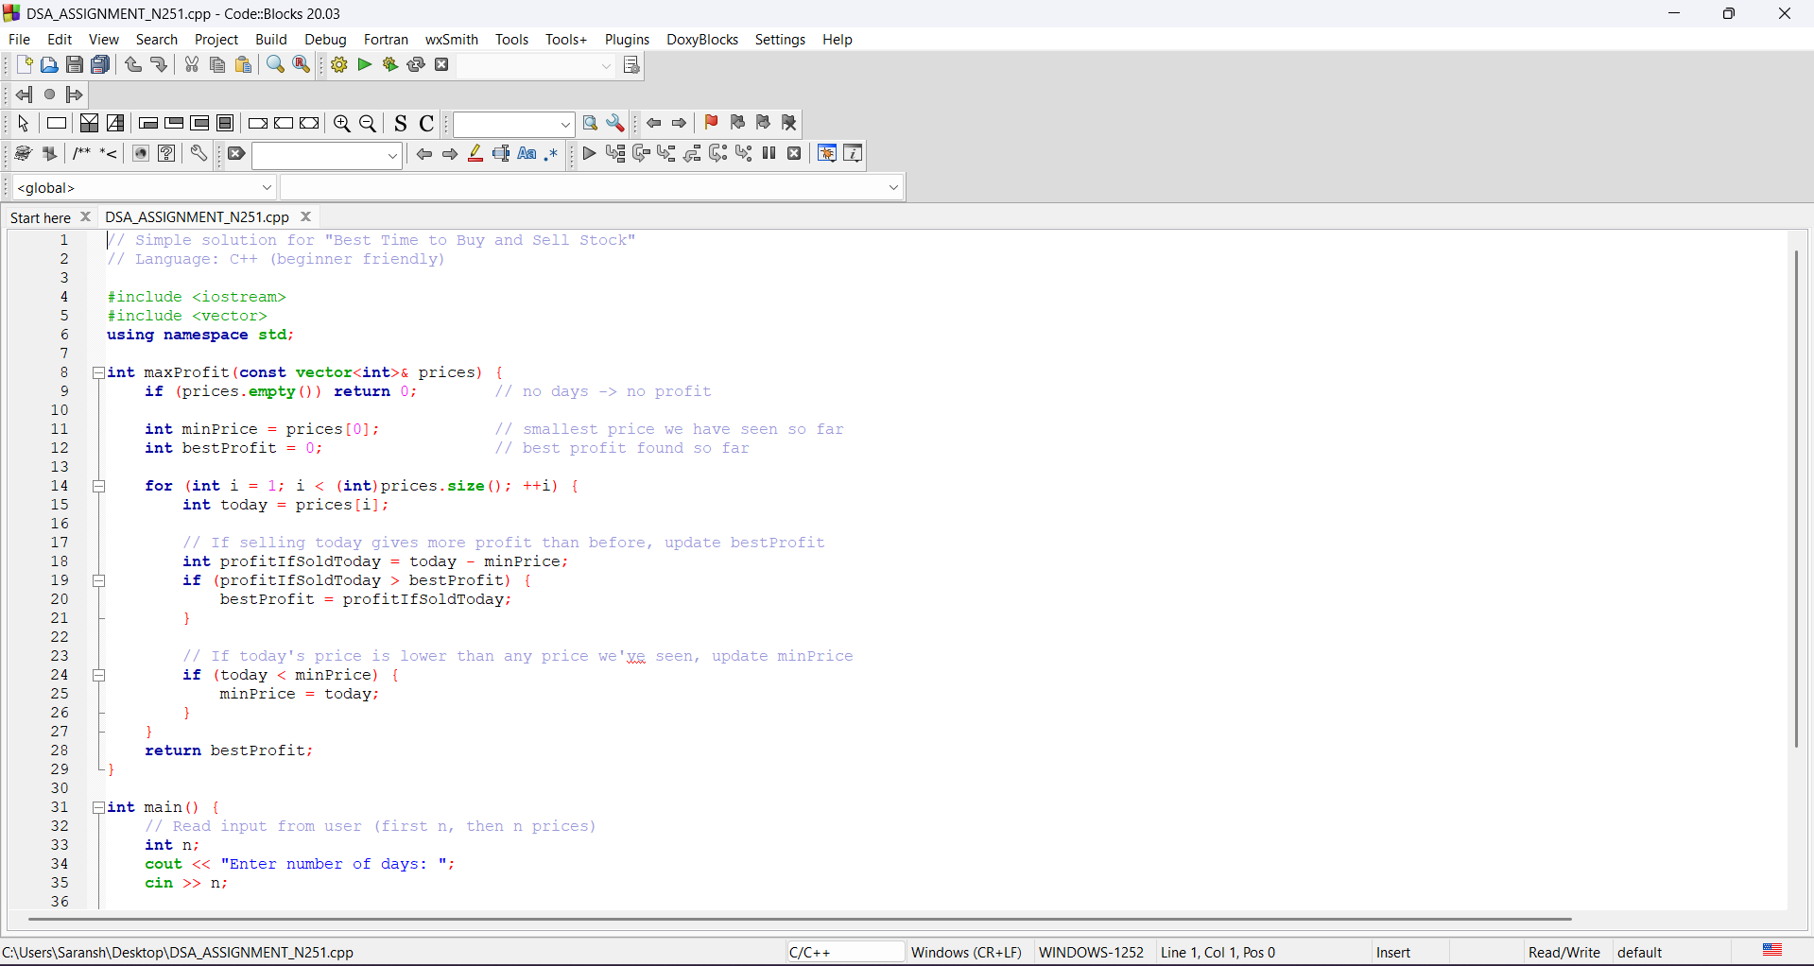
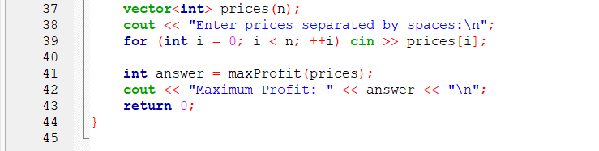

📷 Output Screenshot
📎 Screenshot Name: problem1_output.png
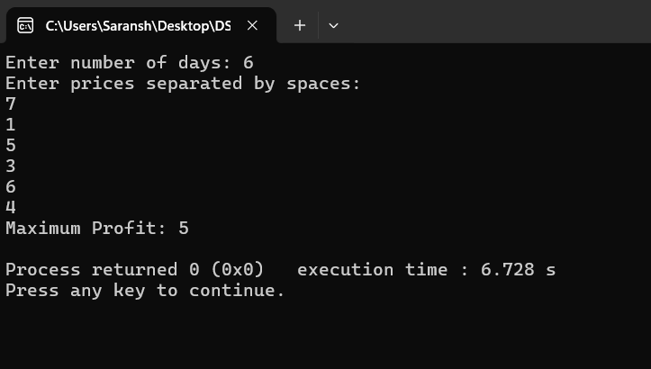

----------------------------------------------------------------------------------------------------------------------

✅ Problem 2: Design Browser History – (Stack Based Problem)
🔗 Platform: LeetCode
🔗 Problem Link: https://leetcode.com/problems/design-browser-history/

📌 Problem Description
Design a system that simulates browser navigation using Stack.
You can:
- Visit a new URL
- Go back a certain number of steps
- Go forward a certain number of steps
Your task is to implement a class BrowserHistory that supports these operations efficiently.

✅ Sample Input / Output
Input:
BrowserHistory browser("leetcode.com");
browser.visit("google.com");
browser.visit("facebook.com");
browser.visit("youtube.com");
browser.back(1);
browser.back(1);
browser.forward(1);
Output:
facebook.com

🧠 Concepts Used
✔ Stack Data Structure
✔ Push & Pop for Back/Forward navigation
✔ Time Complexity: O(1) average per operation

🧾 C++ Code (Screenshot Attached)
📎 Screenshot Name: problem2_code.png
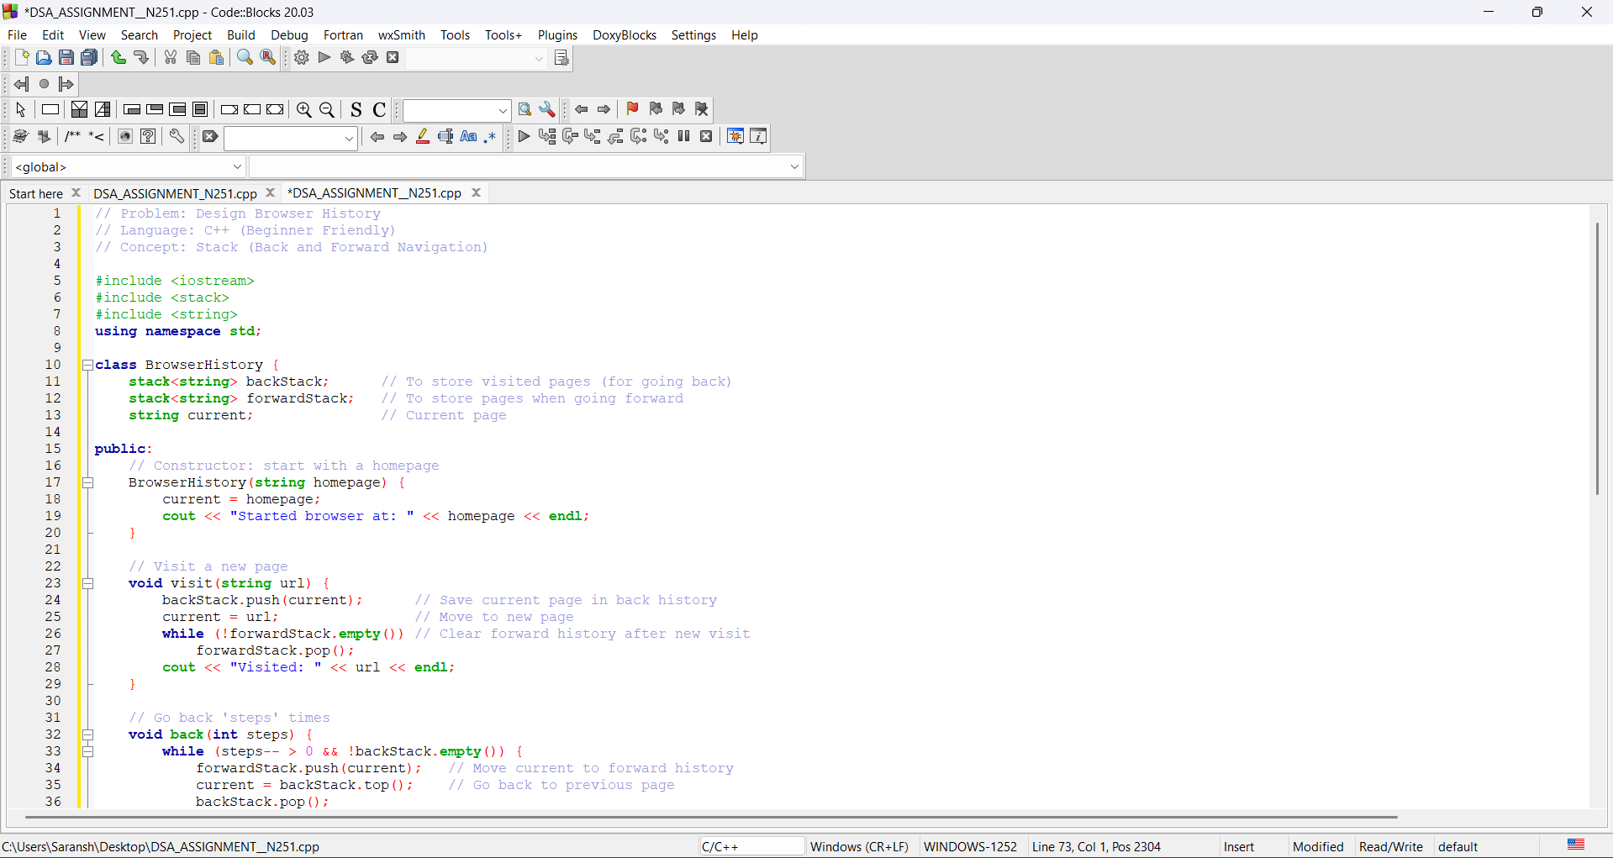
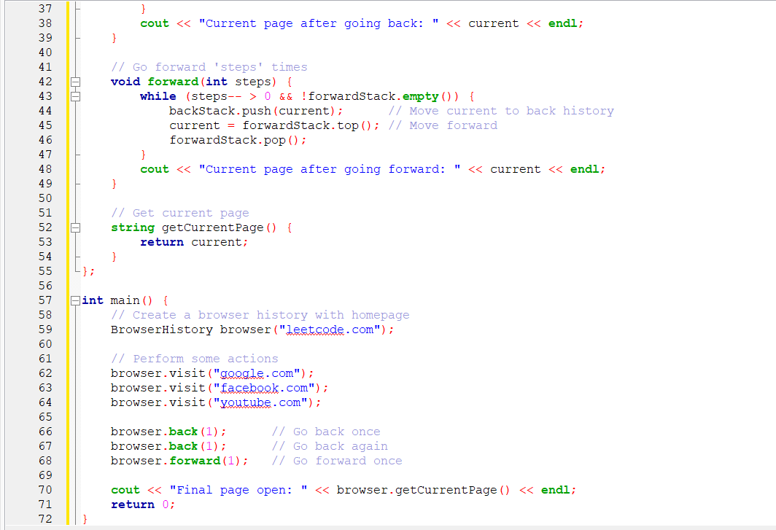

📷 Output Screenshot
📎 Screenshot Name: problem2_output.png
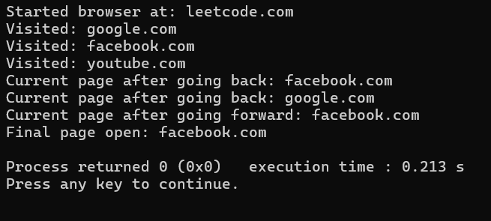

✅ GitHub Repository Link
🔗 (To be added later)

📌 Conclusion
✔ Successfully implemented two DSA problems in C++
✔ Demonstrated Array and Stack concepts using real-world examples
✔ Screenshots, code, and repository link (to be added) complete the submission

