**SQL Interview Questions with Solutions:**

**What do DDL, DML, and DCL stand for?**

DDL is the abbreviation for Data Definition Language dealing with database schemas, as well as the description of how data resides in the database.

DML denotes Data Manipulation Language which helps to modify the content/data of the table

DCL stands for Data Control Language

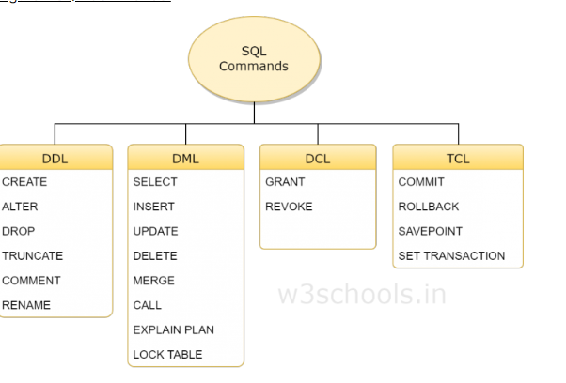

**How can you filter the duplicate data while retrieving records from the table?**

**Answer:**A DISTINCT keyword is used to filter the duplicate data from the table while retrieving the records from a table.

### ****Difference between CHAR and VARCHAR data types?****

When a table is created, CHAR is used to define the fixed length of the table and columns. The length value could be in the range of 1–255. The VARCHAR command is used to adjust the column and table lengths as required.

**What is the difference between NOW() and CURRENT_DATE()?**

**Answer:**Both **NOW()** and **CURRENT_DATE()** are built-in MySQL methods. **NOW()** is used to show the current date and time of the server and **CURRENT_DATE()** is used to show only the date of the server.

**What are joins and Group By ?**

**Answer:**The SQL statement that is used to make a connection between two or more tables based on the matching columns is called a join. It is mainly used for complex queries.

The GROUP BY clause is a SQL command that is used to **group rows that have the same values**

**Explain the different types of MySQL joins.**

**Different types of SQL joins are mentioned below:**

* **Inner Join**: It is a default join. It returns records when the values match in the joining tables.
* **Left Outer Join**: It returns all the records from the left table based on the matched records from the right table.
* **Right Outer Join**: It returns all the records from the right table based on the matched records from the left table.
* **Full Outer Join**: It returns all the records that match from the left or right table.

### ****What are the different types of strings used in database columns in MySQL?****

In MySQL, the different types of strings that can be used for database columns are SET, BLOB, VARCHAR, TEXT, ENUM, and CHAR

**How can you change the name of any existing table by using the SQL statement?**

RENAME TABLE table_name TO new_name

### ****What is the difference between the primary key and the Foreign key?****

The primary key in MySQL is used to identify every row of a table in a unique manner. For one table, there is only one primary key.

A foreign key refers to a field or a collection of fields in a database record that uniquely identifies a key field of another database record in some other table. In simple terms, it establishes a link between records in two different tables in a database. Meaning a foreign key defined in a table refers to the primary key of some other table

Primary Key cant be null and Foreign key accepts Null values

**When do we use LIKE operator in SQL?**

The LIKE operator is used in the WHERE clause of the SELECT , DELETE , and UPDATE statements to filter data based on patterns

There are two wildcards often used in conjunction with the LIKE operator:

* % - The percent sign represents zero, one, or multiple characters
* _ - The underscore represents a single character 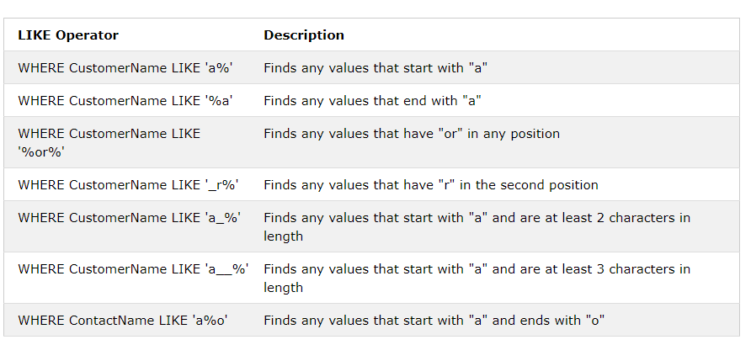

### ****What is BLOB data type?****

BLOBs are binary large object holding huge data.

**How can you retrieve the Data in Sorted order from the tables?**

Using Order By clause followed by asc or desc

**What is the view? How can you create and drop view in MySQL?**

In SQL, a view is a virtual table.A view contains rows and columns, just like a real table. The fields in a view are fields from one or more real tables in the database.

**How can you retrieve a particular number of records from a table?**

**LIMIT** clause is used with the SQL statement to retrieve a particular number of records from a table. From which record and how many records will be retrieved are defined by the LIMIT clause.

**Difference between WHERE and Having clause in SQL?**

The main difference between WHERE and HAVING clause comes when used together with GROUP BY clause, In that case WHERE is used to filter rows before grouping and HAVING is used to exclude records after grouping

**List out Aggregate Functions:**

The ISO standard defines five (5) aggregate functions namely;

1) COUNT  
2) SUM  
3) AVG  
4) MIN  
5) MAX

**What are all the Common SQL Functions?**

CONCAT(A, B) – Concatenates two string values to create a single string output. Often used to combine two or more fields into one single field.

FORMAT(X, D) – Formats the number X to D significant digits.

CURRDATE(), CURRTIME() – Returns the current date or time.

NOW() – Returns the current date and time as one value.

MONTH(), DAY(), YEAR(), WEEK(), WEEKDAY() – Extracts the given data from a date value.

HOUR(), MINUTE(), SECOND() – Extracts the given data from a time value.

DATEDIFF(A, B) – Determines the difference between two dates and it is commonly used to calculate age

SUBTIMES(A, B) – Determines the difference between two times.

FROMDAYS(INT) – Converts an integer number of days into a date value.

**What are SQL Constraints?**

MySQL CONSTRAINT is used to define rules to allow or restrict what values can be stored in columns. The purpose of inducing constraints is to enforce the integrity of a database

<https://www.w3resource.com/mysql/creating-table-advance/constraint.php>

**What is default table in databases?**

The **DUAL** is special one row, one column **table** present by **default** in all Oracle databases.

Example: Select current_date from dual