# TRAFFIC MANAGEMENT SYSTEMS

**TEAM MEMBER**

**962121104020:SARANYA.S**

**Phase 5: Submission document**

**Project Title: Traffic Management**

**Topic :In this part you will document your project and prepare it for submission**

## 

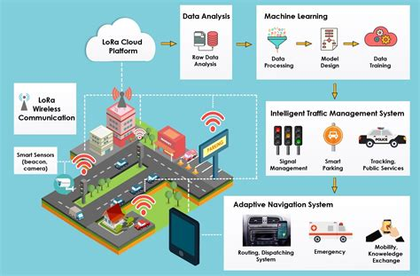

.

**Introduction:**

* Traffic management is the organisation, arrangement, guidance and control of both stationary and moving traffic, including pedestrians, bicyclists and all types of vehicles. Its aim is to provide for the safe, orderly and efficient movement of persons and goods, and to protect and, where possible, enhance the quality of the local environment on and adjacent to traffic facilities.
* This book is an introduction to traffic management, written in laypersons' language, and assuming no background knowledge of the subject. Various basic traffic characteristics relating to road users, vehicles and roads, and traffic regulation and control, are discussed, including some traffic volume and traffic flow considerations relevant to traffic management. For effective traffic management, it is essential that the practitioner works from factual information. Road inventory and statistical methods, and the more common types of traffic studies, including traffic volume and composition, origin and destination, speed, travel time and delay, accidents and parking are described. "Before and after" studies, and estimation of future traffic are also covered.
* As a basis for logically applying traffic management techniques it is necessary to develop a classification or hierarchy of all roads to ensure that the primary purpose of each of them is defined, agreed and understood. A functional classification of roads suitable for traffic management purposes, and a process for developing such a system is described. Several chapters go on to discuss various aspects of traffic management, including signing and delineation, pedestrian facilities, bicycle facilities, intersections, traffic signals, road capacity, parking, roadside safety and roadway lighting.
* The objectives of local area traffic management schemes, and a systematic process for developing them are described, and the various techniques that may be used and the principles of design of traffic management devices are summarised. The application of traffic management techniques to rural and urban arterial roads respectively is discussed, emphasising the desirability of treating routes or networks as a whole rather than simply focussing on isolated problem spots. Past and likely future trends in road travel, and various techniques for travel demand management are described. While these sorts of techniques are well known, and their use should be encouraged, they are unlikely to have much effect on travel in Australia at least for the foreseeable future.
* The important area of traffic enforcement and the associated aspects of education and encouragement are considered. Unless traffic management is logically applied and consistently enforced, it will not be effective. Enforcement must be considered an integral part of traffic management. (TRRL) management is the organisation, arrangement, guidance and control of both stationary and moving traffic, including pedestrians, bicyclists and all types of vehicles.
* For effective traffic management, it is essential that the practitioner works from factual information. Road inventory and statistical methods, and the more common types of traffic studies, including traffic volume and composition, origin and destination, speed, travel time and delay, accidents and parking are described. "Before and after" studies, and estimation of future traffic are also covered.
* Enforcement must be considered an integral part of traffic management. (TRRL)

# *PURPOSE AND OBJECTIVES:*

* Road Network Operations is a strategic approach to maximising efficiency on existing and future road infrastructure. At the tactical level this strategy translates into improving operations with the objective of reducing traffic delays and operating day-by-day in a more efficient way.
* At the strategic level, it means integrating the operations concept early on in the development of all road infrastructure projects, beginning with the planning and design process and ensuring adequate resources, both fiscal and personnel.

The road network operator has to consider the methods, organisational structures and resources needed to support strategies for road network operations, maintenance and incident response.

Objectives of the network operator :

* improving safety on the road network
* optimising traffic flow on arterial and freeway networks
* reducing congestion within and between cities
* co-ordinating agency traffic/transit operations
* managing incidents, reducing delays and adverse effects of incidents and congestion, weather, roadwork, special events, emergencies and disaster situations
* effectively managing maintenance and construction work to minimise the impact on safety and congestion
* informing travellers with timely and accurate information
* improving the interfaces between modes of transport for passengers and freight
* eliminating bottlenecks due to inadequate road geometry
* providing reliable and convenient public transport services

* **message** traffic incidents ahead, congestion, events, parking availability **signs** and weather conditions.

There are three broad categories of information that can be displayed via VMSs:

* control (e.g. lane control, prescribing control)
* warning (e.g. weather conditions, incidents, congestion, road works, road closures)
* information (e.g. useful traffic/weather information, network messages, safety messages)

The benefits of providing real time travel information include:

* a reduction in driver frustration
* allowing drivers to choose to use alternative routes
* a reduction in congestion
* improved safety

### **Real-time traffic updates:**

* Real-time traffic monitoring systems play a key role in the transition toward smart cities. A considerable amount of literature has been published on intelligent traffic management systems based on the [IoT](https://www.sciencedirect.com/topics/engineering/internet-of-things" \o "Learn more about IoT from ScienceDirect's AI-generated Topic Pages) paradigm Autonomous traffic sensing is at the heart of smart city infrastructures, wherein smart wireless sensors are used to measure traffic flow, predict congestion, and adaptively control traffic routes. Doing so effectively provides an awareness that enables more efficient use of resources and infrastructure.
* Identifying and measuring congestion is the very first step in the traffic management process. The flow, occupancy, density is the widely used traffic congestion measures, which are mostly obtained from images or videos captured by vision systems initially. Based on these measures, the traffic warning messages are broadcasted through smartphones, radio, televisions, light signals, dynamic variable message signs, or display units. Among them, the mobile-based web applications received much attention among researchers.
* Most of the recent developments in delivering real-time traffic updates used the congestion estimates to dynamically control the traffic signal An IoT based real-time traffic monitoring system is proposed for dynamic handling of traffic signals based on traffic density. The proposed system uses a set of [ultrasonic sensors](https://www.sciencedirect.com/topics/engineering/ultrasonic-sensor) and has two modules: one for vehicle monitoring and other for priority management.
* The ultrasonic sensors are used to detect vehicles, and the density levels of a given road are sent to an LCD, and the data sent to the server for later usage. In similar research [[63](https://www.sciencedirect.com/science/article/pii/S2589791820300207#bib63)], the authors proposed an ultrasonic sensor-based system model specifically for road intersections. In addition to traffic signal lightings, the system alarms on any false vehicle activities such as crossing the red signals.
* In another research, an IoT based smart traffic management system is proposed [[29](https://www.sciencedirect.com/science/article/pii/S2589791820300207#bib29)] to manage real-time traffic through both central and local servers. The data collection layer uses sensors, cameras, and RFIDs. The application layer automatically controls the traffic signal based on traffic density and provides a daily report through a web application. Besides sensors, video monitoring is also used to estimate traffic congestion density [[32](https://www.sciencedirect.com/science/article/pii/S2589791820300207#bib32)] and update traffic signals in real-time.
* The internet of connected vehicles is another research development in this area [[26](https://www.sciencedirect.com/science/article/pii/S2589791820300207#bib26)] to collect real-time traffic data. The connected vehicles support individual vehicle monitoring which enables efficient emergency vehicle management.
* Integrating roadside units (eg: traffic lights) with the vehicular network to ensure the trustworthiness of traffic events [[66](https://www.sciencedirect.com/science/article/pii/S2589791820300207#bib66)]. The emergency vehicle (e.g. Police cars, Fire engines, Ambulances) handling is very critical, the delay of every second matter because of the urgency of the services they are providing.
* Automatic scheduling of emergency vehicles can be performed by controlling the traffic signals [[45](https://www.sciencedirect.com/science/article/pii/S2589791820300207#bib45),[64](https://www.sciencedirect.com/science/article/pii/S2589791820300207#bib64)] to improve the response time [[57](https://www.sciencedirect.com/science/article/pii/S2589791820300207#bib57)]. However, these systems are specifically designed for highways.
* As this research does not anticipate any smart devices with the drivers, the traffic updates through roadside message units are analyzed in detail. A patented device for displaying traffic conditions [[17](https://www.sciencedirect.com/science/article/pii/S2589791820300207#bib17)] is designed to install on the roadside. The graphical message unit displays the upcoming traffic conditions and incidents through messages, signs, or colors. The studies on the impact of dynamic message signs through roadside message units show that it has received acceptance among drivers [[23](https://www.sciencedirect.com/science/article/pii/S2589791820300207#bib23),[35](https://www.sciencedirect.com/science/article/pii/S2589791820300207#bib35),[65](https://www.sciencedirect.com/science/article/pii/S2589791820300207#bib65)]. The dynamic message signs can be delivered in permanent mode through roadside message units (installed on bridges, toll plazas, [tunnels](https://www.sciencedirect.com/topics/engineering/tunnels), etc.) or portable units.
* The portable units are mainly used to warn about unusual traffic incidents. The roadside units mostly display the messages about over spilled roads, planned activities, environmental updates, traffic flow conditions, etc. The impact analysis of such message units reported that they mainly assist elderly drivers in their decision making [[23](https://www.sciencedirect.com/science/article/pii/S2589791820300207#bib23)].
* The transportation project for the Beijing Olympics (F [[69](https://www.sciencedirect.com/science/article/pii/S2589791820300207#bib69)]. is a great example of providing traffic updates through public message units. The project used changeable message boards, radios, television, internet, and in-vehicle displays to monitor and dispatch traffic updates. However, system development was quite expensive due to advanced programs and devices [[5](https://www.sciencedirect.com/science/article/pii/S2589791820300207#bib5)]. After that, several research efforts have been made in this area to provide real-time traffic updates. A system is proposed to display traffic intensity through three different light colors on installed electronic boards at decision points [[60](https://www.sciencedirect.com/science/article/pii/S2589791820300207#bib60)].
* In this system, the real-time traffic density is calculated from the average vehicle speed determined by vehicle detection systems. The authors apply [image processing algorithms](https://www.sciencedirect.com/topics/engineering/image-processing-algorithm) to process real-time traffic videos, and the traffic congestion estimation is based on [optical flow](https://www.sciencedirect.com/topics/medicine-and-dentistry/optic-flow). Similarly, electronic signboards are used to avoid congestions by setting up different speed limits [[21](https://www.sciencedirect.com/science/article/pii/S2589791820300207#bib21)].
* The studies discussed above are tested for highways, and real-time updates are delivered through traffic signals or mobile applications.
* Instead, this research proposes a system model for real-time traffic updates through roadside message units using an IoT platform Nowadays, digital electronic boards are widely used in smart campuses, that can be also reused (if any) to deliver traffic updates during peak hours. Next, discuss the wireless sensors which are mainly used for vehicle detection, classification, speed estimation, etc.
* Objective:
* IOT based traffic management
* Easy penalize traffic violators and helpofficials identify unauthorized drivers.
* Reroute the ambulance to the low congestion roads tohelp get medical care at the earliest.

1. PROBLEM STATEMENT

Lack of an efficient Traffic management to replace the faulty and inefficient manual system leading to congestion and for critical emergency vehicles.

1. EXISTING SYSTEM

Traffic congestion mainly focuses on the signals failure, reduced law enforcement and improper traffic management. Because the existing foundation cannot be expanded further, the only option is to improve traffic management. As a result, the window of opportunity to effectively address traffic congestion has passed. Many ways have been developed to manage traffic

and reduce congestion. Infrared sensor, inductive loop detection, video data analysis, wireless sensor network, and other are used to somewhat solve the congestion in the traffic and to manage the traffic smartly.

1. ***SCOPE***
   * An IOT based real-time traffic monitoring system is proposed for dynamic handling of traffic signals basedon traffic density.
   * Provides a real-time dashboard to monitor the traffic updates.
   * This can save their time expansion for reaching the proposed destination and can prevent the loss of human

* vehicle numbers purpose a slew of issues, along with time and gasoline waste, air and sound pollution, or even mortality from trapped emergency motors. The Internet of Things(IOT) and facts analytics are used on this studies to create an actual time site visitors control device(TMS).

**Objective:**

* IOT based traffic management
* Easy penalize traffic violators and helpofficials identify unauthorized drivers.
* Reroute the ambulance to the low congestion roads tohelp get medical care at the earliest.

1. PROBLEM STATEMENT:

Lack of an efficient Traffic management to replace the faulty and inefficient manual system leading to congestion and for critical emergency vehicles.

1. EXISTING SYSTEM

Traffic congestion mainly focuses on the signals failure, reduced law enforcement and improper traffic management. Because the existing foundation cannot be expanded further, the only option is to improve traffic management. As a result, the window of opportunity to effectively address traffic congestion has passed. Many ways have been developed to manage traffic

and reduce congestion. Infrared sensor, inductive loop detection, video data analysis, wireless sensor network, and other are used to somewhat solve the congestion in the traffic and to manage the traffic smartly.

1. SCOPE
   * An IOT based real-time traffic monitoring system is proposed for dynamic handling of traffic signals basedon traffic density.
   * Provides a real-time dashboard to monitor the traffic updates.
   * This can save their time expansion for reaching the proposed destination and can prevent the loss of human life up to great extent.

LITERATURE SURVEY:

* 1. Internet of Things-Smart Traffic Management System for Smart cities using Big Data Analytics (IEEE,2017) Author: Abida Sharif, Mudassar Khalil Summary: proposes a low-cost future STS to provide better service by deploying traffic instant update. Every 500 meters, low-cost vehicle detection sensors are installed in the middle of the road. Internet of Things (IOT) is being used to attain publictraffic data quickly and send it for data processing. For Big Dataanalytics, real-time streaming data is sent. There are a number of analytical scriptures that can be used to measure traffic density and propose solutions using predictive analytics. Usingcutting-edge technology such as the Internet of Things and Big Data. App-based traffic updates, state of road-based vehicle strength, and other features are user- friendly. Interaction provided by using these technologies approach is to completely IoT based vehicle information gathering system. Intel IoT kit with all the latest capabilities and sensors for vehicle detection. Connected the sensors based on our criteria deploy on road Â½ km or 1 km and more it depends best is to deploy very near distance forgetting better results. At least five sensors are linked together and interact with a single IoT kit. All of the kits are connected to the network, which allows them to share information over the Internet. It continues to look for automobiles and sends changes to the big data storage and analytics system. It gets sensor data together with the sensor Id.Compute all of the data while running analytics procedures. For determining individual sensor strength and adding each other sensor entry, as well as leaving vehicle information road capacity, a variety of criteria are taken into account. Every 500 meters, low-cost vehicle-detecting sensors are shown in the middle of the road.
  2. IoT based dynamic road traffic management for smart cities (IEEE,2015) Author: Syed Misbahuddin Summary: All metropolitan cities face traffic congestion problems especially in the downtown areas. By utilizing information and communication technologies, ordinary cities can be turned into "smart cities" (ICT). The Internet of Things (IoT) paradigm has the potential to play a significant role in thedevelopment of smart cities. This study provides IoT-based traffic management solutions for smart cities, in which traffic flow can be dynamically regulated by onsite traffic cops via their smart phones, or can be monitored and controlled centrally over the Cyber Sever. We utilized the holy city of Makkah in Saudi Arabia as an example, where traffic behavior alters dynamically due to constant pilgrim visits throughout the 12 month. As a result, in addition to the existing traffic control systems, Makkah city requires special traffic control algorithms. However, the proposed approach is generic and can be implemented in any Metropolitan city without losing its generality.

**Mobile App Development**

* Smart traffic App is one of the largest community based Traffic and Navigation App. It bid the benefit of joining drivers in your area who love to share real-time Traffic and road info, gas money and improve your daily computing for all.
* Just by driving with Smart Traffic app, you're as of now contributing huge amounts of ongoing movement data to your neighborhood group. You can effectively report mischances, police traps and different dangers you see out and about.
* Get street alarms along your course and locate the least expensive gas costs around you shared by the group. Furthermore, you can include companions, send areas or update others as often as possible on your entry time.

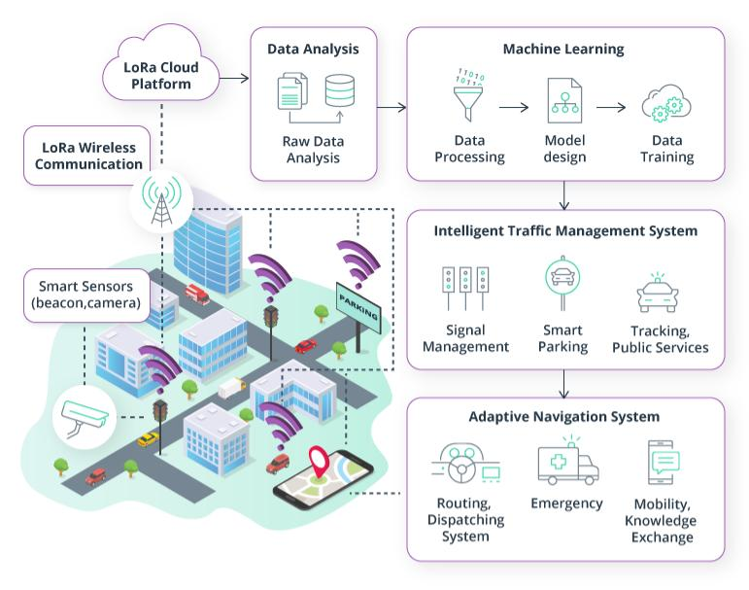

## TARGETS FOR [RNO](https://rno-its.piarc.org/en/acronyms#RNO) ACTIVITIES:

**Congestion:**

* Relieving congestion is achieved by optimizing the management of traffic signals; detecting and managing incidents on the highway network, access control systems; High-Occupancy Vehicle (HOV) lanes; journey time information; speed management. (See [**Network Control**](https://rno-its.piarc.org/en/network-control))

**Safety:**

* Improving safety requires measures such as adaptive speed control, collision detection and avoidance; enhanced vehicle safety systems; weather and road condition information. (See [**Road Safety**](https://rno-its.piarc.org/en/network-control/road-safety))

**Security:**

* Maintaining security is done through evacuation route signing and priority; homeland security initiatives such as deployed in the USA, hazardous load monitoring and assistance for vulnerable road users. (See [**Network Security**](https://rno-its.piarc.org/en/network-operations/network-security) and [**Emergency Response**](https://rno-its.piarc.org/en/network-control-traffic-management-integrated-strategies/emergency-response))

**Environmental protection:**

* Ensuring environmental monitoring and protection requires a reduction in traffic congestion, creation of low-emission zones and promotion of public transport alternatives. (See [**Transport Demand Management**](https://rno-its.piarc.org/en/user-services-passenger-transport/transport-demand-management))

**Support for business & commerce:**

* Increasing productivity and operational efficiencies can be achieved by fleet management; computer aided dispatch; automatic vehicle location; automatic cargo tracking; electronic pre-clearance; vehicle compliance checking and driver monitoring. (See [**Freight and Commercial Services**](https://rno-its.piarc.org/en/user-services/freight-and-commercial))

**Road user services:**

* Providing comfort to users of transportation system who need to feel confident and secure is the motivation for applications such as route confirmation, journey time estimates and clear advice on approaching interchanges and connections. Relevant [ITS](https://rno-its.piarc.org/en/acronyms#ITS) services include real-time traffic and public transport information; dynamic route guidance; automotive vehicle location (AVL); smart card payment systems for toll highway and public transport use. (See [**Traveller Services**](https://rno-its.piarc.org/en/user-services/traveller-services)).
* VSL systems primarily aim to reduce incidents by managing the posted speed limits for congested or hazardous situations.

The benefits of variable speed signs is that they:

* improve journey times
* smooth traffic flow by minimising vehicles stopping and starting
* reduce accidents
* produce environmental benefits through fewer emissions

part time running lanes

* lane management for specific vehicle types e.g. bus priority lanes
* lane management systems e.g. overhead lane control matrix signs
* dynamic road markings

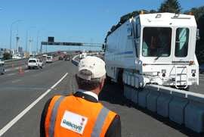

Lane Control with movable barrier – Auckland Harbour Bridge

* Adaptive traffic signals can improve network efficiency by **traffic signal** optimising signal timings and balancing traffic flows.
* This is **control** achieved through automatic updating of cycle times that highlight changes in traffic distribution and volumes.
* Adaptive Traffic signal control enable traffic signal controlled junctions to interact with each other. Such tools include Sydney Coordinated Adaptive Traffic System (SCATS).

* Adaptive traffic signal control systems seek to optimise traffic flow by considering traffic flow at multiple sites rather than a single junction’s performance. This area wide approach can bring significant traffic management benefits including reduced congestion and faster more reliable journey times.

## Where to apply these Tools:

|  |  |  |  |  |
| --- | --- | --- | --- | --- |
|  | Centre | Urban | Suburban | Rural |
| Automatic Incident Detection | ««« | ««« | «« | « |
| Ramp Signalling/ Measuring | ««« | ««« | «« | - |
| Variable Message Signs | ««« | ««« | ««« | «« |
| Variable Speed Limits | ««« | ««« | «« | « |
| Lane Control | ««« | ««« | «« | « |
| Adaptive Traffic Signal Control | ««« | ««« | «« | « |

This table is an indication only. Individual projects should consider the unique features of the local environment.

**Code implementation:**

import java.awt.*;

import javax.swing.*;

import java.awt.event.*;

import javax.swing.border.*;

public class TrafficLight extends JFrame implements ActionListener {

JButton b1, b2, b3;

Signal green = new Signal(Color.green);

Signal yellow = new Signal(Color.yellow);

Signal red = new Signal(Color.red);

public TrafficLight(){

super("Traffic Light");

getContentPane().setLayout(new GridLayout(2, 1));

b1 = new JButton("Red");

b2 = new JButton("Yellow");

b3 = new JButton("Green");

b1.addActionListener(this);

b2.addActionListener(this);

b3.addActionListener(this);

green.turnOn(false);

yellow.turnOn(false);

red.turnOn(true);

JPanel p1 = new JPanel(new GridLayout(3,1));

p1.add(red);

p1.add(yellow);

p1.add(green);

JPanel p2 = new JPanel(new FlowLayout());

p2.add(b1);

p2.add(b2);

p2.add(b3);

getContentPane().add(p1);

getContentPane().add(p2);

pack();

}

public static void main(String[] args){

TrafficLight tl = new TrafficLight();

tl.setVisible(true);

}

public void actionPerformed(ActionEvent e){

if (e.getSource() == b1){

green.turnOn(false);

yellow.turnOn(false);

red.turnOn(true);

} else if (e.getSource() == b2){

yellow.turnOn(true);

green.turnOn(false);

red.turnOn(false);

} else if (e.getSource() == b3){

red.turnOn(false);

yellow.turnOn(false);

green.turnOn(true);

}

}

}

class Signal extends JPanel{

Color on;

int radius = 40;

int border = 10;

boolean change;

Signal(Color color){

on = color;

change = true;

}

public void turnOn(boolean a){

change = a;

repaint();

}

public Dimension getPreferredSize(){

int size = (radius+border)*2;

return new Dimension( size, size );

}

public void paintComponent(Graphics g){

g.setColor( Color.black );

g.fillRect(0,0,getWidth(),getHeight());

if (change){

g.setColor( on );

} else {

g.setColor( on.darker().darker().darker() );

}

g.fillOval( border,border,2*radius,2*radius3

}

}

**System Components**:

* The hardware comprises of Raspberry pi and Smart counter unit. Proposed system uses Cloud service from ThingsBoard open source IOT platform. Here we see detail information about the hardware and software part involved in the system.

1. **Smart counter unit:**

* This unit counts the number of vehicle passing on the road. Hardware and system code make this unit smart i.e. capable of counting two wheeler and four wheeler vehicles separately per minute. This unit also counts the total number of vehicles. Unit uses separate two counters for two type of vehicles i.e. two wheeler and four wheeler. Prototype road is made in such a way that the smart counter unit can count vehicle counts individually.

1. **Raspberry pi:**

* System is using raspberry pi 3 B+ model as a controller. Raspberry pi is used to perform operations and control the system flow.
* Reference [6] the Raspberry Pi 3 Model B+ is the latest product in the Raspberry Pi 3 range.

¨ Broadcom BCM2837B0, Cortex-A53 (ARMv8) 64-bit SoC @ 1.4GHz

¨ 1GB LPDDR2 SDRAM

¨ 2.4GHz and 5GHz IEEE 802.11.b/g/n/ac wireless LAN, Bluetooth 4.2, BLE

¨ Gigabit Ethernet over USB 2.0 (maximum throughput 300 Mbps)

¨ Extended 40-pin GPIO header

¨ Full-size HDMI

¨ 4 USB 2.0 ports

¨ CSI camera port for connecting a Raspberry Pi camera

¨ DSI display port for connecting a Raspberry Pi touchscreen display

¨ 4-pole stereo output and composite video port

¨ Micro SD port for loading your operating system and storing data

¨ 5V/2.5A DC power input

¨ Power-over-Ethernet (PoE) support (requires separate PoE HAT)

* The Raspberry Pi 3 Model B+ is the latest product in the Raspberry Pi 3 range, boasting a 64-bit quad core processor running at 1.4GHz, dual-band 2.4GHz and 5GHz wireless LAN, Bluetooth 4.2/BLE, faster Ethernet, and PoE capability via a separate PoE HAT The dual-band wireless LAN comes with modular compliance certification, allowing the board to be designed into end products with significantly reduced wireless LAN compliance testing, improving both cost and time to market. The Raspberry Pi 3 Model B+ maintains the same mechanical footprint as both the Raspberry Pi 2 Model B and the Raspberry Pi 3 Model c.

**Block diagram:**

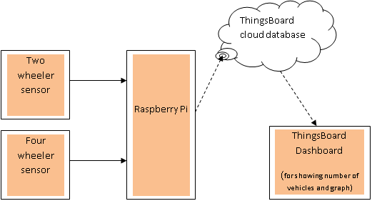

**System Implementation:**

* System uses hardware comprising of counting unit, WiFi enabled raspberry pi, LED screen. Software has python code to control the flow through raspberry pi and ThingsBoard open source IOT platforms

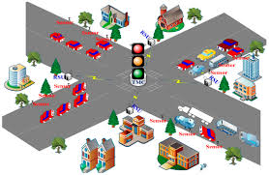

## Real-Time Traffic Management System

##### **Abstract:**

* Monitoring traffic efficiently has been one of the biggest modern day problems. As population has exponentially increased in the last century, the same effect has been observed on vehicles. This has put tremendous pressure on the existent traffic systems.
* Even today, several traffic systems work with the concept of fixed time slots attached to each traffic light while overlooking the density of traffic at that junction. This causes millions of people to waste their precious time in traffic while concurrently affecting the nature through air and noise pollution. Another consequence of this waiting is the toll on the mental health of the commuters.
* To overcome these problems, we propose a system that manages traffic by taking the primary factor of real time traffic density into consideration. This system utilizes cameras along with image processing to achieve its goal. It ensures that the lanes switch based on the number of vehicles, consequently cutting down waiting periods while reducing pollution substantially.

**PROPOSED SYSTEM:**

* A. Proposed System Overview
* The system we propose takes input from cameras & infrared sensors and switches the signals at the junction. Thus traffic signals keep switching based on the density of traffic at that moment. In order to show the utility of our system, we have created a miniature model that shows the monitoring of a four-way traffic junction. The model system works in two phases, the primary system and a backup system. The primary system monitors the four-way intersection using two cameras and two sensors for the respective four lanes whereas the backup system uses two sensors for each lane (eight sensors in total). Arduino Mega 2560 [6] is at the heart of both systems and works in unison with the software on the computer. Fig. 1 illustrates the miniature model.
* 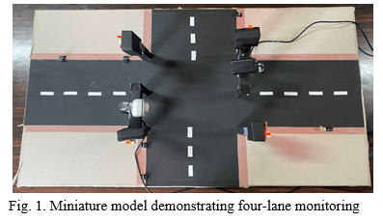

**Primary System:**

* As mentioned previously, the primary system uses two infrared sensors and two cameras to monitor the live traffic. Assuming the four lanes at the junction to be lanes A, B, C and D, lanes A and C are monitored using the two sensors (one sensor for each lane) while the two cameras keep a check on lanes B and D respectively. Three 5mm LEDs are used for every lane to replicate a real life traffic signal.
* The sensors for the model are TCRT5000 [7] infrared sensor modules that provide a good range to measure the presence of an object in front of the sensor. At the same time, the cameras detect appearance of a vehicle and send the data back to the controlling system. All hardware components, apart from the two cameras (which are directly connected to the laptop ports) are then connected to the Arduino Mega 2560 board which is eventually connected to the computer.
* Fig. 2 shows the schematic circuit diagram of the primary system.

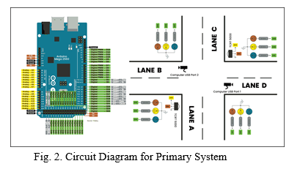

* The software of this system comprises of Arduino IDE (Integrated Development Environment) which controls the sensors and Python (through OpenCV using PyCharm [8]) which makes decisions depending on the feedback from the cameras. While the sensitivity of the TCRT5000 infrared sensors can be adjusted using the potentiometer present on the module, the area captured by cameras to detect the vehicles can be adjusted using the PyCharm software.
* The adjustment to the contour area in the software helps us to enable these changes. The Arduino code is first uploaded to the Arduino Mega board. Later, input is given to the PyCharm terminal to execute the code, thus making the system operational.
* Once the system is active, traffic signals of all lanes will turn red. They will remain in this state as long as none of the sensors and cameras present at the junction detect any vehicle. Whenever any lane detects a particular vehicle, the traffic light for that lane will turn green. This pathway will now remain green for as long as there are no automobiles present in any of the remaining three lanes. As soon as you remove the vehicle from that lane, the traffic indicator will once again turn red.
* However, if the car is not removed and another car is made to enter either one of the three available paths, the first lane will not remain green for an immeasurable time but will rather have a limit of six seconds. Thus the two lanes that have been occupied with traffic will keep switching between themselves with a maximum time of six seconds. Again, if any of the two lanes become vacant, the other lane will remain green endlessly
* . The same logic can be applied to the presence of traffic in three lanes or all four lanes at the junction.
* As the name suggests, the backup system comes into action in an emergency situation where the main system fails. The backup system makes use of eight TCRT5000 infrared sensor modules (two sensors on each lane) to monitor traffic. Just like the primary system, the backup system too uses three 5mm LEDs to demonstrate each traffic signal. Four 7-segment displays are used as timers to display the time for which the respective lanes will remain green. For the backup system, each hardware component is connected to the Arduino Mega 2560 board that is ultimately attached to the computer. Arduino IDE (Integrated Development Environment) makes up the complete software for this system. Fig. 3 reveals the circuit diagram for the backup system.

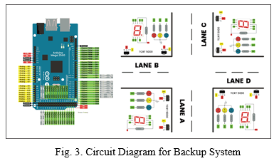

* The backup system gets activated once the necessary code is uploaded to the Arduino board. When no traffic is detected, the system starts working in a cycle from lane A to lane D, switching to each traffic signal for a maximum period of three seconds. The 7-segment timers too get activated in the first cycle and display the obligatory time.
* The preference hierarchy for the backup system is as mentioned below: 2 sensor trigger > 1 sensor trigger > Absence of traffic.
* Thus, a crowded lane which has traffic present at both the sensors will be preferred over a lane with vehicle present at the first sensor. Traffic light switching based on the real time density is hence achieved through the backup system. Fig. 4 presents a traffic lane with three seconds displayed on the timer due to lack of traffic.

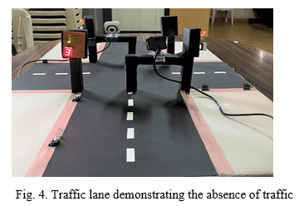

* Whenever a single sensor, i.e. the first sensor of any traffic path detects a vehicle, it will assign a five second timer to that particular lane instead of the previously mentioned three seconds that were assigned due to the absence of automobiles.
* Unlike the primary system, the backup system will remain green for the entire duration of five seconds even if the vehicle is removed immediately after the timer is assigned. If multiple pathways of the junction have a vehicle present at the first sensor, the system will keep running in a loop, starting from lane A to D, assigning those lanes a timing of five seconds while the remaining lanes with no presence of traffic will remain red. Thus the presence of a single vehicle at lane A will trigger its signal first followed by the single vehicles present at lanes B, C and D respectively.
* A traffic light of the miniature model displaying five seconds on its timer is shown below in Fig. 5.

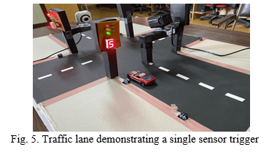

* Lastly, if a particular road at the junction has both its sensors triggered by traffic, it will assign that lane a timer of eight seconds instead of the three seconds or five seconds. Just as a green light remains in the same state for five seconds irrespective of the car being present later for a single sensor trigger, the same is the case when two sensors are triggered.
* The path will remain green here for all eight seconds. Similarly, if more than one lane has vehicles present at two sensors, the system will run in a cycle, assigning eight seconds to those lanes.
* Fig. 6 illustrates a traffic light which displays a timer of eight seconds due to the presence of vehicles on both sensors.

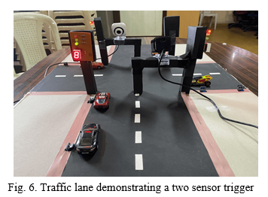

**FUTURE WORK:**

Even though the proposed system improves the current traffic monitoring system, there is room for the following improvements that can be added in the near future:

1. Accident Monitoring: Everyone is aware about the frequency of accidents that happen on the road. Whenever such an unforeseen event takes place, it takes a long time to provide assistance to the victim and this leads to many fatalities which could have been somehow prevented. With the help of traffic cameras installed at the junctions, any vehicle that happens to remain stationary in an inapt position (to avoid confusion with parked cars) could be identified as an effected automobile and the emergency services could be notified immediately. This would not only help them to respond faster in these kind of situations but also help in avoiding the resulting traffic jams.
2. Adaptive System for Emergency Vehicles: It is estimated that 1 in 10 patients in India loses his/ her life due to the ambulance being stuck in traffic [10]. This is a huge number and makes us realize how bad the existing traffic management is. To overcome this situation, a model can be trained which will allow the cameras to identify any emergency vehicle and allow it to cross a traffic junction at the earliest.
3. Recognizing Traffic Rule Violators: Traffic rule violators are a common sight on most traffic junctions. People tend to break traffic laws and expect to get away with it without facing any consequences. Not long back, these offenders would be fined by identifying their number plate and sending them an online penalty. However, since these mulcts are not followed up regularly, the entire cause fails. A future system could capture the number plate and send the penalty directly to the contact number of the registered owner, making it mandatory to pay up the fine in accordance with the sterner rules.
4. Synchronization of Traffic Signals at Multiple Junctions: It is often observed that once you finally get to cross a traffic junction after waiting there for several minutes, you once again have to wait at the very next junction. This situation is clearly frustrating and needs a solution. A synchronized traffic model would help overcome this problem by giving a preference to the lane which has maximum traffic approaching from the previous junction.
5. Reducing Pedestrian Inconvenience: In India, pedestrians often violate the traffic rules in place for them by crossing the lanes whenever they see an opportunity. This not only risks their life but also endangers the passengers in vehicles. This problem can be solved by providing bearable waiting time periods for pedestrians after every lane switching cycle, hence allowing them to cross the roads without waiting for long periods unnecessarily.

## 

**Other policies addressed** :

* Congestion
* Economic Efficiency
* Land use
* Safety

## Further Information

**Resources** Auckland Motorways – ramp signaling [http://www.aucklandmotorways.co.nz/rampsignalling/rampsignalling.htm](http://www.aucklandmotorways.co.nz/rampsignalling/rampsignalling.html)l

UK, Highways Agency, <http://www.highways.gov.uk/knowledge/1361.aspx>

The Auckland Traffic Management Unit

[http://www.oag.govt.nz/2004/working-together/case-study3.htm](http://www.oag.govt.nz/2004/working-together/case-study3.htm/)/

US Department of Transportation

<http://www.fhwa.dot.gov/tfhrc/safety/tms.htm>

LTSA, Road Safety Management System

[http://www.ltsa.govt.nz/roads/sms/overview-of-sms.htm](http://www.ltsa.govt.nz/roads/sms/overview-of-sms.html)l

**Key Contents   :**

* [Role of IoT in Smart City Traffic Management](https://www.rishabhsoft.com/blog/smart-traffic-control-using-iot#role-of-iot)
* [Advantages of a Smart Traffic Management System](https://www.rishabhsoft.com/blog/smart-traffic-control-using-iot#advantages)
* [Functioning of Traffic Monitoring System Using IoT Capabilities](https://www.rishabhsoft.com/blog/smart-traffic-control-using-iot#functioning)
* [Application of IoT in Traffic Management](https://www.rishabhsoft.com/blog/smart-traffic-control-using-iot#use-cases)
* [Key Features of a Smart Traffic Management System](https://www.rishabhsoft.com/blog/smart-traffic-control-using-iot#features)
* [Implementation of a Smart Traffic Management System – Key Elements](https://www.rishabhsoft.com/blog/smart-traffic-control-using-iot#implementation)
* [Rishabh’s Role in IoT-based Smart Traffic Management](https://www.rishabhsoft.com/blog/smart-traffic-control-using-iot#rishabh)

## Role of IoT in Smart City Traffic Management:

* With cities worldwide experiencing ongoing population growth – it results in stressed municipal infrastructure. And the problem of traffic congestion across smart cities is continuously increasing. [INRIX suggests](https://inrix.com/press-releases/2021-traffic-scorecard/) that the average American driver lost 36 hours due to congestion, costing $564 in wasted time.
* This increasing growth in cities leads to the demand to meet sustainability goals while evaluating traffic management strategies.

Integrating innovative traffic technology helps achieve phenomenal cost savings in smart cities’ infrastructure expenses while improving system reliability. [Juniper research suggests](https://www.juniperresearch.com/press/smart-traffic-management-to-significantly-reduce) that smart traffic management systems could save cities $277 billion. It is while reducing emissions and congestion by 2025.

* With the pressing demand for advanced communication & network technologies, digitalization is the driving force that stimulates the implementation of smart traffic control using IoT capabilities.

It enables them to;

* Expand the capacity of city streets without having to build new roads.
* Optimize the traffic flow and keep the drivers safe. It would include cameras, sensors, and cellular technologies that automatically adjust traffic lights, expressway lanes, speed limits, and highway exit counters.
* Transmit accurate information about available parking spaces to citizens in real-time
* Collect data on congestion and improve traffic signaling to reduce blockages and optimize commute
* Locate incidents and report them to emergency rooms immediately with road sensors and video surveillance
* Employ real-time data feeds to ensure the streetlights turn dim or brighten up per the changing weather conditions and the onset of day and night

## Advantages of Traffic Management System:

Cleaner, greener, safer, and more accessible roads are a few benefits of implementing IoT and intelligent technology.

It helps with the following:

* Reducing traffic jams and accidents on the streets
* Ensuring immediate clearance for emergency vehicles
* Facilitating safer and shorter commute times
* Reducing congestion & energy consumption at intersections
* Offering significant productivity benefits with real-time monitoring of crucial infrastructures
* Reducing operating costs with efficient traffic management processes
* Ensuring compliance with the regulations for reducing the carbon footprint
* Saving billions of gallons of fuel wasted every year
* Accurate tracking & quick recovery of lost and stolen vehicles

## Application of IoT in Traffic Management:

City governments can improve their operations & infrastructure by placing IoT sensors and tracking devices on roads and highways for recording, analyzing, and sharing data in real-time.

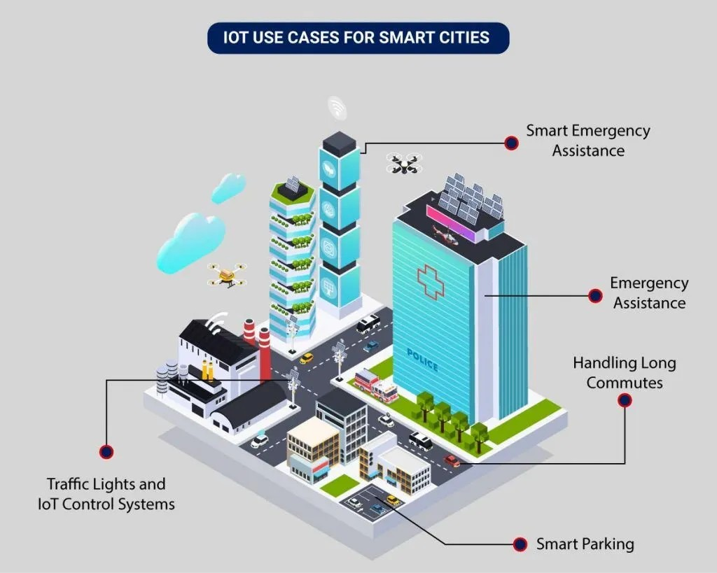

**Conclusion:**

Smart Traffic Management System has been developed by using multiple features of hardware components in IoT. Traffic optimization is achieved using IoT platform for efficient utilizing allocating varying time to all traffic signal according to available vehicles count in road path. Smart TrafficManagement System is implemented to deal efficiently with problem of congestion and perform re- routing at intersections on a road. This research presents an effective solution for rapid growth of traffic flow particularly in big cities which is increasing day by day and traditional systems have some limitations as they fail to manage current traffic effectively. Keeping in view the state of the art approach for traffic management systems, a smart traffic management system is proposed to control road traffic situations more efficiently and effectively. It changes the signal timing intelligently according to traffic density on the particular roadside and regulates traffic flow by communicating with local server more effectively than ever before. The decentralized approach makes it optimized and effective as the system works even if a local server or centralized server has crashed. The system also provides useful information to higher authorities that can be used in road planning which helps in optimal usage of resources.