### 1.5 People who code as hobby also opensource their code ?

data = df[['Hobby','OpenSource']].dropna()

trace1 = go.Bar(

x=['Yes', 'No'],

y=[data[(data['OpenSource'] == 'Yes') & (data['Hobby'] == 'Yes')].count()[0], data[(data['OpenSource'] == 'Yes') & (data['Hobby'] == 'No')].count()[0]],

name='Yes',

opacity=0.6

)

data = [trace1]

layout = go.Layout(

barmode='group'

)

fig = go.Figure(data=data, layout=layout)

py.iplot(fig)

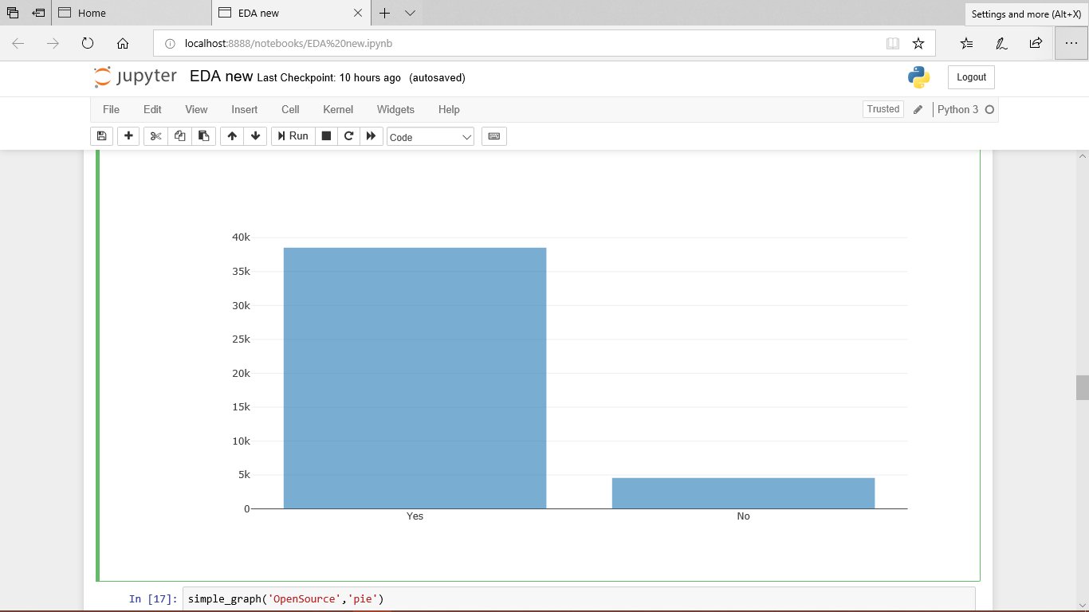

### 2.2 open sorce based on gender

data = df[['OpenSource','Gender']].dropna()

trace1 = go.Bar(

x=['Female', 'Male'],

y=[data[(data['Gender'] == 'Female') & (data['OpenSource'] == 'Yes')].count()[0], data[(data['Gender'] == 'Male') & (data['OpenSource'] == 'Yes')].count()[0]],

name='Yes',

opacity=0.6

)

trace2 = go.Bar(

x=['Female', 'Male'],

y=[data[(data['Gender'] == 'Female') & (data['OpenSource'] == 'No')].count()[0], data[(data['Gender'] == 'Male') & (data['OpenSource'] == 'No')].count()[0]],

name='No',

opacity=0.6

)

data = [trace1, trace2]

layout = go.Layout(

barmode='group',

)

fig = go.Figure(data=data, layout=layout)

py.iplot(fig)

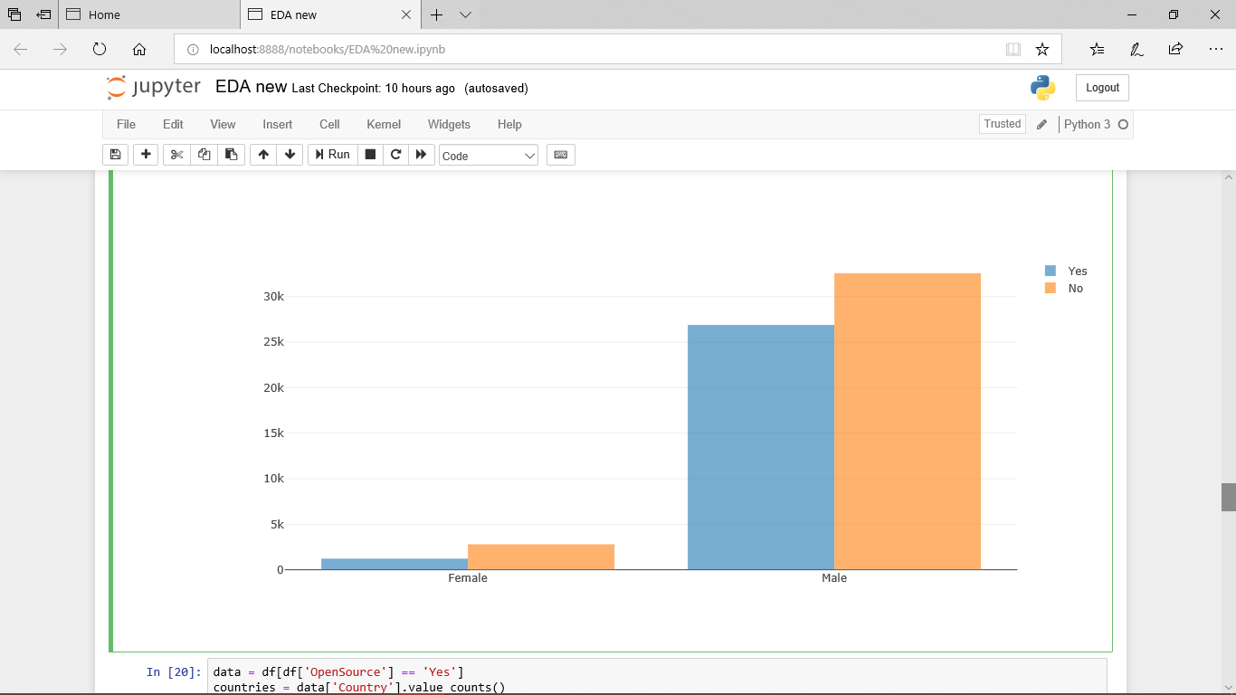

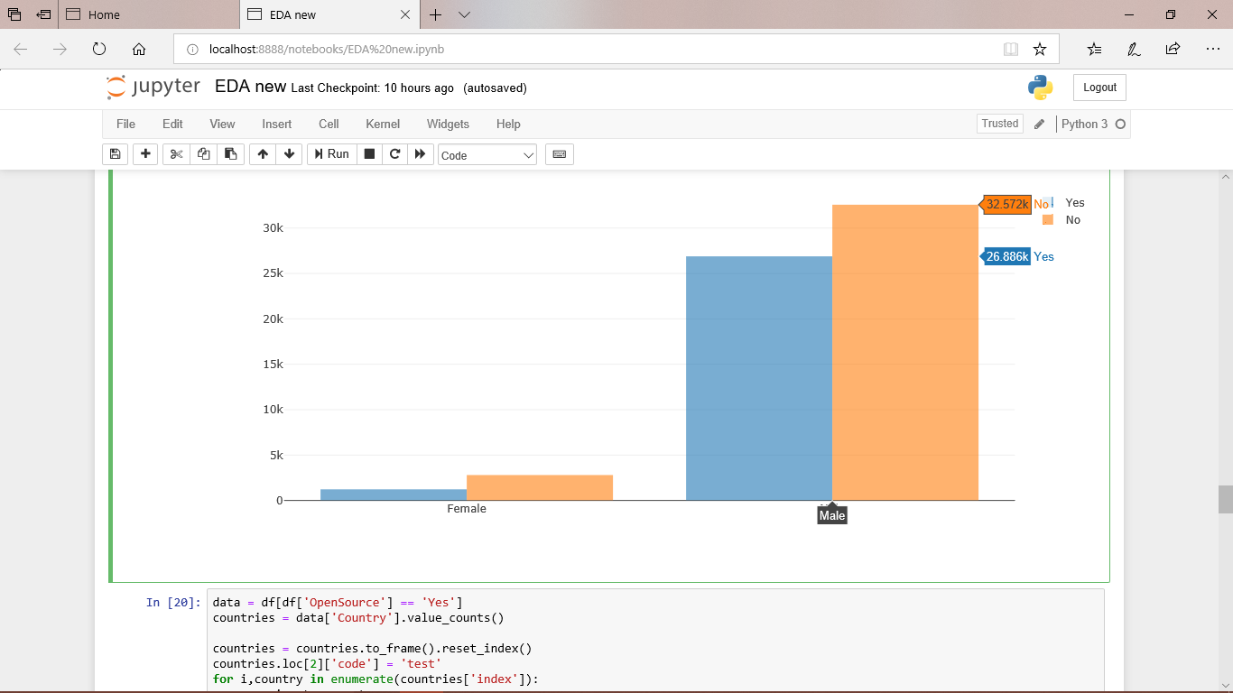

**Employement status of developers**

temp = stack_data['Employment'].value_counts()

df = pd.DataFrame({'labels': temp.index,

'values': temp.values

})

df.iplot(kind='pie',labels='labels',values='values', title='Employment Status of Developers', hole = 0.8, color = ['#8B7355','#FF6103','#8EE5EE','#458B00','#FFF8DC','#68228B'])

