Product Catalog System

Home Page
URL: http://localhost:9001/product/index

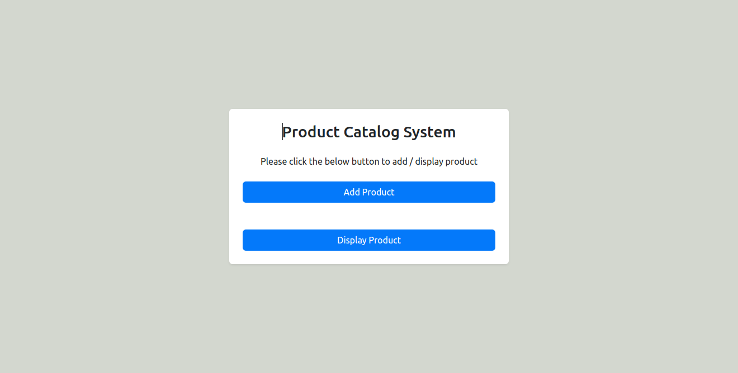

Add Product Page
URL: http://localhost:9001/add

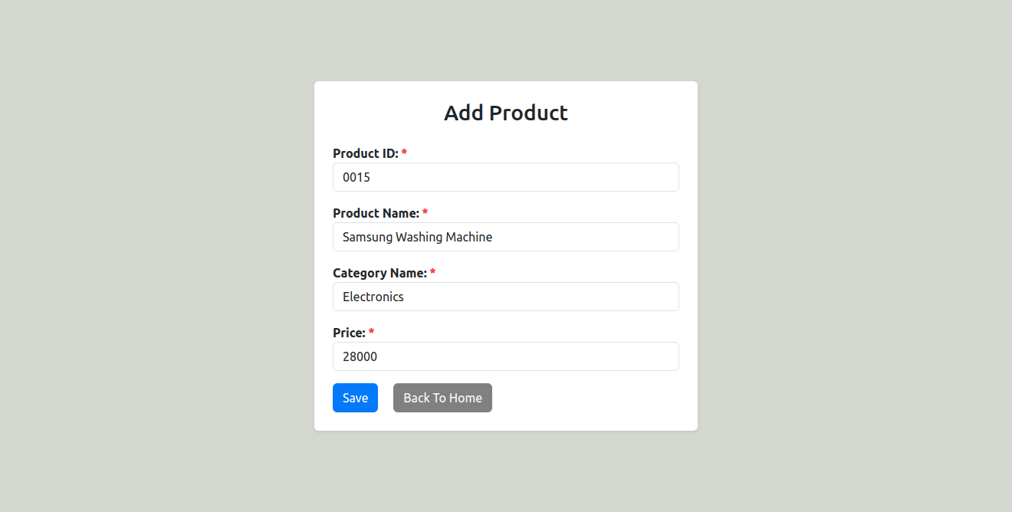

Display All Products
URL: http://localhost:9001/product/displayAll

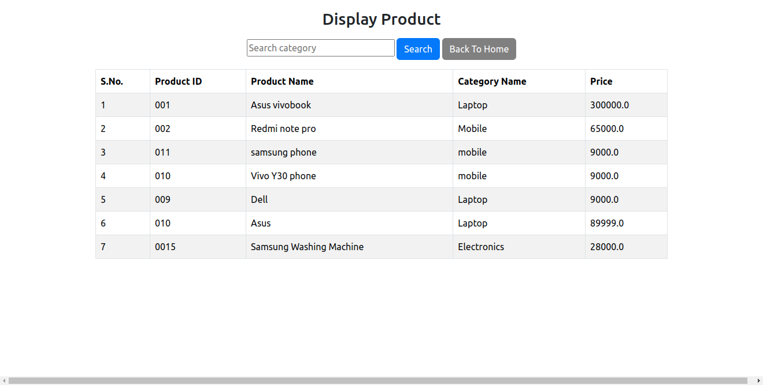

Display Product By Category Name(Search)
URL: http://localhost:9001/product/display

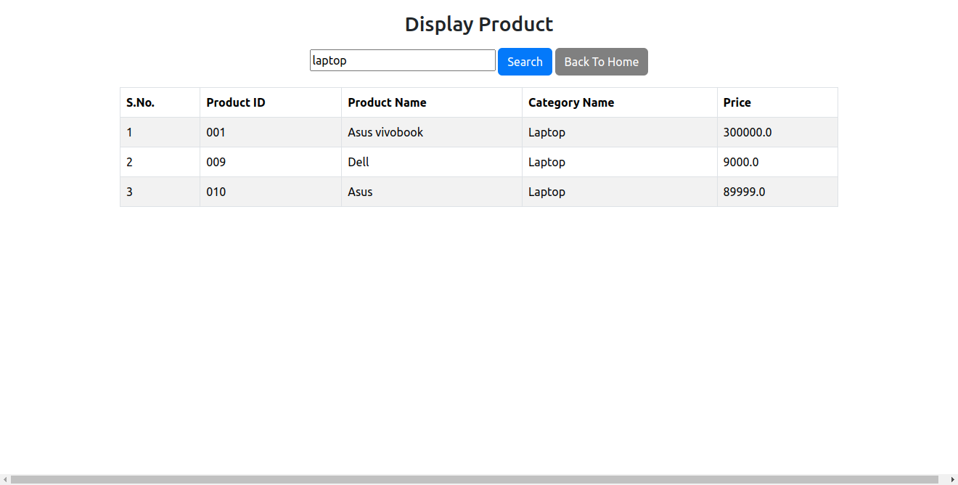

Product Table

