**ALAGAPPA GOVT ARTS COLLEGE**

**KARAIKUDI-630003**

**NAAN MUDHALVAN PROJECT**

**PROJECT NAME: UNLOCKING INSIGHTS INTO THE GLOBAL AIR TRANSPORTATION NETWORK WITH TABLEAU**

**1.INTRODUCTION**

**1.1 Overview**

**1.2 Purpose**

**2.PROBLEM DEFINITION AND DESIGN THINKING**

**2.1 Empathy map**

**2.2 Ideation and Brainstorming map**

**3.RESULT**

**3.1 Data model**

**3.2 Activity and screenshot**

**4.TRAILHEAD PROFILE PUBLIC URL**

**5.ADVANTAGES AND DISADVANTAGES**

**6.APPLICATIONS**

**7.CONCLUSION**

**8.FUTURES**

**IREVOLATION: UNLOCKING INSIGHTS INTO THE GLOBAL AIR TRANSPORTATION NETWORK WITH TABLEAU.**

**INTRODUCTION:**

**OVERVIEW:**

**Unlocking insights into the global air transportation network with Tableau is a transformative process that harnesses the power of data visualization and analytics. By integrating diverse data sources, creating interactive dashboards, and utilizing geographic mapping capabilities, Tableau empowers aviation industry professionals to explore flight routes, on-time performance, passenger volumes, and more.**

**PURPOSE:**

* **Operational efficiency**
* **Safety and compliance**
* **Supply chain management**

**MILESTONE:**

**PROBLEM AND DESIGN THINKING:**

**EMPATHY MAP:**

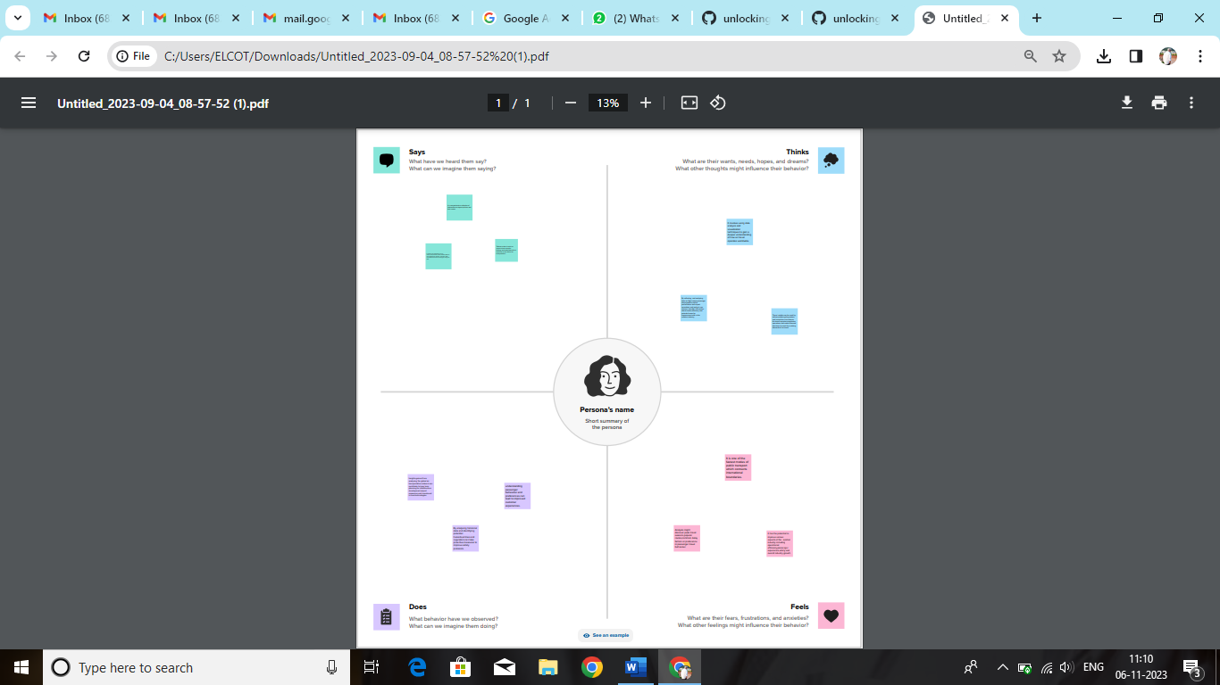

[**https://github.com/saranya1303/unlocking-insights-into -the-global-air-transportation-networl-with-tableau/blob/e3fd748999794c09e710c9799d4f09a212166ab0/Untitled_2023-09-04_08-57-52.pdf**](https://github.com/saranya1303/unlocking-insights-into%20-the-global-air-transportation-networl-with-tableau/blob/e3fd748999794c09e710c9799d4f09a212166ab0/Untitled_2023-09-04_08-57-52.pdf)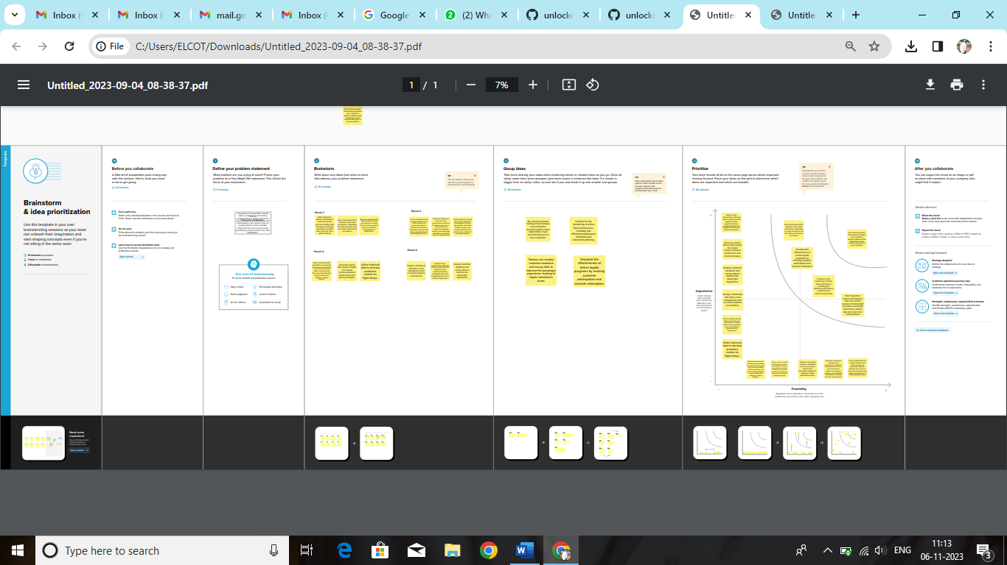

[**https://github.com/saranya1303/unlocking-insights-into-the-global-air-transportation-network-with-tableau/blob/e3fd748999794c09e710c9799d4f09a212166ab0/Untitled_2023-09-04_08-38-37.pdf**](https://github.com/saranya1303/unlocking-insights-into-the-global-air-transportation-network-with-tableau/blob/e3fd748999794c09e710c9799d4f09a212166ab0/Untitled_2023-09-04_08-38-37.pdf)

**RESULT:**

**Unlocking insights into the global air transportation network with Tableau results in improved operational efficiency, enhanced safety and compliance, better customer experiences, cost savings, optimized supply chain management, informed strategic decision-making, predictive insights, and increased transparency and collaboration among stakeholders, ultimately transforming the aviation industry and driving its success.**

**MILESTONE 2:**

**DATA COLLECTION AND PREPARATION:**

**ACTIVITY 1:**

**COLLECT THE DATASET:**

**Please use the link to download the dataset:** [**https://drive.google.com/drive/folders/1RJnbcGxvIVuIM3fkZH1Wz3_IbLDP2RjY?usp=share_link**](https://drive.google.com/drive/folders/1RJnbcGxvIVuIM3fkZH1Wz3_IbLDP2RjY?usp=share_link)

**ACTIVITY 1.1: Understand the data**

**Data contain all the meta information regarding the column described in the CSV files. We have provided the XLX file:**

**COLUMN DESCRIPTION FOR AIRPORTS.CSV:**

**Name: The name of the airport. (String)**

**City: The city the airport is located in. (String)**

**country: The country the airport is located in. (String)**

**IATA: The International Air Transport Association code for the airport. (String)**

**ICAO: The International Civil Aviation Organization code for the airport. (String)**

**Latitude: The latitude of the airport. (Float)**

**Longitude: The longitude of the airport. (Float)**

**Altitude: The altitude of the airport. (Float)**

**Timezone: The timezone of the airport. (String)**

**DST: The Daylight Savings Time of the airport. (String)**

**Tz database time zone: The timezone of the airport in the Tz database. (String)**

**Type: The type of airport (large_airport, medium_airport etc.). (String)**

**Source: The source of the data. (String)**

**Column Description for airplanes.csv:**

**Name: The name of the airport. (String)**

**IATA code: International Air Transport Association code, a three-letter code used**

**to identify airports. (String)**

**ICAO code: International Civil Aviation Organization code, a four-letter code used**

**to identify airports. (String)**

**Column Description for airlines.csv:**

**Name: The name of the airport. (String)**

**IATA: The International Air Transport Association code for the airport. (String)**

**ICAO: The International Civil Aviation Organization code for the airport. (String)**

**Country: The country the airport is located in. (String)**

**Alias: An alternate name for the airport. (String)**

**Callsign: The call sign of the airline operating at the airport. (String)**

**Active: An alternate name for the airport. (String)**

**Column Description for routes.csv:**

**Airline: The name of the airline operating the route. (String)**

**Source airport: The IATA code of the airport from which the route originates.**

**(String)**

**Destination airport: The IATA code of the airport to which the route is headed.**

**(String)**

**Codeshare: Indicates whether the route is operated by another airline under a**

**codeshare agreement. (Boolean)**

**Stops: The number of stops on the route. (Integer)**

**Equipment: The type of aircraft used on the route. (String)**

**ACTIVITY 2: Connect datasets states & country with tableau**

**Reference video link:**

[**https://drive.google.com/file/d/1HnZfPjKEedSmOVdiGecfJr8WAgYSMrm/view?usp=sharelink**](https://drive.google.com/file/d/1HnZfPjKEedSmOVdiGecfJr8WAgYSMrm/view?usp=sharelink) 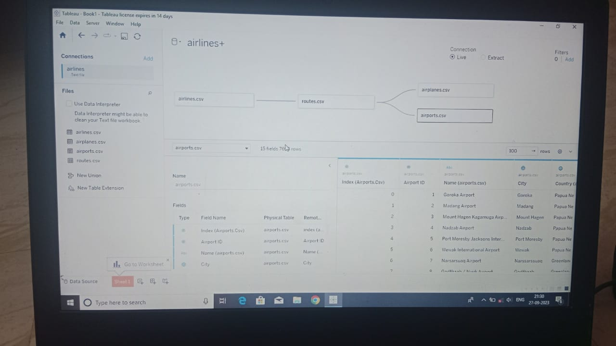

**MILESTONE 3:**

**DATA PREPARATION:**

**Data modules are containers that describe data and rules for combining and shaping data to prepare it for analysis and visualization in Tableau. Data module sources. Data modules can be based on data servers, packages, uploaded files, data sets, and other data modules.**

**MILESTONE 4:**

**DATA VISUALISATION:**

**Data visualization is the process of creating graphical representations of data in order to help people understand and explore the information.**

**ACTIVITY 1: No of unique visualisations.**

**The number of unique visualizations that can be created with a given dataset.**

**ACTIVITY 1.1:**

**Create the world map on the tableau Book 1**

**Go to your data set select airlines and go to your sheet 1 the sheet will appear.**

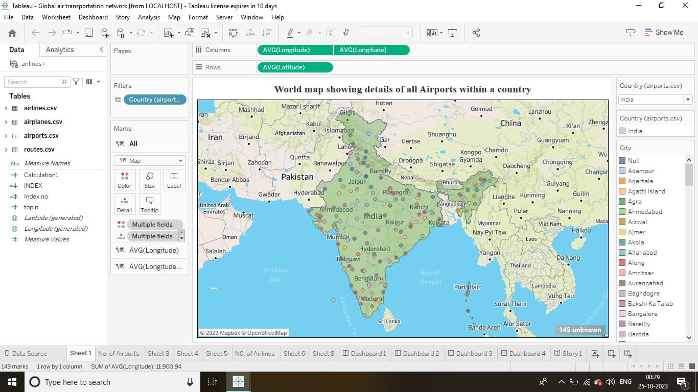

* **Click on the sheet 1 the page will appear.**
* **Click the AVG (latitude) and drag into X-axis.**
* **Click the AVG (longitude) and drag in Y-axis.**
* **Make filters in country(airports), colours and label in the filter box.**
* **Then drag the AVG (longitude).**
* **Then finally the world map is appear in the sheet.**
* **Finally save the map in the tableau.**
* **Click the save as in the file option and save the sheet.**

**ACTIVITY1.2:**

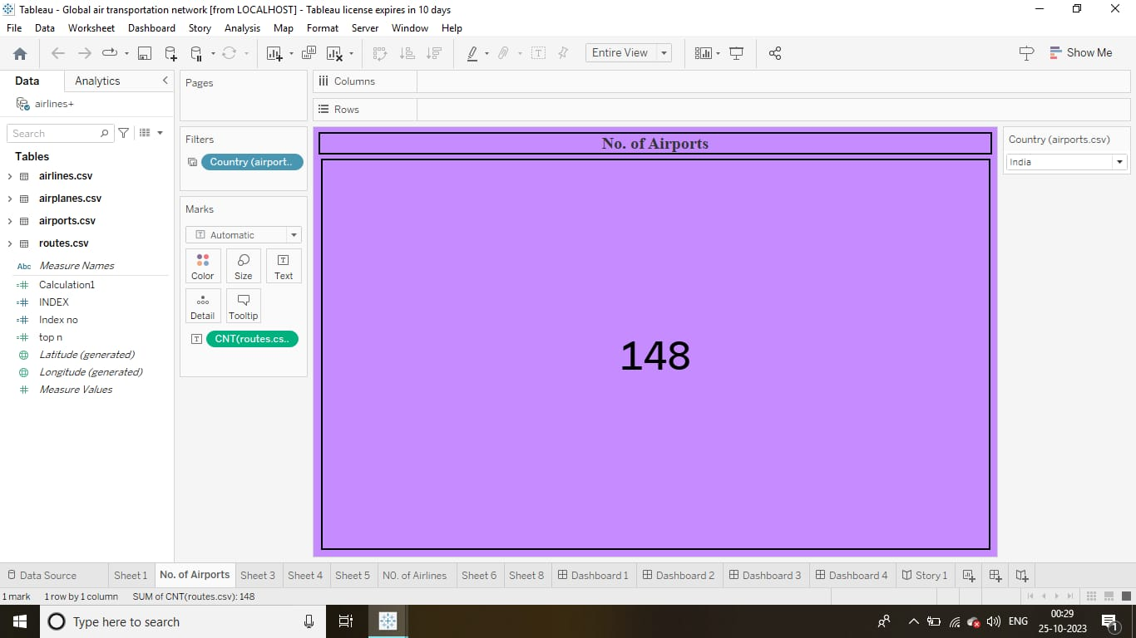

**•Click Country (airport) and drag into the filter**

**•Then go to the filter and click show filter**

**•Now you can see country in the right side corner**

**•Then click Country and choose single value drop down**

**•Click CNT (routes) and drag into the text**

**•Then customise the text colour, font and size**

**•Using format to edit the table**

**•Then click right on the country you can select whatever country you want and you can see how many airports are there in the country**

**•Then finally save the changes in the workbook**

**ACTIVITY 1.3:**

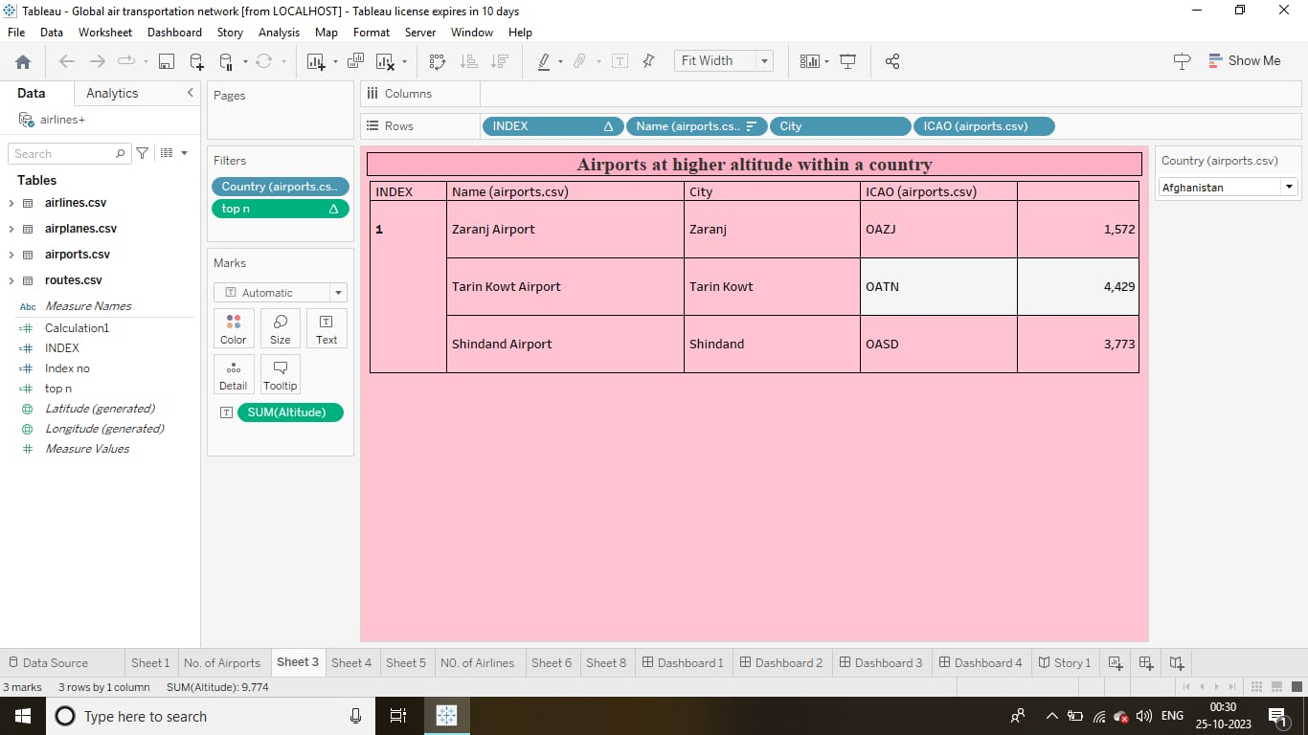

* **Click Country(airports) and drag into the filter**
* **Then go to the filter and click show filter**
* **Now click Country and choose single value drop down**
* **Click Index and drag into the row**
* **Then click Name(airports) and drag into the row**
* **Click City and drag into the row**
* **Click ICAO (airports) and drag into the row**
* **Click top n in the measure names and drag into the filter**
* **Click Sum(altitude) and drag into the text**
* **Then customise the text colour, font and size**
* **Using format to edit the worksheet colour, table**
* **Now click the right on the country you can select any country and it show you the airports higher altitude within a country.**

**ACTIVITY 1.4**

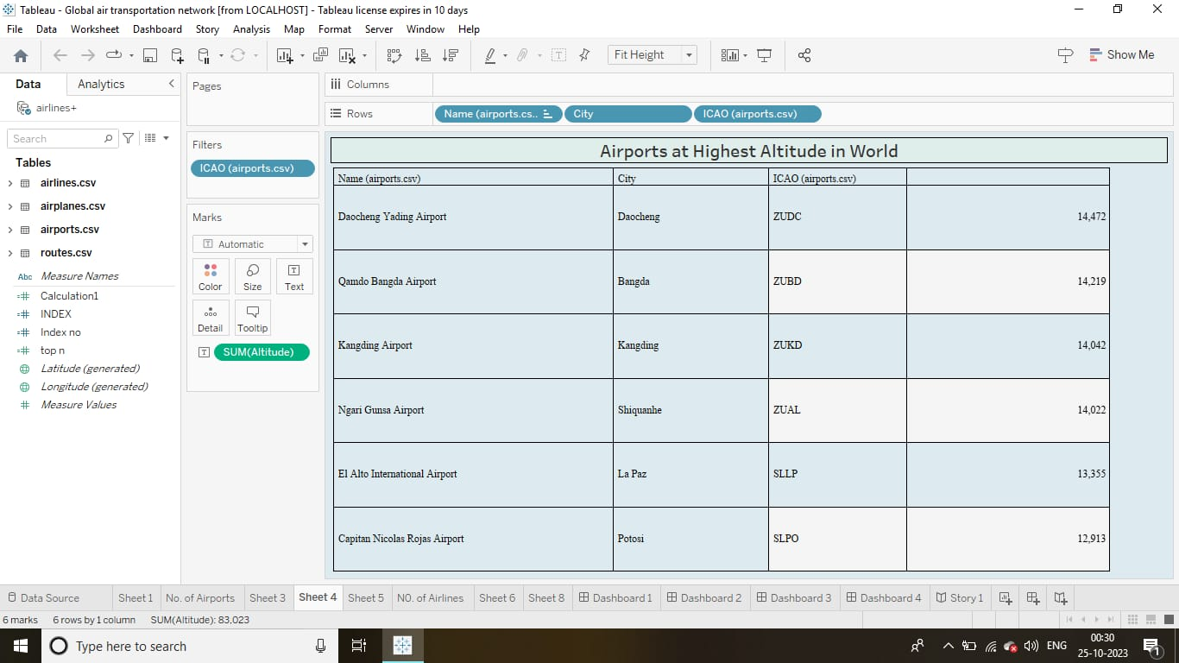

* **Click ICAO (airports) and drag into the filter**
* **Click name(airports) and drag into the row**
* **Click City and drag into the row**
* **Click ICAO (airports) and drag into the row**
* **Click Sum(altitude) and drag into the text**
* **Then customise the text colour, font and size**
* **Then click the name on the row and change into descending order**
* **Now finally you can see the airports at highest altitude in world**

**ACTIVITY 1.5**

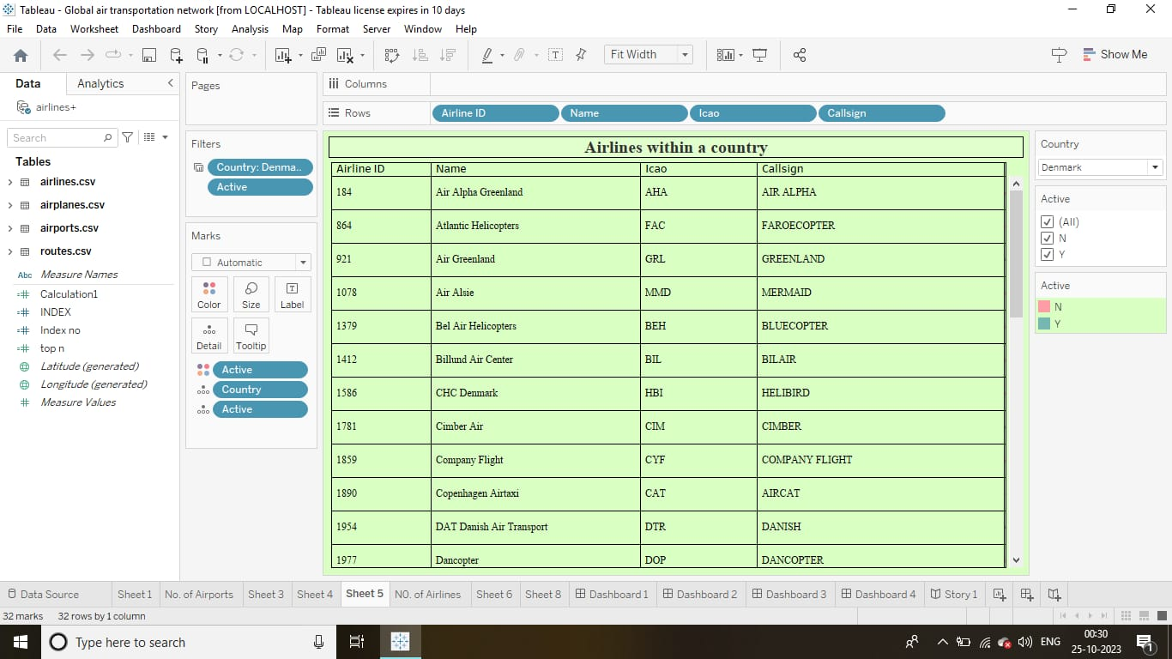

* **Click Country (airports) and drag into the filter**
* **Then go to the filter and click show filter**
* **Now click Country and choose single value drop down**
* **Click active and drag into the filter**
* **Then click show filter**
* **Now it can show you the active one and also you can activate anything**
* **Click Airline ID and drag into the row**
* **Click Name and drag into the row**
* **Then click ICAO and drag into the row**
* **Click Callsign and drag into the row**
* **Click active and drag into the colour**
* **Now you can change the colour of "Y" and "N"**
* **Click Country and drag into the details**
* **Click active and drag into the details**
* **Finally you can see the Airlines within a country**

**ACTIVITY 1.6**

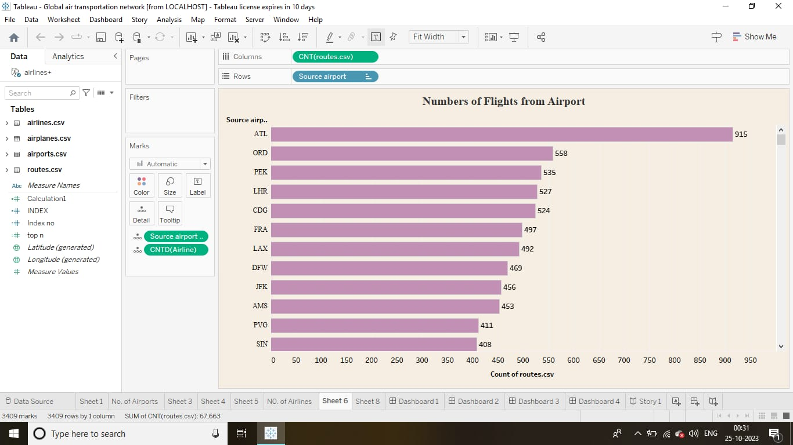

* **Click CNT (routes) and drag into the column**
* **Click source airport and drag into the row**
* **Then click source airport and change into descending order**
* **Click Source airport and drag into the details**
* **Then click CNTD (airline) and drag into the details**
* **Using format to edit the worksheet**
* **Now finally you can see the Number of flights from airport**

**MILESTONE 5:**

**DASHBOARD:**

**A dashboard is a graphical user interface (GUI) that displays information and data in an organized, easy-to-read format. Dashboards are often used to provide real-time monitoring and analysis of data, and are typically designed for a specific purpose or use case. Dashboards can be used in a variety of settings, such as business, finance, manufacturing, healthcare, and many other industries. They can be used to track key performance indicators (KPIs), monitor performance metrics, and display data in the form of charts, graphs, and tables.**

**ACTIVITY 1:**

**DASHBOARD 1:**

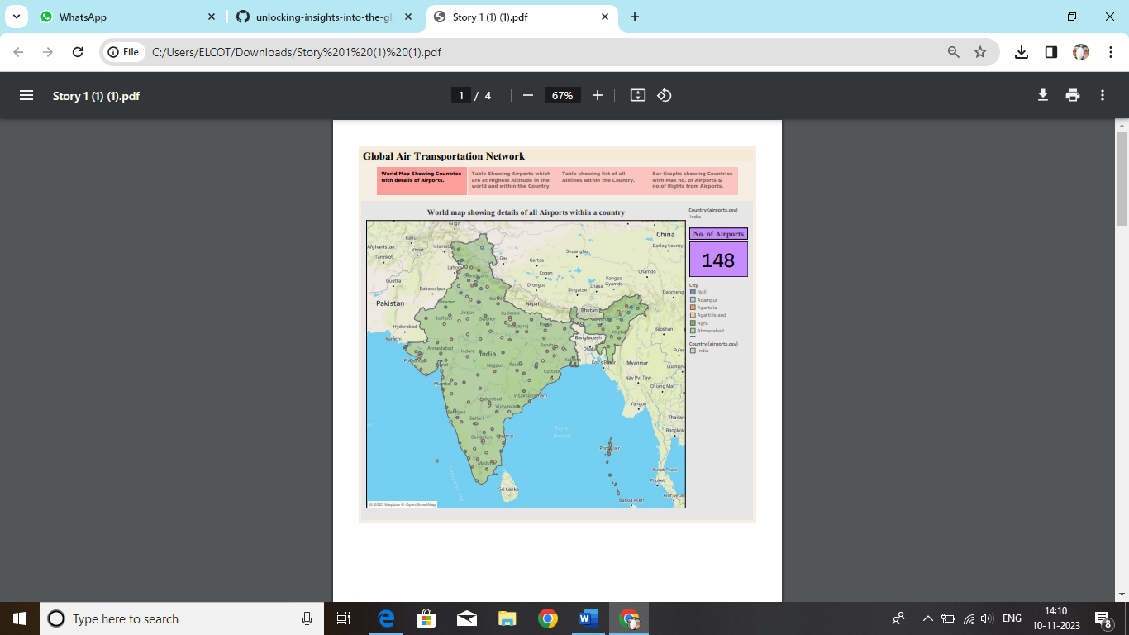

**`** <https://public.tableau.com/shared/N6ZDZH4ZJ?:display_count=n&:origin=viz_share_link>

**DASHBOARD 2:**

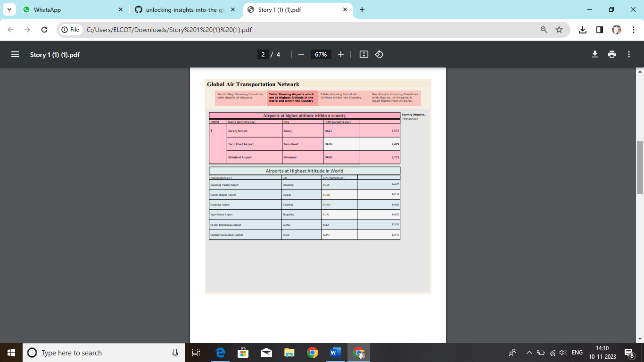

<https://public.tableau.com/shared/HMHWWDJ3S?:display_count=n&:origin=viz_share_link>

**DASHBOARD 3:**

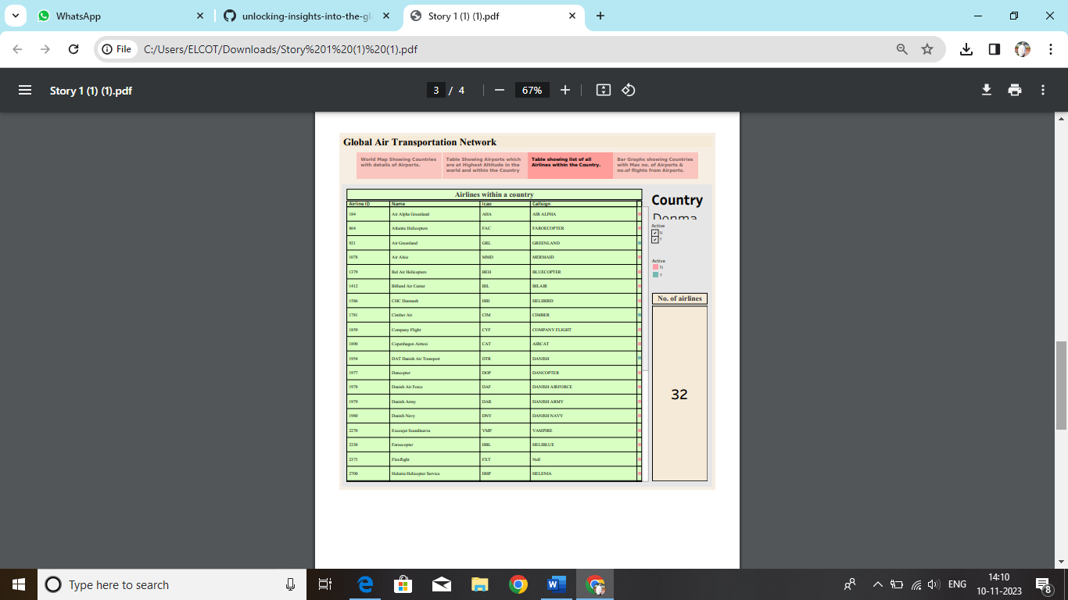

<https://public.tableau.com/shared/2CWX6C63N?:display_count=n&:origin=viz_share_link>

**DASHBOARD 4:**

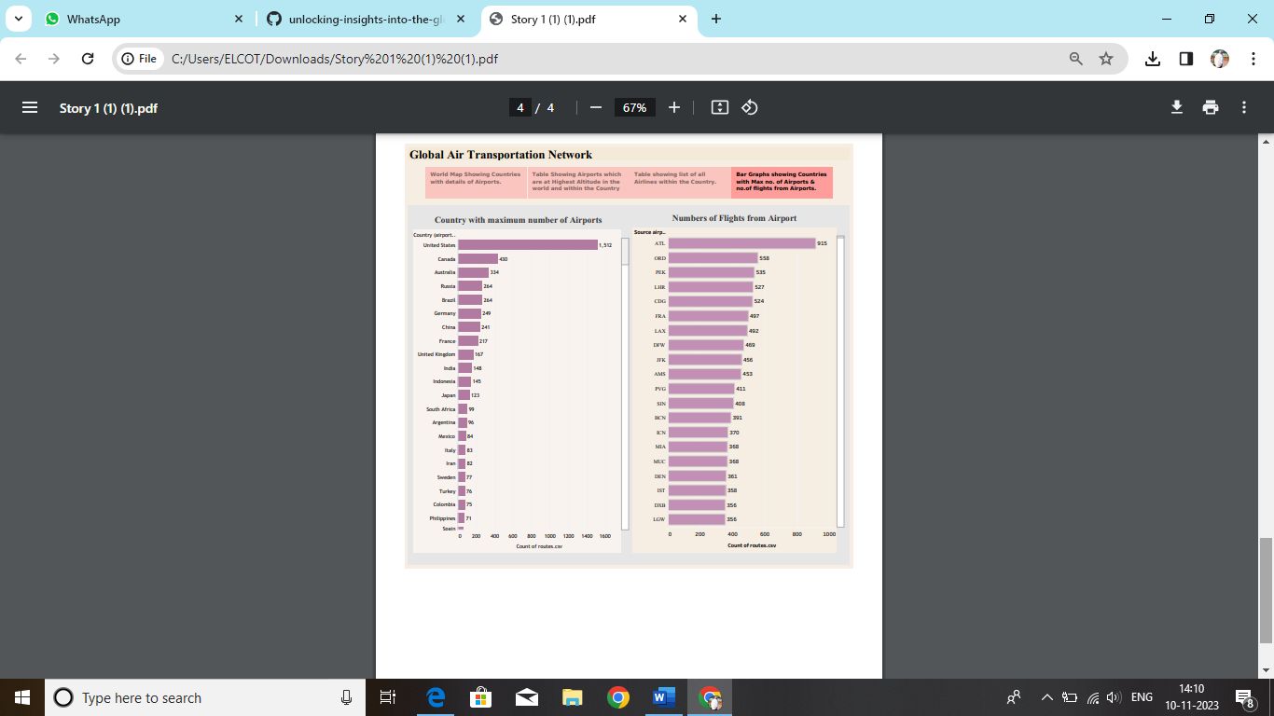

<https://public.tableau.com/views/nmabi/Story1?:language=en-US&:display_count=n&:origin=viz_share_link>

**MILESTONE 6:**

**STORY:**

**A data story is a way of presenting data and analysis in a narrative format, with the goal of making the information more engaging and easier to understand. A data story typically includes a clear introduction that sets the stage and explains the context for the data, a body that presents the data and analysis in a logical and systematic way, and a conclusion that summarizes the key findings and highlights their implications. Data stories can be told using a variety of mediums, such as reports, presentations, interactive visualizations, and videos.**

**STORY 1:**

[https://github.com/saranya1303/unlocking-insights-into-the-global-air-transportation-network-with-tableau/blob/e3fd748999794c09e710c9799d4f09a212166ab0/Story 1 (1).pdf](https://github.com/saranya1303/unlocking-insights-into-the-global-air-transportation-network-with-tableau/blob/e3fd748999794c09e710c9799d4f09a212166ab0/Story%201%20(1).pdf)

**MILESTONE 7:**

**UPLOADING:**

**Publishing helps us to track and monitor key performance metrics, to communicate results and progress. help a publisher stay informed, make better decisions, and communicate their performance to others.**

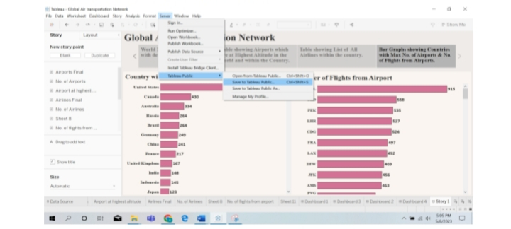**Publishing dashboard and reports to tableau public**

**● Step1: Go to data Source and Select Extract so that hyper extension files are created and save it at your desktop. ( please wait for pop up of file to save)**

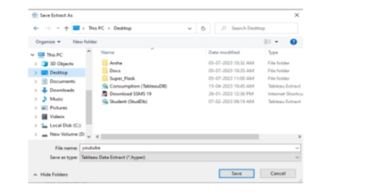

**● Step 2: Go to Dashboard/story, click on share button on the top ribbon**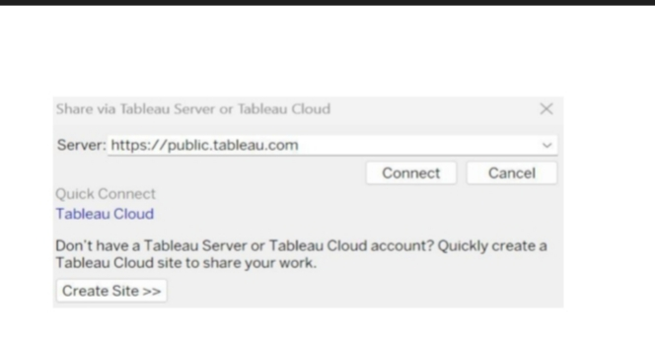

**Give the server address of your tableau public account and click on connect.**

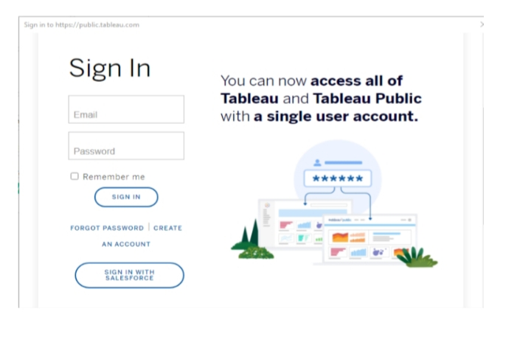

**Sign in to your Tableau Public account or create a new account if you don't have one. You can visit the Tableau Public website (public.tableau.com) and click on the "Sign In" or "Join" button.**

**In the "Tableau Public Sign In" window, enter your Tableau Public account credentials and click "Sign In." Next, you'll need to provide a title and description for your workbook. Fill in the appropriate details in the provided field of workbook Title.**

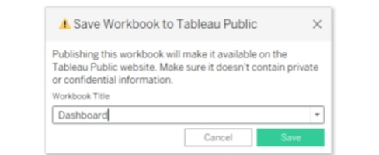

**Click on the "Save" button to start the publishing process. Tableau Desktop will upload your workbook to Tableau Public.**

**Once the upload is complete, a browser window will automatically open, displaying your published workbook on Tableau Public. Review the workbook to ensure that everything appears as expected. So in Similar way we can also publish Story to tableau public.**

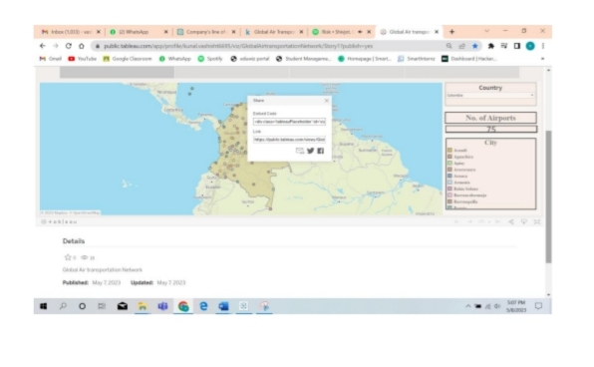

**Similarly we can also publish dashboard to tableau public.**

**MILESTONE 8:**

**ADVANTAGES:**

* **Visual Clarity**
* **Interactive Exploration**
* **Efficient Decision-Making**
* **Geospatial Analysis**
* **Cost Optimization**
* **Performance Monitoring**
* **Scenario Planning**
* **Data Collaboration**

**DISADVANTAGES:**

* **Learning Curve**
* **Cost**
* **Data Security**
* **Hardware Requirements**
* **Dependency on Data Quality**
* **Limited Real-time Capabilities**
* **Customization Challenges**
* **Integration Issues**

**CONCLUSION:**

**Leveraging Tableau for unlocking insights into the global air transportation network offers numerous advantages, including visual clarity, interactive exploration, and efficient decision-making. However, organizations should be mindful of potential challenges such as a learning curve, costs, and data security concerns. With careful implementation and management, Tableau can be a valuable tool for optimizing performance, enhancing decision-making processes, and gaining actionable insights within the dynamic landscape of global air transportation.**

**FUTURE SCOPE:**

**The future of unlocking insights into the global air transportation network with Tableau holds great promise. Anticipated advancements include enhanced analytics integration for predictive modelling, real-time data processing improvements, and integration with emerging technologies like artificial intelligence and the Internet of Things.**

**User accessibility may see improvements, reducing the learning curve and making Tableau more widely applicable. Customization and automation features are expected to evolve, allowing tailored analyses and streamlined reporting.**

**These developments position Tableau as a pivotal tool for more informed decision-making and efficient management within the evolving landscape of global air transportation.**

**MILESTONE 9:**

**TABLEAU PUBLIC DASHBOARD URL:**

<https://public.tableau.com/shared/N6ZDZH4ZJ?:display_count=n&:origin=viz_share_link>

<https://public.tableau.com/shared/HMHWWDJ3S?:display_count=n&:origin=viz_share_link>

<https://public.tableau.com/shared/2CWX6C63N?:display_count=n&:origin=viz_share_link>

<https://public.tableau.com/views/nmabi/Story1?:language=en-US&:display_count=n&:origin=viz_share_link>

**TABLEAU PUBLIC STORY URL:**

[https://github.com/saranya1303/unlocking-insights-into-the-global-air-transportation-network-with-tableau/blob/e3fd748999794c09e710c9799d4f09a212166ab0/Story 1 (1).pdf](https://github.com/saranya1303/unlocking-insights-into-the-global-air-transportation-network-with-tableau/blob/e3fd748999794c09e710c9799d4f09a212166ab0/Story%201%20(1).pdf)

**TABLEAU PUBLIC PROFILE URL:**

<https://public.tableau.com/views/nmabi/Story1?:language=en-US&:display_count=n&:origin=viz_share_link>

**VIDEO DEMONSTRATION LINK:**

<https://drive.google.com/file/d/14uGZ42uam5rx9ulrMiLDFW6_liAc-AeH/view?usp=drivesdk>