**Assessment project: File handling Mechanisms**

**Screenshots:**

**Listing the file names in ascendeing order**

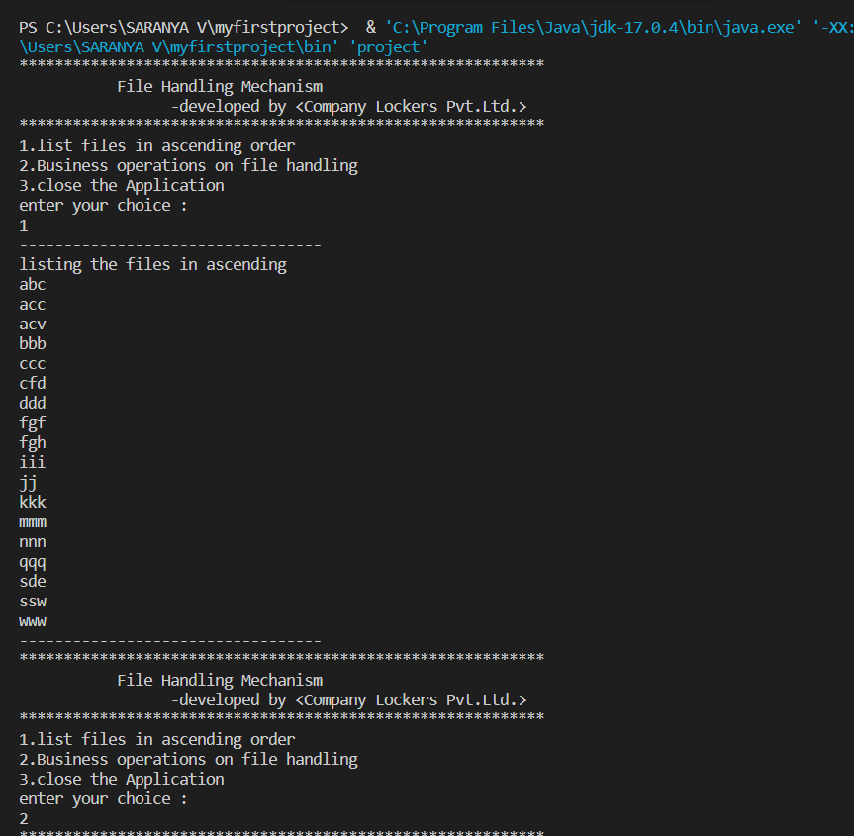

**Adding and Deleting files**

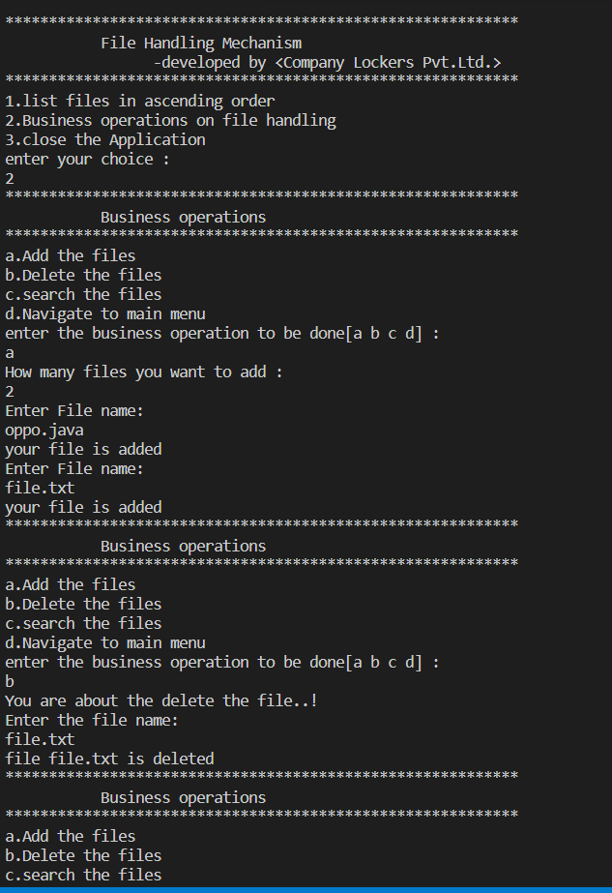

**Searching and navigating to main menu**

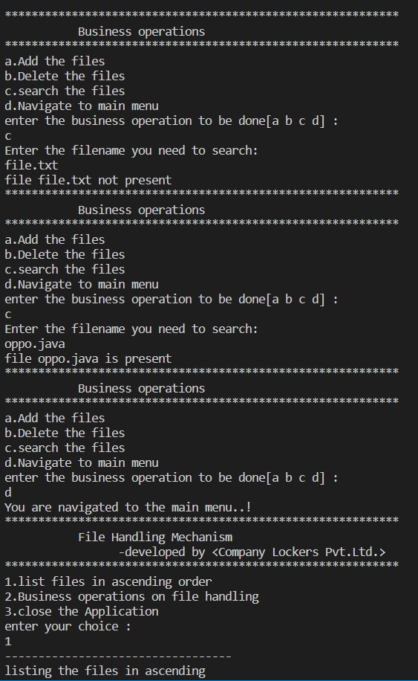

**Main menu and closing of application**

