**Displaying User Feedback**

**Screenshot:**

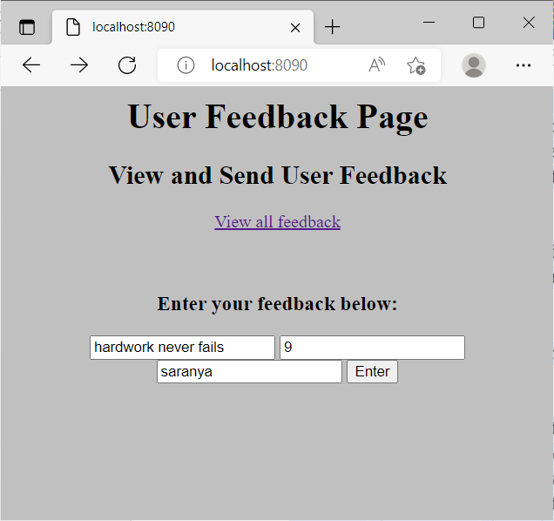

**After entering the feedback,**

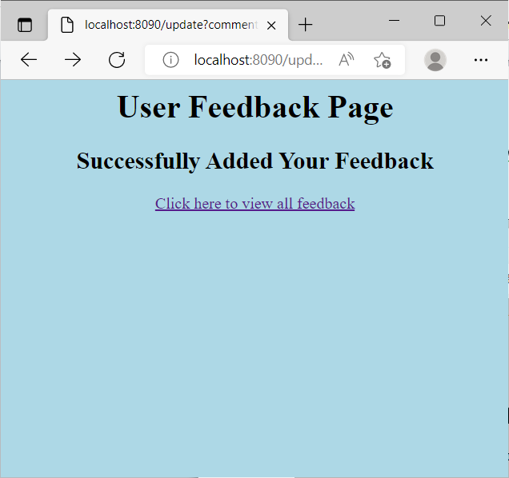

**The feedback table to view all the feedbacks in the table**

