**RETRIEVE THE PRODUCT DETAILS USING PRODUCT ID**

After running on server

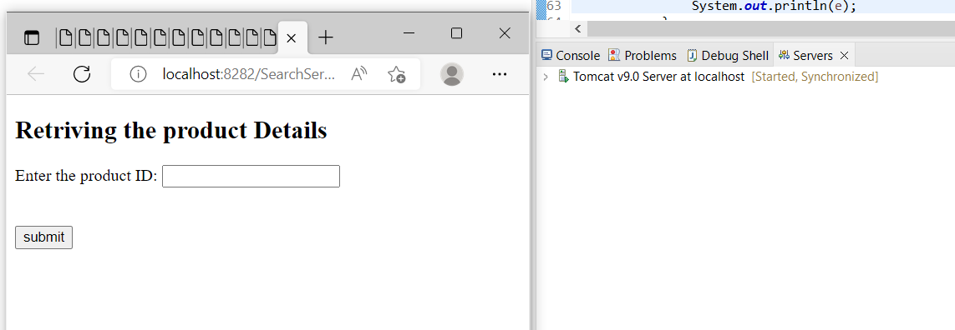

After entering the product ID,

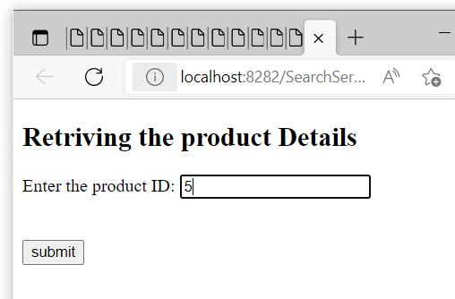

After submit, if product present, the details are retrieved.

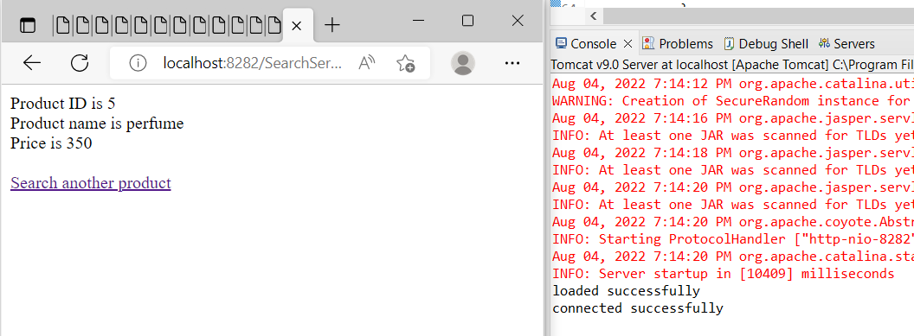

After entering product id 23, which is not present

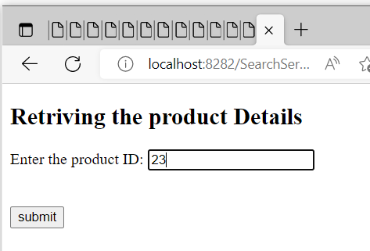

If there is no product is present in that product id,

