**Validation of the User Login**

**Screenshots:**

**Welcomepage:**

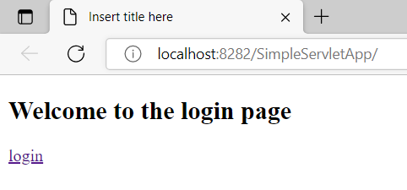

**Loginpage:**

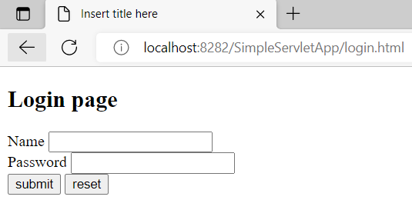

**Login details:**

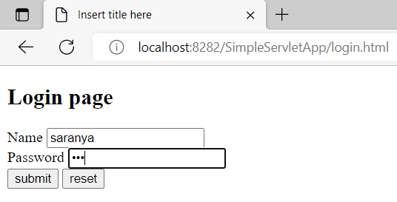

**On successful login:**

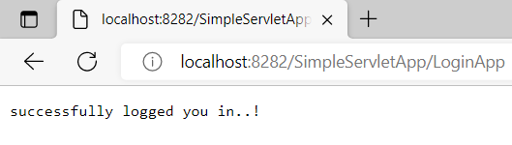

**Invalid login:**

