Library Management Book Availability System
Project Report
B. Saranya  2503A52637 | CH. Varshini  2503A52632 | T. Bindu  2503A52638

Project overview
A course prototype that combines historical borrowing analysis with a database-backed inventory dashboard. It helps library users find titles and helps staff review circulation and collection status.

Problem statement
Readers and staff need a clear way to check whether books are available, reserved, borrowed or overdue. When inventory and borrowing information are difficult to scan together, readers may not know which title to choose and staff spend time answering routine status questions.

Proposed solution
Preserve and clean the source CSV, analyze borrowing patterns, and create visual charts. Provide an interactive dashboard that reads book inventory and active-loan records from SQLite to show copy-level availability and support borrowing and returns.

How it helps users
- Students can search titles and see available-copy counts before choosing a book.
- Library staff can record borrowing and returns, review loan history and identify overdue loans.
- Administrators can compare collection size, category mix, demand and usage when planning purchases.

Project files and GitHub workflow
File or folder | Purpose
data/raw/library_datasets.csv | Original Kaggle dataset; kept as the source copy.
data/processed/library_datasets_cleaned.csv | Cleaned 1,000-row, 9-column dataset for record-based analysis.
data_cleaning.py | Normalizes fields, removes exact duplicates, parses dates and standardizes known flags.
Data_analysis.py | Writes category, reservation, overdue, duration and monthly borrowing summaries.
Data_visualisation.py | Creates category, reservation, overdue and borrowing-duration charts from the cleaned CSV.
reports/ | Analysis summary plus saved chart images.
dashboard/app.py | Main Streamlit dashboard with five navigation sections.
dashboard/catalogue.py / loans.py / live_inventory.py | Focused Streamlit modules for catalogue, loan actions and inventory views.
database/ and library.db | SQLite schema/seed helpers and project inventory/loan database.
webapp/backened/main.py | API backend source.
Dashboard.pbix | Power BI project file is present in the repository.
README.md / PROJECT_PROPOSAL.md / TASK_ASSIGNMENTS.md | Run instructions, project scope and task-to-issue mapping.

Data workflow
Kaggle CSV → raw file → cleaning → analysis → charts → dashboard. The CSV describes historical events; SQLite books and loans provide current copy-level availability in the application.

GitHub collaboration
- Issues #10–#15 track proposal, dataset collection, cleaning, dashboard, analysis and visualisation tasks.
- Merged pull requests on main: #16 dashboard, #17 dataset collection, #18 borrowing analysis. The checked-out main branch contains these merges.
- MISSING_ITEMS_CHECKLIST.txt still says Dashboard.pbix is missing although the file is present. Update the checklist before the final submission.
Repository: github.com/saranyaachowdary027/Library-management-book-availability-system

Power BI dashboard Dashboard.pbix
The repository includes a separate Power BI report file. Its single page is titled “Smart Library Management System” with the subtitle “Borrowing & Reader Insights.”
- KPI cards are labeled Total Borrowing Records, Unique Readers, Overdue Loans and Reserved Transactions.
- Slicers filter by reservation status, borrow-date range and user role.
- Visuals include borrowing records by book category, a yearly borrowing trend, reservation and overdue breakdowns, borrowing by user role and borrowing duration by role; a category detail table is also included.
- Use the PBIX to filter and compare historical borrowing patterns. It is a separate report from the Streamlit dashboard screenshots and should not be presented as live copy-level inventory.

Full dashboard walkthrough
The main application is dashboard/app.py. The sidebar has five sections. Inventory and loan screens read the SQLite database; Historical Borrowing Analytics reads the cleaned CSV.
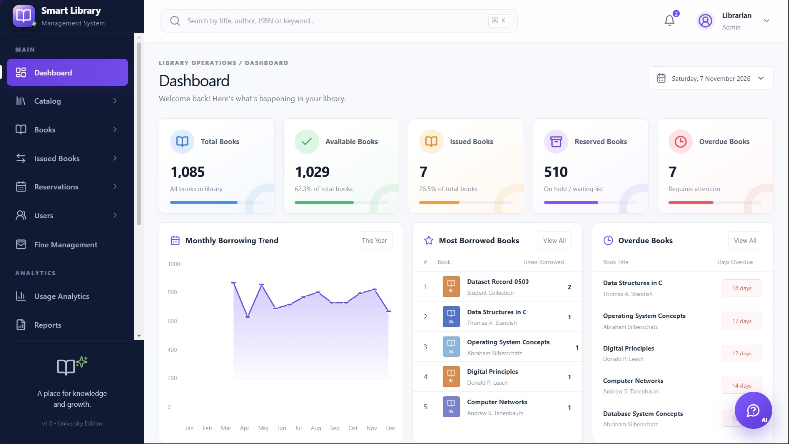  Overview cards, availability trend and circulation panels | 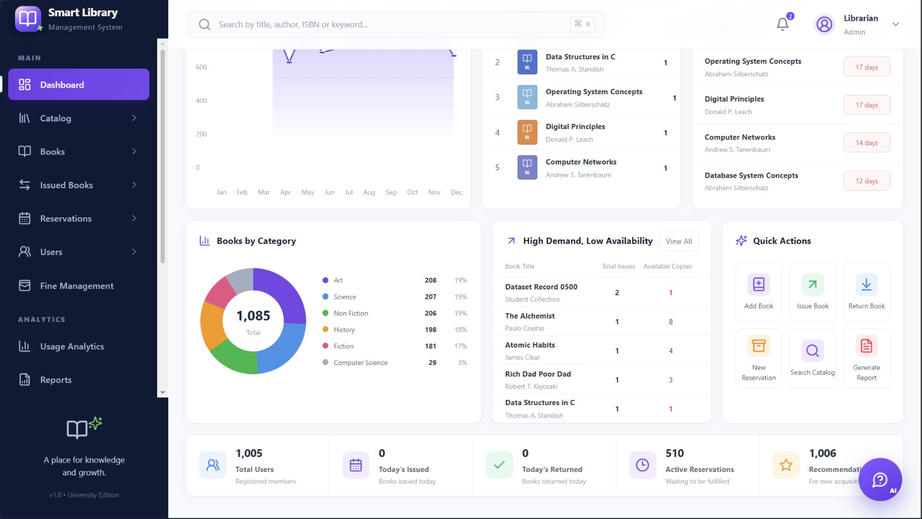  Category, demand, title lists and quick actions

1. Overview
- Four cards: book titles, total copies, available copies and currently borrowed.
- Collection availability bar chart compares available copies with total copies by title.
- Circulation status shows overdue loans, titles with no available copies and active loans. A current-inventory table and quick links open Catalogue, Borrow & Return or Live Inventory.

2. Live Inventory
- Search titles by title, author or category.
- Summary cards show matching titles, available copies and unavailable copies.
- The results table lists book ID, title, author, category, total copies and available copies.

3. Catalogue
- Search the collection by title, author or category.
- The results table shows each matching title with author, category, total copies and available copies.

4. Borrow & Return
- Borrow tab: select an available title, enter the borrower name and choose borrow and due dates; the app checks that copies remain available.
- Return tab: select an active loan, enter the return date and confirm the return.
- Loan history tab: review loan records and whether each is currently borrowed or returned.

5. Analytics
- Shows the number of historical CSV records, a bar chart of records by category and a monthly borrowing line chart.
- The full historical dataset is shown in a table for inspection. This section is explicitly separate from current SQLite inventory.

Charts, findings and interpretation
The project creates record-based visualisations from the cleaned CSV. The overdue chart below is rendered from the same cleaned records for this report.
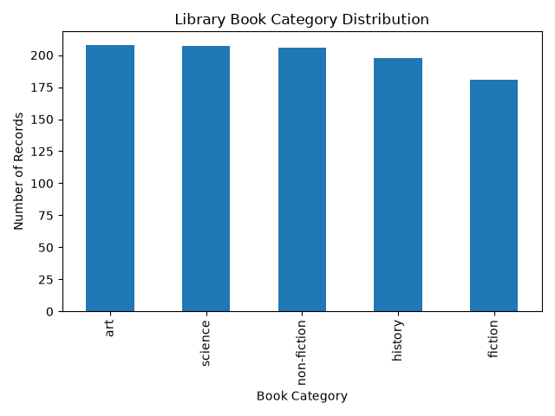  Category: Art 208, Science 207, Non-fiction 206, History 198, Fiction 181. | 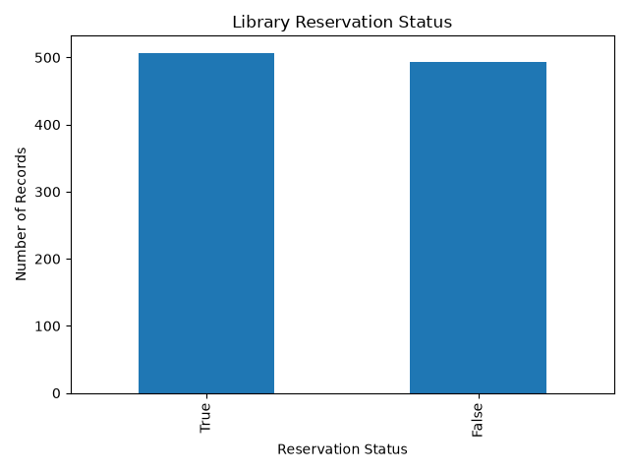  Reservations: 507 true, 493 false.
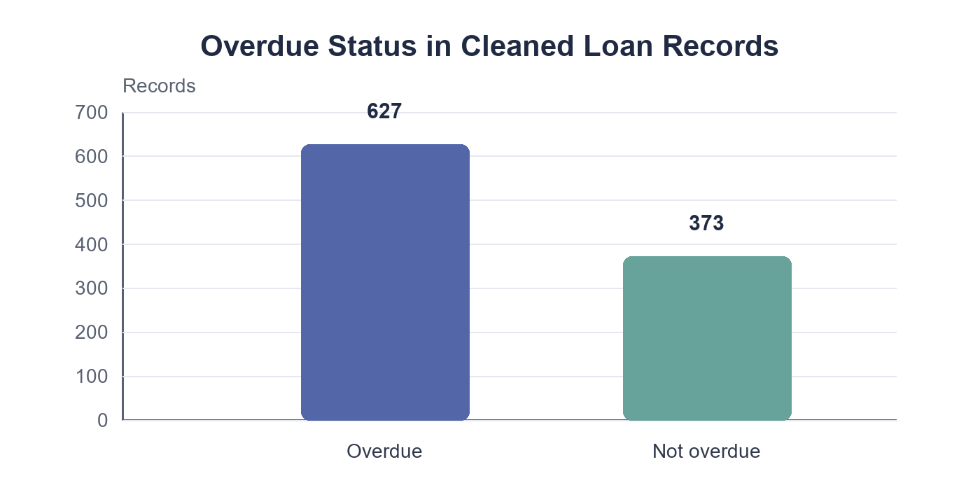  Overdue flag: 627 overdue, 373 not overdue. | 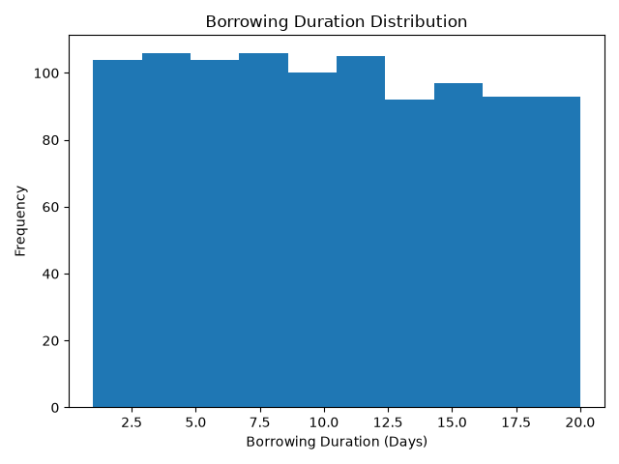  Loan duration: mean 10.22 days, median 10, range 1–20.

Key interpretation notes
- The category groups are close in size (181–208 records); reservation flags are nearly balanced.
- The popular_books.png plot lists book IDs seen once each, so this CSV cannot identify repeat-borrowed or genuinely popular titles.
- The project folder has a book_availability.png image whose bars show reservation True/False; its filename/title should be clarified before calling it an availability chart.
- The cleaned CSV has 1,000 historical loan rows, not a live stock feed. Current availability should be calculated from inventory and unreturned loans in SQLite.
- Dashboard screenshot counts show 1,029 available of 1,085 total (94.8%); the image label reads 62.3%. It shows 7 issued (0.6%) while the label reads 25.5%. Verify dashboard percentages before presenting them.

Project conclusion
The project combines a repeatable data workflow, interpretable charts and an interactive library dashboard. Historical CSV analysis and current database availability answer different questions; keep those sources distinct when describing results.

