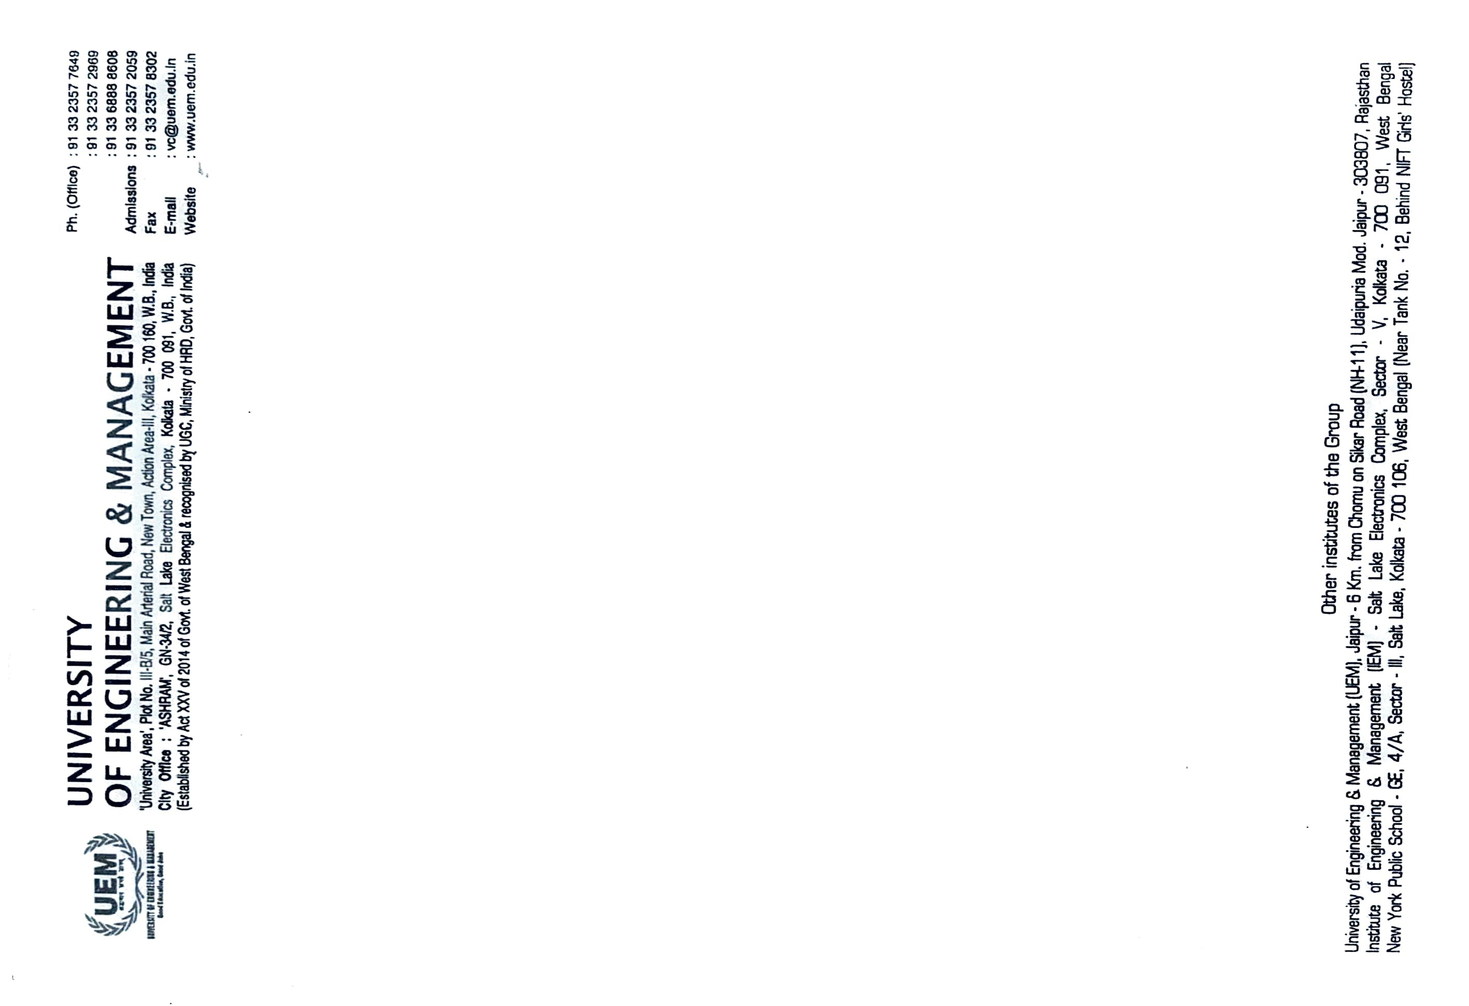
CERTIFICATE

This is to certify that the project titled “Transfer Learning-based Pneumonia Detection using Chest X-Ray Images” submitted by,

Saranya Bhattacharjee (University Roll No. 12019009001311),
Aditya Jaiswal (University Roll No. 12019009023073),
Nisha Kumari (University Roll No. 12019009023082),
Aman Chopra (University Roll No. 12019009022013),
Aniket Singh (University Roll No. 12019009022126),
and Shubham Mukherjee (University Roll No. 12019009001221)

students of UNIVERSITY OF ENGINEERING & MANAGEMENT, KOLKATA, in partial fulfillment of the requirement for the degree of Bachelor of Computer Science Batch 2023, is a bonafide work carried out by them under the supervision and guidance of Prof. Sankhadeep Chatterjee and Prof. Amartya Chakraborty during 8th Semester of the academic session of 2023. The content of this report has not been submitted to any other university or institute. I am glad to inform you that the work is entirely original and its performance is found to be quite satisfactory.

_______________________ _______________________
Prof. Sankhadeep Chatterjee Prof. Amartya Chakraborty
Dept. of Computer Science & Technology Dept. of Computer Science & Technology
UEM, Kolkata UEM, Kolkata

______________________
Prof. (Dr.) Sukalyan Goswami
Head of the Department (HOD)
Department of Computer Science
UEM, Kolkata

