ASSIGNMENT 1

SAI SARANYA BYRAPUNENI

16338876

**Data Reproducibility**

There were three stages of data reproducibility.

1. Data Acquisition

2. Data Cleaning/Processing

3. Data Analysis

**1.Data Acquisition:**

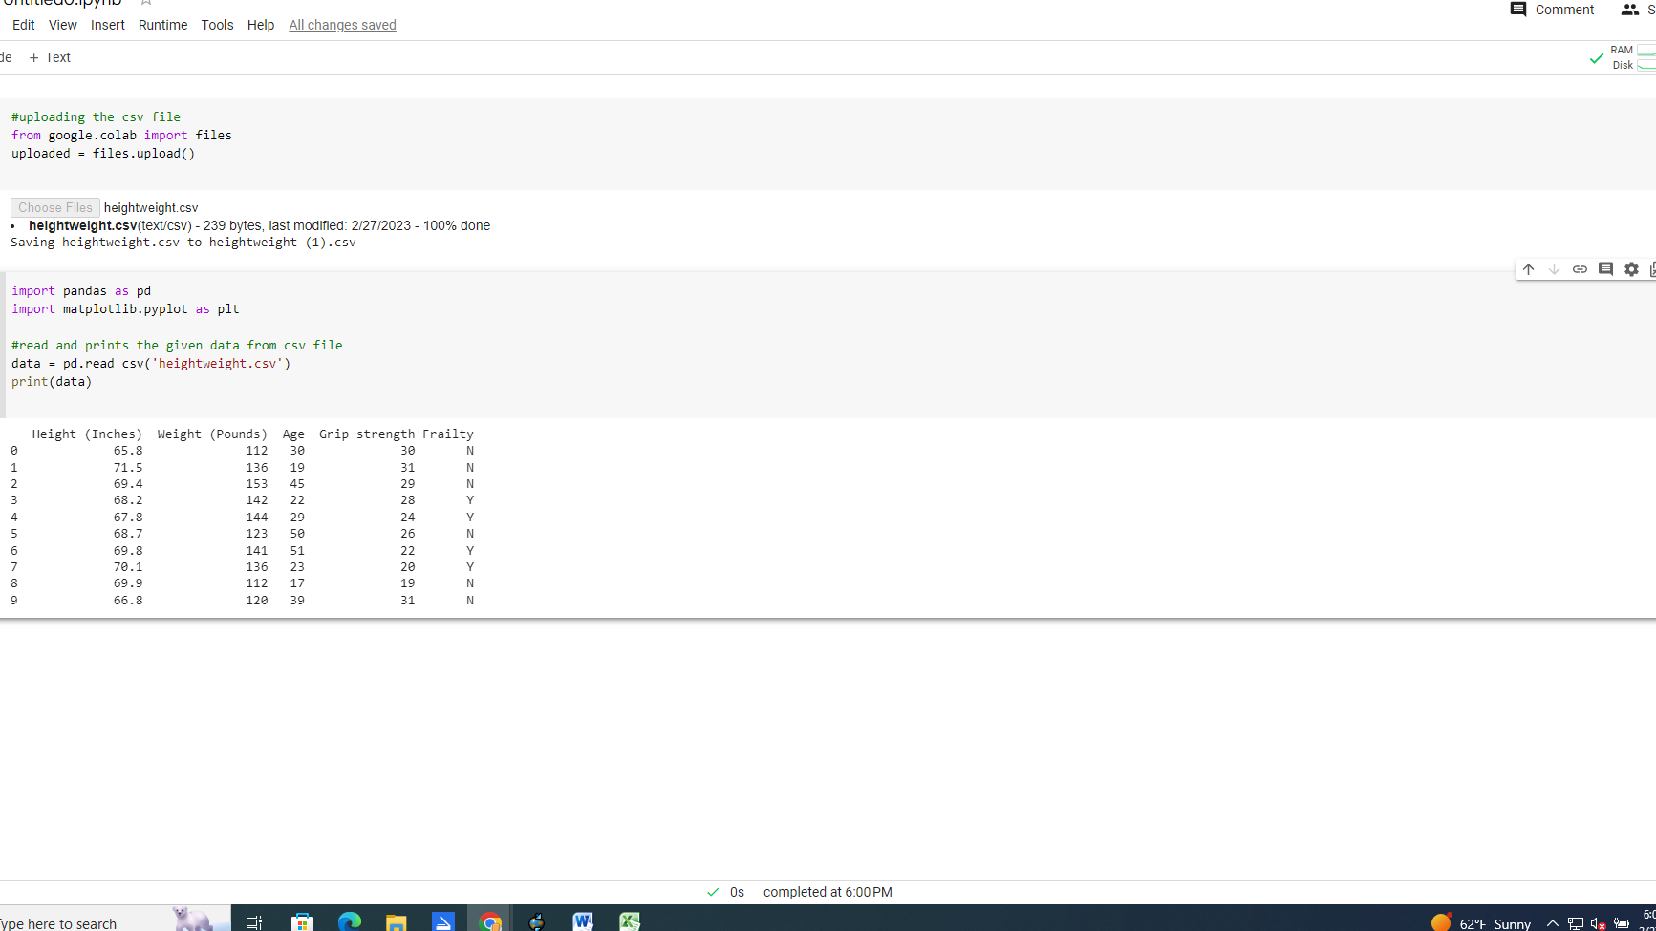

**2. Data Cleaning/Processing**

The second stage, known as data cleaning or processing, entails cleaning up the data that was generated in the previous stage. We go on to step 3 because the provided data are clear-cut, uncomplicated, and free of noise or null values, and cleaning is not necessary for these data.

3.**Data Analysis**

It is the last step in the reproduction of data. In this part of the study, we look at the data using different mathematical techniques or visuals to identify correlations between the variables.

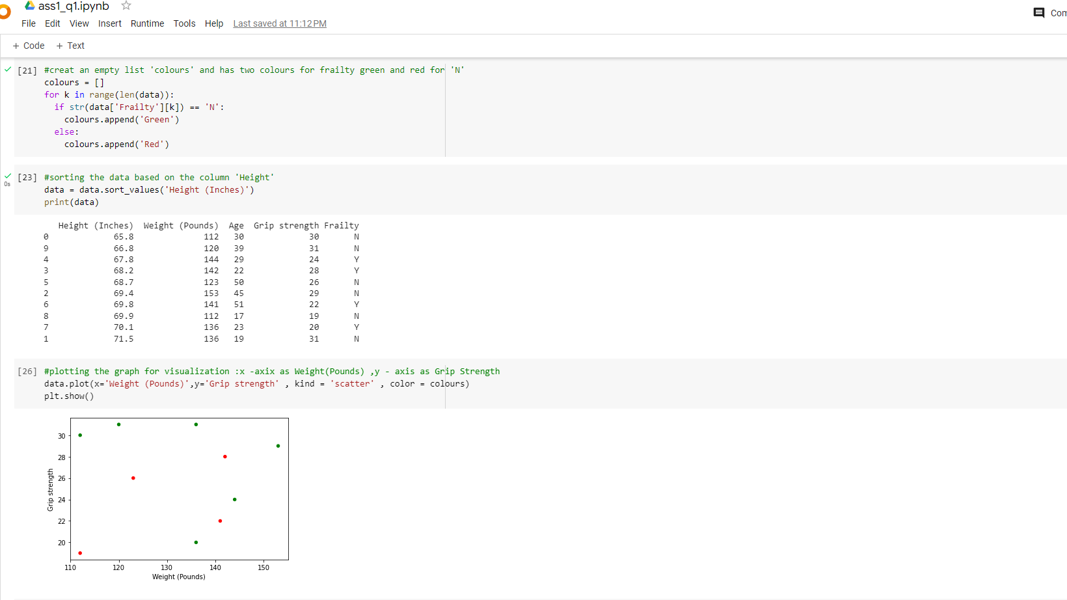

Here in the picture shows both sorting based on data column and scatter plot based on weight and grip strength.

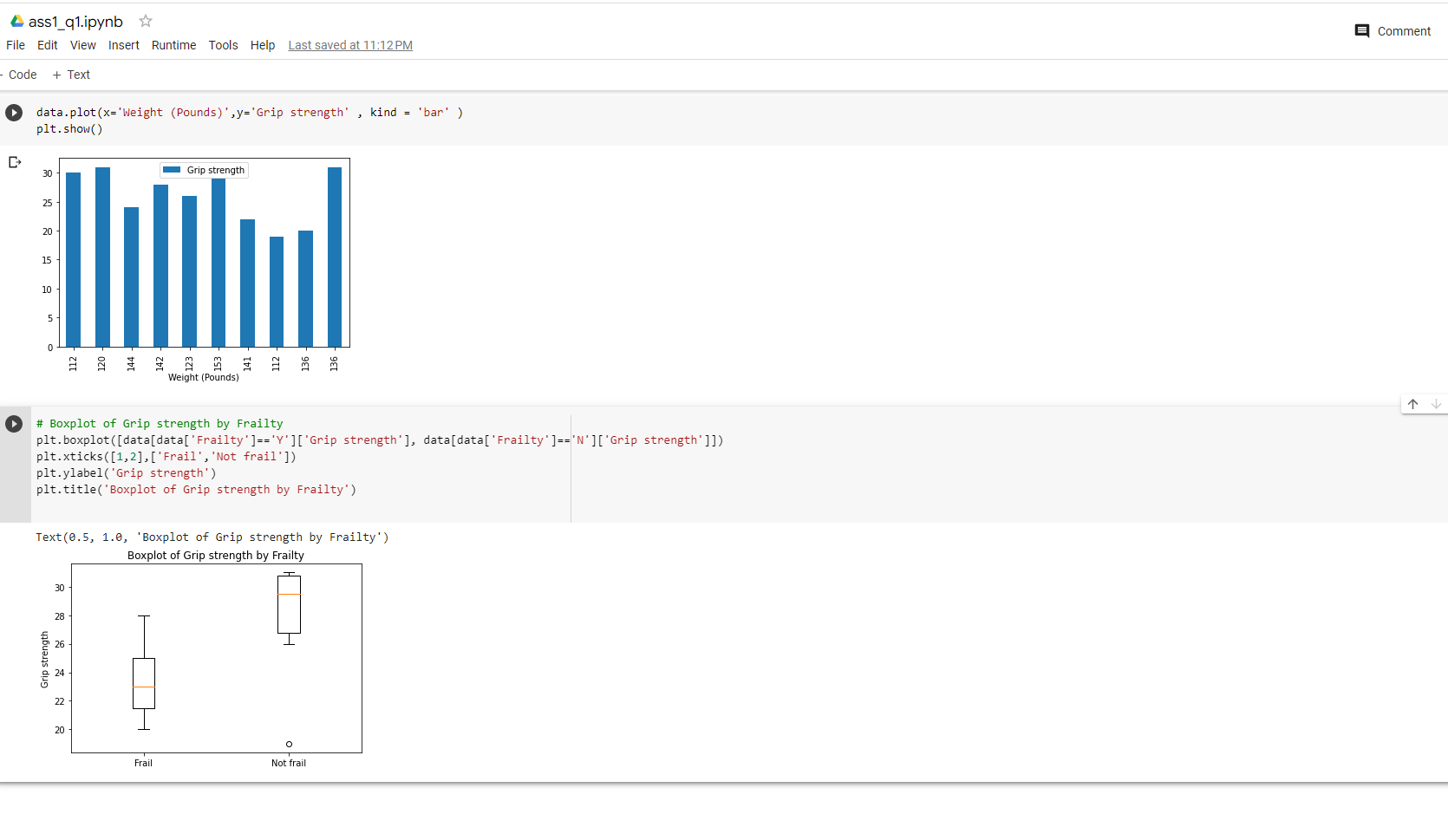

Box plot between frailty and grip strength