FitBuddy – AI Fitness Plan Generator
Technical Documentation | Built with FastAPI + Google Gemini AI

1. Project Overview
FitBuddy is a full-stack AI-powered web application that generates personalized 7-day workout plans and targeted nutrition tips based on each user's fitness profile. It leverages Google Gemini Flash models via the google-genai SDK, served through a FastAPI backend with a Jinja2 HTML frontend and a persistent SQLite database.
Key capabilities include: personalized workout plan generation, AI-driven nutrition advice, feedback-driven plan refinement, persistent storage per user, and an admin dashboard to view all users and their plans.

2. Tech Stack
Layer | Technology
Backend Framework | FastAPI 0.141.1 + Uvicorn 0.54.0
AI / LLM | Google Gemini Flash (google-genai 2.25.0)
Database | SQLite + SQLAlchemy ORM 2.1.1
Frontend | HTML5 + CSS3 + Jinja2 3.1.6 Templates

3. Project Structure
The project follows a clean separation of concerns with the FastAPI application layer in app/, HTML templates in templates/, static assets in static/, and a top-level launcher in run.py.

app/ — Application Package
- main.py — FastAPI application entry point. Creates the app instance with title FitBuddy – AI Fitness Plan Generator (version 1.0.0), mounts the /static directory, initialises database tables via Base.metadata.create_all(), and registers all routes.
- routes.py — All HTTP route handlers: GET /, POST /generate-workout, POST /submit-feedback, GET /view-all-users. Contains the private _build_result_context() helper that constructs the Jinja2 template context dict.
- database.py — SQLite engine (sqlite:///app/fitbuddy.db), session factory, and CRUD helpers: save_user, save_plan, get_original_plan, update_plan, get_user, get_all_users, get_all_plans.
- models.py — Two SQLAlchemy ORM models: User (id, user_id, username, age, weight, goal, intensity) and WorkoutPlan (id, user_id, original_plan, updated_plan, nutrition_tip). WorkoutPlan.user_id is a foreign key to users.user_id.
- schemas.py — Pydantic request validation models: UserInput (user_id, username, age 5–120, weight > 0, goal, intensity) and FeedbackRequest (user_id, feedback min 5 chars).
- gemini_generator.py — Generates the 7-day workout plan using Gemini Flash models. Implements multi-model fallback (_MODELS list) with up to 3 retries on 503 overload, immediate skip on 404/429. Input is validated (age 10–120, weight > 0, non-empty fields) before calling the API.
- gemini_flash_generator.py — Generates a concise nutrition/recovery tip (3–5 sentences) tailored to the user's fitness goal using the same Gemini Flash fallback chain.
- updated_plan.py — Revises an existing workout plan incorporating user feedback. Uses the same fallback chain and raises RuntimeError if Gemini returns an empty response.

templates/ — Jinja2 HTML Templates
- index.html — Homepage with the user input form (Name, User ID, Age, Weight, Goal, Intensity). Submits via POST to /generate-workout.
- result.html — Displays the generated 7-day workout plan, nutrition tip, and (when available) the AI-revised updated plan. Also contains the Refine Your Plan feedback form that POSTs to /submit-feedback.
- all_users.html — Admin dashboard showing all registered users and their workout plans, keyed by user_id via the plans_by_user lookup dict.

4. AI Model Architecture
FitBuddy uses a multi-model fallback chain to maximise reliability when individual Gemini endpoints are overloaded or deprecated. All three Gemini modules (gemini_generator.py, gemini_flash_generator.py, updated_plan.py) share the same fallback strategy.

Model Fallback Chain (tried in order)
1. gemini-flash-latest 2. gemini-3.8-flash 3. gemini-3.7-flash 4. gemini-3.6-flash 5. gemini-3.5-flash 6. gemini-flash-lite-latest

Retry Logic
Each model is retried up to 3 times on HTTP 503 (Service Overloaded) with a 2-second delay between attempts. On HTTP 404 (model not found or deprecated) or 429 (quota exhausted), the model is skipped immediately and the next model in the list is tried. If all 6 models are exhausted, the last exception is re-raised and a user-facing error message is displayed.

Prompt Design
- Workout Plan Prompt (gemini_generator.py): Instructs Gemini to act as an expert personal fitness trainer and produce a strictly formatted 7-day plan. Each day includes a Warm-Up (5–10 min), Main Workout (4–6 exercises with sets x reps and rest time), and a Cool-Down/Recovery Tip. The prompt passes the user's Name, Age, Weight, Goal, and Intensity, and explicitly requests no introduction or closing remarks.
- Nutrition Tip Prompt (gemini_flash_generator.py): Instructs Gemini to act as a certified nutritionist, returning one concise paragraph (3–5 sentences) covering specific foods/macros/hydration advice, recovery strategies, and the rationale for the recommendation relative to the user's goal.
- Plan Update Prompt (updated_plan.py): Provides the original 7-day plan and the user's free-text feedback. Instructs Gemini to keep the 7-day structure, incorporate all feedback, maintain the original formatting (DAY X – Focus, Warm-Up / Main Workout / Cool-Down sections), and return only the updated plan.

5. API Endpoints
Method | Endpoint | Description
GET | / | Homepage — renders index.html with the user input form
POST | /generate-workout | Generates 7-day plan + nutrition tip; persists to SQLite; renders result.html
POST | /submit-feedback | Revises plan using user feedback; saves updated_plan; renders result.html
GET | /view-all-users | Admin dashboard — all users and plans

6. Database Schema
FitBuddy uses a SQLite database (app/fitbuddy.db) with two tables managed by SQLAlchemy ORM. The database file is created automatically on first run via Base.metadata.create_all().

users Table
Column | Type | Description
id | Integer (PK) | Auto-increment primary key
user_id | String(50), UNIQUE | Unique identifier supplied by the user
username | String(100) | Display name
age | Integer | Age in years (validated 5–120 in schema)
weight | Float | Body weight in kilograms (> 0)
goal | String(100) | Fitness goal (e.g., weight loss, muscle gain)
intensity | String(50) | Workout intensity level (low / medium / high)

workout_plans Table
Column | Type | Description
id | Integer (PK) | Auto-increment primary key
user_id | String(50), FK | Foreign key referencing users.user_id
original_plan | Text | Full 7-day workout plan as generated by Gemini (NOT NULL)
updated_plan | Text (nullable) | Revised plan after user feedback; NULL until first refinement
nutrition_tip | Text (nullable) | AI-generated nutrition/recovery tip for the user's goal

7. Setup & Installation

Prerequisites
- Python 3.10 or higher
- VS Code with the Python extension (recommended)
- A free Google Gemini API key from https://aistudio.google.com/app/apikey

Step 1 — Create and Activate Virtual Environment
Open a terminal in the FitBuddy_AI folder and run: python -m venv fitbuddy-env fitbuddy-env\Scripts\activate (Windows)

Step 2 — Install Dependencies
pip install -r requirements.txt
The requirements.txt pins: fastapi==0.141.1, uvicorn[standard]==0.54.0, jinja2==3.1.6, sqlalchemy==2.1.1, python-multipart==0.0.32, google-genai==2.25.0, python-dotenv==1.2.3, aiofiles==25.1.0, protobuf>=5.0,<6.0.

Step 3 — Configure the API Key
Copy .env.example to .env and set GOOGLE_API_KEY=<your_key>. The key is loaded by python-dotenv at startup in main.py before any Gemini client is initialised.

Step 4 — Run the Application
python run.py or equivalently: uvicorn app.main:app --reload

8. Usage Guide

Generate a Personalised Plan
- Navigate to http://127.0.0.1:8000 in your browser.
- Fill in your Name, User ID, Age (years), Weight (kg), Fitness Goal, and Intensity level.
- Click Generate My Plan. FitBuddy will call Gemini to produce a 7-day workout schedule and a nutrition tip, then display them on the result page.

Refine Your Plan with Feedback
- On the result page, scroll to Refine Your Plan.
- Enter free-text feedback, e.g. Add more rest days, include yoga or Reduce cardio and add strength training.
- Click Update My Plan. Gemini will revise the plan incorporating all feedback and return a new 7-day schedule alongside the original.

Admin Dashboard
Visit http://127.0.0.1:8000/view-all-users to see all registered users and their stored plans. The interactive API documentation (Swagger UI) is available at http://127.0.0.1:8000/docs.

9. Notes & Behaviour
- Idempotent User Creation: submitting /generate-workout for an existing User ID updates the profile fields (username, age, weight, goal, intensity) rather than creating a duplicate record.
- Missing API Key: if GOOGLE_API_KEY is absent or equals the placeholder your_gemini_api_key_here, a descriptive warning message is returned to the UI instead of making a Gemini API call.
- Input Validation: the gemini_generator validates age (10–120) and weight (> 0) before building the prompt. Pydantic schemas enforce age 5–120, weight > 0, and feedback minimum 5 characters at the HTTP layer.
- Shared Client Instance: each Gemini module uses a module-level _client singleton to avoid re-creating the genai.Client on every request.
- Database Location: app/fitbuddy.db is created automatically at first startup. No additional database setup is required.

Fitbuddy-login
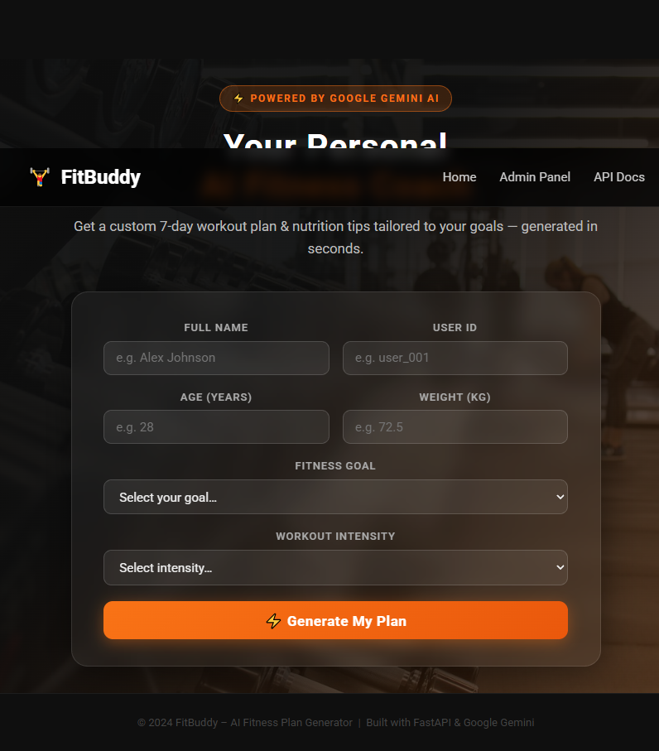

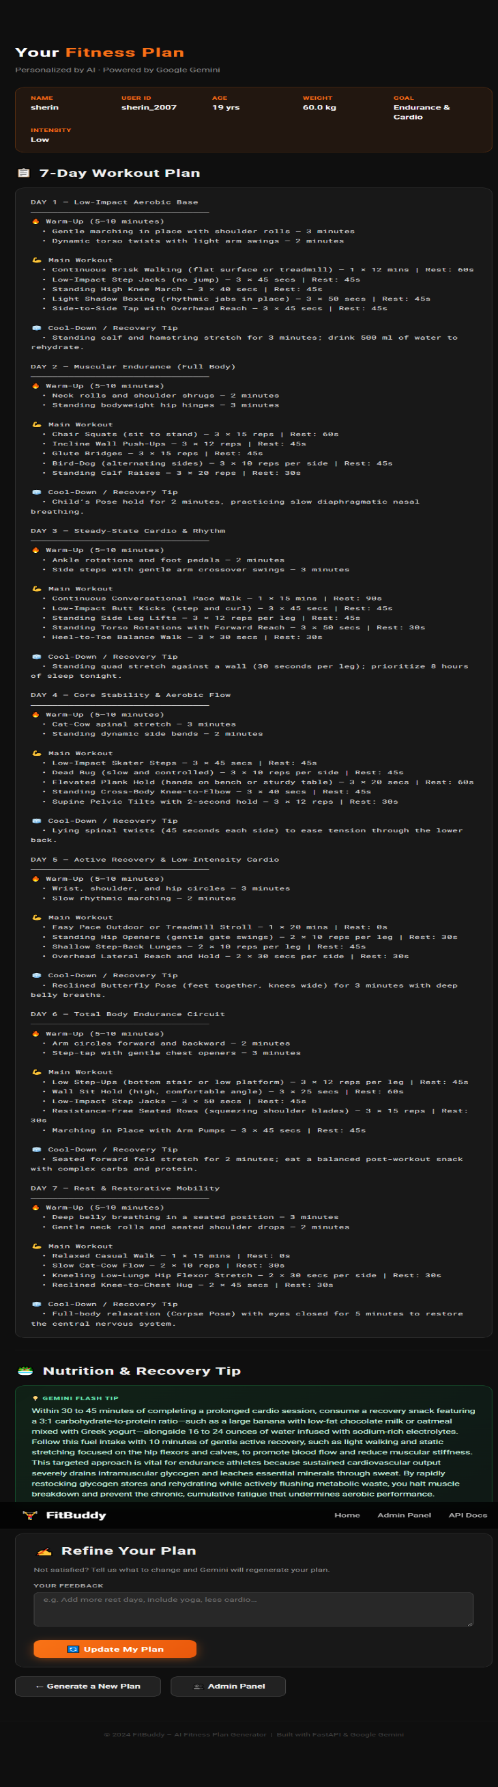
Fitbuddy-output
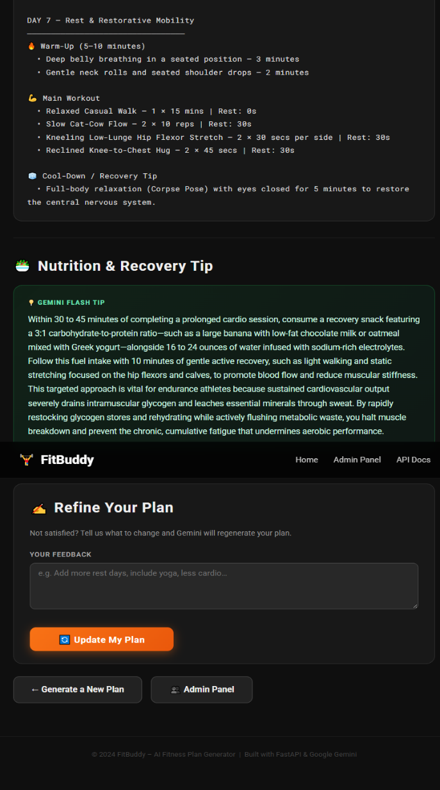

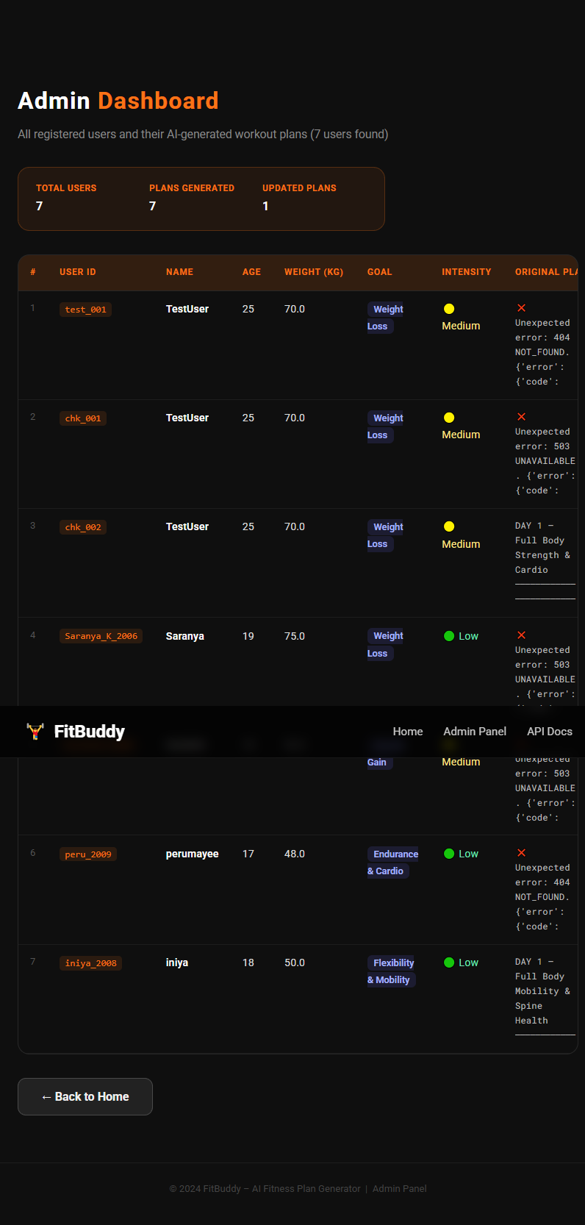
Fitbuddy-Admin panel

