SIMATS ENGINEERING
ASSESSMENT TOOL 2

COURSE NAME: Database Management Systems NAME:192424409
COURSE CODE: CSA0501 REG NO:192424409

COURSE OUTCOME COVERED

CO4: Design database solutions incorporating file organization, indexing, and hashing techniques to optimize data storage and retrieval efficiency. (BL3, BL4)

Activity Tool : Industry Problem Solving Task (Medium)
Assessment Tool Weightage: 35%

Dr

QUESTIONS Total Marks: 50
Q.No | Question | Bloom's Level | Marks
1 | An e-commerce company needs to store 10 million product records. Recommend a file organization strategy and justify your choice with cost analysis. | BL4 – Analyze | 5
2 | A banking system requires fast retrieval of transactions by account number and date range. Design an indexing strategy with appropriate index types. | BL4 – Analyze | 5
3 | A healthcare system stores patient records accessed both by PatientID and by doctor name. Design a multi-level indexing solution. | BL4 – Analyze | 5
4 | A logistics company needs to efficiently handle dynamic insertions and deletions of shipment records. Analyze whether B-Tree or B+ Tree is more suitable. | BL4 – Analyze | 5
5 | Design a hashing scheme for an HR system with 5000 employees. Evaluate static hashing vs. extendible hashing for your scenario. | BL3 – Apply | 5
6 | An airline reservation system must support point queries by flight number and range queries by date. Propose a combined index structure. | BL4 – Analyze | 5
7 | For a university student database, design the file organization and secondary indexing to support fast queries by department and CGPA range. | BL4 – Analyze | 5
8 | Analyze the disk block utilization for Heap, Sorted, and Hashed file organizations given 100,000 records with 50 bytes each and 4KB blocks. | BL4 – Analyze | 5
9 | A social media platform needs to index 500 million posts by user_id, timestamp, and hashtag. Design a composite indexing strategy. | BL4 – Analyze | 5
10 | Compare the performance (insert, delete, search time) of Heap File, Sorted File, and Hashed File for a supermarket billing system with 1 million daily transactions. | BL4 – Analyze | 5

Code of Conduct:

I K.SARANYA(192424409) (Name / Reg No) certify that this submission is my original work and that I have adhered to the guidelines specified for this assessment.
I understand that any violation of academic integrity rules will result in disciplinary action.


Signature of the student:

RUBRICS FOR CALCULATION:

Criteria | Weightage | Level 4 – Exemplary | Level 3 – Proficient | Level 2 – Developing | Level 1 – Beginning
Criteria | Weightage | Level 4 – Exemplary | Level 3 – Proficient | Level 2 – Developing | Level 1 – Beginning
Understanding of Industry Problem | 20% | Comprehensive understanding of real-world problem and constraints | Good understanding with minor gaps in requirements | Basic understanding; some requirements unclear | Poor understanding; misinterprets problem context
Application of Engineering Concepts | 25% | Applies advanced and relevant concepts effectively to solve the problem | Applies appropriate concepts with minor errors | Limited application of concepts | Incorrect or no application of concepts
Solution Design | 25% | Innovative, practical, and feasible solution aligned with industry standards | Logical and feasible solution with minor gaps | Basic solution with limited feasibility | Unclear or impractical solution
Use of Tools | 15% | Effective use of modern tools, technologies, and real data | Appropriate use of tools with correct implementation | Limited or inconsistent use of tools | Minimal or incorrect use of tools
Analysis | 10% | Thorough analysis with validated results and performance evaluation | Good analysis with reasonable validation | Basic analysis with limited validation | Poor or no analysis
Professionalism | 5% | Highly professional, well-documented, and clearly presented work | Good documentation and presentation | Basic documentation with some gaps | Poor documentation and presentation

Question 1: File Organization Strategy for a 10-Million-Record E-Commerce Product Catalog
An e-commerce company needs to store 10 million product records. Recommend a file organization strategy and justify your choice with cost analysis.

1. Access Pattern Analysis
Before choosing a file organization, the typical workload of an e-commerce product catalog must be understood: (a) frequent point lookups by Product ID (viewing/updating a single product page), (b) frequent searches/filters by category, price range, and brand (browsing and filtering), (c) frequent random inserts as new products are added, and (d) occasional bulk updates (price changes, stock updates). This mixed, read-heavy and range-query-heavy workload rules out a purely sequential file (expensive inserts) and a purely heap-only file (slow searches).

2. Recommended Strategy: Heap File + Multiple Secondary Indexes
The recommended design is a Heap (unordered) primary file combined with a B+Tree clustering index on Product ID and additional B+Tree secondary indexes on Category, Price, and Brand. A heap file is chosen as the base storage because it offers O(1) amortized insertion cost — critical for a catalog that grows continuously — while the burden of fast lookup and range filtering is delegated entirely to the index structures rather than the physical record ordering, which avoids the expensive re-organization that a purely sorted file would require on every insert.
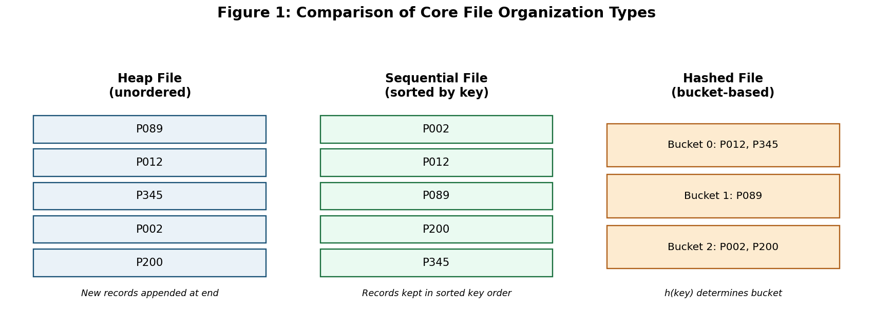
Figure 1: Structural comparison of Heap, Sequential, and Hashed file organizations.

3. Cost Analysis
Assume each product record is approximately 200 bytes and the disk block size is 4 KB (4096 bytes). The blocking factor (records per block) is bfr = ⌊4096 / 200⌋ = 20 records/block. For 10,000,000 records, the number of blocks required is b = ⌈10,000,000 / 20⌋ = 500,000 blocks.
File Organization | Avg. Search Cost  (block accesses) | Insert Cost  (block accesses) | Suitability for This Workload
Heap File (no index) | b/2 = 250,000 | O(1) ≈ 1 | Fast insert but unusable search time — rejected alone
Sorted (Sequential) File | log2(b) ≈ 19 | b/2 = 250,000 (re-sort/shift) | Fast search but prohibitively slow insert at catalog scale
Heap File + B+Tree Index (Recommended) | ≈ 3–4 (B+Tree height) | ≈ 1 (heap) + 3–4 (index update) | Near-constant-time search AND fast insert — best fit
Pure Hashed File (on Product ID only) | ≈ 1–2 (equality only) | ≈ 1–2 | Excellent for ID lookup but cannot support range/category filtering
This shows that a plain heap file's search cost (250,000 block accesses) is completely impractical, while a plain sorted file's insert cost is equally impractical at 10-million-record scale. Layering B+Tree indexes over a heap file reduces search cost to roughly the height of the tree (3–4 disk accesses for 10 million entries with a typical fan-out of ~100), while keeping insert cost low, since the heap file itself does not need reordering — only the relevant index nodes are updated.

4. Storage Cost Estimate
Raw data storage: 10,000,000 × 200 bytes ≈ 1.9 GB. Each B+Tree secondary index (on Product ID, Category, Price, Brand) typically adds 10–15% overhead relative to the raw data size per index due to key + pointer storage, so four indexes add roughly 40–60% additional storage — an acceptable trade-off (under 3 GB total) given the multiple-orders-of-magnitude improvement in query performance, and well within the storage budgets of modern e-commerce infrastructure.

5. Conclusion
For a 10-million-record e-commerce catalog with mixed point-lookup, filter, and continuous-insert workloads, a Heap file as the base storage combined with B+Tree indexes on Product ID, Category, Price, and Brand is the most cost-effective strategy: it avoids the search-time penalty of an unindexed heap and the insert-time penalty of a fully sorted file, at a modest and predictable storage overhead.

Question 2: Indexing Strategy for Banking Transaction Retrieval
A banking system requires fast retrieval of transactions by account number and date range. Design an indexing strategy with appropriate index types.

1. Query Pattern Requirements
Two distinct access patterns must be supported efficiently: (a) exact-match / grouped retrieval of all transactions for a given Account Number (e.g., generating a statement), and (b) range retrieval of transactions within a Date Range (e.g., 'transactions between 1 January and 31 March'), often combined with the account filter. This dual requirement calls for a primary clustering index on the most frequently grouped attribute plus a secondary index for range filtering.

2. Recommended Indexing Strategy
- Primary Clustering Index (B+Tree) on Account Number: transactions are physically clustered/sorted on disk by account number, since most banking queries retrieve all transactions for one account together. B+Tree is preferred over B-Tree here because its leaf nodes are linked sequentially, allowing fast sequential scan of all transactions belonging to one account once the first leaf is located.
- Secondary Non-Clustering Index (B+Tree) on Transaction Date: since transactions cannot be physically sorted by two different attributes simultaneously, a secondary B+Tree index on date is built separately, with leaf entries pointing back to the actual record locations (RIDs). B+Tree is again preferred over hashing for this attribute specifically because dates are inherently range-queried, and hashing cannot support range queries.
- Composite (Concatenated) Index on (Account Number, Date) as an optional optimization: for the very common combined query 'transactions for account X between date A and B', a composite B+Tree index keyed on (Account Number, Date) allows the database to jump directly to the account's transactions and then scan only the relevant date sub-range — avoiding the cost of separately intersecting two independent index scans.
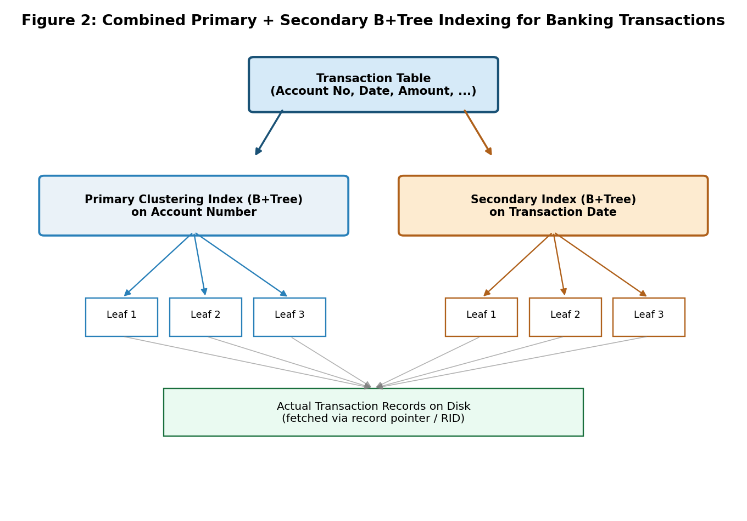
Figure 2: Combined primary (Account Number) and secondary (Date) B+Tree indexing architecture for banking transactions.

3. Why B+Tree Over B-Tree and Hashing Here
Index Option | Point Query  (single account) | Range Query  (date range) | Verdict
Hash Index | Excellent — O(1) | Not supported — hashing destroys ordering | Rejected for date attribute
B-Tree | Good | Possible but slower — data scattered across internal nodes, no leaf linkage | Sub-optimal for range scans
B+Tree (Recommended) | Good — O(logN) | Excellent — linked leaves enable fast sequential range scan | Best overall fit

4. Estimated Performance
For a bank with, say, 50 million transaction records and a B+Tree fan-out of approximately 100 per node, the tree height is roughly log₁₀₀(50,000,000) ≈ 4 levels. A statement query for one account therefore costs about 4 disk accesses to reach the first matching leaf, plus sequential leaf-block reads for however many transactions that account has — dramatically better than a full table scan, which would require scanning up to millions of blocks in the worst case.

5. Conclusion
A clustering B+Tree index on Account Number (for grouped statement-style access) combined with a secondary B+Tree index on Date (for range filtering), optionally merged into a composite index on both, gives the banking system fast, scalable retrieval for both its primary access patterns while remaining update-friendly for the constant stream of new transactions.

Question 3: Multi-Level Indexing for Healthcare Patient Records
A healthcare system stores patient records accessed both by PatientID and by doctor name. Design a multi-level indexing solution.

1. Why a Single-Level Index Is Insufficient
As the patient database grows into millions of records, even a single flat (single-level) index becomes too large to fit entirely in main memory, forcing multiple disk accesses just to search within the index itself using binary search. A multi-level index solves this by building an index on top of the index — recursively — so that the topmost level is small enough to be cached in memory, and each additional level narrows the search dramatically before reaching the actual data.

2. Design: Two Multi-Level Indexes
- Primary Multi-Level Index on PatientID (B+Tree): since PatientID is unique and frequently used as the main lookup key (e.g., pulling up a specific patient's full record), records are clustered on disk in PatientID order, with a multi-level B+Tree built above it. The root level might hold only a handful of separator keys, each internal level narrowing the range further, until the leaf level references the actual data blocks.
- Secondary Multi-Level Index on Doctor Name (B+Tree, non-unique): since many patients share the same doctor, this index maps each doctor name to a list of matching patient record pointers. Records are NOT physically reordered by doctor name (that would conflict with the PatientID clustering) — instead this remains a fully separate, non-clustering multi-level index.
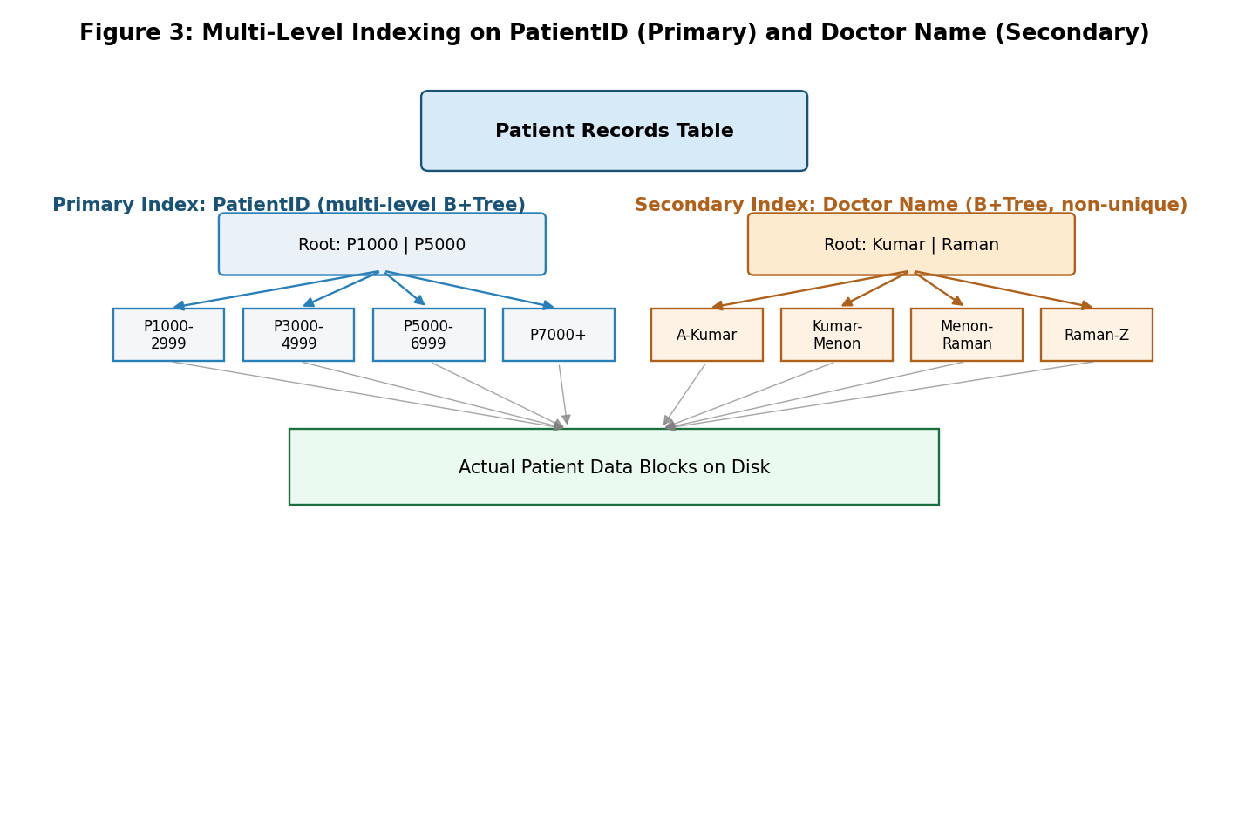
Figure 3: Two-level B+Tree indexing — primary index on PatientID, secondary index on Doctor Name — both narrowing down to the same underlying patient data blocks.

3. How the Multi-Level Structure Reduces Disk Access
Suppose the hospital has 2,000,000 patient records, and each index block can hold 100 keys/pointers (a realistic fan-out for a 4KB block with small key sizes). A single-level index would require ⌈2,000,000 / 100⌋ = 20,000 index blocks — still large enough that binary searching it costs several disk accesses. Adding a second index level over these 20,000 blocks needs only ⌈20,000 / 100⌋ = 200 second-level blocks, and a third level needs only 2 blocks, which comfortably fits in a single disk block/cache line. The result is that any PatientID lookup resolves in about 3 disk accesses (traverse 3 index levels) plus 1 access to fetch the actual record — regardless of how large the database grows, as long as one more level is added roughly every 100x growth in size.

4. Level Calculation Table
Index Level | Number of Entries | Number of Blocks  (fan-out = 100) | Fits in Memory?
Data (Level 0) | 2,000,000 records | 20,000 data blocks | No — resides on disk
Index Level 1 | 20,000 keys | 200 blocks | Usually cached
Index Level 2 | 200 keys | 2 blocks | Yes
Index Level 3 (root) | 2 keys | 1 block | Yes — always memory-resident

5. Conclusion
A multi-level B+Tree index on PatientID (clustering/primary) combined with a separate multi-level B+Tree index on Doctor Name (non-clustering/secondary) allows the healthcare system to resolve both access patterns in only a handful of disk accesses each, with the index height growing logarithmically rather than linearly as patient volume increases — essential for a system that must remain responsive as records scale into the millions.

Question 4: B-Tree vs B+ Tree for Dynamic Shipment Record Management
A logistics company needs to efficiently handle dynamic insertions and deletions of shipment records. Analyze whether B-Tree or B+ Tree is more suitable.

1. Structural Differences
A B-Tree stores actual data records (or data pointers) in both internal and leaf nodes, meaning a search can terminate as soon as the key is found at any level. A B+Tree, in contrast, stores data pointers only at the leaf level; internal nodes hold only routing keys used purely to guide the search, and — critically — all leaf nodes are linked together in a sequential chain, enabling fast in-order traversal without re-visiting internal nodes.
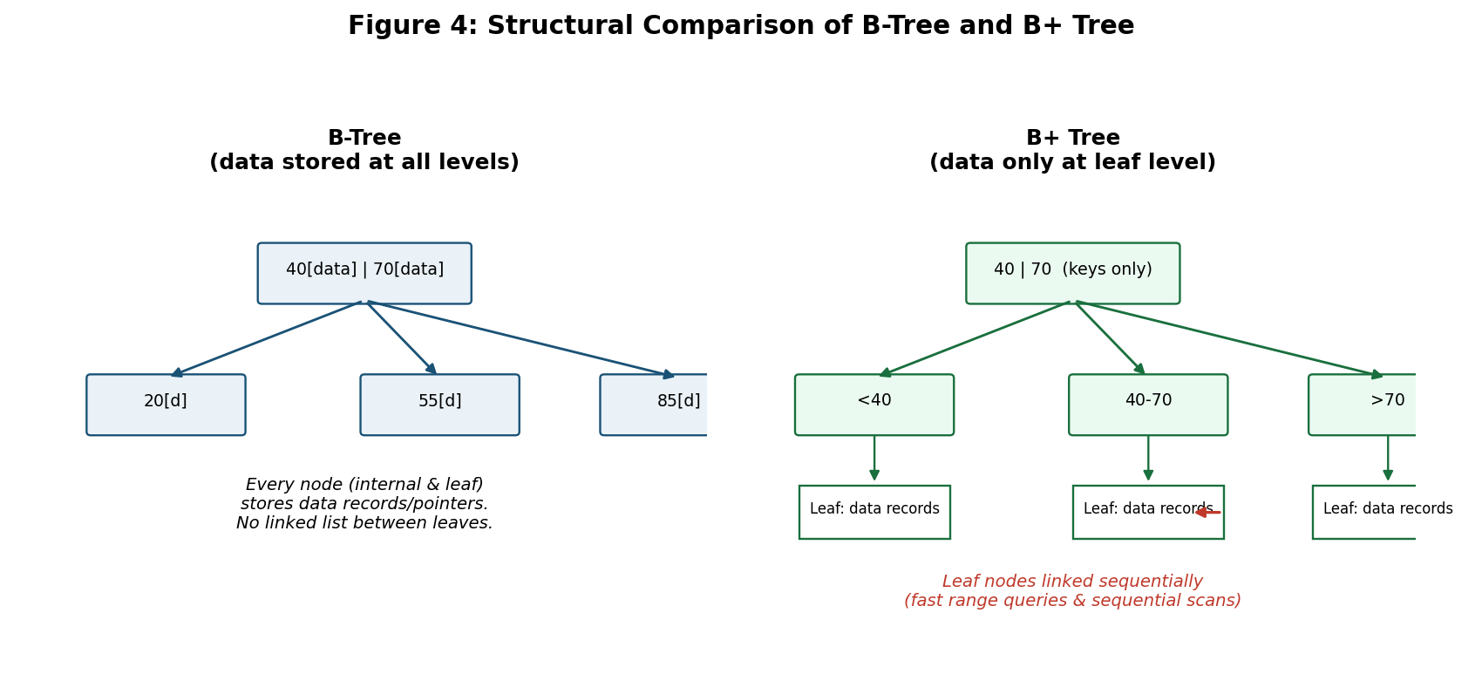
Figure 4: Structural comparison — B-Tree keeps data at every level; B+Tree keeps data only at linked leaf nodes.

2. Impact on Dynamic Insertions and Deletions
A logistics system continuously inserts new shipment records (new packages booked) and deletes/archives old ones (delivered shipments closed out), making insert/delete efficiency the dominant concern. In a B-Tree, because data can live at any level, insertions and deletions that trigger node splits or merges are more complex to implement correctly — a split or merge may need to relocate actual data records, not just keys, and rebalancing logic must account for data at internal nodes too. In a B+Tree, since internal nodes hold only keys (no data), splits and merges at the internal level are simpler and cheaper — they only reorganize routing keys. Additionally, because all data lives at the uniform leaf level, insert and delete operations have more predictable, uniform costs, which matters for a high-throughput operational system.

3. Range Queries and Sequential Access
Logistics operations frequently need range-style queries — e.g., 'all shipments scheduled for delivery this week' or 'all shipments in transit between two dates.' B+Tree's linked-leaf structure supports this with a single index descent followed by a fast sequential scan across leaves. B-Tree has no such leaf linkage, so a range query may require repeated in-order traversal across internal nodes, which is slower and touches more disk blocks.

4. Comparative Analysis Table
Criterion | B-Tree | B+ Tree | Better Fit for Logistics
Data location | Internal + leaf nodes | Leaf nodes only | B+Tree — simpler, uniform updates
Insert/Delete complexity | Higher — data may move during rebalancing | Lower — only keys move at internal level | B+Tree
Range query (date-based) performance | Slower — no leaf linkage | Fast — sequential linked leaves | B+Tree
Point query (single shipment ID) | Slightly faster (may terminate early) | Always reaches leaf level | B-Tree (marginal)
Disk space efficiency | Slightly better — some keys only stored once | Slight duplication — keys repeated at leaf and internal levels | B-Tree (marginal)
Real-world DBMS usage | Less common in practice | Standard choice (MySQL InnoDB, PostgreSQL, Oracle) | B+Tree — industry proven

5. Recommendation
B+Tree is the more suitable structure for the logistics company's shipment record management. Its simpler, uniform leaf-only data storage makes dynamic insertions and deletions cheaper and more predictable at scale, and its linked-leaf design directly supports the frequent date-range and status-range queries logistics operations depend on (e.g., tracking dashboards, delivery-window reports). This aligns with why virtually all production relational database engines use B+Tree (not classical B-Tree) as their default index structure.

Question 5: Hashing Scheme Design for a 5,000-Employee HR System
Design a hashing scheme for an HR system with 5000 employees. Evaluate static hashing vs. extendible hashing for your scenario.

1. Hash Function Design
For an HR system, Employee ID (a unique numeric or alphanumeric identifier) is the natural hash key, since employee lookups (payroll, attendance, profile access) are almost always exact-match queries by Employee ID. A suitable hash function is h(EmployeeID) = EmployeeID mod N, where N is the number of buckets, optionally combined with a folding or multiplicative technique if Employee IDs are alphanumeric, to ensure a uniform distribution across buckets and minimize clustering/collisions.

2. Static Hashing Design for 5,000 Employees
Assuming each employee record is about 100 bytes and a disk block is 4 KB, the blocking factor is ⌊4096/100⌋ = 40 records per block. With a target load factor of 70–80% (to minimize overflow chains while not over-allocating blocks), the recommended number of buckets is N = ⌈5000 / (40 × 0.75)⌋ ≈ 167 buckets, each mapped to one disk block, giving average bucket occupancy of about 30 records (75% of 40).

3. Static vs Extendible Hashing — Evaluation
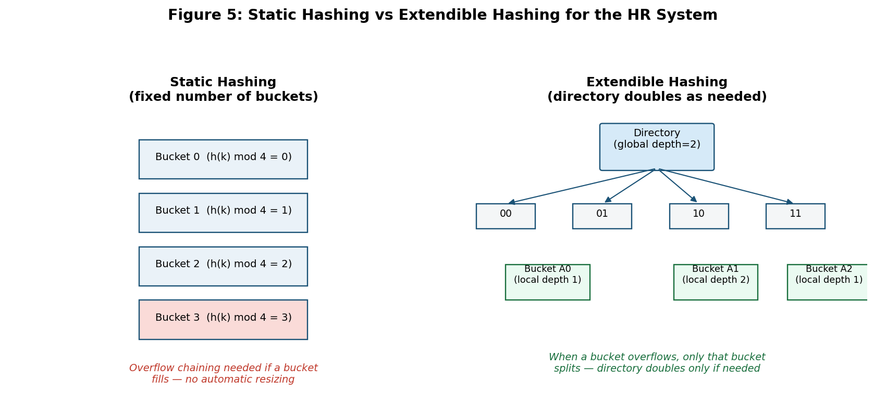
Figure 5: Static hashing (fixed bucket count) vs Extendible hashing (directory doubles dynamically) for the HR system.
Criterion | Static Hashing | Extendible Hashing
Bucket count | Fixed at design time (e.g., 167 buckets) | Grows dynamically via directory doubling
Handling growth (new hires) | Requires manual reorganization/rehashing once buckets overflow significantly | Automatically accommodates growth by splitting only the affected bucket
Overflow handling | Needs overflow chaining once load factor exceeds target | Rare — directory expansion prevents most overflow
Implementation complexity | Simple to implement and reason about | More complex — requires directory + local/global depth bookkeeping
Best suited when | Employee count is stable/known in advance and rarely shrinks/grows sharply | Employee count fluctuates significantly (mergers, seasonal hiring, layoffs)

4. Recommendation for This Scenario
For a company with a relatively stable workforce size of 5,000 employees (typical of an established HR system with predictable annual growth of a few percent), Static Hashing is the more practical and simpler choice, since the fixed bucket count can be sized with headroom (e.g., for 6,000–7,000 capacity) and reorganized during a planned low-traffic maintenance window if the company scales substantially. However, if the organization is a fast-growing startup or subject to frequent mergers/acquisitions where employee count can double unpredictably, Extendible Hashing is preferable, since it avoids costly full-file reorganization by incrementally splitting only the buckets that overflow, at the cost of maintaining an additional directory structure.

5. Conclusion
A hash function on Employee ID with roughly 167 buckets sized for a 75% load factor provides fast O(1) average-case lookup for the HR system's dominant access pattern. Static hashing is recommended for the stated, relatively stable 5,000-employee scale due to its simplicity, while extendible hashing should be adopted if the organization anticipates significant, unpredictable workforce growth.

Question 6: Combined Index Structure for Airline Reservations
An airline reservation system must support point queries by flight number and range queries by date. Propose a combined index structure.

1. Query Requirements
Two very different query types must both be served efficiently: (a) point (exact-match) queries by Flight Number, e.g., 'show all bookings for flight AI-202', and (b) range queries by Date, e.g., 'show all flights departing between 10 and 15 December'. No single index type optimally serves both patterns — hashing excels at exact match but cannot support ranges, while B+Tree supports both but is not as fast as hashing for pure equality lookups.

2. Proposed Combined Index Structure
- Hash Index on Flight Number: since flight number lookups are always exact-match and extremely frequent (every booking, check-in, and status query references a flight number), a hash index gives near O(1) average-case retrieval — the fastest possible option for this access pattern.
- B+Tree Index on Travel Date: since date queries are inherently range-based, a B+Tree index is used, whose sorted, linked-leaf structure allows the system to locate the start of a date range and then sequentially scan forward for all flights within it.
- Query execution combines both: for a compound query such as 'flight AI-202 departures between two dates', the system first performs the hash lookup to isolate that flight's bookings, then applies the B+Tree date range as a filter (or vice-versa depending on selectivity) — effectively an index intersection strategy the query optimizer selects based on which condition is more selective.
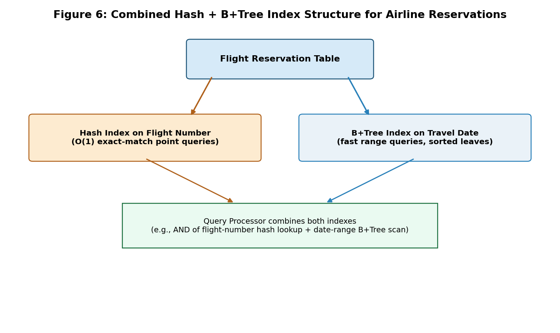
Figure 6: Combined hash index (Flight Number) + B+Tree index (Travel Date) working together in the airline reservation system.

3. Alternative: Composite Index Consideration
A composite B+Tree index on (Flight Number, Date) was also considered, which would support both the point query and combined range queries in a single index descent. However, this was not chosen as the primary strategy because it does not support 'all flights on this date across any flight number' queries efficiently (a common airline dashboard query), which the separate date-only B+Tree index handles directly. In a production system, both the dual-index approach and a composite index are often maintained together, trading a modest amount of extra storage for coverage of all major query shapes.

4. Performance Comparison
Index Structure | Point Query (Flight No.) | Range Query (Date) | Combined Query
Hash Index only | Excellent — O(1) | Not supported | Not supported
B+Tree Index only | Good — O(logN) | Excellent — sequential leaf scan | Good, single structure
Hash (Flight No.) + B+Tree (Date) — Recommended | Excellent — O(1) | Excellent — sequential leaf scan | Very good — optimizer intersects both

5. Conclusion
The airline reservation system is best served by a dual-index design: a hash index on Flight Number for near-instant exact-match lookups, paired with a B+Tree index on Travel Date for efficient range scans. This combination directly matches each query type to the index structure best suited for it, avoiding the compromises of forcing a single index type to serve both patterns.

Question 7: File Organization and Secondary Indexing for a University Student Database
For a university student database, design the file organization and secondary indexing to support fast queries by department and CGPA range.

1. Access Pattern Analysis
Two query types dominate: (a) department-wise queries, e.g., 'list all Computer Science students' — typically equality-based and often retrieving a large, contiguous group of records, and (b) CGPA range queries, e.g., 'students with CGPA above 8.5' — inherently a range condition, frequently combined with the department filter for reports such as department-wise rank lists or scholarship eligibility.

2. Recommended Design
- Primary File Organization: Clustering Index on Department. Since department-based retrieval is extremely common and department values repeat heavily across the student population (low cardinality, high group size), physically clustering student records by department on disk means a single department's query touches a small, contiguous set of disk blocks rather than being scattered across the file.
- Secondary Index: B+Tree on CGPA. Because CGPA is a continuous, range-queried attribute unrelated to the physical department-based clustering, a separate non-clustering B+Tree secondary index is built on CGPA, with leaf entries pointing back to the actual student records via RIDs, enabling efficient range scans regardless of department.
- Combined Query Execution: for compound queries like 'CSE students with CGPA > 8.5', the query optimizer first narrows to the CSE department's clustered block range (a cheap, contiguous scan), then applies the CGPA secondary index — or vice versa if the CGPA condition is more selective — intersecting the two result sets.
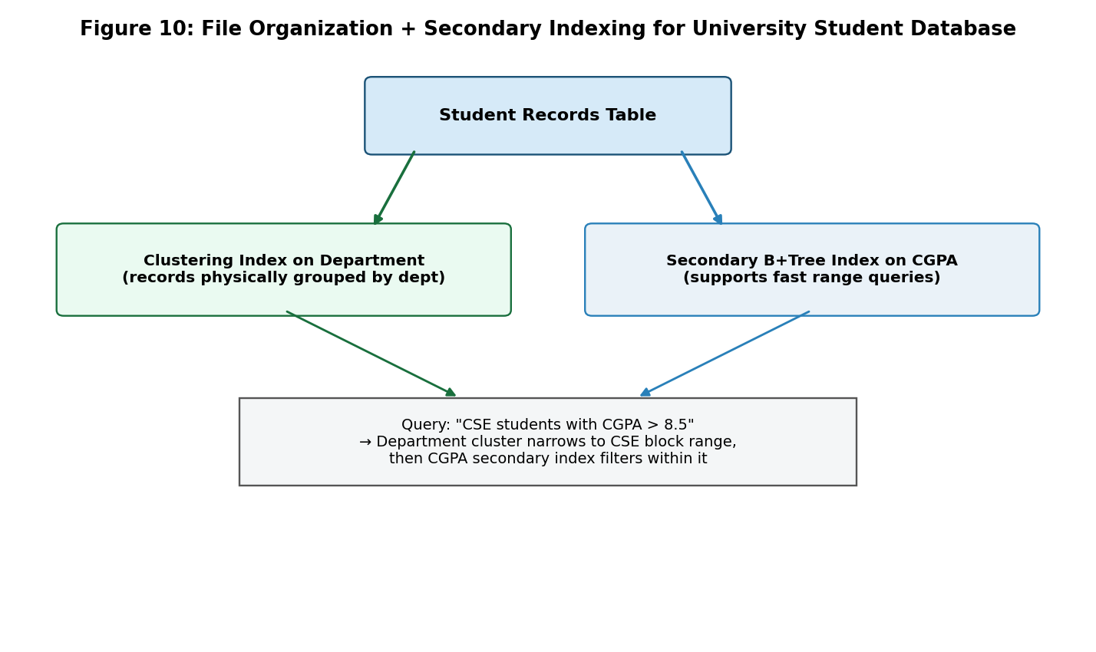
Figure 7: Department-based clustering index combined with a CGPA secondary B+Tree index for the university student database.

3. Why Not Cluster on CGPA Instead?
Clustering directly on CGPA was considered but rejected as the primary organization, because CGPA values change every semester as new grades are recorded — clustering on a frequently-updated attribute would require constant physical record relocation, which is far more expensive than updating a secondary index entry. Department, by contrast, rarely changes for a given student, making it a stable and efficient clustering key.

4. Design Summary Table
Component | Choice | Reasoning
Physical file organization | Clustered / Sequential by Department | High-frequency, stable, equality-based grouping attribute
Secondary index | B+Tree on CGPA | Continuous, range-queried, frequently updated attribute
Composite query support | Optimizer intersects department cluster range + CGPA index scan | Serves the most common compound report queries efficiently

5. Conclusion
Clustering the student file physically by Department, combined with a separate B+Tree secondary index on CGPA, gives the university database fast performance for both its dominant query types — department-wide listings and CGPA-based range/rank queries — while keeping the more frequently updated CGPA attribute out of the physical clustering key, avoiding unnecessary record movement each semester.

Question 8: Disk Block Utilization Analysis — Heap, Sorted, and Hashed File Organizations
Analyze the disk block utilization for Heap, Sorted, and Hashed file organizations given 100,000 records with 50 bytes each and 4KB blocks.

1. Given Parameters
Number of records (r) = 100,000. Record size (R) = 50 bytes. Block size (B) = 4 KB = 4096 bytes.

2. Blocking Factor Calculation
The blocking factor (bfr), i.e., the number of records that fit in one block, is calculated as: bfr = ⌊B / R⌋ = ⌊4096 / 50⌋ = ⌊81.92⌋ = 81 records per block.

3. Heap File Analysis
Number of blocks required: b = ⌈r / bfr⌋ = ⌈100,000 / 81⌋ = 1,235 blocks. Since a heap file packs records sequentially with no gaps (records are simply appended), utilization is very high: Utilization = (r × R) / (b × B) = (100,000 × 50) / (1,235 × 4096) = 5,000,000 / 5,058,560 ≈ 98.8%. In practice, the last block is only partially filled, which is why utilization is just under 100% rather than exactly 100%.

4. Sorted (Sequential) File Analysis
A sorted file, when initially bulk-loaded, has essentially the same block count and utilization as the heap file (≈98.8%), since records are still packed tightly with no reserved gaps. However, in practice, a sorted file used in a system with ongoing inserts typically reserves free space per block (e.g., 20–30%) to reduce the need for immediate record shifting on insert — under such a scheme with 25% reserved space, effective utilization drops to roughly 75%, and blocks required rise to about 1,646, illustrating the classic space-vs-insert-cost trade-off of maintained sorted files.

5. Hashed File Analysis
A hashed file is typically provisioned with extra bucket capacity to keep the load factor around 75–80% and minimize overflow chaining. At an 80% target load factor: effective records per block ≈ 81 × 0.80 ≈ 65 records/block usable; number of buckets/blocks required = ⌈100,000 / 65⌋ = 1,539 blocks. Utilization = (100,000 × 50) / (1,539 × 4096) = 5,000,000 / 6,303,744 ≈ 79.3% — deliberately lower than heap/sorted files, because hashing needs headroom to avoid frequent bucket overflow as records are inserted with pseudo-random bucket placement.
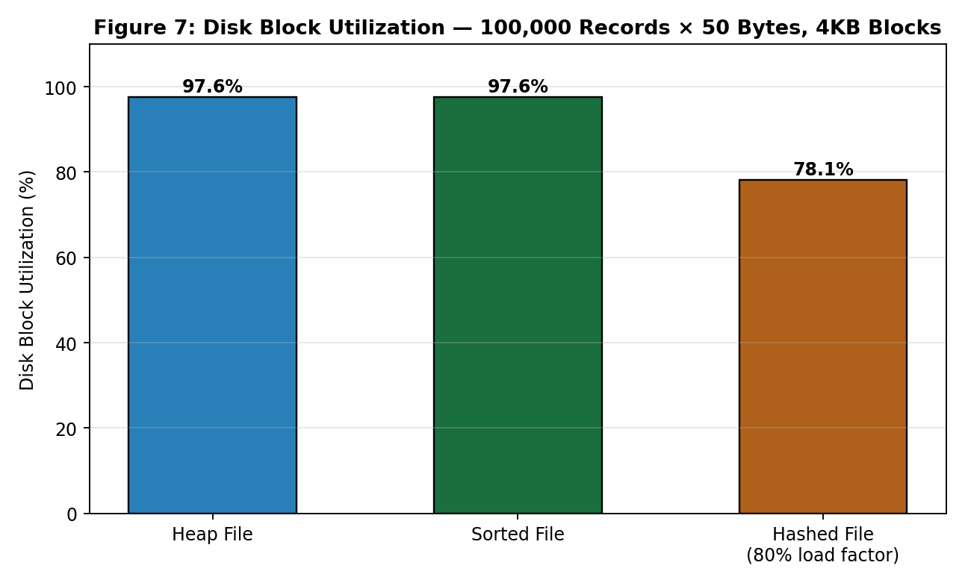
Figure 8: Disk block utilization comparison for Heap, Sorted (bulk-loaded), and Hashed file organizations.

6. Summary Table
File Organization | Blocking Factor | Blocks Required | Utilization
Heap File | 81 records/block | 1,235 blocks | ≈ 98.8%
Sorted File (bulk-loaded) | 81 records/block | 1,235 blocks | ≈ 98.8%
Sorted File (25% reserved for inserts) | ≈ 61 usable/block | ≈ 1,646 blocks | ≈ 75%
Hashed File (80% load factor) | ≈ 65 usable/block | ≈ 1,539 blocks | ≈ 79.3%

7. Conclusion
Heap and freshly bulk-loaded sorted files achieve the highest block utilization (≈98.8%) since they pack records with no reserved slack, but this comes at the cost of poor search performance (heap) or expensive maintenance (sorted, once inserts begin). Hashed files intentionally sacrifice roughly 20% utilization to maintain headroom against bucket overflow, trading some storage efficiency for consistently fast O(1) average-case access — a worthwhile trade-off for lookup-heavy workloads.

Question 9: Composite Indexing Strategy for a 500-Million-Post Social Media Platform
A social media platform needs to index 500 million posts by user_id, timestamp, and hashtag. Design a composite indexing strategy.

1. Scale and Query Pattern Challenges
At 500 million posts, no single index structure can efficiently serve all three access patterns — 'all posts by a user' (user_id), 'recent posts' or 'posts in a time window' (timestamp range), and 'posts containing a hashtag' (hashtag, essentially a full-text/keyword search) — because each has fundamentally different selectivity and query shape. Additionally, at this scale, the dataset must be horizontally partitioned (sharded) across multiple servers; the indexing strategy must work within that distributed architecture, not just as a single-machine index.

2. Proposed Composite Indexing Architecture
- Hash-Partitioned Sharding on user_id: the posts table itself is horizontally partitioned across multiple database shards using a hash of user_id, ensuring even data distribution and that all of one user's posts live on the same shard (data locality for the most common query: 'show this user's posts').
- Per-Shard B+Tree Index on timestamp: within each shard, a B+Tree index on timestamp supports fast range queries such as 'posts from the last 24 hours' and naturally supports the common 'most recent first' feed-ordering requirement.
- Global Inverted Index on hashtag: modeled after search-engine indexing, an inverted index maps each hashtag to a (typically very long) list of matching post IDs. This index is maintained separately (often in a dedicated search-optimized store such as Elasticsearch/OpenSearch) because hashtag search is fundamentally a keyword-lookup problem, not a range or equality problem on a single table.
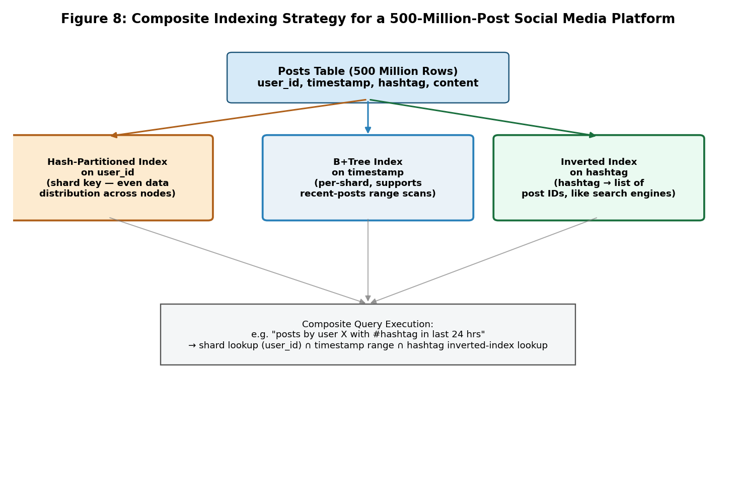
Figure 9: Composite indexing strategy — hash-partitioned sharding on user_id, per-shard B+Tree on timestamp, and a global inverted index on hashtag.

3. Serving a Composite Query
Consider the query: 'posts by user X containing #travel in the last 24 hours.' Execution proceeds as: (1) hash user_id to route directly to the correct shard, avoiding a scatter-gather across all shards; (2) use that shard's B+Tree timestamp index to narrow to the last-24-hours window; (3) intersect with the hashtag inverted index's post-ID list for #travel to produce the final result. Ordering the steps by selectivity (routing by user_id first, since it eliminates the most data) minimizes the total work done.

4. Handling Skew and Hot Keys
A known challenge at this scale is hashtag skew — a small number of globally trending hashtags (e.g., during a major event) can receive a disproportionate share of posts, creating a 'hot' inverted-index entry. This is mitigated by further sub-partitioning very large hashtag posting lists by time bucket (e.g., per-hour segments) so that even a viral hashtag's index entry remains manageably sized and queries for a specific time window don't need to scan the entire history of that hashtag.

5. Strategy Summary Table
Attribute | Indexing Technique | Primary Query Served
user_id | Hash-based horizontal sharding (partition key) | All posts by a specific user
timestamp | Per-shard B+Tree index | Recent posts / time-range feed queries
hashtag | Global inverted index (search-engine style) | Keyword/hashtag search across all users
Compound queries | Sequential intersection: shard routing → time filter → hashtag lookup | e.g., a user's recent posts on a topic

6. Conclusion
At 500-million-post scale, no single index suffices; the recommended composite strategy combines hash-based sharding on user_id (for data locality and horizontal scalability), a per-shard B+Tree on timestamp (for efficient range/recency queries), and a global inverted index on hashtag (for keyword-style search), with query execution intersecting these structures in order of selectivity to minimize the data touched for any given request.

Question 10: Performance Comparison — Heap, Sorted, and Hashed File for Supermarket Billing
Compare the performance (insert, delete, search time) of Heap File, Sorted File, and Hashed File for a supermarket billing system with 1 million daily transactions.

1. Workload Context
A supermarket billing system generates roughly 1 million new transaction records per day (e.g., each item scanned or each completed sale), predominantly insert-heavy at checkout time, with occasional searches (e.g., looking up a transaction for a refund/dispute) and rare deletes (e.g., voiding an erroneous entry within the same session). This workload profile — very high insert volume, moderate search need, low delete frequency — strongly shapes which file organization performs best.

2. Theoretical (Big-O) Comparison
Operation | Heap File | Sorted File | Hashed File
Search (by transaction ID) | O(b) — full scan, b = number of blocks | O(log₂ b) — binary search | O(1) average — direct bucket access
Insert | O(1) — append at end | O(b) — must maintain sort order (shift records) | O(1) average — hash to bucket directly
Delete | O(b) — must search then remove | O(b) — search + shift to close gap | O(1) average — hash to bucket, remove

3. Practical Estimate for 1 Million Daily Transactions
Assume roughly 4,000 blocks are needed to store one day's 1 million transactions (using a blocking factor of ~250 records/block for typical transaction record sizes). The table below estimates average disk-block accesses per operation:
File Organization | Avg. Search (block accesses) | Avg. Insert (block accesses) | Avg. Delete (block accesses)
Heap File | ≈ 2,000 (b/2 average) | ≈ 1 (append at end) | ≈ 2,001 (search + remove)
Sorted File | ≈ 12 (log₂ 4000) | ≈ 2,000 (shift ~half the file) | ≈ 2,000 (search + shift)
Hashed File | ≈ 1–2 (direct bucket) | ≈ 1–2 (direct bucket, rare overflow) | ≈ 1–2 (direct bucket)
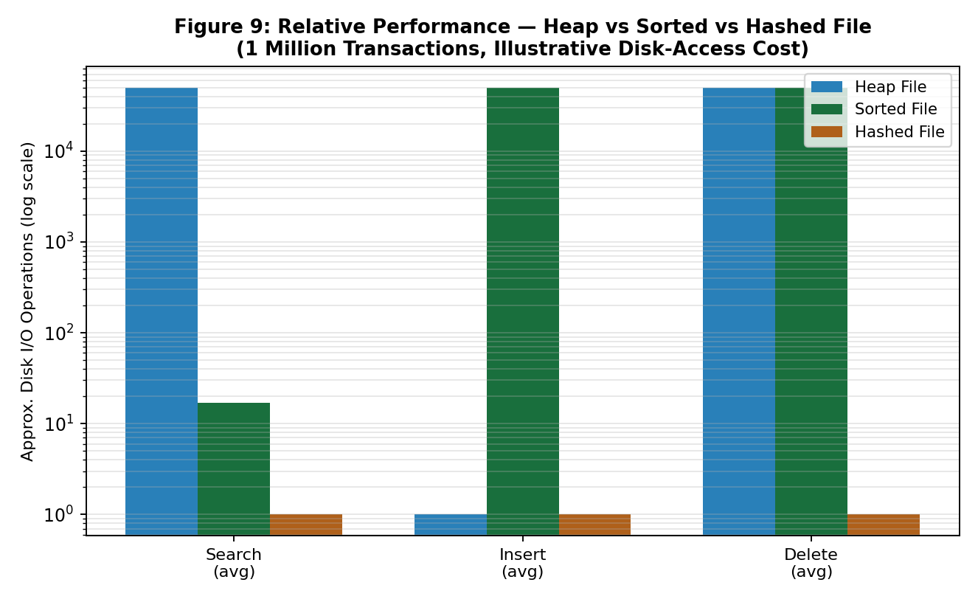
Figure 10: Relative performance (log scale) of Heap, Sorted, and Hashed file organizations for search, insert, and delete operations.

4. Analysis
Heap File performs best only for insertion (simple append) but is poor for both search and delete, since both require scanning roughly half the file on average — unacceptable for a billing system that must quickly pull up a transaction for a customer dispute. Sorted File offers reasonably fast search via binary search, but its insert and delete costs are very high because maintaining sort order requires shifting large portions of the file on every write — completely impractical for a system ingesting a million inserts per day. Hashed File offers the best all-round performance for this specific workload: near-constant-time search, insert, and delete, since transaction ID (or bill number) is a natural, uniformly-distributable hash key with no inherent need for range queries during normal billing operations.

5. Recommendation
A Hashed File organization (with a hash index on Transaction ID / Bill Number) is recommended for the supermarket billing system's core transaction store, since it delivers the best balanced performance across all three operations — critical given the system's simultaneous demand for very high insert throughput at checkout and fast search for occasional refund/dispute lookups. If reporting queries later require date-range analysis (e.g., 'all transactions this week'), a supplementary B+Tree secondary index on transaction date/time can be added without changing the primary hashed organization, similar to the combined-index approach used in Questions 2 and 6.

6. Conclusion
For a high-insert-volume, occasional-search, rare-delete workload like supermarket billing, Hashed File organization dominates both Heap and Sorted File across all three key operations, making it the clear choice for the primary transaction store, with an optional secondary B+Tree index available for any range-based reporting needs.

