SIMATS ENGINEERING
ASSESSMENT TOOL 3

COURSE NAME: Database Management Systems NAME:K.SARANYA
COURSE CODE: CSA0501 REG NO:192424409

COURSE OUTCOME COVERED

CO4: Design database solutions incorporating file organization, indexing, and hashing techniques to optimize data storage and retrieval efficiency. (BL3, BL4)

Activity Tool : Comparative Analysis (Low)
Assessment Tool Weightage: 10%

QUESTIONS
Q.No | Question | Bloom's Level
1 | Compare sequential file organization and heap file organization in terms of data insertion, deletion, and retrieval efficiency. | Bloom’s Level: 4 – Analyze
2 | Differentiate between clustered indexing and non-clustered indexing with suitable database examples. | Bloom’s Level: 4 – Analyze
3 | Compare primary indexing and secondary indexing based on storage requirements and search performance. | Bloom’s Level: 4 – Analyze
4 | Analyze the differences between static hashing and dynamic hashing in database systems. | Bloom’s Level: 4 – Analyze
5 | Compare B-Tree indexing and B+ Tree indexing for large-scale database applications. | Bloom’s Level: 4 – Analyze
6 | Differentiate linear hashing and extendible hashing in terms of bucket management and scalability. | Bloom’s Level: 4 – Analyze
7 | Compare dense indexing and sparse indexing with respect to memory usage and access speed. | Bloom’s Level: 4 – Analyze
8 | Analyze the advantages and limitations of indexed sequential file organization versus direct file organization. | Bloom’s Level: 4 – Analyze
9 | Compare single-level indexing and multi-level indexing for efficient database retrieval operations. | Bloom’s Level: 4 – Analyze
10 | Evaluate the performance of hashing techniques and indexing techniques for exact-match and range queries in databases. | Bloom’s Level: 5 – Evaluate

Code of Conduct:

I K.SARANYA(192424409) (Name / Reg No) certify that this submission is my original work and that I have adhered to the guidelines specified for this assessment.
I understand that any violation of academic integrity rules will result in disciplinary action.


Signature of the student:

RUBRICS FOR CALCULATION:

Criteria | Weightage (%) | Level 4 (Exemplary) | Level 3 (Proficient) | Level 2 (Developing) | Level 1 (Beginning)
Scope of Items | 20% | Selects highly relevant items with clear scope and justification | Selects appropriate items with minor gaps | Selection is limited or partially relevant | Items are unclear or not relevant
Comparison Depth | 25% | Provides detailed and comprehensive comparison across multiple aspects | Provides adequate comparison with some depth | Limited comparison with few aspects | Very minimal or no comparison
Use of Evidence | 20% | Supports comparison with accurate data, examples, or references | Uses some supporting evidence with minor gaps | Limited or weak supporting evidence | No supporting evidence provided
Critical Thinking | 20% | Demonstrates strong critical thinking with clear interpretation and reasoning | Shows reasonable interpretation with minor gaps | Basic interpretation; lacks depth | No meaningful interpretation
Clarity of Presentation | 15% | Well-organized, clear, and logically structured presentation | Generally clear with minor issues | Somewhat unclear or poorly structured | Disorganized and difficult to understand

Table of Contents
Q1. Sequential File vs Heap File Organization
Q2. Clustered Indexing vs Non-Clustered Indexing
Q3. Primary Indexing vs Secondary Indexing
Q4. Static Hashing vs Dynamic Hashing
Q5. B-Tree Indexing vs B+ Tree Indexing
Q6. Linear Hashing vs Extendible Hashing
Q7. Dense Indexing vs Sparse Indexing
Q8. Indexed Sequential File Organization vs Direct File Organization
Q9. Single-Level Indexing vs Multi-Level Indexing
Q10. Hashing vs Indexing - Exact-Match and Range Query Performance (Evaluate)

Question 1: Sequential File Organization vs Heap File Organization
Bloom's Level: BL4 - Analyze
1.1 Overview
A Sequential File Organization stores records physically ordered by a chosen key field, which makes range scans and ordered reporting efficient but complicates maintenance. A Heap (unordered) File Organization stores records in whatever order they arrive, which makes insertion trivially fast but leaves searching and range access expensive. The two represent opposite trade-offs between write cost and read cost.
1.2 Detailed Comparison
Aspect | Sequential File Organization | Heap File Organization
Physical order | Records sorted by key | No defined order (arrival order)
Insertion | O(n) - may require shifting records  to keep the file sorted | O(1) - simply appended to the  last block with space
Deletion | O(n) - locate then shift/compact,  or use tombstones | O(n) to locate + O(1) to tombstone
Exact-match search | O(log2 n) via binary search | O(n) - full linear scan required
Range query | O(log2 n + k) - very efficient,  records already contiguous | O(n) - must scan every record
Best suited for | Batch processing, reporting,  read-heavy static data | Write-heavy workloads, staging  areas, small/temporary tables
Maintenance overhead | High - reorganisation needed  as file grows | Low - no reorganisation required

1.3 Diagram
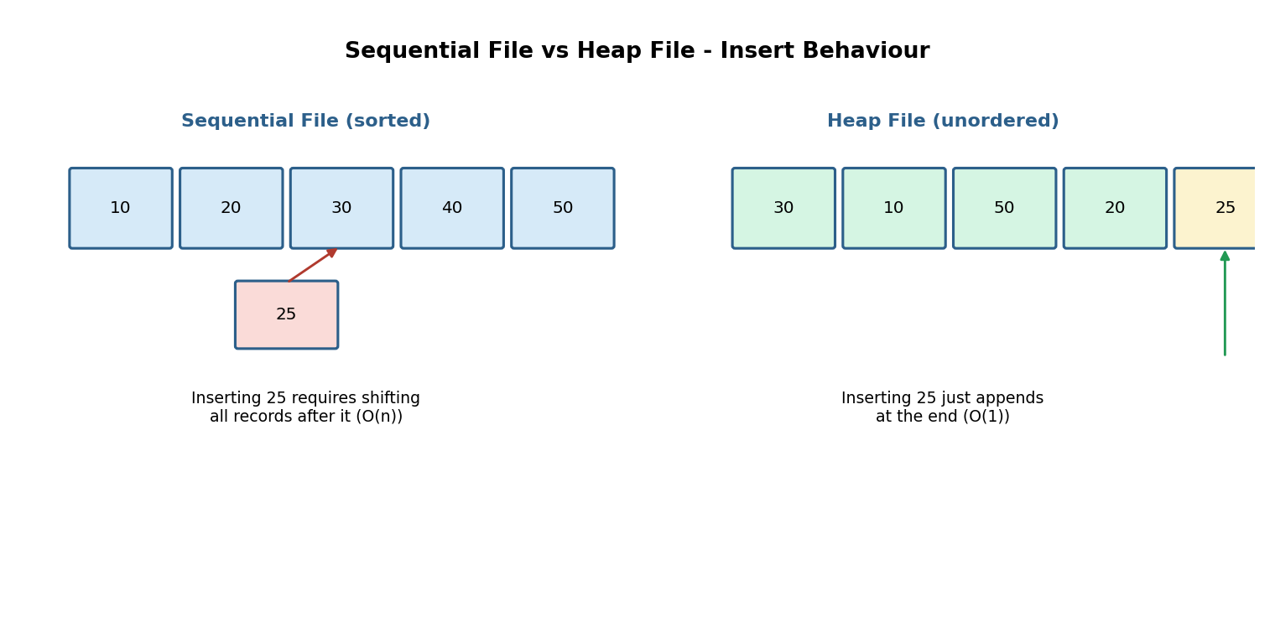
Fig. 1 - Inserting a new key: sequential file needs a shift, heap file just appends.
1.4 Practical Example
Consider a university 'Alumni Records' table that is rarely updated but frequently queried by graduation-year ranges - a Sequential organization on graduation_year is ideal because range reports run in O(log n + k). In contrast, a temporary 'Login Attempts' staging table that receives thousands of inserts per second but is queried rarely is better served by a Heap organization, since insertion speed dominates.
1.5 Conclusion
Sequential organization favours read/range-query performance at the cost of expensive writes; heap organization favours write throughput at the cost of expensive reads. The choice should be driven by the read:write ratio and whether range queries on the key are common.

Question 2: Clustered Indexing vs Non-Clustered Indexing
Bloom's Level: BL4 - Analyze
2.1 Overview
A Clustered Index determines the physical storage order of the table's data itself - the data rows ARE the leaf level of the index, so a table can have only one clustered index. A Non-Clustered Index is a separate structure that stores index keys alongside pointers (row locators) to the actual data rows, which are stored elsewhere in their own order (heap or clustered). A table can have several non-clustered indexes.
2.2 Detailed Comparison
Aspect | Clustered Index | Non-Clustered Index
Data storage | Data rows physically sorted  by the index key | Data stored separately;  index holds pointers to rows
Number allowed per table | Only one | Multiple (several per table)
Lookup speed (indexed column) | Very fast - direct access  to sorted data | Fast, but one extra pointer  hop (bookmark lookup)
Storage overhead | No extra copy of data | Extra space for index +  row pointers
Insert/Update cost | Higher - may reorder  physical rows | Lower on the indexed column,  but extra index maintenance
Typical use case | Primary key / most-queried  range column | Foreign keys, frequently  filtered non-key columns

2.3 Diagram
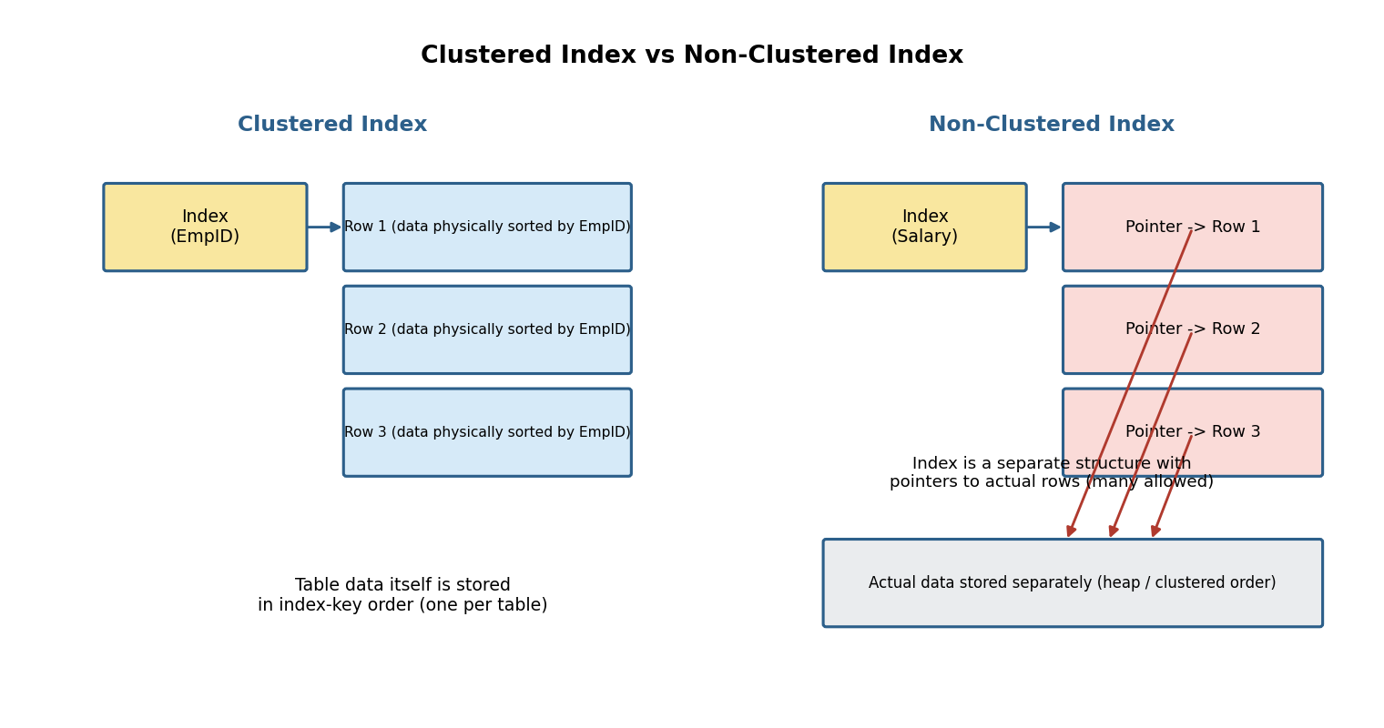
Fig. 2 - Clustered index IS the sorted data; non-clustered index points to rows stored elsewhere.
2.4 Database Examples
- MySQL InnoDB: the PRIMARY KEY is automatically a clustered index; any other index (e.g., on 'email') is non-clustered and stores the primary-key value as its row pointer.
- SQL Server: 'CREATE CLUSTERED INDEX idx_orderdate ON Orders(OrderDate)' physically sorts the Orders table by date; 'CREATE INDEX idx_custid ON Orders(CustomerID)' creates a separate non-clustered structure.
- PostgreSQL: does not maintain clustering automatically, but 'CLUSTER table USING index_name' can physically re-sort the table once to mimic clustered behaviour.
2.5 Conclusion
Clustered indexing is best for the single most-common access pattern (typically the primary key or a heavily range-queried column), while non-clustered indexes supplement it to accelerate additional lookup paths, at the cost of extra storage and a pointer de-reference per lookup.

Question 3: Primary Indexing vs Secondary Indexing
Bloom's Level: BL4 - Analyze
3.1 Overview
A Primary Index is built on the ordering key of a sorted data file - since the data is already sorted, the index can be sparse (one entry per block) and still support fast search. A Secondary Index is built on a non-ordering field (or the data file is not sorted by that field at all); because there is no guaranteed physical grouping, the index must be dense (one entry per distinct value or per record) to be usable.
3.2 Detailed Comparison
Aspect | Primary Indexing | Secondary Indexing
Built on | The ordering (sorted) key  of the data file | A non-ordering field, or any  field in an unsorted file
Index density | Usually sparse - one entry  per block | Usually dense - one entry  per distinct search value
Storage requirement | Low - proportional to  block count | High - proportional to record  count (or distinct values)
Search performance | Fast - binary search on index  + short in-block scan | Fast lookup, but result rows are  scattered - extra I/O per row
Number per file | One (only one field can  define physical order) | Many - one per additional  searchable field
Maintenance on insert | Simpler - order is preserved  by design | More overhead - every extra  index must be updated

3.3 Diagram
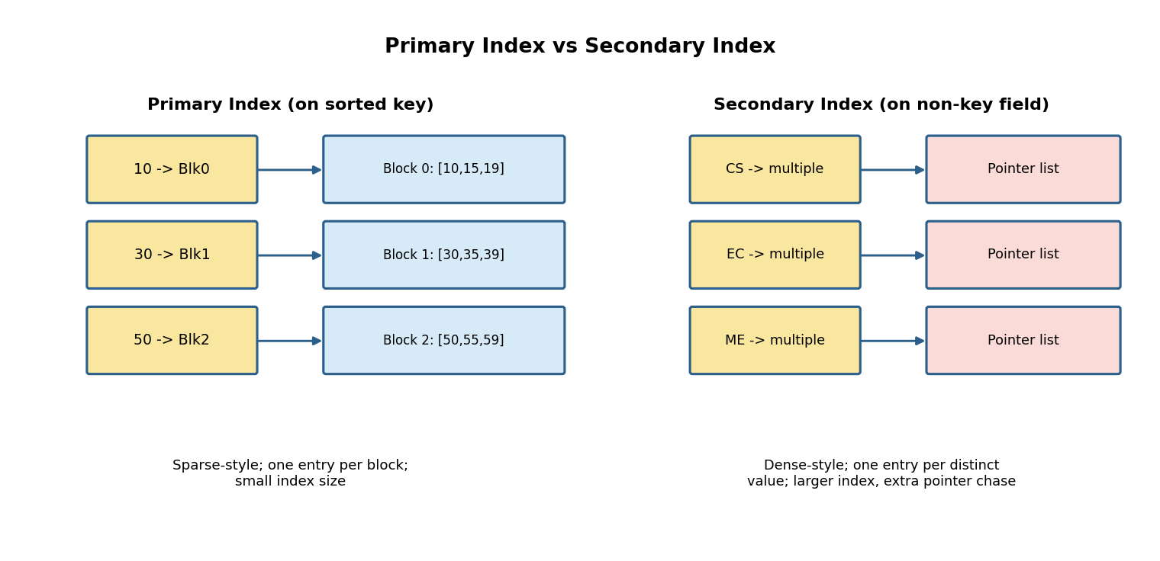
Fig. 3 - Primary index (sparse, one entry/block) vs secondary index (dense, pointer list per value).
3.4 Worked Example
In an Employees table sorted physically by EmployeeID, a primary index on EmployeeID needs only one entry per disk block (e.g., 100 entries for 10,000 records at 100 records/block). A secondary index on Department (an unordered attribute) must store every distinct department value with a list of pointers to all matching, physically scattered rows - e.g., 5 entries for 5 departments, but each with hundreds of row pointers, or one entry per employee if built densely on EmployeeID duplicated data.
3.5 Conclusion
Primary indexes exploit existing physical order to stay small and fast; secondary indexes trade extra storage and an additional I/O hop for the flexibility of searching on fields that do not match the file's physical layout.

Question 4: Static Hashing vs Dynamic Hashing
Bloom's Level: BL4 - Analyze
4.1 Overview
Static Hashing uses a fixed number of buckets M determined at file-creation time, with h(key) = key mod M mapping keys to buckets. It performs well while the data volume stays close to what was planned for, but degrades as the file grows because overflow chains lengthen. Dynamic Hashing (extendible or linear hashing) allows the number of buckets to grow and shrink automatically as records are inserted or deleted, avoiding long overflow chains and expensive full-file rehashing.
4.2 Detailed Comparison
Aspect | Static Hashing | Dynamic Hashing
Bucket count | Fixed at creation time | Grows/shrinks with data volume
Performance as data grows | Degrades - long overflow chains | Stays near-constant - buckets  split before overflow worsens
Rehashing cost | None until manually resized  (then a full, expensive rehash) | Incremental - only affected  buckets are touched
Extra structure needed | None beyond the bucket array | Directory (extendible) or split  pointer (linear) adds a hop
Predictability | Simple, predictable for  stable-size datasets | More complex, but adapts to  unpredictable/growing datasets
Best suited for | Fixed-size lookup tables  (e.g., a code/constant table) | Databases with unknown or  rapidly changing record counts

4.3 Diagram
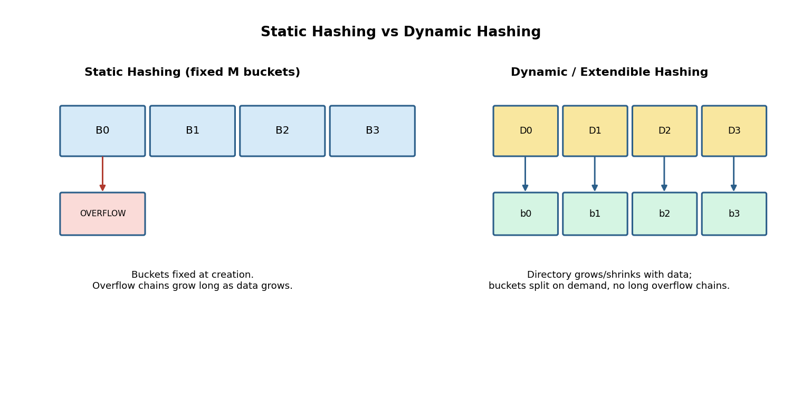
Fig. 4 - Static hashing overflows as data grows; dynamic hashing adds buckets on demand.
4.4 Conclusion
Static hashing is simple and fast when the record count is known and stable, but its performance collapses under overflow chaining once the load factor exceeds design expectations. Dynamic hashing trades a small amount of extra indirection (directory or split-pointer lookup) for graceful, incremental scalability, making it the standard choice for modern DBMS hash indexes.

Question 5: B-Tree Indexing vs B+ Tree Indexing
Bloom's Level: BL4 - Analyze
5.1 Overview
A B-Tree stores actual data (or record pointers) alongside keys at every level of the tree, including internal nodes. A B+ Tree stores data only at the leaf level; internal nodes hold copies of keys purely to guide the search, and all leaves are linked together in a sorted chain. This single design difference has significant consequences for large-scale database applications.
5.2 Detailed Comparison
Aspect | B-Tree | B+ Tree
Data location | Keys and data in every node  (internal + leaf) | Data only in leaf nodes;  internal nodes = keys only
Fan-out (children per node) | Lower - node space shared  with data pointers | Higher - internal nodes are  smaller, more keys per block
Tree height for large n | Taller - fewer children per  level | Shorter - better for millions  of records, fewer disk I/Os
Range queries | Requires repeated in-order  traversal / backtracking | Fast - just walk the linked  leaf chain sequentially
Exact-match search | Can be faster - value may be  found at an internal node | Always descends to a leaf,  slightly more consistent cost
Industry usage | Less common in DBMS indexes | Standard for most RDBMS  (MySQL InnoDB, PostgreSQL, Oracle)

5.3 Diagram
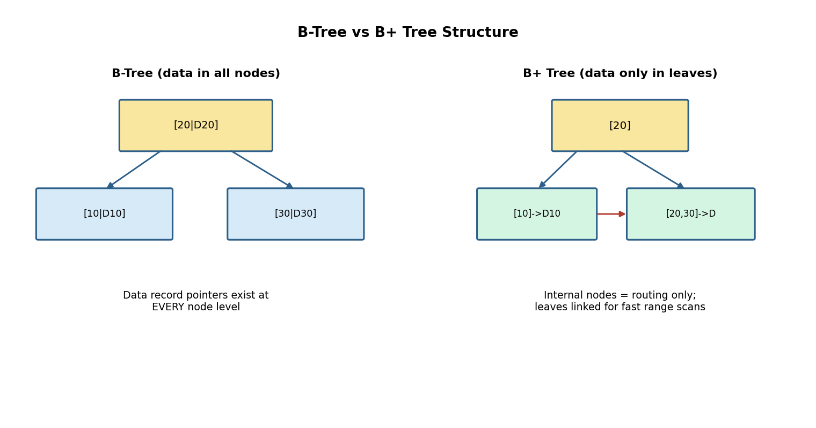
Fig. 5 - B-Tree holds data at every node; B+ Tree keeps data only in linked leaves.
5.4 Why B+ Trees Dominate Large-Scale Systems
- Higher fan-out (since internal nodes carry no data) means fewer levels for the same number of records, directly reducing disk I/O per lookup.
- The linked leaf chain gives O(log n + k) range scans, essential for SQL 'BETWEEN' and 'ORDER BY' queries on indexed columns.
- Sequential leaf access is disk-friendly (fewer random seeks), which matters more than raw comparison count on real storage hardware.
5.5 Conclusion
For large-scale database applications, B+ Trees are almost universally preferred over plain B-Trees because their higher fan-out reduces tree height and their linked leaves make range queries dramatically cheaper - the two operations that dominate real-world OLTP and OLAP workloads.

Question 6: Linear Hashing vs Extendible Hashing
Bloom's Level: BL4 - Analyze
6.1 Overview
Both are dynamic hashing schemes that grow the bucket space as data is inserted, but they differ fundamentally in how they decide which bucket to split and how they route lookups. Extendible Hashing uses an explicit directory of 2^(global depth) pointers and always splits the bucket that actually overflowed. Linear Hashing avoids a directory entirely, splitting buckets in a fixed, predetermined round-robin order controlled by a moving 'split pointer', regardless of which bucket overflowed.
6.2 Detailed Comparison
Aspect | Linear Hashing | Extendible Hashing
Directory structure | None - buckets addressed  directly via a split pointer | Explicit directory of 2^gd  pointers to buckets
Which bucket splits | Next bucket in round-robin  order (may not be the full one) | Only the bucket that actually  overflowed
Extra memory overhead | Low - no directory to store | Directory grows with global  depth; can itself get large
Overflow handling | Temporary overflow chains  allowed until its turn to split | No chains - directory doubles  immediately if depth is insufficient
Lookup cost | O(1) average, plus possible  overflow-chain traversal | O(1) - one directory hop  plus one bucket access
Scalability pattern | Very smooth, gradual  bucket-by-bucket growth | Can require a full directory  doubling in one step

6.3 Diagram
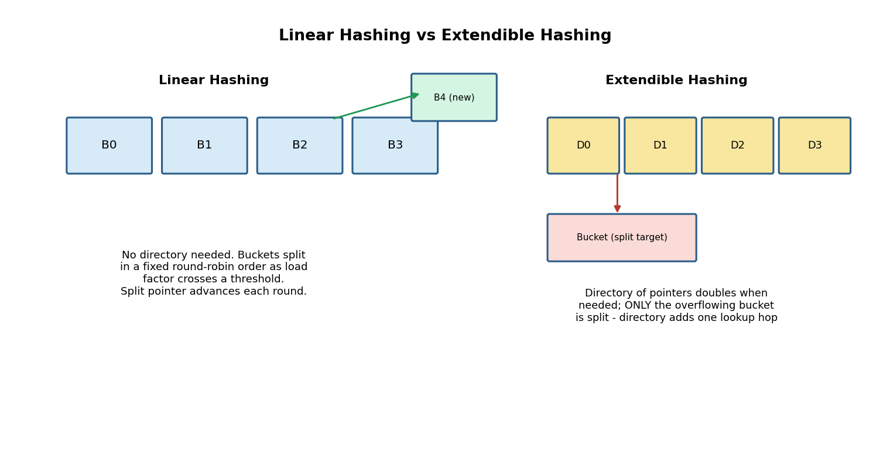
Fig. 6 - Linear hashing splits buckets in fixed order; extendible hashing splits only the overflowing bucket via a directory.
6.4 Conclusion
Linear hashing avoids directory overhead and grows very smoothly, but tolerates temporary overflow chains and may split buckets that are not yet full. Extendible hashing always splits exactly where the overflow occurred, keeping buckets closer to capacity, at the cost of maintaining (and occasionally doubling) an explicit directory.

Question 7: Dense Indexing vs Sparse Indexing
Bloom's Level: BL4 - Analyze
7.1 Overview
A Dense Index stores an index entry for every search-key value present in the data file, guaranteeing that every lookup can jump directly to the target block with no further scanning. A Sparse Index stores an entry only for some keys (typically the first key of each block), trading a small in-block scan for a much smaller index that is more likely to fit entirely in memory.
7.2 Detailed Comparison
Aspect | Dense Indexing | Sparse Indexing
Index entries | One per record (or per  distinct key) | One per block (first key  of the block)
Memory usage | Higher - grows linearly  with record count | Lower - grows linearly with  block count only
Access speed (single lookup) | Slightly faster - direct  pointer to the exact record | Slightly slower - needs a final  in-block linear/binary scan
Applicability | Works on sorted or  unsorted files | Requires the data file to be  physically sorted
Cache/memory residency | Less likely to fit fully  in memory for large files | More likely to fit entirely  in memory, reducing disk I/O
Maintenance on insert/delete | Every record change may  need an index update | Only affects the index when a  block's first key changes

7.3 Diagram
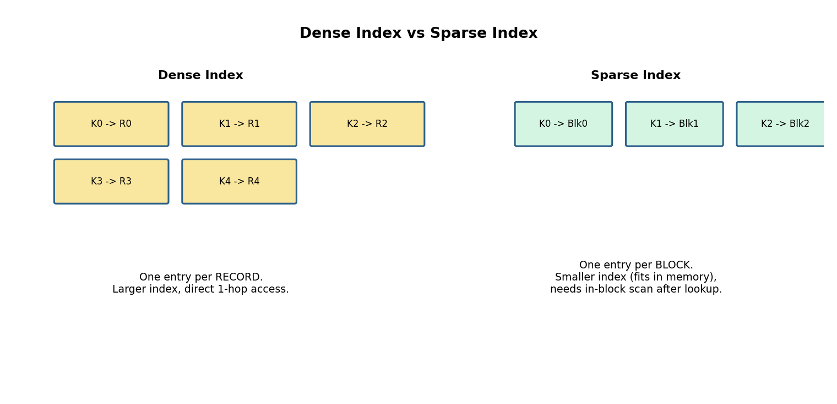
Fig. 7 - Dense index: one entry/record. Sparse index: one entry/block.
7.4 Conclusion
Dense indexes give the fastest possible single-record lookups at the price of larger index size, while sparse indexes sacrifice a small amount of per-lookup speed (one extra in-block scan) for a dramatically smaller index footprint - often the deciding factor when the index itself must be cached in memory for good overall performance.

Question 8: Indexed Sequential File Organization vs Direct File Organization
Bloom's Level: BL4 - Analyze
8.1 Overview
Indexed Sequential Access Method (ISAM) combines a sorted data area with a separate multi-level index, supporting both efficient sequential scans and reasonably fast random access. Direct (hashed) File Organization computes a bucket address directly from the key using a hash function, giving very fast exact-match access but no usable notion of key ordering.
8.2 Detailed Comparison
Aspect | Indexed Sequential (ISAM) | Direct (Hashed) Organization
Physical order | Sorted by key, with an  index layered on top | No meaningful order -  placement is hash-determined
Exact-match access | O(log n) via the index | O(1) average via hash function
Range queries | Efficient - contiguous  sorted scan | Poor - must scan the entire  file since order is not preserved
Insert cost | Can be costly - overflow  areas or reorganisation needed | Usually fast, O(1) - but bucket  overflow can occur
Storage overhead | Extra space for the index  levels | Minimal extra structure, but  load-factor must be tuned
Best suited for | Reports, range scans, and  ordered batch processing | High-speed key lookups (e.g.,  session/cache tables)

8.3 Diagram
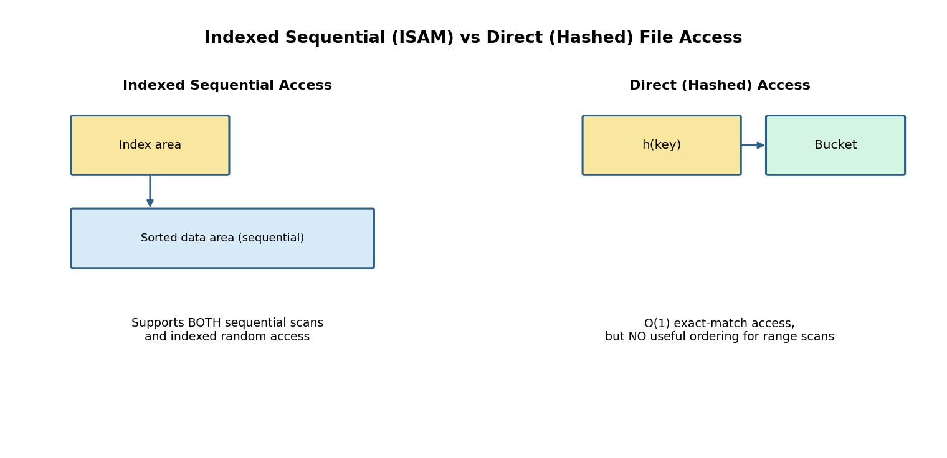
Fig. 8 - ISAM supports both scan and index access; direct/hashed access is O(1) but unordered.
8.4 Advantages and Limitations Summary
8.4.1 Indexed Sequential (ISAM)
- Advantage: supports fast sequential AND indexed random access from the same file.
- Advantage: naturally supports range queries and ordered reports.
- Limitation: insertions can require overflow areas, degrading performance until periodic reorganisation.
8.4.2 Direct (Hashed) Organization
- Advantage: very fast O(1) average-case exact-match retrieval.
- Advantage: simple to implement, no index maintenance overhead.
- Limitation: no support for efficient range queries - a full scan is required.
- Limitation: poor hash-function choice or high load factor causes bucket overflow.
8.5 Conclusion
ISAM is the better choice when both range queries and ordered access matter, while direct/hashed organization is preferable when only fast exact-match lookup is needed and range access is rare or unnecessary.

Question 9: Single-Level Indexing vs Multi-Level Indexing
Bloom's Level: BL4 - Analyze
9.1 Overview
A Single-Level Index is one flat list mapping keys to block pointers; when the data file is very large, this index itself can grow too large to fit comfortably in memory, forcing extra disk I/O even to search the index. A Multi-Level Index solves this by recursively building an index over the index - an outer (top) level small enough to reside in memory, pointing to inner index blocks, which in turn point to the actual data blocks.
9.2 Detailed Comparison
Aspect | Single-Level Indexing | Multi-Level Indexing
Structure | One flat index over  the data file | Hierarchy of indexes  (index of an index)
Search on the index | Binary search - O(log2 b)  where b = index blocks | O(logf b) where f = fan-out;  fewer comparisons per level
Memory residency | May not fit in memory  for very large files | Outer level(s) small enough  to stay resident in memory
Disk I/O per lookup | Higher for large indexes -  index itself needs paging | Lower - most levels besides  the root are rarely touched
Maintenance complexity | Simpler to implement  and maintain | More complex - insertions may  cascade through several levels
Typical realisation | A single sorted array  of (key, pointer) pairs | B-Tree / B+ Tree index  structures

9.3 Diagram
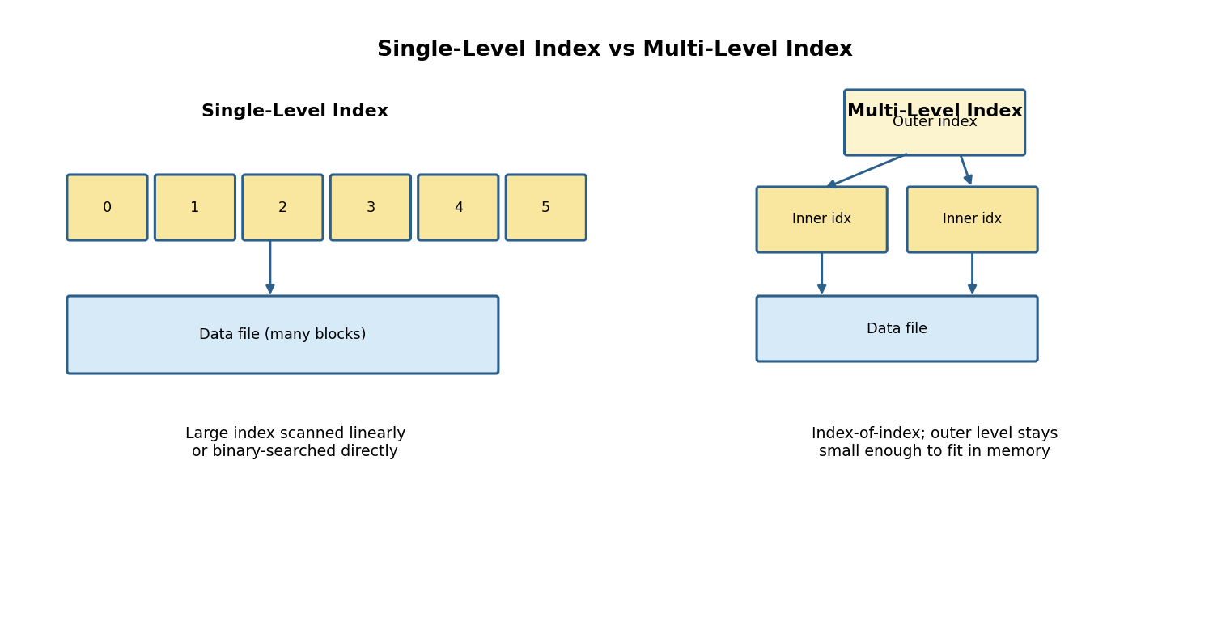
Fig. 9 - Single flat index vs a small memory-resident outer index over inner index blocks.
9.4 Conclusion
Single-level indexing is adequate while the index fits comfortably in memory; once the data (and hence the index) grows beyond that point, multi-level indexing becomes essential - it is, in effect, the underlying idea behind B-Tree and B+ Tree indexes used throughout modern database systems.

Question 10: Evaluating Hashing vs Indexing for Exact-Match and Range Queries
Bloom's Level: BL5 - Evaluate
10.1 Overview
Exact-match queries ('WHERE id = 105') and range queries ('WHERE age BETWEEN 20 AND 30') place very different demands on a data-access structure. This section evaluates hashing techniques against tree-based indexing techniques (B-Tree / B+ Tree) for both query types, using both theoretical complexity and a simulated I/O-cost comparison.
10.2 Theoretical Complexity
Technique | Exact-Match Cost | Range Query Cost | Ordering Preserved?
Static / Dynamic Hashing | O(1) average case | O(n) - full file scan;  hashing destroys ordering | No
B-Tree Index | O(log n) | O(log n + k) with  repeated traversal | Yes
B+ Tree Index | O(log n) | O(log n + k) via linked  leaf-chain scan (fastest range) | Yes
Sequential / Sorted File | O(log n) binary search | O(log n + k) - contiguous  scan once located | Yes

10.3 Simulated I/O Cost (100,000 records, illustrative)
The chart below illustrates typical relative disk I/O counts for a single exact-match query versus a range query returning roughly 1% of the table, comparing a hash index against a B+ Tree index.
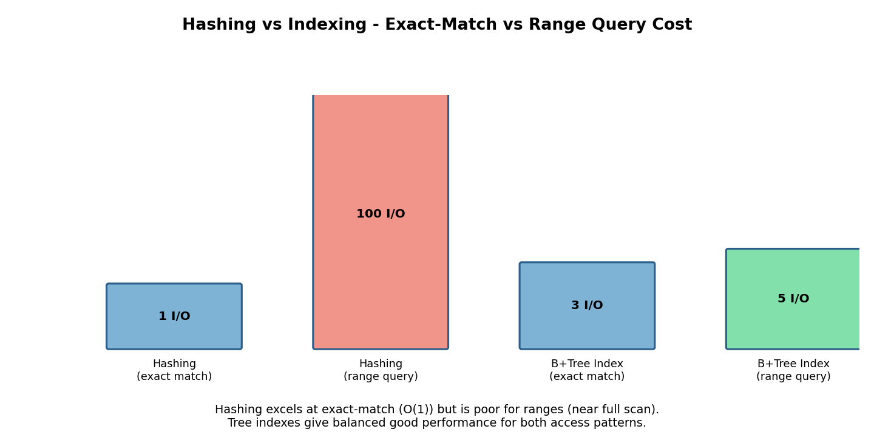
Fig. 10 - Hashing wins on exact match; B+ Tree index wins decisively on range queries.
10.4 Evaluation and Recommendation
- For pure exact-match workloads (e.g., a session cache keyed by session ID), hashing gives the best average-case performance - O(1) versus O(log n) for a tree index - and should be preferred.
- For workloads that mix exact-match with occasional range queries (most real-world OLTP systems), a B+ Tree index is the safer general-purpose choice, since it supports both patterns reasonably well, whereas hashing fails badly on ranges.
- For read-heavy analytical workloads dominated by range scans, sorting/clustering (sequential file organization or a clustered B+ Tree index) outperforms both plain hashing and non-clustered tree indexes.
- Many production DBMS engines therefore offer both: a hash index option for equality-only columns, and a B+ Tree (the default) for general-purpose columns that may be range-queried.
10.5 Overall Verdict
There is no universally 'better' technique - the correct choice depends entirely on the query workload. Hashing is optimal specifically for exact-match lookups and should be selected when range queries on that column are rare or absent. Indexing (B-Tree / B+ Tree) is the more robust default because it handles exact-match queries efficiently while remaining strong on range queries, which hashing cannot support at all without a full scan.
10.6 Summary of All 10 Comparative Topics
Q.No | Comparison Topic | Key Trade-off
1 | Sequential vs Heap File | Read/range speed vs write speed
2 | Clustered vs Non-Clustered Index | One sorted copy vs many pointer indexes
3 | Primary vs Secondary Index | Sparse & small vs dense & flexible
4 | Static vs Dynamic Hashing | Simplicity vs graceful scalability
5 | B-Tree vs B+ Tree | Data-at-every-node vs leaf-only + linked scans
6 | Linear vs Extendible Hashing | No directory vs targeted bucket splitting
7 | Dense vs Sparse Index | Lookup speed vs index memory footprint
8 | ISAM vs Direct/Hashed File | Ordered flexibility vs O(1) equality speed
9 | Single-Level vs Multi-Level Index | Simplicity vs memory-resident scalability
10 | Hashing vs Indexing (Evaluate) | Exact-match speed vs range-query capability

End of Comparative Analysis Solution Set.

